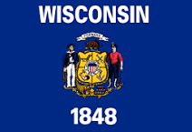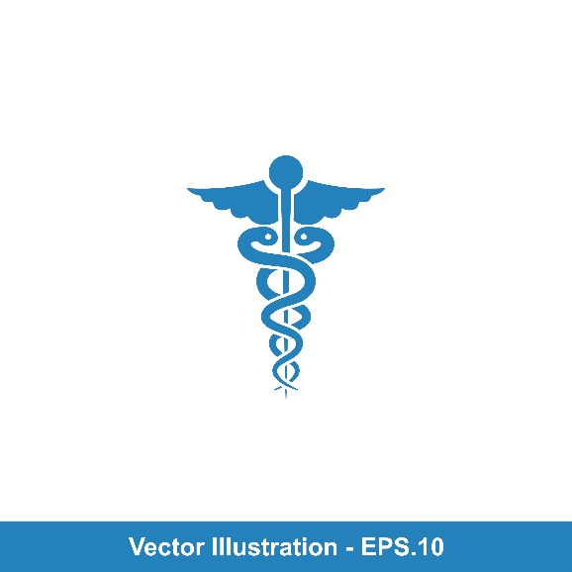

**Testing with Exact Sciences Laboratories**

Account Set-up

Order Supplies

Go to State Website <https://covid19supplies.wi.gov/Testing> to order **Exact Sciences Supplies**

Follow Link to complete Account Set-up with Exact Sciences

Receive EXAS Supplies

State will deliver supplies to your location

* Result will be provided electronically through EpicCare Link
* Report to CDC and WEDSS
* De-viral
* Extraction
* PCR
* Exact Laboratories receives sample at designated time
* Create patient record and enter order into Epic
* Scan TRF into OnBase
* Secure sample in biohazard bag
* Decontaminate bag
* Refrigerate in 2-8C

Complete manifest

* Complete paper test requisition form (TRF)
* Complete Patient label
* Use nasal swab to collect specimens
* Count samples and complete manifest (exhibit 3)
* Pack shipping container for chilled transport
* Transport to EXAS Labs within 72 hours from collection

Transport Sample

Store Sample

Service residents and staff

Sample Receipt

Accessioning

Perform Test

Report results