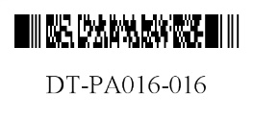
DEPARTMENT OF HEALTH SERVICES STATE OF WISCONSIN
Division of Medicaid Services DHS 106.03(4), Wis. Admin. Code
F-11035 (07/2012) DHS 152.06(3)(h), Wis. Admin. Code

FORWARDHEALTH
PRIOR AUTHORIZATION DENTAL REQUEST FORM (PA/DRF)

Providers may submit prior authorization (PA) requests by fax to ForwardHealth at 608-221-8616 or by mail to: ForwardHealth, Prior Authorization, Suite 88, 313 Blettner Boulevard, Madison, WI 53784. Instructions: Type or print clearly. Before completing this form, read the Prior Authorization Dental Request Form (PA/DRF) Completion Instructions, F-11035A.

SECTION I — PROVIDER INFORMATION
1. Check only if applicable  HealthCheck “Other Services”  Wisconsin Chronic Disease Program |  |  |  |  | 2. Process Type (Check one)  124 (Dental)  125 (Ortho) |  |  |  | 3. Telephone Number ― Billing Provider
4. Name and Address — Billing Provider (Street, City, State, ZIP+4 Code) |  |  |  |  |  |  |  |  | 5a. Billing Provider Number
 |  |  |  |  |  |  |  |  | 5b. Billing Provider Taxonomy Code
 |  |  |  |  |  |  |  |  | 6a. Rendering Provider Number
 |  |  |  |  |  |  |  |  | 6b. Rendering Provider Taxonomy Code

SECTION II — MEMBER INFORMATION
7. Member Identification Number |  |  |  | 8. Date of Birth — Member |  |  |  | 9. Address — Member (Street, City, State, ZIP+4 Code)
10. Name — Member (Last, First, Middle Initial) |  |  |  |  |  |  | 11. Gender — Member  Male Female

SECTION III — DIAGNOSIS / TREATMENT INFORMATION
12. Place of Service  Dental Office (POS “11”) Outpatient Hospital (POS “22”) Ambulatory Surgical Center (POS “24”)  Skilled Nursing Facility (POS “31”) Other (specify): |  |  |  |  |  |  |  |  |  |  |  | 13. Dental Diagram  - Check periodontal case type if applicable.  I  II  III  IV  V  - Cross out missing teeth.  - Circle teeth to be extracted.  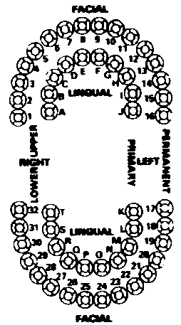  Staple X-Ray Envelope Here  Number of X-rays  Type of X-rays
14.  Area of Oral Cavity | 15.  Tooth | 16.  Procedure Code | 17.  Modifier |  |  | 18.  Description of Service |  |  |  | 19.  Quantity Requested | 20.  Charge
An approved authorization does not guarantee payment. Reimbursement is contingent upon enrollment of the member and provider at the time the service is provided and the completeness of the claim information. Payment will not be made for services initiated prior to approval or after the authorization expiration date. Reimbursement will be in accordance with ForwardHealth payment methodology and policy. If the member is enrolled in a BadgerCare Plus Managed Care Program at the time a prior authorized service is provided, ForwardHealth reimbursement will be allowed only if the service is not covered by the Managed Care Program. |  |  |  |  |  |  |  |  |  | 21. Total Charges
22. SIGNATURE — Rendering Provider |  |  |  |  |  |  |  |  |  | 23. Date Signed
24. SIGNATURE — Member / Guardian (if applicable) |  |  |  |  |  |  |  |  |  | 25. Date Signed

