Date

Participant’s Name

Address

City, State, Zip

RE: Retroactive Overtime to Be Calculated – IRIS Program

Dear Participant’s Name,

The Department of Health Services has completed the calculation of the amount of retroactive overtime pay due your participant-hired worker (PHW), PHW’s Name. This calculation was made in accordance with the Fair Labor Standards Act (FLSA).

Please inform your worker that a separate overtime payment of Amount to be Paid, less any required payroll taxes, will be issued to them within the next 30 days.

The Department of Health Services reminds you that it is your responsibility as an IRIS participant to comply with all IRIS policies and this includes the policy that limits your PHW to not working more than 40 hours per week unless you have an approved exception to the policy. Your IRIS consultant should have already discussed this policy with you, and the Department of Health Services expects that you are taking steps to fully comply with this policy. Failure to comply may result in a referral for disenrollment from the IRIS Program.

Sincerely,

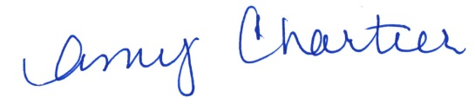

Amy Chartier, IRIS Section Chief

Bureau of Adult Programs and Policies

IRIS Management Section