INCOME MAINTENANCE (IM) ALLOCATION FLOWCHART

Reporting Profiles

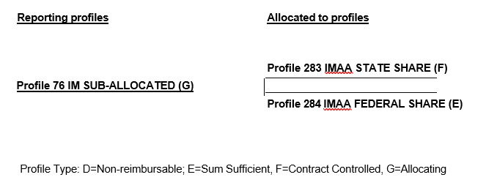

Reporting Instructions

Costs from Profile 76 are allocated to Profiles 283 and 284. Profile 283 is the State share and is a contract controlled profile. Profile 284 is the Federal share and is a Sum Sufficient profile. See Profile 76 in the Find a Profile spreadsheet for specific reporting instructions.

