GEARS Process for Specialized Services Activities Program

Reporting Profiles

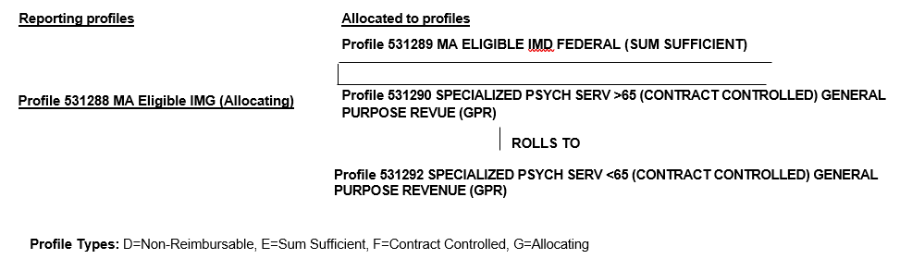

Reporting Profile Explanations

- Agency Reports expenses for clients 65 years of age and over on Profile 532188. Costs are allocated to Profiles 531289 (Fed share) and 531290 (GPR share) based on the current FFP rate. GPR share of expenses in excess of contract on Profile 531290 will roll to Profile 531292 for payment up to the contract level.
- Agency should report expenses for clients aged 21 to 64 on Profile 531292.

FFP Rates

FFY 2026 FFP Rate: 60.68% FED and 39.32% GPR

