TPCP Wisconsin Outreach MA and Non-MA Eligible

2025

Reporting Profiles

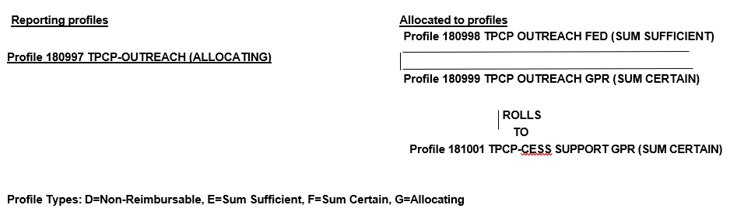

Reporting Profile Explanations

- Allocation is based on specified rate (Ratio in GEARS)
- Profile Type G – Gears Allocating – Ratios Required
- Profile Type E – Gears Sum Sufficient – Gears Contract Level of $0 or More
- Profile Type F – Gears Sum Certain – Gears Contract Level of $0 Required to Roll
- Profile Type F – Gears Sum Certain – Gears Contract Level >$0 Required to Reimburse

Profile Instructions

Profile 180997 allocates to Profile 180998 which is Fed portion and a sum sufficient profile and profile 180999 which is GPR and Sum Certain. Profile 181001 rolls to Profile 181001 which is also GPR and a Sum Certain profile.

