TPCP Wisconsin Outreach MA and Non-MA Eligible

2025

Reporting Profiles

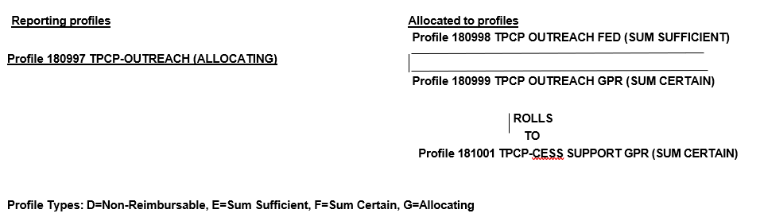

Reporting Profile Explanations

- Allocation is based on specified rate (Ratio in GEARS)
- Profile Type G – Gears Allocating – Ratios Required
- Profile Type E – Gears Sum Sufficient – Gears Contract Level of $0 or More
- Profile Type F – Gears Sum Certain – Gears Contract Level of $0 Required to Roll
- Profile Type F – Gears Sum Certain – Gears Contract Level >$0 Required to Reimburse

Reporting Instructions

Reporting Profile for Agencies to get reimbursed based on state and federal allocations. Wisconsin Medicaid will claim Federal Financial Participation from CMS for 50% of the tobacco outreach services and administration expenditures paid with state funds that serve Wisconsin Medicaid members (caller registration, counseling, and materials, contract manager, promotion/media, and integration of into healthcare).

