
Promoting Respiratory Illness Vaccination Toolkit for Local and Tribal Health Departments




Wisconsin Department of Health Services | Division of Public Health
https://www.dhs.wisconsin.gov/dph/bcd.htm | DHSDPHBCD@dhs.wi.gov
Bureau of Communicable Diseases
10/2025

Table of Contents
Contents
No table of contents entries found.

Contents
Health Education and Outreach 2
RSV posters, fact sheets, and more 2
COVID-19 posters, fact sheets, and more 2
Flu posters, fact sheets, and more 2
Sample Press Release 3
Talking Points 5
Sample social media 6



Health Education and Outreach
Community members and partners trust you to provide accurate information on staying healthy and protected against respiratory diseases. Stay updated by regularly reviewing state respiratory virus surveillance and vaccination information. Remind your community that it is not too late to get protection against respiratory illnesses with vaccination and proper hygiene.

.

COVID-19 posters, fact sheets, and more
- Print a free educational DHS fact sheet for the general public in multiple languages on COVID-19 signs and symptoms, exposure, and prevention.
- Find posters about respiratory illness prevention, like
  - Washing your hands (available in multiple languages)
  - Covering your cough (available in multiple languages)
  - Protecting those around you (available in multiple languages)

Flu posters, fact sheets, and more
- Print free posters made for different audiences from the Wisconsin Department of Health Services (DHS):
  - Children
  - Parents of young children
  - Teens
  - Adults (fall)
  - Adults (winter)
  - Employees
  - Employers
- Print a free educational DHS fact sheet for the general public in multiple languages on flu signs and symptoms, diagnosis, and prevention
- Use trivia questions from the Children’s Hospital of Philadelphia on TVs in waiting room or upload to website.
- Looking for other resources of posters? Check out the DHS Influenza Prevention page, Families Fighting Flu’s free resources or the Children’s Hospital of Philadelphia’s education resources.

RSV posters, fact sheets, and more
- Print free DHS posters about RSV for pregnant people and for infants.
- Print a free educational DHS fact sheet for the general public in multiple languages on different respiratory viruses, including RSV, and symptoms, exposure, and prevention.
- Looking for other resources or posters? Check out the DHS RSV page, for more information on RSV vaccines for older adults, testing, treatment, and more.

Sample Press Release


This is a sample press release template for local health care providers, health departments, and tribal health directors in Wisconsin. We encourage you to modify the template to meet the needs of your jurisdiction.

For Immediate Release
Date: [xx-xx-xxxx]

Don’t Let Respiratory Viruses Steal Your Moments—Get Your Respiratory Vaccines Now
It is never too late to protect yourself, family, and community with flu, COVID-19, and RSV vaccines
As respiratory illnesses continue to spread, public health officials encourage you to protect yourself and your family by getting a yearly flu and COVID-19 vaccine. You can get both vaccines for as long as the diseases are spreading. A one-time RSV vaccine is also recommended for adults aged 75 and older and adults aged 50–74 at increased risk of severe RSV. Vaccines are safe and effective and are the best way to protect against serious respiratory disease. It is never too late to get vaccinated.
“When we get vaccinated, we protect ourselves and our loved ones from respiratory illnesses, reduce hospitalizations and death, and keep our communities safer.” said [insert health officer name and name of local health department].
Everyone ages 6 months and older is recommended to get a yearly flu and COVID-19 vaccine. Getting a flu and COVID-19 vaccine is especially important for people at higher risk for serious disease complications, including:
- People who are pregnant.
- Young children.
- People 65 years and older, especially those living in group settings.
- People with certain medical conditions, such as asthma or heart disease.

Everyone 75 years and older and people aged 50–74 who are at higher risk for severe RSV should talk to their doctor about getting an RSV vaccine. This approved RSV vaccine can protect older adults against serious RSV complications, especially those living in group settings. Parents of infants and children under two are also encouraged to talk with their child’s pediatrician about receiving one dose of a monoclonal antibody, to prevent severe illness from RSV.
Health care providers in [insert your jurisdiction name] are making sure that you can get vaccinated in a safe and convenient way. You can get a yearly flu vaccine at [list any known flu vaccine sites in your jurisdiction] and a yearly COVID-19 vaccine at [list any known COVID-19 vaccine sites in your jurisdiction]. If you are over the age of75, you can get an RSV vaccine at your doctor’s office or local pharmacy. Please check with your health insurance plan about any costs associated with each vaccine. If you don’t have insurance, check with [insert name of free vaccine clinics in your jurisdiction].
Getting vaccinated is one of the best ways to stay healthy and prevent getting sick with respiratory illnesses like the flu, COVID-19, and RSV. It is never too late to get protection. You can safely get your yearly flu vaccine, COVID-19 vaccine, and RSV vaccine at the same time. Call a doctor or other health care provider today to make vaccine appointments for yourself and your family. If the cost of the vaccine is a concern, you or your children may be eligible for free or lower-cost vaccines [or insert your local vaccine program information].



- Vaccines are the best tool we have to protect ourselves and our loved ones during respiratory season.
  - Respiratory illness can cause serious complications, especially for certain higher risk groups like young children and older adults. Respiratory illnesses like flu and COVID-19 can spread easily when people are gathered together, especially indoors, so getting vaccinated is especially important during back-to-school season and the holidays, when we’re indoors more often and gathering for celebrations.
  - Most respiratory illnesses are caused by viruses, not bacteria, so antibiotics won’t work and can even be harmful. Vaccines are your best protection against respiratory viruses.
- Getting vaccinated is easier than you think.
  - Pharmacies have weekend appointments for flu and COVID vaccines, and the COVID and flu vaccines are available at no cost through most insurance plans, including Medicare Part B. You can book multiple people under one appointment so the whole family can get vaccinated at once.
- Beat the surge.
  - Don’t wait until disease levels are high to get vaccinated. Getting a respiratory vaccine early in the season (September/October) gives you protection before viruses start spreading widely and people around you are getting sick. helps protect you before everyone around you is getting sick.
- It’s never too late to get vaccinated.
  - Getting vaccinated later in the season is better than not get vaccinated at all. Respiratory illness season can last into spring, so you can still benefit from getting vaccinated later in the year.
- Vaccine safety data hasn’t changed.
  - The U.S. has been tracking vaccine safety since the 1970s, and there are studies from around the world proving that vaccines are safe and effective. Vaccines, just like any medicine, can have side effects. These side effects are rare and outweigh the risks of not getting vaccinated, which can be much more harmful.
- Vaccines do not cause autism.
  - Autism traits often present in early childhood—the same time children receive a lot of vaccines. This, combined with a highly publicized but scientifically inaccurate study linking vaccines and autism, feeds misinformation and allows myths to persist.

Talking Points



Sample Social Media
Timeframe | Graphic | Suggested caption
Early Fall | 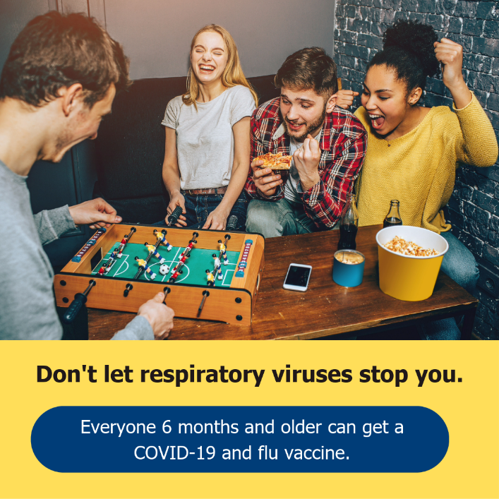  Download here | Respiratory viruses steal your moments. Stay healthy for what matters by getting your respiratory virus vaccines!
Early/Mid Fall | 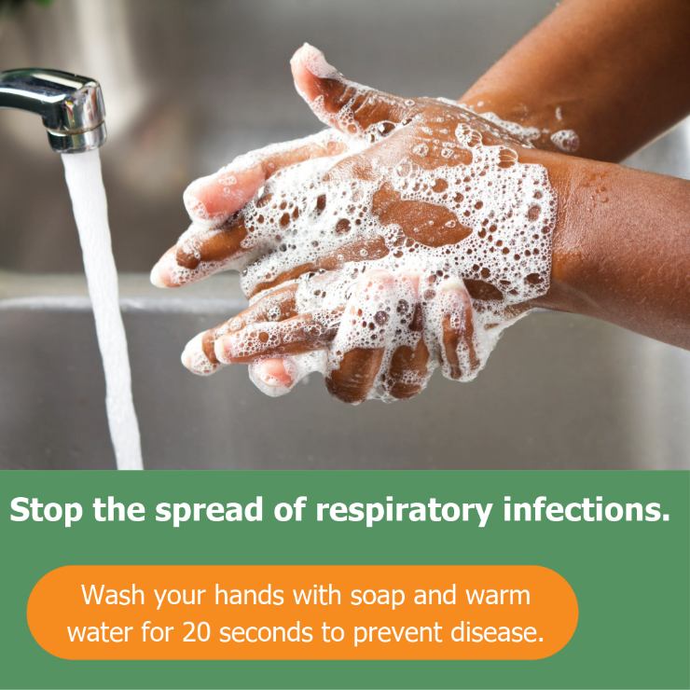  Download here | Washing your hands regularly, covering your coughs and sneezes, and staying home when you’re sick all help keep our community healthy.
Ealy/Mid Fall | 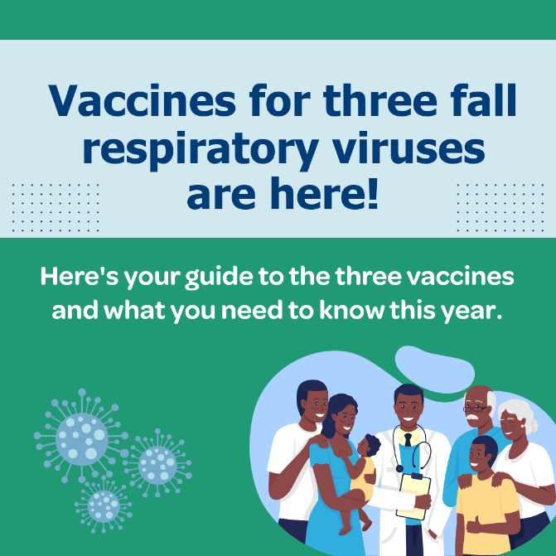  Download here | It’s officially flu season and now is the time to get protected against seasonal viruses. Who should get them, and when? Find vaccine recommendations to make sure your family is protected.
Mid Fall | 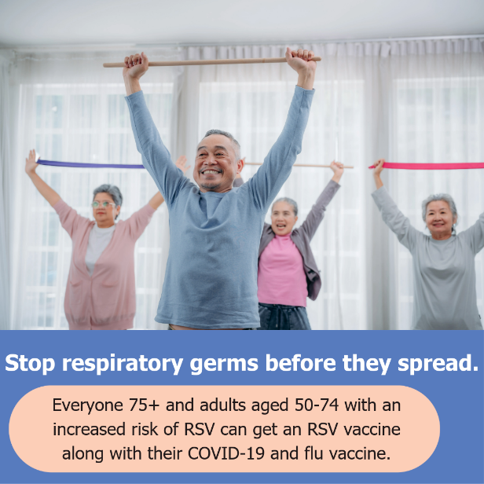Download here | RSV, or Respiratory Syncytial Virus, can cause serious illness in older adults. Talk to your health care provider about getting an RSV vaccine.
Mid/Late Fall | 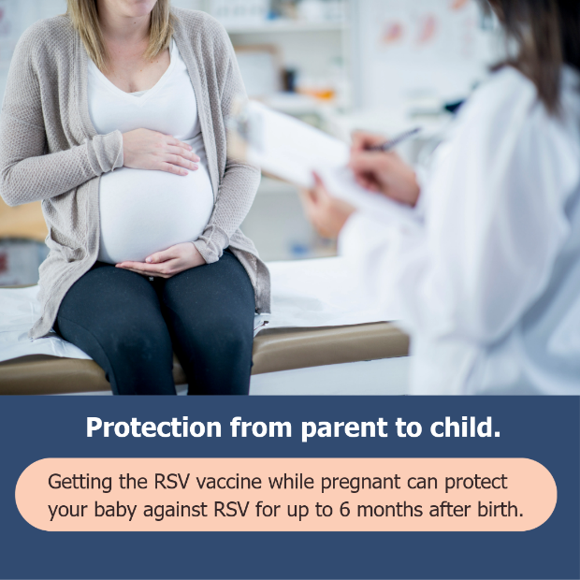  Download here | Did you know you can pass your protection against respiratory viruses to your baby by getting vaccinated? Schedule a vaccine appointment with your health care provider.
Early/Mid Fall | 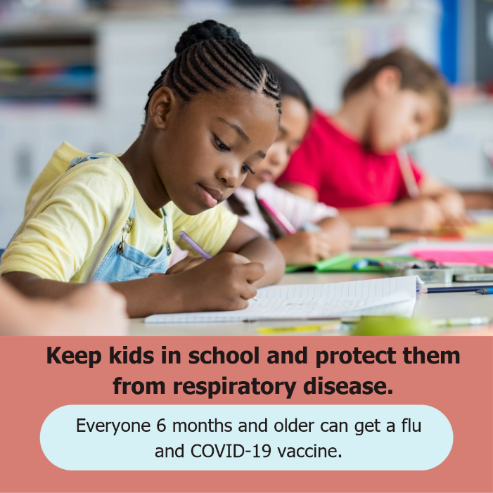  Download here | Don’t let respiratory viruses steal your moments. Taking a few minutes to get vaccinated can help protect you and loved ones from being sick, including missing work or school.

