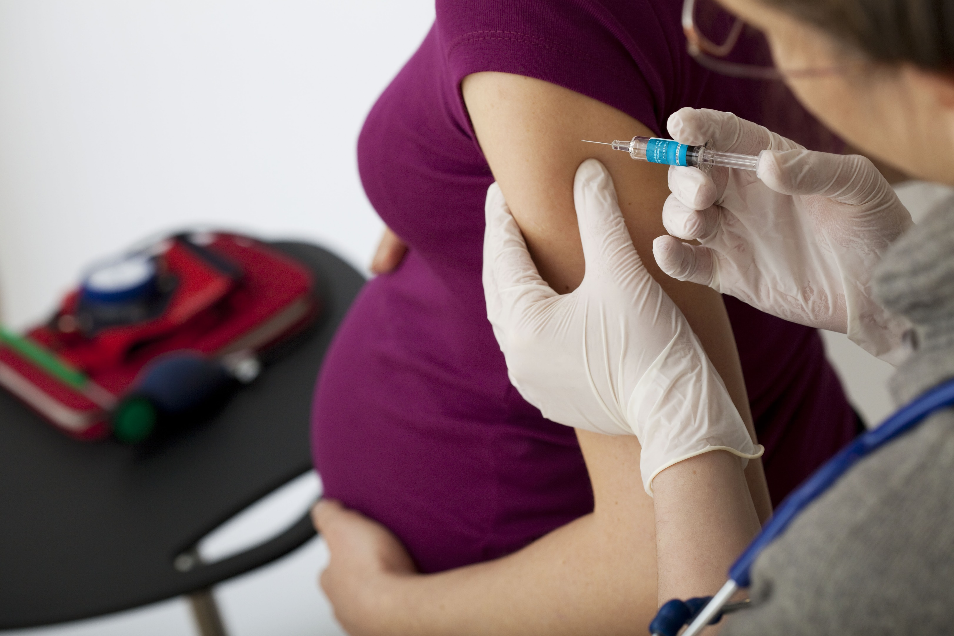


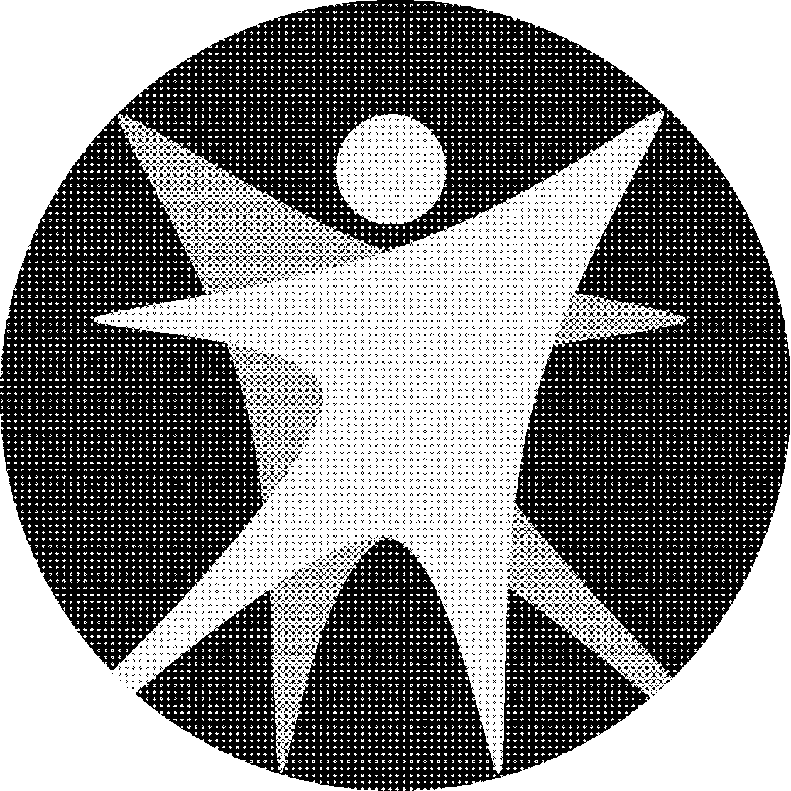
Bureau of Communicable Diseases
https://www.dhs.wisconsin.gov/dph/bcd.htm | DHSDPHBCD@dhs.wi.gov
Wisconsin Department of Health Services | Division of Public Health
Promoting Respiratory Illness Vaccination Toolkit for Pregnant People
10/2025

Contents
No table of contents entries found.

Contents
Background 2
Health Education and Outreach Tools 3
Posters, fact sheets, and more 3
Talking with people who are pregnant about flu vaccination 3
Message Map 4
Sample Social Media 5

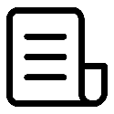

Background
People who are pregnant are at higher risk of getting seriously sick with respiratory illnesses due to the changes in their immune system, heart, and lungs that happen during pregnancy. Therefore, pregnant people are encouraged to get their respiratory illness vaccines for influenza, COVID-19, and RSV.
Getting flu, COVID-19, and RSV vaccines is the best way to prevent getting severely sick, hospitalized, or worse from respiratory illnesses. In addition, people who get vaccinated while pregnant also protect their babies from respiratory viruses for several months after birth when they are too young to be vaccinated.
Pregnant people should receive one dose of the annual flu and COVID-19 vaccines, and one dose of the RSV vaccine. Respiratory syncytial virus, or RSV, is a common respiratory virus that causes mild, cold-like symptoms but can be severe for babies and infants. The vaccine can prevent severe RSV in babies for up to six months after they are born. Pregnant people can receive the RSV vaccine (Abrysvo) between 32 and 36 weeks and 6 days pregnant. The vaccine is administered between September 1 and January 31.
If pregnant people do not get the RSV vaccine, it is recommended infants less than 8 months old and infants 8-19 months with an increased risk of RSV receive one dose of a monoclonal antibody. RSV antibodies should be administered during respiratory season (October–March). Either a vaccine during pregnancy or a monoclonal antibody can provide protection to infants, but both are usually not needed.
The Wisconsin Department of Health Services (DHS) encourages partners and health care providers offering services to people who are pregnant to use the resources included in this toolkit to promote respiratory illness vaccination during the 2025–2026 season.

Patient Education and Outreach Tools

Promote respiratory illness vaccination among people who are pregnant by sharing the information included in this toolkit and the following materials from partners.

Posters, fact sheets, and more
- Print free posters from DHS about flu vaccination and additional respiratory illnesses (available in multiple languages) to post in restrooms and waiting areas.
- Print and distribute a free educational fact sheet on how to prevent flu, COVID-19, and other respiratory viruses (available in multiple languages).
- Downloadable infographics about RSV vaccination during pregnancy in English and Spanish.
- The organizations Families Fighting Flu offers free resources about respiratory virus prevention
- Looking for other resources or posters? Check out the DHS Respiratory Viruses page for more information on COVID-19, flu, and RSV.

Talking with people who are pregnant about vaccination
- See answers to frequently asked questions about flu vaccine for people who are pregnant.
- See answers to frequently asked questions about COVID-19 vaccination.
- See answers to frequently asked questions about RSV vaccination.
- See answers to frequently asked questions about vaccine safety during pregnancy.



Message Map

Key Message | Evidence
- You should get your flu and COVID-19 vaccines in fall. | - People who are pregnant, breastfeeding, trying to get pregnant now, or might become pregnant in the future should get a flu and COVID-19 vaccine as recommended by the Wisconsin Department of Health Services.  - It takes about two weeks for the flu and COVID-19 vaccines to fully work by activating your immune system to build up antibodies that protect you against each virus.  - Even if you didn’t get vaccinated before respiratory illness season began, it is never too late to protect yourself and baby by getting a flu and COVID-19 vaccine.
- Getting a flu and COVID-19 vaccine protects both you and your baby. | - People who are pregnant are at higher risk of getting seriously sick with flu and COVID-19 due to the changes in their immune system, heart, and lungs that happen during pregnancy. These changes in the body can continue even after pregnancy. Getting a flu and COVID-19 vaccine is the best way to prevent getting severely sick, hospitalized, or worse from both diseases.  - Getting your flu and COVID-19 vaccine while pregnant can protect your baby from flu and COVID-19 for several months after they are born. This gives them protection when they are too young to get vaccinated.  - You can get your flu or COVID-19 vaccine at any time while you are pregnant.  - Flu vaccines have been safely given to people who are pregnant for decades. Evidence continues to build showing that COVID-19 vaccinations during pregnancy are safe and effective.
- Getting and RSV vaccine will protect your baby from RSV. | - RSV is a common respiratory virus that causes mild, cold-like symptoms but can be severe for babies and infants. RSV is the leading cause of infant hospitalizations in the U.S.  - Pregnant people can receive the RSV vaccine (Abrysvo) between 32 and 36 weeks and 6 days pregnant to protect their babies from RSV.  - The vaccine is administered between September 1 and January 31.  - The vaccine protects your baby from serious illness and hospitalization for up to six months after they are born.
- Make a vaccine appointment today. | - You can get vaccinated at a doctor’s office, local pharmacy, or local health department.  - If the cost of the vaccine is a concern, you may be eligible for free or lower-cost vaccines.  - You can get both a COVID-19 and flu vaccine at the same time.



Sample Social Media
Timeline | Graphic | Suggested caption
Early Fall | 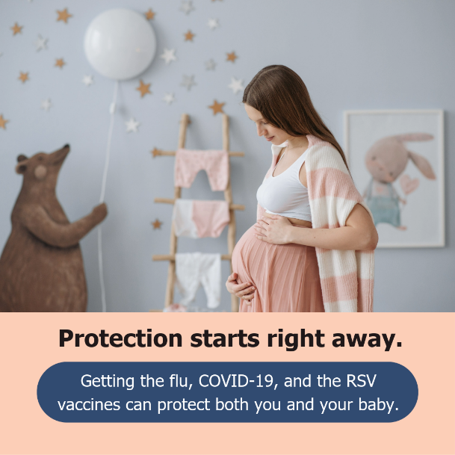  Download here | Did you know you can pass your protection against respiratory viruses to your baby by getting vaccinated? Schedule a vaccine appointment with your health care provider.
Early Fall | 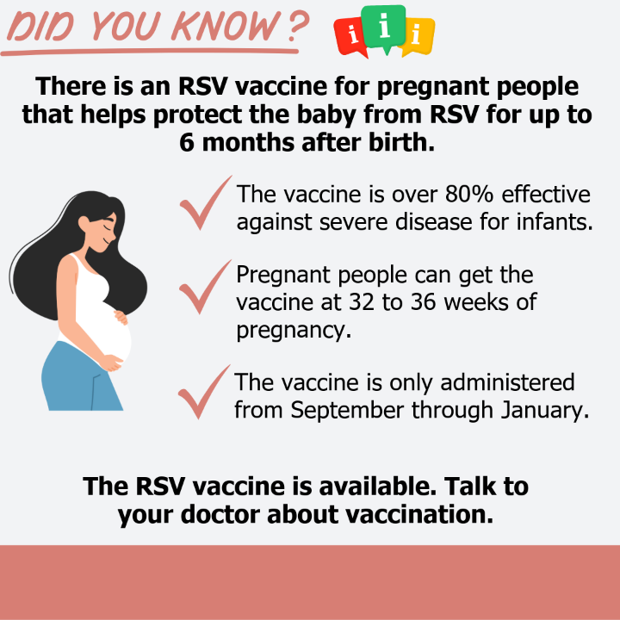  Download here | The RSV vaccine is recommended for people who are 32 to 36 weeks pregnant. Talk to your health care provider about the RSV vaccine.
Early/Mid Fall | 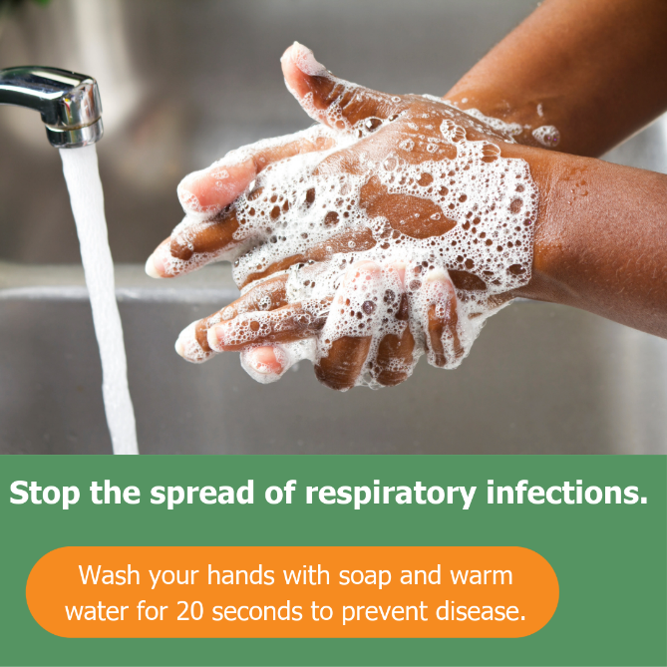  Download here | Washing your hands regularly, covering your coughs and sneezes, and staying home when you’re sick all help keep our community healthy.
Mid Fall | 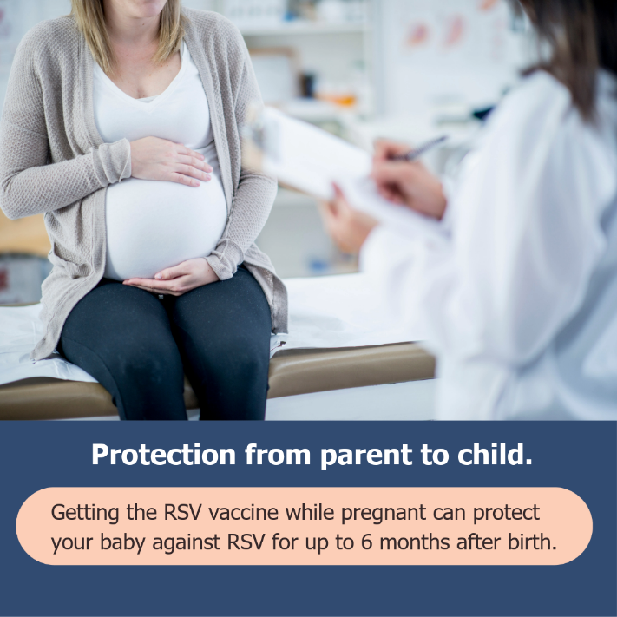  Download here | RSV , or respiratory syncytial virus, is a respiratory illness that can make infants and young children seriously sick. Protect your baby from RSV by getting an RSV vaccine.
Early/Mid Winter | 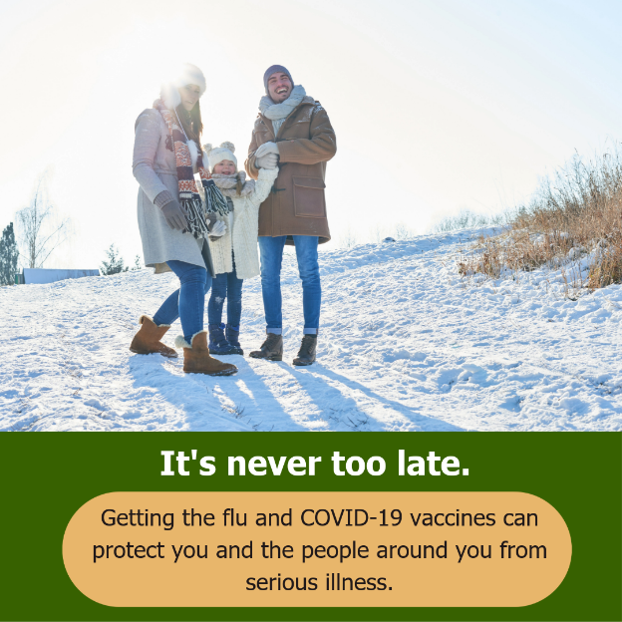  Download here | Getting vaccinated later in the season is better than not get vaccinated at all. Respiratory illness season can last into spring, so you can still benefit from getting vaccinated later in the year.

