





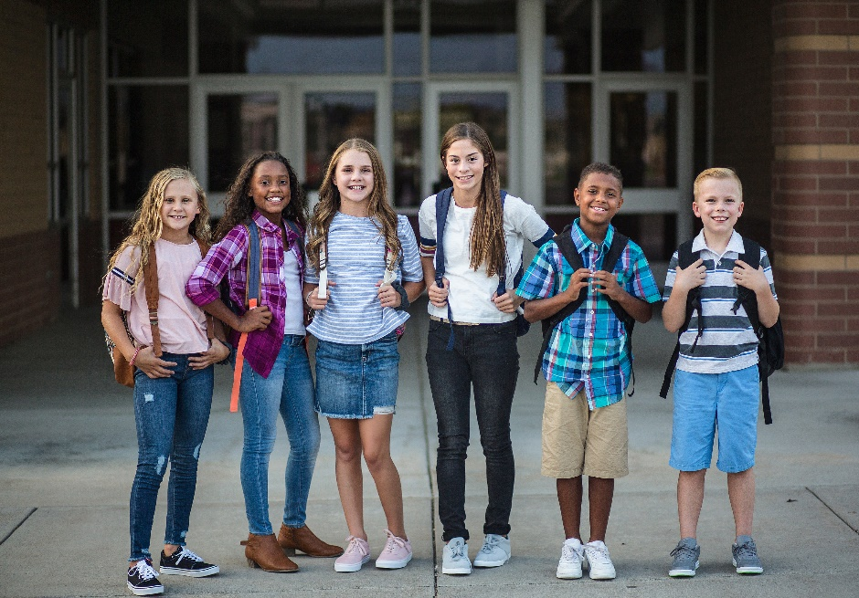

Promoting Respiratory Illness Vaccination Toolkit for Early Care Programs and K-12 Schools
v
Wisconsin Department of Health Services | Division of Public Health
Bureau of Communicable Diseases
https://www.dhs.wisconsin.gov/dph/bcd.htm | DHSDPHBCD@dhs.wi.gov
10/2025

Table of Contents
Contents
No table of contents entries found.

Contents
Education and Outreach Tools 2
Posters, fact sheets, and more 2
Sample Letter to Parents/Guardians 3
Sample Social Media 5



Education and Outreach Tools
Parents and guardians, staff, and community members trust you to provide up-to-date information on staying healthy and in school. Promote flu, COVID-19, and other routine vaccinations in your community by sharing the information included in this toolkit and the Department of Health Services’ (DHS) website. Additionally, parents can find information on vaccine safety and efficacy on the DHS Vaccine Facts webpage.

.

Posters, fact sheets, and more
- Print free posters from DHS and hang them in restrooms and common areas:
  - Children, P-02267
  - Parents of young children, P-02269
  - School Immunization Requirements: Kindergarten-6th grades, P-02395
  - School Requirements for Immunization: 7th-11th grades, P-02395A
- Use trivia questions from the Children’s Hospital of Philadelphia on TVs in common areas or upload them to your website.
- Additional resources include Families Fighting Flu’s free resources or the Children’s Hospital of Philadelphia’s excellent vaccine education resources.
- Use the sample posts in this toolkit on your social media channels.
- Looking for other resources or posters? Check out the DHS Back to School page and the DHS Respiratory Viruses page.



Sample Letter to Parents/Guardians

This is a sample letter for school and early care and education (ECE) program administrators to send to parents and guardians encouraging routine vaccinations and other everyday actions to prevent respiratory and other serious diseases. We encourage you to modify the letter to meet the needs of your district or program.

Date: [xx-xx-xxxx]
Dear parents and guardians,
With the new school year starting and winter on the horizon, [name of school or ECE program] encourages you to protect yourself and your family by getting up to date on your recommended and routine vaccinations. It’s never too early or too late to get your vaccinations. Vaccination is especially important for children with health conditions, such as asthma or heart disease, that can put them at a higher risk for severe respiratory illness. Staying up to date on vaccinations can protect against the serious consequences of respiratory viruses and other diseases to keep your child safe, healthy, and in [school/program].
Children can get seriously sick and spread illnesses to others. Vaccines are a safe and effective way to protect children against disease. The Wisconsin Department of Health Services (DHS), and [local health department] recommend that everyone 6 months and older get a yearly flu vaccine and a COVID-19 vaccine. DHS recommends everyone 6 months and older get a flu and COVID-19 vaccine. There are other routine childhood immunizations that your health care provider may also recommend for your child based on their age and vaccination history.
[Insert any details about school or community-based vaccination clinics, if applicable]. Talk to a doctor or other care provider about getting recommended vaccines for your child. If the cost of the vaccine is a concern, you or your children may be eligible for free or lower-cost vaccines. Visit the Vaccines for Children website for more information [or insert your local vaccine program information].
In addition to getting vaccinated, [name of school or ECE program] encourages children, parents and guardians, and staff to take the following everyday actions to prevent respiratory illnesses:
- Stay home when sick. If possible, avoid close contact with people who are sick and stay home from school and work when you are sick.
- Frequently wash your hands with soap and warm water for at least 20 seconds. Avoid touching your eyes, nose, or mouth with unwashed hands.
- Cover your mouth when you cough and sneeze.
- Clean and disinfect frequently touched surfaces and items in your home, especially when someone in your home is sick.

For more information on back to school routine vaccination, respiratory illnesses, and protecting your family, visit DHS’s Back to School webpage.

If you have any questions, please contact [Full name and title] at [phone and email address].

Sincerely,
[Print name, Title]



Sample Social Media

Timeline | Graphic | Caption
Early Fall | 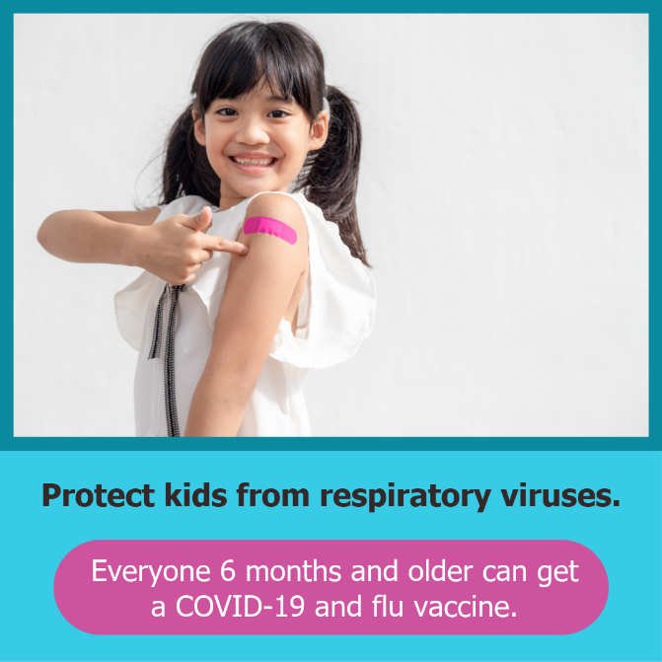  Download here | Back to school season means respiratory viruses can spread more easily. Schedule your respiratory virus vaccine appointments now!
Early Fall | 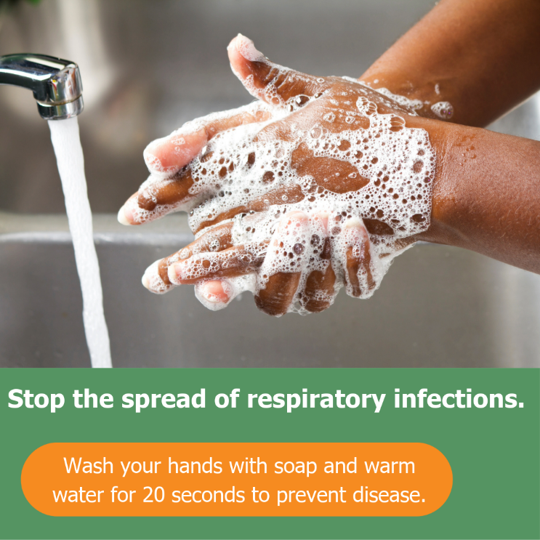  Download here | Washing your hands regularly, covering your coughs and sneezes, and staying home when you’re sick all help keep our school healthy.
Early/Mid Fall | 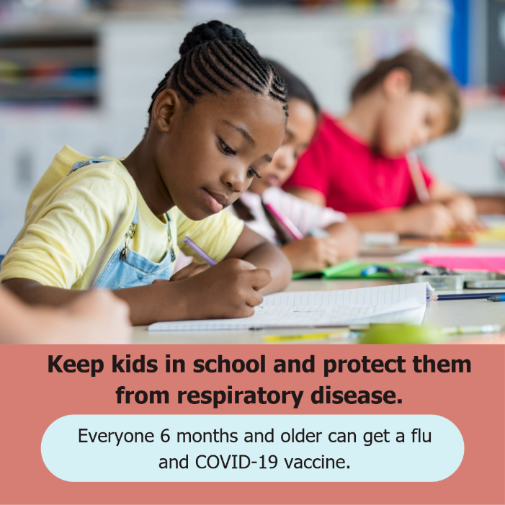  Download here | Don’t let respiratory viruses steal your moments. Taking a few minutes to get vaccinated can help protect you and loved ones from being sick, including missing work or school.
Early/Mid Fall | 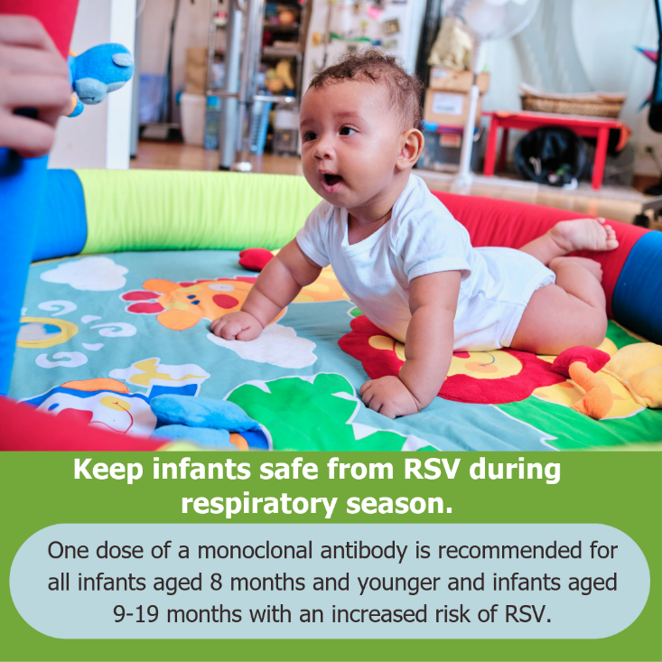  Download here | Children and infants who have an increased risk of RSV should talk to their health care provider about receiving a dose of RSV antibodies.

