Lead-Based Paint Inspection   
(Full) Report

|  |  |
| --- | --- |
| For the property at:  Click or tap to enter street address, Click or tap to enter apartment or unit number  Click or tap to enter city, WI Click or tap to enter zip code  Constructed in Click or tap to enter date of construction  Owned by:  Click or tap to enter owner name Click or tap to enter mailing address  Click or tap to enter city, Click or tap to enter state Click or tap to enter zip code  Click or tap to enter phone number | The street facing side of the exterior of the building investigated. |
|  |

|  |  |  |  |  |
| --- | --- | --- | --- | --- |
| Lead inspection and report completed by:  Click or tap to enter name  Lead Risk Assessor, DHS No. Click or tap to enter lead risk assessor’s DHS number  Click or tap to enter direct phone number | |  | Lead inspection and report assisted by:  Click or tap to enter name,  Choose discipline, DHS No. Click or tap to enter assistant’s DHS number  Click or tap to enter direct phone number | |
| Signature Date | | Signature Date | | | |
| Company logo | Click or tap to enter company name, DHS No. Click or tap to enter company DHS number  Click or tap to enter street address  Click or tap to enter city, Click or tap to enter state Click or tap to enter zip code  Click or tap to enter phone number | | |

Date of lead inspection: Select drop down to enter a date.

Date of report: Select drop down to enter a date.

**Table of Contents**

1.0 Purpose and key findings 4

1.1 Lead-based paint inspection 4

2.0 Property owner’s next actions 5

2.1 Take precautions during future remodeling 5

2.2 Disclose this report to future purchasers and renters of this property 5

3.0 Methods 6

3.1 Paint testing 6

4.0 Limitations 6

5.0 Full results 6

5.1 Paint test results (XRF) 6

5.2 Paint chip sampling results 10

Appendix A: XRF and Calibration Information 11

Appendix B: Laboratory Analysis Report(s) 14

Appendix C: Floor Plan(s) and Site Sketch 15

Appendix D: Pictures 16

# Purpose and key findings

This report is for the lead-based paint inspection in a property Choose option. Lead-based paint inspections are regulated by the [Wisconsin Department of Health Services](http://dhs.wi.gov/lead/)[1] (DHS) under [Wis. Admin. Code ch. DHS 163](https://docs.legis.wisconsin.gov/code/admin_code/dhs/110/163/Title)[2].

## 1.1 Lead-based paint inspection

A lead-based paint inspection is conducted to determine the presence of lead in *all* coated surfaces, regardless of the condition of the coatings. Lead-based paint was found in this property in the following locations:

Lead-based paint (intact and deteriorated)

|  |  |  |
| --- | --- | --- |
| Room equivalent | Substrate | Component and location |
| 1. Click or tap to enter room equivalent | Select substrate | Click or tap to enter component(s) and location |
| 1. Click or tap to enter room equivalent | Select substrate | Click or tap to enter component(s) and location |
| 1. Click or tap to enter room equivalent | Select substrate | Click or tap to enter component(s) and location |
| 1. Click or tap to enter room equivalent | Select substrate | Click or tap to enter component(s) and location |
| 1. Click or tap to enter room equivalent | Select substrate | Click or tap to enter component(s) and location |
| 1. Click or tap to enter room equivalent | Select substrate | Click or tap to enter component(s) and location |
| 1. Click or tap to enter room equivalent | Select substrate | Click or tap to enter component(s) and location |
| 1. Click or tap to enter room equivalent | Select substrate | Click or tap to enter component(s) and location |

For full lead inspection results, including a list of surfaces classified as negative for lead-based paint, see Results.

Non-lead-based paint (intact and deteriorated)

|  |  |  |
| --- | --- | --- |
| Room Equivalent | Substrate | Component and location |
| Click or tap to enter room equivalent | Select substrate | Click or tap to enter component(s) and location |
| Click or tap to enter room equivalent | Select substrate | Click or tap to enter component(s) and location |
| Click or tap to enter room equivalent | Select substrate | Click or tap to enter component(s) and location |
| Click or tap to enter room equivalent | Select substrate | Click or tap to enter component(s) and location |
| Click or tap to enter room equivalent | Select substrate | Click or tap to enter component(s) and location |
| Click or tap to enter room equivalent | Select substrate | Click or tap to enter component(s) and location |
| Click or tap to enter room equivalent | Select substrate | Click or tap to enter component(s) and location |

# 2.0 Property owner’s next actions

☐ **Give current and future residents a copy** of this report.

☐ **Save a copy of this report for future purchasers of this property.** This report must be disclosed prior to the sale.

## 2.1 Take precautions during future remodeling

Now that you know where lead-based paint is present, it’s important to deal with it safely in any future remodeling or repairs. Remodeling or repair work on surfaces with lead-based paint can create dangerous lead hazards if not done safely. To protect the occupants, use a certified company for repairs that will disturb paint that was not tested or classified as positive for lead-based paint in this report. Find a contractor using the Wisconsin Department of Health Services’ online [search tool](https://www.dhs.wisconsin.gov/lead/contractor/index.htm).

## 2.2 Disclose this report to future purchasers and renters of this property

Provide a copy of this report, along with a copy of the educational pamphlet, [Protect Your Family from Lead in Your Home](https://www.epa.gov/node/5197)[3], to potential tenants or purchasers of this property before they become obligated under a sales contract or lease. More information on complying with this federal regulation is available at [Lead-Beaded Paint Disclosure Rule (Section 1018 of Title X)](https://www.epa.gov/lead/lead-based-paint-disclosure-rule-section-1018-title-x).

# 3.0 Methods

## 3.1 Paint testing

The risk assessor followed the documented methodologies (for example: HUD Guidelines) to identify all surfaces with distinct paint history for testing. A Click or tap to enter XRF Manufacturer and Model X-Ray Fluorescence (XRF) instrument, serial number Click or tap to enter the serial number, was used to test each of these surfaces. For additional details on the procedures used for paint analysis, see Appendix A: XRF and Calibration.

The results of paint analyses were used to determine the presence of lead-based paint.

# 4.0 Limitations

Lead inspection data does not expire, though the standards used to evaluate readings may change over time.

Some surfaces could not be fully inspected because they were inaccessible. For example, carpeted flooring is not tested, and lead-based paint could be present underneath. These surfaces are noted by room in Results in the Room Notes table.

# 5.0 Full results

## 5.1 Paint test results (XRF)

The findings in this report are based on the [Federal definition](https://www.ecfr.gov/cgi-bin/retrieveECFR?gp=&SID=8d332398364f1afd177c536af0b1887b&mc=true&n=pt40.34.745&r=PART&ty=HTML#se40.34.745_163)[4] of lead-based paint[5]: *Lead-based paint means paint or other surface coatings that contain lead equal to or in excess of 1.0 milligrams per square centimeter or more than 0.5 percent by weight.*

The complete lead-based paint inspection results that follow are organized by room, followed by a section on dust wipe sampling results. Calibration readings and the performance characteristics sheet of the X-Ray Fluorescence (XRF) instrument used for this investigation is provided in Appendix A: XRF and Calibration .

**Click or tap to enter room equivalent name**

|  |  |  |  |  |  |  |
| --- | --- | --- | --- | --- | --- | --- |
| Reading # | Substrate | Component(s)  represented | Test location  (if more specific) | Side | Result  (mg/cm2) | Condition (optional) |
| Click or tap to enter reading #. | Select substrate | Click or tap to add | Click or tap to add | Select side | Enter value | Select condition |
| Click or tap to enter reading #. | Select substrate | Click or tap to add | Click or tap to add | Select side | Enter value | Select condition |
| Click or tap to enter reading #. | Select substrate | Click or tap to add | Click or tap to add | Select side | Enter value | Select condition |
| Click or tap to enter reading #. | Select substrate | Click or tap to add | Click or tap to add | Select side | Enter value | Select condition |
| Click or tap to enter reading #. | Select substrate | Click or tap to add | Click or tap to add | Select side | Enter value | Select condition |
| Click or tap to enter reading #. | Select substrate | Click or tap to add | Click or tap to add | Select side | Enter value | Select condition |
| Click or tap to enter reading #. | Select substrate | Click or tap to add | Click or tap to add | Select side | Enter value | Select condition |
| Click or tap to enter reading #. | Select substrate | Click or tap to add | Click or tap to add | Select side | Enter value | Select condition |

**Room notes -** Click or tap here to enter room equivalent.

|  |  |  |  |
| --- | --- | --- | --- |
| Substrate | Components | Condition (optional) | Reason not tested |
| Select substrate | Click or tap to add | Select condition | Click or tap to enter reason |
| Select substrate | Click or tap to add | Select condition | Click or tap to enter reason |
| Select substrate | Click or tap to add | Select condition | Click or tap to enter reason |
| Select substrate | Click or tap to add | Select condition | Click or tap to enter reason |
| Select substrate | Click or tap to add | Select condition | Click or tap to enter reason |
| Select substrate | Click or tap to add | Select condition | Click or tap to enter reason |

**Click or tap to enter room equivalent name**

|  |  |  |  |  |  |  |
| --- | --- | --- | --- | --- | --- | --- |
| Reading # | Substrate | Component(s)  represented | Test location  (if more specific) | Side | Result  (mg/cm2) | Condition (optional) |
| Click or tap to enter reading #. | Select substrate | Click or tap to add | Click or tap to add | Select side | Enter value | Select condition |
| Click or tap to enter reading #. | Select substrate | Click or tap to add | Click or tap to add | Select side | Enter value | Select condition |
| Click or tap to enter reading #. | Select substrate | Click or tap to add | Click or tap to add | Select side | Enter value | Select condition |
| Click or tap to enter reading #. | Select substrate | Click or tap to add | Click or tap to add | Select side | Enter value | Select condition |
| Click or tap to enter reading #. | Select substrate | Click or tap to add | Click or tap to add | Select side | Enter value | Select condition |
| Click or tap to enter reading #. | Select substrate | Click or tap to add | Click or tap to add | Select side | Enter value | Select condition |
| Click or tap to enter reading #. | Select substrate | Click or tap to add | Click or tap to add | Select side | Enter value | Select condition |
| Click or tap to enter reading #. | Select substrate | Click or tap to add | Click or tap to add | Select side | Enter value | Select condition |
| Click or tap to enter reading #. | Select substrate | Click or tap to add | Click or tap to add | Select side | Enter value | Select condition |

**Room notes -** Click or tap to enter room equivalent

|  |  |  |  |
| --- | --- | --- | --- |
| Substrate | Components | Condition (optional) | Reason not tested |
| Select substrate | Click or tap to add | Select condition | Click or tap to enter reason |
| Select substrate | Click or tap to add | Select condition | Click or tap to enter reason |
| Select substrate | Click or tap to add | Select condition | Click or tap to enter reason |
| Select substrate | Click or tap to add | Select condition | Click or tap to enter reason |
| Select substrate | Click or tap to add | Select condition | Click or tap to enter reason |
| Select substrate | Click or tap to add | Select condition | Click or tap to enter reason |
| Select substrate | Click or tap to add | Select condition | Click or tap to enter reason |

**Click or tap to enter room equivalent name**

|  |  |  |  |  |  |  |
| --- | --- | --- | --- | --- | --- | --- |
| Reading # | Substrate | Component(s)  represented | Test location  (if more specific) | Side | Result  (mg/cm2) | Condition (optional) |
| Click or tap to enter reading #. | Select substrate | Click or tap to add | Click or tap to add | Select side | Enter value | Select condition |
| Click or tap to enter reading #. | Select substrate | Click or tap to add | Click or tap to add | Select side | Enter value | Select condition |
| Click or tap to enter reading #. | Select substrate | Click or tap to add | Click or tap to add | Select side | Enter value | Select condition |
| Click or tap to enter reading #. | Select substrate | Click or tap to add | Click or tap to add | Select side | Enter value | Select condition |
| Click or tap to enter reading #. | Select substrate | Click or tap to add | Click or tap to add | Select side | Enter value | Select condition |
| Click or tap to enter reading #. | Select substrate | Click or tap to add | Click or tap to add | Select side | Enter value | Select condition |
| Click or tap to enter reading #. | Select substrate | Click or tap to add | Click or tap to add | Select side | Enter value | Select condition |
| Click or tap to enter reading #. | Select substrate | Click or tap to add | Click or tap to add | Select side | Enter value | Select condition |
| Click or tap to enter reading #. | Select substrate | Click or tap to add | Click or tap to add | Select side | Enter value | Select condition |

**Room notes -** Click or tap to enter room equivalent

|  |  |  |  |
| --- | --- | --- | --- |
| Substrate | Components | Condition (optional) | Reason not tested |
| Select substrate | Click or tap to add | Select condition | Click or tap to enter reason |
| Select substrate | Click or tap to add | Select condition | Click or tap to enter reason |
| Select substrate | Click or tap to add | Select condition | Click or tap to enter reason |
| Select substrate | Click or tap to add | Select condition | Click or tap to enter reason |
| Select substrate | Click or tap to add | Select condition | Click or tap to enter reason |
| Select substrate | Click or tap to add | Select condition | Click or tap to enter reason |
| Select substrate | Click or tap to add | Select condition | Click or tap to enter reason |

## 5.2 Paint chip sampling results

The findings in this report are based on the [Federal definition](https://www.ecfr.gov/cgi-bin/retrieveECFR?gp=&SID=8d332398364f1afd177c536af0b1887b&mc=true&n=pt40.34.745&r=PART&ty=HTML#se40.34.745_163)[6] of lead-based paint[7]: *Lead-based paint means paint or other surface coatings that contain lead equal to or in excess of 1.0 milligrams per square centimeter or more than 0.5 percent by weight.*

Lead in paint, varnish, shellac, or other surface coatings can be identified by laboratory analysis of paint chips or by direct readings using an X-ray florescence (XRF) instrument. In this assessment, paint chip samples were collected in accordance with Appendix 13.2, Paint Chip Sampling found in the HUD Guidelines For The Evaluation and Control of Lead Based Paint Hazards in Housing.

A total of Click or Tap to enter number of samples paint chip samples were collected and analyzed. Samples were analyzed by the:

Click or tap to enter name of Laboratory

Click or tap to enter address

Click or tap to enter city, state, and zip code

Click or tap to enter phone number

Click or tap to enter Laboratory ID #

|  |  |  |  |  |  |  |
| --- | --- | --- | --- | --- | --- | --- |
| Sample # | Substrate | Component | Location | Side | Result  (mg/cm2 or %) | LBP? |
| Click or tap to enter sample #. | Select substrate | Click or tap to add component | Click or tap to add location | Select side | Enter value | Select yes/no |
| Click or tap to enter sample #. | Select substrate | Click or tap to add component | Click or tap to add location | Select side | Enter value | Select yes/no |
| Click or tap to enter sample #. | Select substrate | Click or tap to add component | Click or tap to add location | Select side | Enter value | Select yes/no |
| Click or tap to enter sample #. | Select substrate | Click or tap to add component | Click or tap to add location | Select side | Enter value | Select yes/no |
| Click or tap to enter sample #. | Select substrate | Click or tap to add component | Click or tap to add location | Select side | Enter value | Select yes/no |
| Click or tap to enter sample #. | Select substrate | Click or tap to add component | Click or tap to add location | Select side | Enter value | Select yes/no |
| Click or tap to enter sample #. | Select substrate | Click or tap to add component | Click or tap to add location | Select side | Enter value | Select yes/no |
| Click or tap to enter sample #. | Select substrate | Click or tap to add component | Click or tap to add location | Select side | Enter value | Select yes/no |

Appendix A: XRF and Calibration Information

The risk assessor followed manufacturer’s guidelines for calibration and operation of the XRF used to conduct this investigation. The instrument’s calibration was checked before and after the assessment using a known quantity of lead on test films supplied by the National Institute for Standards and Technology (NIST) and was found to be calibrated within the manufacturer’s specifications.

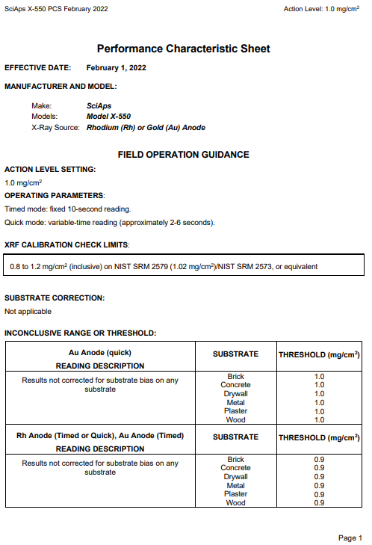

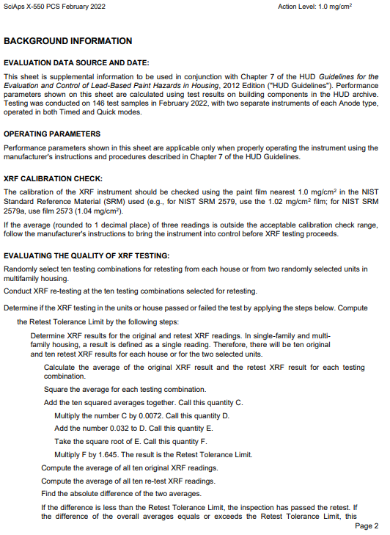

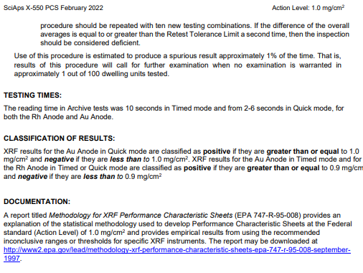

|  |  |  |  |  |
| --- | --- | --- | --- | --- |
| **Pre-lead inspection calibration readings** | | | | |
| **NIST Lead Paint Film Standard** | **1st Reading # – Concentration (mg/cm2)** | **2nd Reading # – Concentration (mg/cm2)** | **3rd Reading # – Concentration (mg/cm2)** | **AVERAGE**  **(mg/cm2)** |
| **1 mg/cm2 standard** | Click or tap to enter concentration | Click or tap to enter concentration | Click or tap to enter concentration | Click or tap to enter average |
| **0 mg/cm2 standard** | Click or tap to enter concentration | Click or tap to enter concentration | Click or tap to enter concentration | Click or tap to enter average |

|  |  |  |  |  |
| --- | --- | --- | --- | --- |
| **Post-lead inspection calibration readings** | | | | |
| **NIST Lead Paint Film Standard** | **1st Reading # – Concentration (mg/cm2)** | **2nd Reading # – Concentration (mg/cm2)** | **3rd Reading # – Concentration (mg/cm2)** | **AVERAGE**  **(mg/cm2)** |
| **1 mg/cm2 standard** | Click or tap to enter concentration | Click or tap to enter concentration | Click or tap to enter concentration | Click or tap to enter average |
| **0 mg/cm2 standard** | Click or tap to enter concentration | Click or tap to enter concentration | Click or tap to enter concentration | Click or tap to enter average |

Appendix B: Laboratory Analysis Report(s)

Appendix C: Floor Plan(s) and Site Sketch



Appendix D: Pictures









1. [www.dhs.wisconsin.gov/lead/index.htm](http://www.dhs.wisconsin.gov/lead/index.htm)
2. Wis. Admin Code DHS Chapter 163 <https://docs.legis.wisconsin.gov/code/admin_code/dhs/110/163/Title>
3. [www.epa.gov/lead/protect-your-family-lead-your-home-real-estate-disclosure](http://www.epa.gov/lead/protect-your-family-lead-your-home-real-estate-disclosure)
4. [eCFR :: 40 CFR Part 745 -- Lead-Based Paint Poisoning Prevention in Certain Residential Structures](https://www.ecfr.gov/current/title-40/chapter-I/subchapter-R/part-745#745.63) <https://www.ecfr.gov/current/title-40/chapter-I/subchapter-R/part-745#745.63>
5. [Wisconsin law](https://docs.legis.wisconsin.gov/document/statutes/254.11(8)) is less restrictive, defining any paint or any other surface coating material containing more than 1 milligram of lead per square centimeter in the dried film of applied paint, as lead-based paint. The federal definition is used here to assure compliance with both state and federal law.
6. [eCFR :: 40 CFR Part 745 -- Lead-Based Paint Poisoning Prevention in Certain Residential Structures](https://www.ecfr.gov/current/title-40/chapter-I/subchapter-R/part-745#745.63) <https://www.ecfr.gov/current/title-40/chapter-I/subchapter-R/part-745#745.63>
7. [Wisconsin law](https://docs.legis.wisconsin.gov/document/statutes/254.11(8)) is less restrictive, defining any paint or any other surface coating material containing more than 1 milligram of lead per square centimeter in the dried film of applied paint, as lead-based paint. The federal definition is used here to assure compliance with both state and federal law.