Environmental Assessment Resources
Available to Local and Tribal Public Health Agencies

October 5, 2016

The investigation and control of environmental health hazards can sometimes be limited by the availability of necessary resources, such as equipment and training. The Wisconsin Division of Public Health (DPH) would like to introduce you to a host of environmental assessment resources available through DPH and the Wisconsin State Lab of Hygiene (WSLH). These resources include:

- A broad inventory of environmental assessment equipment available for use by local health department personnel (see attached list)
- Equipment use and investigation training (offered regionally)
- Investigation assistance (e.g., indoor air quality, meth labs, manufactured gas plant sites, chemical releases, wood stoves, etc.)
http://www.dhs.wisconsin.gov/eh/Air/index.htm
- Community education (e.g., presentations, fact sheet development, public meetings, signage development, etc.)
- Personal protective equipment selection and guidance
http://www.dhs.wisconsin.gov/ppe/PPEforEnvironmentalHealth.htm

The equipment and services listed above are available for your use. Please feel free to call me or one of the contacts in the links provided to discuss your specific environmental health training, equipment or service needs.

Regards,

Ryan J. Wozniak, PhD, MPH
Toxicologist
Health Hazard Evaluation Section
Bureau of Environmental and Occupational Health
608-267-3227
ryan.wozniak@wisconsin.gov
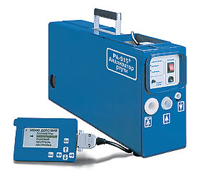
Lumex RA 915+ and RA 915 light Portable Mercury Vapor Analyzers measure airborne vapor levels following mercury spills. Airborne exposure levels for mercury should be as low as 1 microgram per cubic meter (µg/m³) in community settings and 3 µg/m³ in commercial settings, compared to the occupational exposure guideline of 25 µg/m³. Bagged, contaminated articles should have vapor levels less than 10 µg/m³. The Lumex RA 915+ is very sensitive, having a detection limit of 0.002 µg/m³, while the RA 915 light has a detection limit of 0.10 µg/m³. Both instruments afford users the ability to collect real-time data and survey large areas in a short period of time. One RA 915+ and two RA 915 light instruments are available for loan.

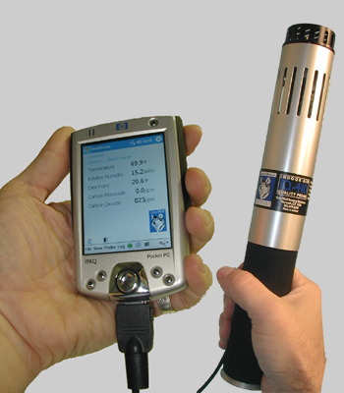
Gray Wolf Indoor Air Quality Monitors provide real-time data for common indoor air quality parameters, such as temperature, humidity, carbon dioxide and carbon monoxide. Recommended guidelines for these parameters are:
Temperature: 68-74ºF (winter), 73-79ºF (summer) (ASHRAE 55-1992)
Humidity: 30% to 60% (ASHRAE 55-1992)
Carbon Dioxide: 700 ppm above outdoor levels (ASHRAE 62-1999)
Carbon Monoxide: 9 ppm over an 8 hour period (USEPA NAAQS)
Other probes for this instrument are also available for the detection of hydrogen sulfide, sulfur dioxide, nitrogen dioxide, chlorine, ammonia and ozone down to levels as low as 0.10 ppm in some cases. Three units are available for loan.

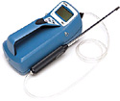
TSI P-Trak Ultrafine Particle Counter counts particles in the size range of 0.01 to 1.0 microns. Particles of this size reach the deepest regions of the lungs and are present in combustion related emissions such as cigarette smoke, wood stoves, diesel exhaust, etc. This instrument is simple to use and is very helpful in tracking the sources of combustion emissions, identifying the points of entry and in evaluating the effectiveness of building filtration systems (i.e. outdoor counts divided by indoor counts should approximate building filtration efficiency). One instrument is available for loan.

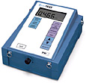
TSI DustTrak Aerosol Monitor measures real-time particulate concentrations in size ranges of 1.0, 2.5, 4.0 and 10.0 microns in milligrams per cubic meter (mg/m³). This instrument can be used to assess community airborne particulate levels in relation to US EPA National Ambient Air Quality Standards (NAAQS). An environmental enclosure is available to enable the user to sample outdoors for periods as long as 24 hours. Five instruments are available for loan. The US EPA NAAQS for particulate matter are:
PM₁₀ 24 hour average: 0.150 mg/m³
PM_{2.5} 24 hour average: 0.035 mg/m³
PM_{2.5} annual average: 0.015 mg/m³

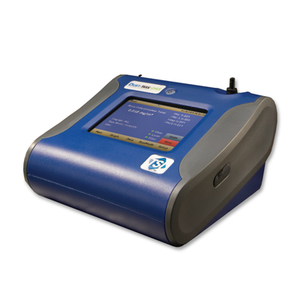
TSI DustTrak DRX Aerosol Monitor simultaneously measures size-segregated mass fraction concentrations for PM1, PM2.5, PM4 (respirable), PM10 and Total PM. This instrument also collects an in-line sample on a filter for later gravimetric analysis and/or particle identification. The DustTrak DRX has an extensive datalogging capacity and can measure an aerosol concentration range from 0.001 to 150 mg/m³. This instrument would be especially useful for investigating emerging particulate concerns, such as silica sand mining or other industrial activities. One instrument is currently available for loan.

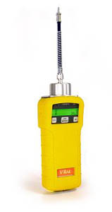
RAE Systems VRAE Multi Gas Monitor provides real-time data for compounds commonly present in seized methamphetamine labs, such as ammonia and phosphine. Ammonia and phosphine have occupational exposure guidelines of 25 ppm and 0.3 ppm, respectively. The VRAE has detection limits of 1 ppm for ammonia and 0.1 ppm for phosphine. While emergency responders address immediate hazards associated with meth labs, clean-up decisions often fall to local health authorities. These monitors can be helpful in determining whether clean-up efforts have been sufficient for re-entry. Please contact DPH for questions related to meth lab investigations. One instrument is available for loan.

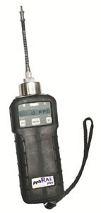
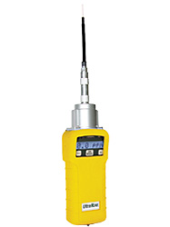
RAE Systems ppbRAE and UltraRAE Photoionization Detectors provide real-time data for volatile organic compounds (VOCs), present in such products as solvents, paints, glues, stored fuels, disinfectants, wood preservatives and air fresheners. They are useful for quickly screening areas for the presence of VOCs. One potential application may include cases where solvent-based materials are used in a building and are creating discomfort for occupants. Research has suggested that building occupants exposed to greater than 1 ppm may experience discomfort in the form of eye, nose and throat irritation, headaches, loss of coordination and nausea. The UltraRAE can detect VOCs as low as 0.10 ppm, while the detection level of the ppbRAE is a few parts per billion. Additionally, the UltraRAE can be configured to provide data specific to benzene. One of each instrument is available for loan.

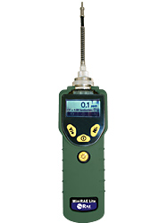
RAE Systems MiniRAE Lite Photoionization Detector is another device available for monitoring VOC levels. It is easy to operate and primarily intended for indoor screening of buildings with suspected VOC elevations. The MiniRAE is not as sensitive as the ppbRAE, but can reliably measure VOC levels as low as 0.10 ppm. One instrument is currently available for loan.
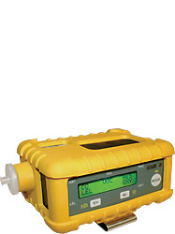
RAE Systems MultiRAE Plus Photoionization Detector (PID) combines a PID with the standard four gases of a confined space monitor (O₂, LEL, CO and H₂S) in one compact monitor with sampling pump. It is easy to operate and primarily intended for indoor screening of buildings and basements with unknown odor complaints. The MultiRAE with PID can detect VOCs as low as 0.1 ppm, and CO and H₂S down to 1 ppm, with standard resolutions for O₂ (0.1%) and LEL (1%). One instrument is currently available for loan.

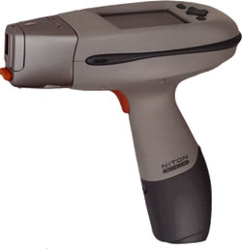
Niton XLt 793 Multi-Element X-ray Fluorescence (XRF) Spectrometer can simultaneously measure the levels of up to 25 elements, including lead, arsenic, cadmium, mercury, chromium, selenium and silver. These elements can be detected low ppm levels in bulk samples (e.g., soil, plastics), wipes, air filters, or other thin film samples. It is useful for screening large areas with potentially contaminated soils or for quickly screening the airborne levels of metals collected on an air filter. Examples of applications include the investigation of former orchard properties where lead arsenate pesticide was used or brownfields where the dumping of metals is suspected to have occurred. One instrument is currently available for loan.

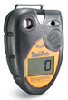
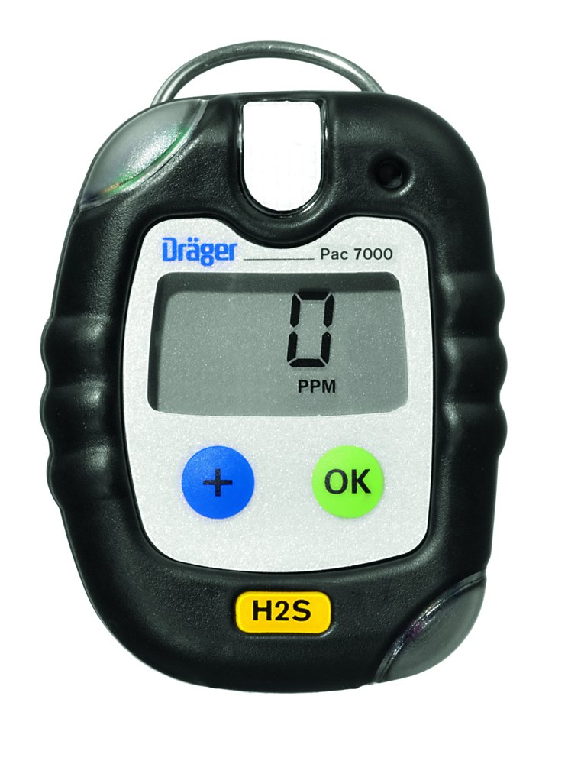
Sperian ToxiPro and Draeger PAC 7000 Monitors are easy-to-use single gas detectors with extensive data-logging capacity. DPH has three ToxiPro monitors that measure NO₂, CO and NH₃, with detection limits of 0.1, 1 and 1 ppm, respectively. DPH also has two H₂S, one NH₃ and one NO₂ Draeger PAC 7000 monitors, all with detection limits of 0.1 ppm. CO and NO₂ are most commonly associated with engine exhaust, while NH₃ is used extensively as a fertilizer and refrigerant, and is produced by the breakdown of urea in urine. H₂S is commonly associated with large animal waste generators. These monitors have recently been used to measure CO and NO₂ levels inside arenas during ice resurfacing and motocross events, to assess NH₃ levels in animal hoarding cases, and to measure H₂S levels near large dairy and poultry farms. Data can be collected for up to 5 days at 1 minute intervals, or longer if the data logging interval is increased.

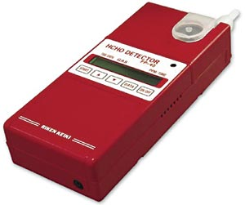
RKI Formaldehyde Gas Detector can measure formaldehyde at low ppb levels, using colorimetric detection tablets. Formaldehyde is a carcinogen and is irritating to inhale. Formaldehyde levels can be significantly elevated in newly constructed buildings using large amounts of pressed wood products (particleboard, plywood, etc.). For example, many of the temporary trailers constructed for victims of Hurricane Katrina had unhealthy formaldehyde levels that required evacuation. One instrument is currently available for loan.
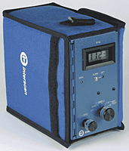
Interscan 4000 Series Portable Analyzers are single gas monitors that can reliably detect pollutants at ppb levels. DPH currently has two Interscan Portable Analyzers, one that detects H₂S and one that detects NO₂. These devices can measure H₂S and NO₂ levels as low as 20 ppb, far below their detection levels of ~500 ppb for the Gray Wolf probe monitors. The odor threshold for H₂S is ~5 ppb, but humans can become rapidly desensitized to H₂S and chronic exposure to levels as low as 100-300 ppb can result in headaches and irritation of the nose and throat. For example, large livestock farms and wastewater collection/treatment facilities can release relatively high levels of H₂S into the environment, which can be irritating and potentially hazardous to those living nearby. NO₂ production is most commonly associated with engine exhaust and fermenting silage. Exposure to NO₂ at low levels can cause eye, nose, throat and lung irritation, including increased bronchial reactivity in asthmatics at levels as low as 100-200 ppb. One of each instrument is available for loan.

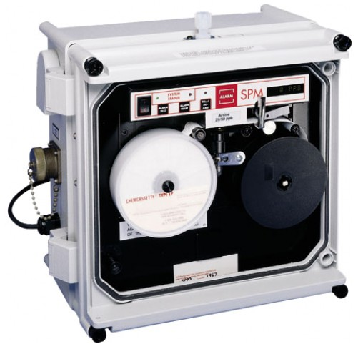
Honeywell Single Point Monitor is a quick response device that can detect toxic gases down to ppb levels, providing physical evidence of a gas event. This is a rugged instrument that utilizes interference-free Chemcassette detection technology, resulting in colorimetric changes on chemically impregnated paper tapes specific for a particular toxic gas. An optical scanning system quantitates and records the color changes (gas levels) at prescribed intervals. A number of Chemcassettes are available for a variety of gases and sampling times. Long play Chemcassette tapes can last up to 90 days, allowing for long-term, low-level gas detection. One instrument is currently available for loan.

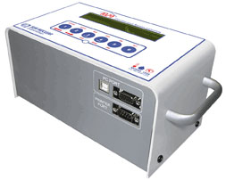
Sun Nuclear 1029 and 1030 Continuous Radon Monitors are sensitive radon gas detectors with selectable interval settings that allow the user to datalog radon levels often as every half an hour, for a testing period of days or weeks. This instrument has a sensitivity of 5 cph/pCi/L and a detection range of 0.1 to 1000 pCi/L. These instruments also have sensors that concurrently record temperature, barometric pressure and relative humidity to provide a more complete environmental assessment. Three 1029 and two 1030 instruments are currently available for loan.

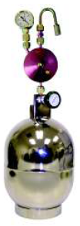
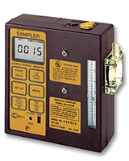
Other services and equipment are available including air sampling canisters (i.e., Summa cans), personal sampling pumps, sorbent media and kits for water and soil sample collection. Assistance and coordination can also be provided by the WSLH. Contact information: http://www.slh.wisc.edu/environmental/

