WEDSS Report Server SSRS





# Contents

Contents 2

A Quick Overview of WEDSS Report Server - SSRS 3

Gaining Access to SSRS and SSRS Security 3

Logging on to SSRS 3

Accessing SSRS Reports 4

Running SSRS Reports 5

# A Quick Overview of WEDSS Report Server - SSRS

This document is provided to give you a complete overview of the SQL Server Reporting Server (SSRS) options available to you, how to gain access to and use the various reports available to you on WEDSS SSRS.

# Gaining Access to SSRS and SSRS Security

For local health department users, SSRS uses your WILMS account (<https://register.wisconsin.gov>) which is also used for access to the WEDSS SharePoint site. For state users, SSRS access is currently tied to your DHS account.

SSRS further restricts access to the folder structure based on the SSRS groups you are placed in. When SSRS reports are run they further limit the data that is returned based on your jurisdictional group assignment in WEDSS.

To gain access to SSRS, send [DHSWEDSS@wi.gov](mailto:DHSWEDSS@wi.gov) an email requesting access to SSRS and the reports you are interested in obtaining. The most commonly requested reports for SSRS are:

* QA Reports
* PHAB (Public Health Accreditation Board Reports)
* Hepatitis B Perinatal Reports
* TB Contact and TB Billing Reports

# Logging on to SSRS

SSRS can be accessed by any current browser. Go to <https://healthreports.wisconsin.gov> to login. At the main login page you should receive a popup asking for your username and password. If your institution uses domain-based logins and you’re using Internet Explorer, your browser will initially attempt to send through your current credentials.

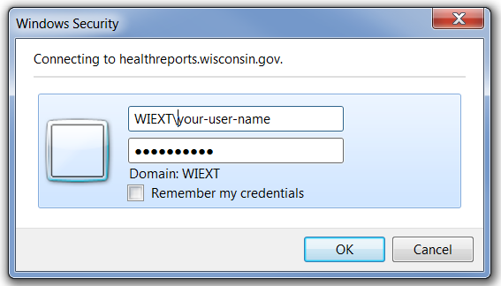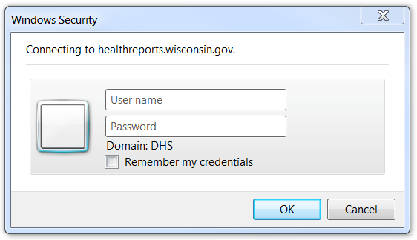In this popup box you must enter the following:

* Wiext\your_user_name

It is very important in Internet Explorer that you type, not paste in, the wiext**\** portion so that the login domain is changed. Once you do that, your login window should look like the figure on the right.

**Note:** There is no “log out” for SSRS. Simply close your browser to logout of your current SSRS session.

# Accessing SSRS Reports

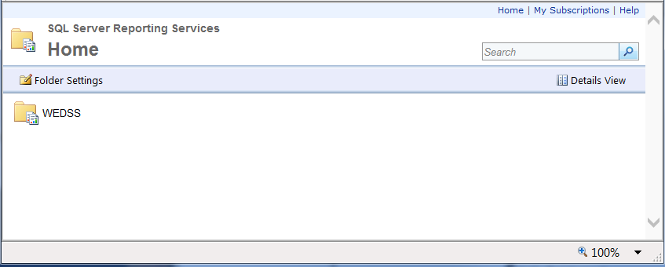Once successfully logged on to SSRS, you will initially see the WEDSS landing page. Click on the WEDSS folder to see all sub-folders in the WEDSS environment you have been granted access to.

Once inside the WEDSS folder you will see all the folders containing reports to which you have been granted access. Figure A. shows the most common configuration, Figure B. displays all current potential folders someone at an LHD level could potentially be granted access to.

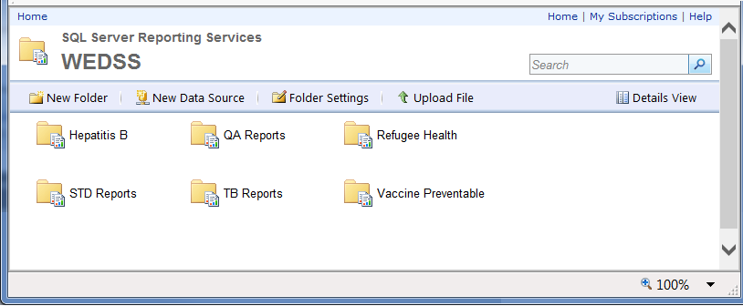

B

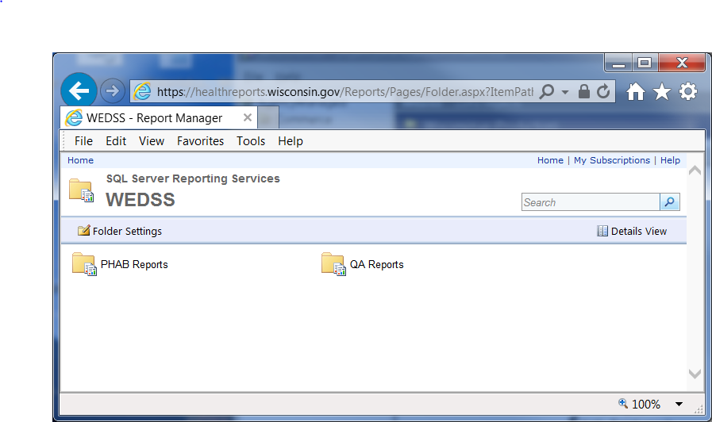

A

To access the reports, click on the folder containing the reports you wish to run.

To navigate between folders, use the navigation menu at the top to move through the folder structure. Clicking on “Home” will always return you to the top level of the report server tree.

# Running SSRS Reports

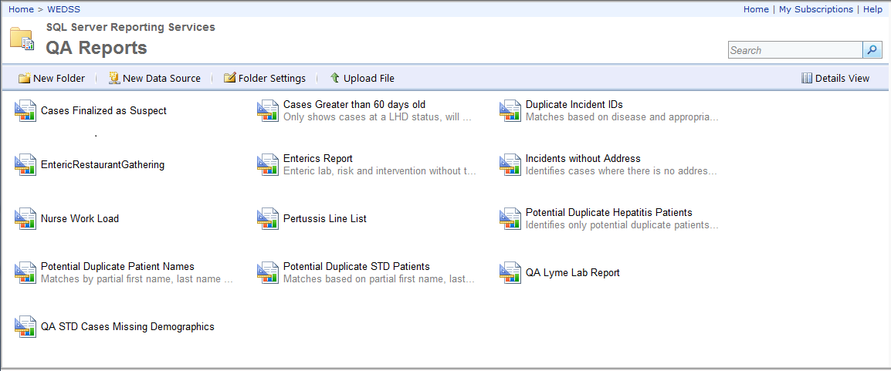After selecting the folder containing the reports you want to run, you will see the full list of reports available to you in that folder. From there, you can select any report you wish to run by clicking on the desired report.

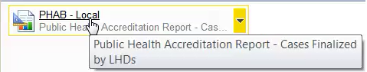Many reports contain a brief description, shown below the bolded report name in gray text. To see the full text of the report description, hold your mouse over the report to see the full description.

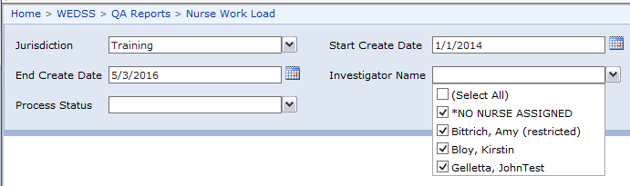Once you have selected the appropriate report, a set of parameters will appear for you to populate. Jurisdiction will be automatically restricted to your WEDSS jurisdiction, but other options such as start and end dates, process status, and nurse investigator can be filled in with your specific parameters. In reports where Investigator Name is a parameter, where an investigator has not been assigned in WEDSS, the option *No Nurse Assigned will return all cases without an assigned investigator.

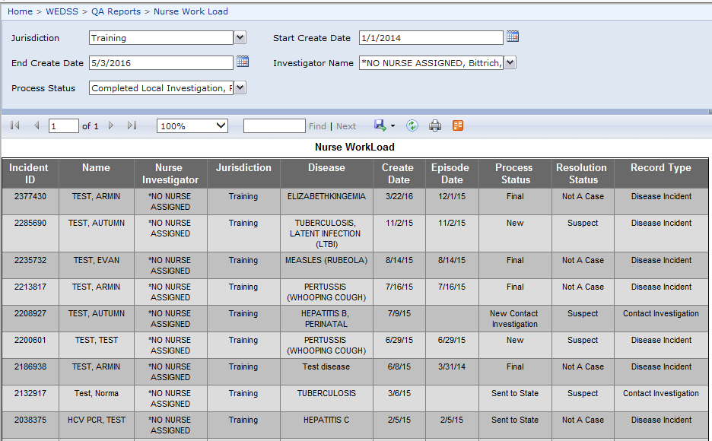Once a report is run it will display your results in the screen below. If there are multiple pages of reports, you can move between pages clicking on the forward and back buttons. The outer buttons will jump to either the first or last page in a multi-page report.

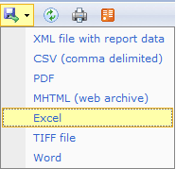To further sort, filter, or manipulate these reports, you have the option to export the reports and work with them off-line. Simply click on the export icon and select your preferred file export type to export your report.

Please note: most reports are optimized for exporting to formats like Excel or a CSV file. The Potential Duplicate Incident Report should ***always*** be exported to CSV format.