 | WISCONSIN DEPARTMENT OF HEALTH SERVICES

PPS – Core Services Upload

Version – 1.5

Version History:

Version | Date | Revised By | Reason for change | PCR #
1.0 | 07-Dec-2012 | Ketan Deorukhakar | Initial Version
1.1 | 28-Feb-2013 | Ketan Deorukhakar | Added the cover sheet to add version history.  Added an example for how to delete service record and updated with missing  error messages. | PCR60699
1.2 | 05/01/2013 | Viswanath Sigmala | Added validation for invalid SSN and invalid character in Middle Initials on page 7. | 60966
1.3 | 08/12/2013 | Viswanath Sigamala | Added MCI Mode Information. | 61976
1.4 | 09/12/2013 | Viswanath Sigmala | Added new Elements, Modified the Error messages to Detail section. | 62287
1.5 | 06/27/2018 | Renuka B | Removed unused tags mentioned in the jira | 64398

Subsystem: | Program Participation System
Page Name: | Core Services Upload
Process Number: | 60.150.DUV.06
Page: | Page 1 of 25

Document Type: Detailed User Views (DUV) | Process Number: 60.150.DUV.06

Subsystem: | Program Participation System
Page Name: | Core Services Upload
Process Number: | 60.150.DUV.06
Page: | Page 2 of 25

Process Overview
This is a batch process for uploading the individual’s/participant’s data related to ‘Core Services’ program into the PPS application so that the uploaded data will be available in the PPS online application.

As part of this process the user will place the file (Currently ‘xml’ format only) with the data to be uploaded on the ‘FTP server’ input location. Once the file is placed on the ‘ftp server’ the batch process will pick the file and move it to batch server location for processing.

Following are the steps involved in processing the file,

- Check the completeness of the file.
  - Here the file is validated against an .xsd (XML Schema Definition) file to make sure the ‘XML’ file provided is ‘Well Formed’.
  - If all tags in a document are correctly formed and follow XML guidelines, then a document is considered as well formed.

- Check the ‘MCI flag’ to find whether the file should be run in MCI clearance mode or Upload mode.
  - If the flag is ‘YES’ the file will be run in MCI clearance mode and if ‘NO’ then it will be run in Upload mode.
  - IN MCI Clearance mode system perform basic field validations to obtain MCI ID.
  - IN Upload Mode with the obtained MCI ID we perform various field level edits and Business validations for processing the file.

- Verify whether required fields data is provided.

- Do the field level Edits (or Validations).
  - This is to make sure the data provided is of proper type and size. For example, the SSN should be a number and should be nine digits long.

- Apply the rules related to the Episode and Service.
  - These rules are to identify whether the provide service information falls between the existing Episode or a new Episode has to created.
  - If a new Episode has to be created then following format will be following when generating the Episode ID,
<MCI ID>_<Agency/County ID>_<Program CD/Type>_<Sequence Number>

- Once all the data is available, data base will be updated with the same.

- An output file (complete input file) with an additional ‘Error/s’ section (if there are any error/s) and ‘Warning/s’ section(if there are any warning/s) will be generated and placed on the ‘FTP server’ output location.

Following is the process flow BLD (Business Logic Diagram) when the file is processed in the

Subsystem: | Program Participation System
Page Name: | Core Services Upload
Process Number: | 60.150.DUV.06
Page: | Page 3 of 25
CI clearance mode:
Start
Process
Decision
File Placed in point
the specified Notes
FTP Location by
Agency

File contains only basic information
File sent to PPS required to obtain MCI with the respective flag being set to Yes

Process validates format of file meets criteria of select type being uploaded. Perform basic field level data validations
Validate File and (date fields, numeric, alpha) required to Perform Edits obtain a MCI

Errors are written to the end of the file

Yes Errors

Write Errors to No
File
Process takes each individual and tries
MCI Matching/ to match with PPS or MCI. Those that
Generation get 75%- 96% match get rejected as
errors and written to the error part of the
file.

Yes Errors

Write Errors to No
File

File with MCI and Errors placed in the FTP Location

Stop

Following is the process flow BLD(Business Logic Diagram) when the file is processed in
upload mode:

M

Subsystem: | Program Participation System
Page Name: | Core Services Upload
Process Number: | 60.150.DUV.06
Page: | Page 4 of 25
Stop
File with MCI, Episode # and Errors placed in the FTP Location

Episode Number is generated by a unique combination of Agency ID + MCI Number + Seq Number

Load Data

Start

File picked by Agency from FTP Location

File contains all data to be uploaded with the respective MCI flag being set to No
File Placed in the specified FTP Location by Agency

File sent to PPS

Process validates format of file meets criteria of select type being uploaded. Perform basic field level data validations (date fields, numeric, alpha)
Errors are written to the end of the file

No
Validations consists of cross field validations and encounter level adjustments
Yes
Errors
Write Errors to File
No
Yes
Errors

Validate File and Perform Field Level Edits

Write Errors to File

Perform Business Rules Validation

Subsystem: | Program Participation System
Page Name: | Core Services Upload
Process Number: | 60.150.DUV.06
Page: | Page 5 of 25

Following are the elements in the header record of the provided XML file,

<submitter_organization_id>
<submission_date>
<mci_flag>
<number_of_records_transmitted>
<number_of_records_uploaded>1</number_of_records_uploaded>
<number_of_records_in_error>0< /number_of_records_in_error >

The value in the <submitter_organization_id> element will provide us the ‘agency ID’ that needs to be used when uploading the data. And the value in the <mci_flag> element will determine whether the file will be run in ‘MCI clearance’ or ‘Upload’ mode.

Following are the validations for the data provided in the header record,

Conditions | Error Description
If ‘Header Section’ is not present in the XML file | 'Header Information' is required to process the provided XML file. Please provide  valid 'Header Information'.
If <submitter_organization_id> element value is empty | Please provide the ‘Agency ID (<submitter_organization_id>)’.
If <submitter_organization_id> element has a value but is not a number. | ‘Agency ID’ should be numeric. Please provide a valid ‘Agency ID  (<submitter_organization_id>)’.
If <submitter_organization_id> element value is not the ID of the agency available in the PPS and also this agency does not have  proper privileges to work on the provided program type. | Provided ‘Agency ID’ does not exist in ‘PPS’. Please provide a valid ‘Agency ID (<submitter_organization_id>)’.
If <submitter_organization_id> element value is not matching the file name Agency id. | Provided 'Agency ID' does not match with XML File Name <FILE NAME >. Please provide a valid  'Agency ID (<submitter_organization_id>)'.
If <mci_flag> element value is empty | Please provide the ‘Mode of operation  (<mci_flag>) flag’.
If <mci_flag> element has a value and is not equal to either ‘Y’ or ‘N’ | Please provide a valid value for ‘Mode of operation (<mci_flag>) flag’.

MCI Clearance Mode:
------------------------------------
When the value of the ‘<mci_flag>’ element in the header record is ‘Y’ the file will be run in ‘MCI Clearance’ mode. After selecting the person from clearance results, PPS is creating an

Subsystem: | Program Participation System
Page Name: | Core Services Upload
Process Number: | 60.150.DUV.06
Page: | Page 6 of 25

individual with selected MCI ID and need to update on MCI application to indicate PPS is using that specified MCI ID.

Following are the XML elements that can be provided when the file runs in MCI clearance mode,

<gender>
<recipient_birth_date>
<recipient_first_name>
<recipient_id>
<recipient_last_name>
<recipient_middle_name>
<recipient_suffix_name>
<social_security_number>

Following are the rules for clearance,

- The system shall interface with MCI to run an automated clearance for each record uploaded.
- If there is a MCI number present (a value for <recipient_id> element) on the record then the system shall validate the MCI ID provided to make sure it is valid and is same as the ID in MCI application for the provided Individual information. If there is no MCI number present then system will perform the MCI clearance and update the ‘<recipient_id>’ with the generated MCI ID.
- For records which are a less than 75% match, a new MCI number shall be generated and the same will be added/updated in the file.
- For records that can’t be cleared automatically (which lie between 75% and 96% match) the system shall reject the record with explanation for the rejection.
- For records that have 96% to 100% match, MCI number will be fetched from MCI and added/updated in the file.
- Modify the MCI clearance mode so that the MCI number will not be returned in case of an error with respect to the validation of recipient first name, recipient last name, recipient birthdate or recipient SSN.(PCR 62287)
- Once the MCI Clearance is being done the new MCI number will be updated in the Provided XML file.

Following are the field level edits/validations of the fields/elements for the MCI clearance,

Conditions | Error Description
If <recipient_first_name> element value is empty | Please provide the ‘First Name (<recipient_first_name>)’.

Subsystem: | Program Participation System
Page Name: | Core Services Upload
Process Number: | 60.150.DUV.06
Page: | Page 7 of 25

If <recipient_first_name> element has a value and is more than 20 characters long | 'First Name' can be only '20 characters' long. Please provide a value that is not more than '20 characters' for the ‘First  Name (<recipient_first_name>)’.
If <recipient_last_name> element value is empty | Please provide the ‘Last Name (<recipient_last_name>)’.
If <recipient_last_name> element has a value and is more than 20 characters long | 'Last Name' can be only '20 characters' long. Please provide a value that is not more than '20 characters' for the ‘Last  Name (<recipient_last_name>)’.
If <recipient_middle_name> element has a value and is more than 20 characters long | 'Middle Name' can be only '20 characters' long. Please provide a value that is not more than '20 characters' for the ‘Middle  Name (<recipient_middle_name>)’.
If <recipient_middle_name> element has a Special characters | Please submit a valid Middle Name or  remove the Middle Name as it is not a required data.
If <recipient_suffix_name> element has a value and is more than 3 characters long | 'Suffix Name' can be only '3 characters' long. Please provide a value that is not more than '3 characters' for the ‘Suffix  Name (<recipient_suffix_name>)’.
If <recipient_birth_date> element value is empty | Please provide the ‘Birth Date (<recipient_birth_date>)’.
If date provide in <recipient_birth_date> element is not a valid date or if the date is not between 01/01/1900 and 12/31/2099 | 'Birth Date' should be in 'yyyy-mm-dd' format and should be between '1900-01-  01' and '2099-12-31'. Please provide a valid 'Birth Date (<recipient_birth_date>)'.
If date provide in <recipient_birth_date> is a valid date but is a future date | ‘Birth Date’ cannot be a future date. Please provide a valid ‘Birth Date  (<recipient_birth_date>)’.
If <gender> element value is empty | Please provide the ‘Gender Code (<gender>)’.
If <gender> element value is not either ‘F’ or ‘M’ | 'Gender Code' can only have a value of 'F  or M'. Please provide a valid value for 'Gender Code(<gender>)'.
If data provided in <social_security_number> element is not Numeric. | ‘SSN’ should be numeric. Please provide a valid ‘SSN (<social_security_number>)’.
If data provided in <social_security_number> element is invalid SSN.  SSN first Group cannot have ‘000’ or ‘666’ or ‘999’,  Second Group cannot have ‘00’, Third Group cannot have ‘000’. | Please submit a valid Social Security number or remove the Social Security number as it is not a required data.
If data provided in <social_security_number> | ‘SSN’ should be ‘9 digits’ long. Please

Subsystem: | Program Participation System
Page Name: | Core Services Upload
Process Number: | 60.150.DUV.06
Page: | Page 8 of 25

Element is not equal to 9 digits. | provide a '9 digits' value for ‘SSN (<social_security_number>)’.
After the clearance run with the provided Individual Information, if maximum percentage value from all the matching  records falls between 75% and 96%. | Could not find a valid match in the MCI application with provided Individual Information. Please provide valid  Individual Information.
If <recipient_id> element has a value and is  not a number | ‘MCI ID’ should be numeric. Please  provide a valid ‘MCI ID (<recipient_id>)’.
If <recipient_id> element has a value and is a number but size is more than 10 digits | 'MCI ID' can only be '10 digits' long. Please provide a value that is not more than '10 digits' for the 'MCI ID  (<recipient_id>)'.
When ‘MCI ID (<recipient_id>)’ is provided in the input XML file and it does not match with the MCI ID in the MCI application for the  given Individual information. | 'MCI ID <recipient_id>' provided does not match with the MCI ID in the MCI application. Please provide a valid 'MCI ID  (<recipient_id>)'.
When the ‘MCI ID’ in the '<episode_id>' is different from the ID provided in '<recipient_id>' | 'MCI ID' value in the provided 'Episode ID  <episode_id>' does not match with the value provided in 'MCI ID (<recipient_id>)' element.
When the ‘Agency ID’ in the '<episode_id>' is different from the ID provided in '<submitter_organization_id>' | 'Agency ID' value in the provided 'Episode ID <episode_id>' does not match with the value provided in 'Agency ID  (<submitter_organization_id>)' element.
When the 'Episode Type Code' in the '<episode_id>' is different from the type of the file that is processed. (eg: if 'Episode  Type Code' is specified as '0001' for CORE file) | 'Episode Type Code' value in the provided 'Episode ID <episode_id>' does not match with the 'Episode Type Code' of the file being processed.
When the 'Episode Sequence Number' in the '<episode_id>' is not a number | 'Episode Sequence Number' value in the provided 'Episode ID <episode_id>' should be numeric. Please provide a valid  'Episode Sequence Number'.

Upload Mode:
-----------------------
When the value of the ‘<mci_flag>’ element in the header record is ‘N’ the file will be run in ‘Upload’ mode.

When running in upload mode following is one of the required fields,

<recipient_id> (Which is a MCI number)

Following are the edit/validation related to the ‘<recipient_id>’ element value,

Conditions | Error Description

Subsystem: | Program Participation System
Page Name: | Core Services Upload
Process Number: | 60.150.DUV.06
Page: | Page 9 of 25

If <recipient_id> element value is empty | Please provide the 'Master Customer Index(MCI) ID (<recipient_id>)'.
If <recipient_id> element has a value and is not a number | ‘MCI ID’ should be numeric. Please provide a valid ‘MCI ID (<recipient_id>)’.
If <recipient_id> element has a value and is a number but size is more than 10 digits | 'MCI ID' can only be '10 digits' long. Please provide a value that is not more than '10 digits' for the 'MCI ID  (<recipient_id>)'.
When ‘MCI ID (<recipient_id>)’ is provided in the input XML file and it does not match with the MCI ID in the MCI application for the  given Individual information. | 'MCI ID <recipient_id>' provided does not match with the MCI ID in the MCI application. Please provide a valid 'MCI ID  (<recipient_id>)'.

Once system get the MCI number from the file it will be validated to make sure it is valid and is same as the ID in MCI application for the provided Individual information. If this validation fails an error message will be added in error section of output file. And if the validation is successful then system will verify whether there is any record in the ‘INDV’ table with the provided number. If the record exists then system will continue with the rest of the processing but if the record is not present then a new record will be inserted in the ‘INDV’ table.

Following are the required fields for the insert in the ‘INDV’ table and once the record is inserted rest of the processing will be done.

<gender>
<recipient_birth_date>
<recipient_first_name>
<recipient_last_name>
<recipient_id> (Which is a MCI number)

Following is the explanation of the ‘rest of the processing’ once an entry in ‘INDV’ table is verified/inserted,

There are two pages in the online application related to ‘Core Services’ program and data in the ‘Details Record(<detail_record>)’ in the given XML should provide the information related to all the two pages.

Following are the two pages in the online application related to ‘Core Services’ program,

- Core Services Summary
- Core Service Details

(Note: Each page details, elements associated with them and other information related to them are listed below.)

Page Overview: Core Services Summary

Subsystem: | Program Participation System
Page Name: | Core Services Upload
Process Number: | 60.150.DUV.06
Page: | Page 10 of 25

Core Services Summary Page allows the user to enter high level case Information and also to view the list of services received by individual. The user can also access the details of a specific service, and add new service/s.
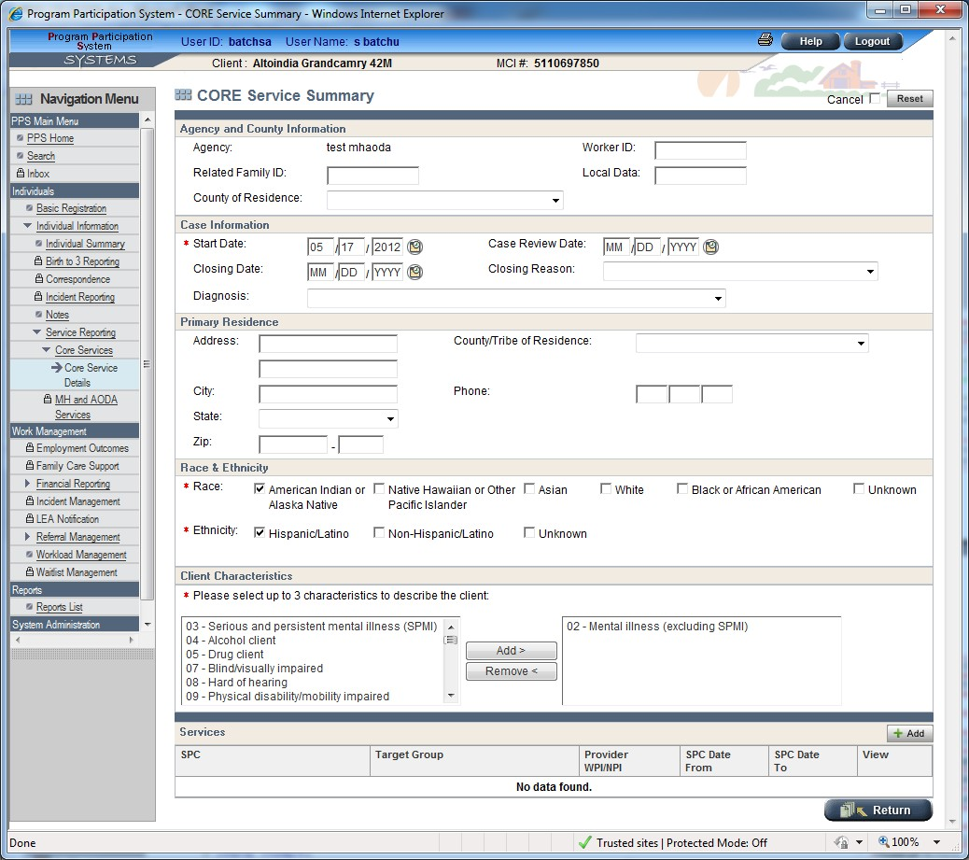

XML elements for the ‘Core service Summary’ Page

<start_date>
<case_review_date>
<closing_date>
<diagnosis_code>
<closing_reason_code>
<race_code1>
<race_code2>
<race_code3>
<race_code4>
<race_code5>

Subsystem: | Program Participation System
Page Name: | Core Services Upload
Process Number: | 60.150.DUV.06
Page: | Page 11 of 25

<unknown_race>
<ethnic_hispanic_latino_flag>
<ethnic_nonhispanic_latino_flag>
<ethnic_unknown_flag>
<client_char_1>
<client_char_2>
<client_char_3>
<related_family_id>
<county_of_responsibility>
<worker_id>
<local_data_dsc>

Required elements for ‘Core Services Summary’ page,
- <Start_date>

- For Client Characteristics one or more of <client_char_1>, <client_char_2>,
<client_char_3> needs to be selected.

- For Race one or more of needs to be selected ‘<race_code1>, <race_code2>,
<race_code3>, <race_code4>, <race_code5>, <unknown_race>’ need to be ’Y’

- For ethnicity one of the <ethnic_hispanic_latino_flag>,<ethnic_nonhispanic_latino_flag>
</ethnic_nonhispanic_latino_flag>,<ethnic_unknown_flag> needs to be ’Y’

Validations for Core Services Summary page
Conditions | Error Description
If date Provided in <start_date> is a valid date but if it is before Birth date. | 'Start date' cannot be less than 'Individual's Birth Date'. Please provide a  valid 'Start Date (<start_date>)'.
If date provided in <start_date> element is not a valid date(yyyy/mm/dd) or if the date is not between 1900/01/01 and 2099/12/31 | The value provided in '<start_date>' should be a Date in 'yyyy-mm-dd' format and should be between '1900-01-01' and '2099-12-31'. Please provide a valid value  for '<start_date>
If date provided in <start_date> is a valid date but is a future date | 'Start Date' cannot be a future date. Please provide a valid 'Start Date  (<start_date>)'.
If <diagnosis_code> element value is not  part of the ‘diagnosis code’ reference table | Please provide a valid value for  'Diagnostic code <diagnosis_code>'.
If <closing_reason_code> element value is not part of the ‘closing_reason_code’  reference table | Please provide a valid value for 'Closing reason <closing_reason_code>'
If date provided in <case_review_date> element is not a valid date or if the date is  not between | The value provided in '<case_review_date>' should be a Date in  'yyyy-mm-dd' format and should be

Subsystem: | Program Participation System
Page Name: | Core Services Upload
Process Number: | 60.150.DUV.06
Page: | Page 12 of 25

1900/01/01 and 2099/12/31 | between '1900-01-01' and '2099-12-31'.  Please provide a valid date for '<case_review_date>'.
If date provided in <closing_date> element is not a valid date or if the date is not between 1900/01/01 and 2099/12/31 | The value provided in '<closing_date>' should be a Date in 'yyyy-mm-dd' format and should be between '1900-01-01' and '2099-12-31'. Please provide a valid date for '<closing_date>'.
If date provided in <closing_date> element is Before date provided in <start_date> element. | 'Closing Date (<closing_date>)' cannot be less than 'Start Date (<start_date>)'.  Please provide a valid 'Closing Date (<closing_date>)'.
If date provided in <closing_date> is a valid date but future date. | 'Closing Date (<closing_date>)' cannot be a future date. Please provide a valid  'Closing Date (<closing_date>)'.
If date Provided in <case_review_date is before the date provided in <start_date>  element. | 'case Review Date' cannot be less than 'Start Date (<start_date>)'. Please provide  a valid 'case Review Date'.
If none of the ‘<race_code1>,  <race_code2>, <race_code3>,  <race_code4>, <race_code5>,  <unknown_race>’ elements have a value | Please provide the 'Race Information', a value for at least one of the '<race_code1>,  <race_code2>, <race_code3>, <race_code4>,  <race_code5>, <unknown_race>' elements.
If none of the ‘<ethnic_hispanic_latino_flag>,  <ethnic_nonhispanic_latino_flag>  <ethnic_unknown_flag>’ elements have a value | Please provide the 'Ethnicity Information', a value for at least one of the '<ethnic_hispanic_latino_flag>,  <ethnic_nonhispanic_latino_flag>,  <ethnic_unknown_flag>' elements.
If ‘<ethnic_hispanic_latino_flag>’ element has a value as ‘Y’ and one of the ‘<ethnic_nonhispanic_latino_flag>,  <ethnic_unknown_flag>’ elements has a value as ‘Y’ | 'Ethnicity' can be only one of the 'Hispanic/Latino (or) Non-Hispanic/Latino (or) Unknown' values. Please make sure only one of the '<ethnic_hispanic_latino_flag>,  <ethnic_nonhispanic_latino_flag>,  <ethnic_unknown_flag>' elements has a value.
If ‘<ethnic_nonhispanic_latino_flag>’ element has a value as ‘Y’ and one of the ‘<ethnic_hispanic_latino_flag>,  <ethnic_unknown_flag>’ elements has a value as ‘Y’ | 'Ethnicity' can be only one of the 'Hispanic/Latino (or) Non-Hispanic/Latino (or) Unknown' values. Please make sure only one of the  '<ethnic_hispanic_latino_flag>,


Subsystem: | Program Participation System
Page Name: | Core Services Upload
Process Number: | 60.150.DUV.06
Page: | Page 13 of 25

<ethnic_nonhispanic_latino_flag>,
<ethnic_unknown_flag>' elements has a value.
If ‘<ethnic_unknown_flag>’ element has a value as ‘Y’ and one of the ‘<ethnic_hispanic_latino>,  <ethnic_nonhispanic_latino_flag>’ elements has a value as ‘Y’ | 'Ethnicity' can be only one of the 'Hispanic/Latino (or) Non-Hispanic/Latino (or) Unknown' values. Please make sure only one of the '<ethnic_hispanic_latino_flag>,  <ethnic_nonhispanic_latino_flag>,  <ethnic_unknown_flag>' elements has a value.
If<race_code1> has a value and is not equal to ‘A (or) B (or) W (or) P (or) I’. | Valid values for ‘<race_code1>’ element are ‘A (or) B (or) W (or) P (or) I’. Please  provide a valid value.
If<race_code2> has a value and is not equal to ‘A (or) B (or) W (or) P (or) I’. | Valid values for ‘<race_code2>’ element are ‘A (or) B (or) W (or) P (or) I’. Please  provide a valid value.
If<race_code3> has a value and is not equal to ‘A (or) B (or) W (or) P (or) I’. | Valid values for ‘<race_code3>’ element are ‘A (or) B (or) W (or) P (or) I’. Please  provide a valid value.
If<race_code4> has a value and is not equal to ‘A (or) B (or) W (or) P (or) I’. | Valid values for ‘<race_code4>’ element are ‘A (or) B (or) W (or) P (or) I’. Please  provide a valid value.
If<race_code5> has a value and is not equal to ‘A (or) B (or) W (or) P (or) I’. | Valid values for ‘<race_code5>’ element are ‘A (or) B (or) W (or) P (or) I’. Please  provide a valid value.
If<unknown_race> has a value and is not equal to ‘Y’. | Valid values for ‘<unknown_race>’ element are ‘Y’ (or) ‘N'. Please provide a  valid value.
If<Ethnic_hispanic_latino_flag> has a value and is not equal to ‘Y’. | Valid values for ‘<hispanic_latino>’  element are ‘Y’ or ‘N’. Please provide a valid value.
If<ethnic_unknown_flag> has a value and is not equal to ‘Y’,’N’ | Valid values for ‘<ethnic_unknown_flag>’  element are ‘Y’ (or) ‘N’. Please provide a valid value.
If ‘Race Code 1’ is not present but one of the ‘<race_code2>, <race_code3>,  <race_code4>, <race_code5>’ elements have a value | ‘Race Codes’ must be specified in order. Please make sure ‘Race Code 1’ has value in the database or specified in the  XML file, before specifying any value for ‘<race_code2>, <race_code3>,

Subsystem: | Program Participation System
Page Name: | Core Services Upload
Process Number: | 60.150.DUV.06
Page: | Page 14 of 25

 | <race_code4>, <race_code5>’ elements.
If ‘Race Code 2’ is not present but one of the ‘<race_code3>, <race_code4>,  <race_code5>’ elements have a value | ‘Race Codes’ must be specified in order. Please make sure ‘Race Code 2’ has value in the database or specified in the XML file, before specifying any value for ‘<race_code3>, <race_code4>,  <race_code5>’ elements.
If ‘Race Code 3’ is not present but one of the ‘<race_code4>, <race_code5>’ elements have a value | ‘Race Codes’ must be specified in order. Please make sure ‘Race Code 3’ has value in the database or specified in the XML file, before specifying any value for  ‘<race_code4>, <race_code5>’ elements.
If ‘Race Code 4’ is not present but one of the ‘<race_code5>’ elements have a value | ‘Race Codes’ must be specified in order. Please make sure ‘Race Code 4’ has value in the database or specified in the XML file, before specifying any value for  ‘<race_code5>’ elements.
If more than one of the ‘<race_code1>,  <race_code2>, <race_code3>,  <race_code4>, <race_code5>’ elements have same value. | 'Race Codes’ cannot have duplicates. Please make sure no two of the '<race_code1>, <race_code2>,  <race_code3>, <race_code4>,  <race_code5>' elements have same value.
If <client_char_1> element value is empty | Please provide the ‘Primary Characteristic  (<client_char_1>)’ information.
If <client_char_1> element value is not part of the ‘Client Characteristics’ reference table | Please provide a valid value for ‘Primary  Characteristic) (<client_char_1>)’.
If <client_char_2> element value is not part of the ‘Client Characteristics’ reference table | Please provide a valid value for  ‘Secondary Characteristic (<client_char_2>)’.
If <client_char_3> element value is not part of the ‘Client Characteristics’ reference table | Please provide a valid value for ‘Tertiary  Characteristic(<client_char_3>)’.
If <client_char_1> is equal to  <client_char_2> or  <client_char_2> is equal to <client_char_3> or  <client_char_3> is equal to <client_char_1> | 'Client Characteristics' cannot have duplicates. Please make sure no two of the '<client_char_1>, &<client_char_2>,  <client_char_3>' elements have same  value.
If <client_char_1> is not present but one of the | 'Characteristics' must be specified in  order. Please make sure 'Primary

Subsystem: | Program Participation System
Page Name: | Core Services Upload
Process Number: | 60.150.DUV.06
Page: | Page 15 of 25

<client_char_2>,<client_char_3> elements have value | Characteristic' has value in the database or specified in the XML file, before specifying any value for '<client_char_2>,  <client_char_3>' elements.
If <client_char_2>is not present but  <client_char_3> element have value | 'Characteristics' must be specified in order. Please make sure 'Secondary Characteristic' has value in the database or specified in the XML file, before specifying any value for '<client_char_3>'  elements.
If <worker_ID> element size greater than 10 characters | The value provided in '<worker_id>' element can only be '10 characters' long. Please provide a valid value for  '<worker_id>'
If <Related_family_ID> element size greater than 7 characters | The value provided in  <Related_family_ID> element can only be '7 characters' long. Please provide a valid value for <Related_family_ID>.
If < worker_id > element value has Special Characters. | Please provide only alphabetic characters and/or numbers for ‘Worker ID  (<worker_id>)’ field.
If < local_data_dsc > element value has Special Characters. | Please provide only alphabetic characters and/or numbers for ‘Local Data  (<local_data_dsc>)’ field.
If < Related_family_ID > element value has Special Characters. | Please provide only alphabetic characters and/or numbers for ‘Related Family ID  (<family_id >) ' field.
If <local_data_dsc> element size is greater than 10 characters | The value provided in '<Loc_data_dsc>' element can only be '10 characters' long. Please provide a valid value for '(<Loc_data_dsc>)'.
If <county_of_responsibility> element value is not part of the ‘County of Responsibility’  reference table | Please provide a valid value for 'County/Tribe of Residence  <county_of_residence>'.
If the value provided in the ‘Start Date’<start_date>’ is prior to Cutover date. | 'Episode Start Date' cannot be less than 'Episode Cutover Date ()'. Please provide a valid 'SPC Start Date  (&lt;spc_start_date&gt;)'.

Subsystem: | Program Participation System
Page Name: | Core Services Upload
Process Number: | 60.150.DUV.06
Page: | Page 16 of 25

Page Overview: Core Service Details

The Core Service Details page allows the user to enter service information for services received by an individual and also to display the entered information if they want to review it.
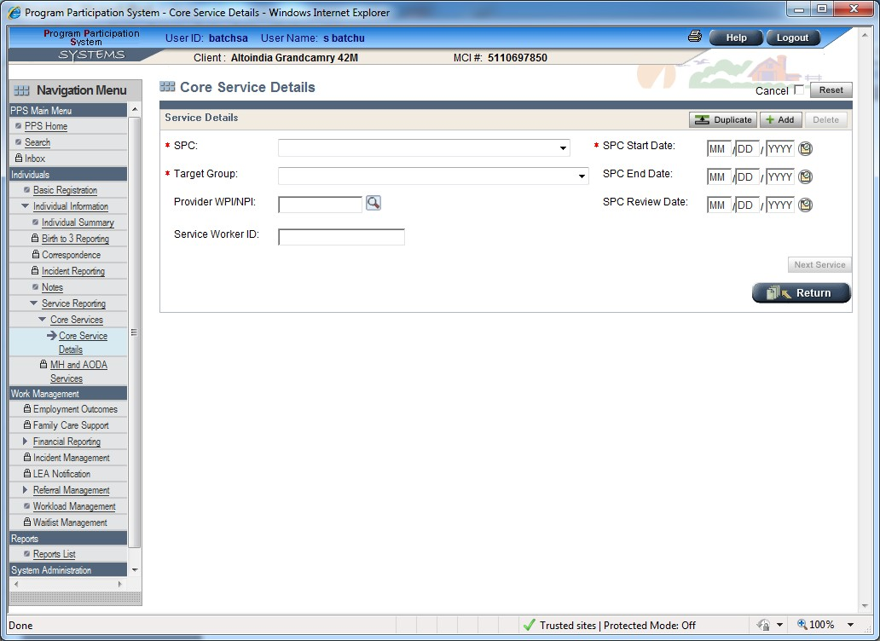

For every ‘Service’ element in the provided XML file there should be ‘<record_id>’ element with a valid value. The value of the ‘<record_id>’ element will be used to identify the service uniquely.

The <record_id> shall be unique across a given agency.

Following are the XML elements that are related to ‘Core services Details’ page,

XML elements of Core services Details Page
<record_id>
<spc>
<target_group>
<spc_start_date>
<spc_end_date>

Subsystem: | Program Participation System
Page Name: | Core Services Upload
Process Number: | 60.150.DUV.06
Page: | Page 17 of 25

<spc_review_date>
<provider_number>
<service_worker_id>

Required elements for ‘Core Services Details’ page,
- <SPC>
- <Target_group>
- <spc_start_date>

Validation for Core Services Details Page

Conditions | Error Description
If <record_id> element empty for the first detail record in the XML | System cannot process a 'Detail Record' without 'Record ID'. Please make sure  'Record ID (<record_id>)' is provided for the record number '1'.
If <record_id> is not unique for a given agency | The <recipient_id> associated with the provided <record_id> does not match with the <recipient_id> for the same 'Record ID' in the PPS system. Please validate  that no duplicate <record_id> is provided.
If <SPC> element value is empty | Please provide the ‘SPC Code (<spc>)’
If <SPC> element value is not part of the  ‘SPC’ reference table | Please provide a valid value for ' SPC Code  <spc>'
If <Target_group> element value is empty | Please provide the ‘Target Group  (<Target_group>)
If <Target_group> element value is not part of the ‘Target group’ reference table. | Please provide a valid value for 'Target Group <target_group>'
If <spc_start_date> element value is empty | Please provide the ‘SPC Start Date (<spc_start_date>)’.
If date provided in <spc_start_date> is a valid date but is a future date | 'SPC Start Date (<spc_start_date>)' cannot be a future date. Please provide a  valid 'SPC Start Date (<spc_start_date>)'.
If date provided in <spc_start_date> element is not a valid date or if the date is not between  1900/01/01 and 2099/12/31 | The value provided in '<spc_start_date>' should be a Date in 'yyyy-mm-dd' format and should be between '1900-01-01' and '2099-12-31'. Please provide a valid date  for '<spc_start_date>'

Subsystem: | Program Participation System
Page Name: | Core Services Upload
Process Number: | 60.150.DUV.06
Page: | Page 18 of 25

If date provided in <spc_start_date> is a valid date but if it is greater than  <closing_date>. | 'SPC Start Date <spc_start_date>' cannot be greater than 'Episode End Date  <closing_date>'. Please provide a valid 'SPC Start Date (<spc_start_date>)'.
If date provided in <spc_start_date> is a valid date but if it is before <start_date> | 'SPC Start Date' cannot be less than  'Episode start Date'. Please provide a valid 'SPC Start Date (<spc_start_date>)'.
If date provided in <spc_end_date> is a valid date but is a future date | 'SPC End Date <spc_end_date>' cannot  be a future date. Please provide a valid 'SPC End Date (<spc_end_date>)'.
If date provided in <spc_end_date> element is not a valid date or if the date is not between1900/01/01 and 2099/12/31 | The value provided in '<spc_end_date>' should be a Date in 'yyyy-mm-dd' format and should be between '1900-01-01' and  '2099-12-31'. Please provide a valid date for '<spc_end_date>'
If date provided in <spc_end_date> element is before the date provided in the  <spc_start_date> element | 'SPC End Date <spc_end_date>' cannot be less than 'SPC Start Date  <spc_start_date>'. Please provide a valid  'SPC End Date (<spc_end_date>)'.
If date provided in <spc_end_date> is a valid date but if it is greater than Case/Episode  <closing_date> | 'SPC End Date <spc_end_date>' cannot be greater than 'Episode End Date  <closing_date>'. Please provide a valid 'SPC End Date (<spc_end_date>)'.
If date provided in <spc_end_date> is a valid date but if it is before Case/Episode  <start_date> | 'SPC End Date <spc_end_date>' cannot be less than 'Episode Start Date  <start_date>'. Please provide a valid 'SPC  End Date (<spc_end_date>)'.
If date provided in <spc_review_date> element  is before the date provided in the  <spc_start_date> element | 'SPC Review Date <spc_review_date>' cannot be less than 'SPC Start Date(<spc_start_date>)'. Please provide a valid 'SPC Review Date  <spc_review_date>'.
If date provided in <spc_Review_date> element is not a valid date or if the date is not between 1900/01/01 and 2099/12/31 | The value provided in '<spc_review_date>' should be a Date in 'yyyy-mm-dd' format and should be between '1900-01-01' and '2099-12-31'.  Please provide a valid value for  '<spc_review_date>'.
If <provider_number> element value is not part of the ‘provider’ reference table. | Please provide a valid value for 'Provider Number/NPI (<provider_number>)'.

County Adjustment Process:

Subsystem: | Program Participation System
Page Name: | Core Services Upload
Process Number: | 60.150.DUV.06
Page: | Page 19 of 25

When records are processed using ‘County Adjustment Process’ following are the rules that apply,
  - For any change in information, a new record has to be submitted with the appropriate changes and appropriate ‘Record ID/s’ needs to provided to identify the entry in the database.
  - If any particular field information needs to be deleted then value ‘0’ has to be provided in the corresponding XML element. Except ‘Record ID (<record_id>)’ which can never be empty or ‘0’.
  - If there is no change in the value for any given field then either previous value or an empty value (no value) can be provided in the corresponding XML element.
  - If a service has to be deleted then all the XML elements related to service should have ‘0’ as value. Except ‘Record ID (<record_id>)’ which can never be empty or ‘0’.
Example – Sample of Detail record for deleting service with record Id -
<detail_record>
<record_id>CORE0123456789</record_id>
<recipient_id>01234567890</recipient_id>
<recipient_birth_date>1901-01-01</recipient_birth_date>
<!-- Service Details -->
<provider_number>0</provider_number>
<spc>0</spc>
<spc_start_date>0</spc_start_date>
<spc_end_date>0</spc_end_date>
<spc_review_date>0</spc_review_date>
<target_group>0</target_group>
</detail_record>

Other Information:

  - When the file runs in ‘MCI clearance’ mode - in spite of whether there are any errors and/or warning present or not, the entire input data will be resent in the output file. If there are any errors or warnings present appropriate Errors and/or Warnings section/s will be added at the end of the input data and sent in the output file. As per the PCR 62287Errors section is moved to the Detail Record section.So Each Detail record will contains its own error section or warning section if applicable.
  - When the file runs in ‘Upload’ mode – here also entire input file with errors (if any) and/or warnings (if any) will be sent as part of the output file.
  - <Target_group> values 18 and 31 are valid only for < submitter_organization_id > related to DSS agency type.
  - If the Header section is not valid or record id is not provided then in error messages we will not show the record Id.
  - At any given time there can be only one open episode for the given individual and an agency.
  - If an episode is closed all the services beneath it are closed automatically, episode end date is assigned to the service/s end date.
  - Once an episode start date is given we cannot update the episode start date by the new service start date. Episode start date needs to be explicitly mentioned.

Subsystem: | Program Participation System
Page Name: | Core Services Upload
Process Number: | 60.150.DUV.06
Page: | Page 20 of 25

  - If there exists an open episode (it means if episode end date is not given),New Episode cannot be created.
  - Following is information regarding the ‘Target Group’ drop-down for CORE module, Below are the Non-DSS agencies,
DCP – Department of Community Programs
HSD - Human Services Dept
DD Board - Developmental Disabilities Board
DOA – Department of Aging

Tribes

Following are the options in the ‘Target Group’ for the Non-DSS reporting units/agencies,

01 - Developmental Disability
72 - Family Member / Other DD Client 57 - Physical and Sensory Disability
- - Family Member / Other of PSD Client 58 - Adults and Elderly
- - Family Member / Other of Adults and Elderly Client 64 - Children and Family.

The ‘Target Group’ drop-down for the DSS agencies will have all of the following options in the CORE module.

01 - Developmental Disability
72 - Family Member / Other DD Client 04* - Alcohol Abuse
05* - Drug Abuse
17* - Intoxicated Driver
18* - Alcohol and other drug abuse
74* - Family Member / Other AODA client 31* - Mental Health
75* - Family Member / Other of MH Client 57 - Physical and Sensory Disability
- - Family Member / Other of PSD 58 - Adults and Elderly
- - Family Member / Other of Adults and Elderly Client 64 - Children and Family

NOTE: *These are target groups that can be reported in the CORE module by DSS but must be reported in either the AODA or the MH module by the other agencies.

Subsystem: | Program Participation System
Page Name: | Core Services Upload
Process Number: | 60.150.DUV.06
Page: | Page 21 of 25

  - Following are the rules related to Episode/s creation,

- When there is no 'Episode' exists for the given individual then a new Episode is created with the 'Episode Start Date (<start_date>)' as 'Episode Start Date'. And if a value is provided for the element '<closing_date>', then it is used as 'Episode End Date'.

- If there is an 'Open Episode' exists for the given individual then all the 'Service/s (all the <detail_record>/s)' will be added to this 'Episode'. A new 'Episode' will not be created when there is an existing 'Open Episode'.

Note: Please refer to the BLD (PP60.150.10) for detailed information regarding (Episode and Service) date logic.

  - Following are the different ways in which multiple 'Service/s' can be added to an 'Episode',

- If we know the 'Episode ID', then this ID has to be specified in all the 'Service/s (<detail_record>/s)' which needs to be added to an 'Episode' with specified ID. (Note: Here ‘Service/s’ will be added only if the ‘Service Date Range’ falls with in the ‘Episode Date Range’.)

- If we know the 'Date Range' of an 'Episode' then, all the 'Service/s' that fall under that date range will be automatically added to that 'Episode'.
(Note: Here ‘Episode ID’ and a value for ‘<start_date>’ should not be specified.)

- If there is an 'Open Episode' then all the 'Service/s' with 'SPC Start Date' greater than or equal to the 'Episode Start Date' will be added to that 'Episode'.

- IF you want to open a new episode and add, multiple services then send same episode start date <start_date> to subsequent record of a recipient.

Note: Please refer to the BLD (PP60.150.10) for detailed information regarding (Episode and Service) date logic.

Subsystem: | Program Participation System
Page Name: | Core Services Upload
Process Number: | 60.150.DUV.06
Page: | Page 22 of 25

Following is a sample input XML file with ‘Details Record(<detail_record>)’ for the ‘CORE’ program,
<?xml version="1.0" encoding="UTF-8" standalone="yes"?>
<submission xmlns="http://www.wisconsinedi.org">
<header_record>
<submitter_organization_id>109</submitter_organization_id>
<submission_date>2009-02-15</submission_date>
<mci_flag>N</mci_flag>
<number_of_records_transmitted>1</number_of_records_transmitted>
<number_of_records_uploaded>0</number_of_records_uploaded>
<number_of_records_in_error>1</number_of_records_in_error>

</header_record>
<detail_record>
<record_id>CO41445303</record_id>
<case_review_date>2011-09-01</case_review_date>
<city>Windsor</city>
<client_char_1>02</client_char_1>
<client_char_2>03</client_char_2>
<client_char_3>04</client_char_3>
<closing_date></closing_date>
<closing_reason_code></closing_reason_code>
<county_of_residence>040</county_of_residence>
<county_of_responsibility>040</county_of_responsibility>
<diagnosis_code>290</diagnosis_code>
<episode_id></episode_id>
<ethnic_hispanic_latino_flag>Y</ethnic_hispanic_latino_flag>
<ethnic_nonhispanic_latino_flag></ethnic_nonhispanic_latino_flag>
<ethnic_unknown_flag></ethnic_unknown_flag>
<gender>M</gender>
<local_data_dsc>test</local_data_dsc>
<provider_number>39017600</provider_number>
<race_code1>A</race_code1>
<race_code2>B</race_code2>
<race_code3>W</race_code3>
<race_code4>P</race_code4>
<race_code5>I</race_code5>
<recipient_birth_date>1970-11-11</recipient_birth_date>
<recipient_first_name>MarkMTD</recipient_first_name>
<recipient_id>8201473388</recipient_id>
<recipient_last_name>SmithMTD</recipient_last_name>
<recipient_middle_name></recipient_middle_name>
<recipient_suffix_name>I</recipient_suffix_name>
<related_family_id>123</related_family_id>
<social_security_number></social_security_number>
<spc_end_date>2011-09-01</spc_end_date>
<spc_review_date>2011-09-01</spc_review_date>
<spc_start_date>2011-08-01</spc_start_date>
<spc>501</spc>
<start_date>2011-08-01</start_date>
<state_abbreviation>WI</state_abbreviation>
<street_address1>3 Tokay Road</street_address1>
<street_address2>East Towne</street_address2>
<target_group>01</target_group>

Subsystem: | Program Participation System
Page Name: | Core Services Upload
Process Number: | 60.150.DUV.06
Page: | Page 23 of 25

<telephone_number></telephone_number>
<unknown_race></unknown_race>
<worker_id>1234</worker_id>
<zip_code></zip_code>
<service_worker_id></service_worker_id>
</detail_record>
</submission>

Following is a sample output XML with ‘Details record (<detail_record>)’, Error/s and Warning/s for the ‘CORE’ program,

<?xml version="1.0" encoding="UTF-8" standalone="yes"?>
<submission xmlns="http://www.wisconsinedi.org">
<header_record>
<submitter_organization_id>109</submitter_organization_id>
<submission_date>2009-02-15</submission_date>
<mci_flag>N</mci_flag>
<number_of_records_transmitted>1</number_of_records_transmitted>
<number_of_records_uploaded>0</number_of_records_uploaded>
<number_of_records_in_error>1</number_of_records_in_error>

</header_record>
<detail_record>
<record_id>CO41445303</record_id>
<case_review_date>2011-09-01</case_review_date>
<city>Windsor</city>
<client_char_1>02</client_char_1>
<client_char_2>03</client_char_2>
<client_char_3>04</client_char_3>
<closing_date></closing_date>
<closing_reason_code></closing_reason_code>
<county_of_residence>040</county_of_residence>
<county_of_responsibility>040</county_of_responsibility>
<diagnosis_code>290</diagnosis_code>
<episode_id></episode_id>
<ethnic_hispanic_latino_flag>Y</ethnic_hispanic_latino_flag>
<ethnic_nonhispanic_latino_flag></ethnic_nonhispanic_latino_flag>
<ethnic_unknown_flag></ethnic_unknown_flag>
<gender>M</gender>
<local_data_dsc>test</local_data_dsc>
<provider_number>39017600</provider_number>
<race_code1>A</race_code1>
<race_code2>B</race_code2>
<race_code3>W</race_code3>
<race_code4>P</race_code4>
<race_code5>I</race_code5>
<recipient_birth_date>1970-11-11</recipient_birth_date>
<recipient_first_name>MarkMTD</recipient_first_name>
<recipient_id></recipient_id>
<recipient_last_name>SmithMTD</recipient_last_name>
<recipient_middle_name></recipient_middle_name>
<recipient_suffix_name>o</recipient_suffix_name>
<related_family_id>123</related_family_id>
<social_security_number></social_security_number>
<spc_end_date>2011-09-01</spc_end_date>

Subsystem: | Program Participation System
Page Name: | Core Services Upload
Process Number: | 60.150.DUV.06
Page: | Page 24 of 25

<spc_review_date>2011-09-01</spc_review_date>
<spc_start_date>2011-08-01</spc_start_date>
<spc>501</spc>
<start_date>2011-08-01</start_date>
<state_abbreviation>WI</state_abbreviation>
<street_address1>3 Tokay Road</street_address1>
<street_address2>East Towne</street_address2>
<target_group>01</target_group>
<telephone_number></telephone_number>
<unknown_race></unknown_race>
<worker_id>1234</worker_id>
<zip_code></zip_code>
<service_worker_id></service_worker_id>
<errors>
<errors_record>
<record_id>CO41445303</record_id>
<error_msg>Please provide the 'Master Customer Index(MCI) ID (&lt;recipient_id&gt;)'.</error_msg>
<error_msg>Please provide a valid value for 'Suffix Name (&lt;recipient_suffix_name&gt;)'.</error_msg>
<error_msg>Please provide the 'valid individual information to process the detail record'.</error_msg>
</errors_record>
</errors>

</detail_record>
</submission>

Following are the sample ‘.XML’ files, (content of which is specified above).


