Clinical Instructions: Wisconsin’s Functional Eligibility Screen for Children’s Long-Term Support Program



Division of Medicaid Services  
P-00936 (04/2025)

Table of Contents

Module 1: Overview of the Children’s Long-Term Support Functional Screen 6

1.1 Introduction 6

1.2 Programs and Levels of Care on the CLTS FS 8

1.3 Protecting the Family’s Information and Rights 9

1.4 The Screening and Interview Process 10

1.5 Screening and Re-Screening Requirements 10

1.6 The NFE Process 11

1.7 Reliability of Screen and Screeners 11

1.8 Requirements for Screener Qualifications and Quality Assurance 12

1.9 Screening Considerations 13

1.10 Impending Discharge Back to Home 14

Module 2: Informational Pages 16

2.1 Identifying Information 16

2.2 Search Function 17

2.3 Screen Types 20

2.4 Screen Dates 22

2.5 Screen Information 22

2.6 Child’s Information 23

2.7 Living Situation 23

2.8 Legal Concerns 24

2.9 Ethnicity and Race Information 25

2.10 Interpreter Language Required 26

2.11 Contact Information 26

Module 3: Diagnoses 28

3.1 Has the child been determined disabled by the Disability Determination Bureau (DDB) or the Social Security Administration (SSA)? 28

3.2 Transplant Information 28

3.3 Whose Diagnosis is Accepted? 28

3.4 Child’s Diagnoses Must Be Current 29

3.5 Mental Health Diagnoses 29

3.6 Other Diagnostic Considerations 30

3.7 Diagnoses Cue Sheet 31

3.8 Is this a PRESENTING Diagnosis? 32

3.9 Primary Care Physician Information 33

Module 4: Mental Health 34

4.1 Does the Child Need More than Outpatient Counseling to Address their Mental Health or Substance Use Disorder Needs? 34

4.2 Duration of Mental Health Diagnosis 34

4.3 Mental Health Symptoms/Minimum Frequency 35

4.4 Mental Health Services 36

4.5 Rare and Extreme Conditions 37

Module 5: Behaviors 39

5.1 Overview of Behaviors 39

5.3 Frequency of Behavior 43

5.4 Current Intervention Category 44

5.5 Duration of Behavior 46

5.6 Describe Behavior in Detail 46

5.7 Unable to Describe Child 46

5.8 Evaluating the Child not the Child in Services 46

Module 6: Activities of Daily Living (ADLs) and Instrumental Activities of Daily Living (IADLs) 48

6.1 Overview of ADLs/IADLs 48

6.2 ADL/IADL Requires Substantial Impairment **AND** Frequent Assistance 48

6.3 "Needs” versus “Safety”/Fluctuating Needs 49

6.4 Step-by-Step Cueing Versus Reminders and Encouragement 50

6.5 Communication and Learning Assessments 50

6.6 Age-Specific ADL/IADL Answer Choices 54

6.7 Bathing 56

6.8 Grooming 59

6.9 Dressing 61

6.10 Eating 63

6.11 Toileting 65

6.12 Mobility 67

6.13 Transfers 69

6.14 Communication 70

6.15 Learning 76

6.16 Social Competency/Self-Direction 83

6.17 Capacity for Independent Living 96

6.18 Duration of Needs 97

Module 7: School and Work 98

7.1 School 98

7.2 Employment 99

Module 8: Health-Related Services 102

8.1 Overview of the Health-Related Services (HRS) Table 102

8.2 Medical or Skilled Nursing Needs 102

8.3 Definitions for Particular Health-Related Services 106

8.4 Frequency of Help/Services Needed 109

8.5 Expected to last, at this frequency, and child is not expected to become independent at this task for at least six months or more 111

Module 9: Screen Time and Notes 113

9.1 Screen Completion Date 113

9.2 Time to Complete Screen 113

9.3 Final Notes 113

Module 10: Functional Eligibility Results 115

10.1 Information Available on the Eligibility Results Page 115

10.2 Confirming the Functional Eligibility Results 117

10.3 Sharing Functional Eligibility Results with Others 118

10.4 Functional Eligibility Results Affecting Eligibility for Other Programs 118

10.5 CLTS Functional Screen with Eligibility Report 120

Module 11: Resources for Certified Screeners 121

11.1 CLTS Functional Screen Online Course 121

11.2 Obtaining, Deleting, or Changing Access for Certified Screeners 121

11.3 CLTS FS Listserv 122

11.4 DHS Website for the Functional Screen 123

11.5 CLTS FS Team 123

11.6 DHS SOS Help Desk 123

11.7 Process for Transferring a Functional Screen 123

11.8 Incomplete Screens 125

11.9 Note Sections on the CLTS FS 126

11.10 Reports Available on the CLTS FS 129

11.11 Not Functionally Eligible LOC Results 135

# Module 1: Overview of the Children’s Long-Term Support Functional Screen

## 1.1 Introduction

The Wisconsin Children’s Long-Term Support Functional Screen (CLTS FS) is an eligibility tool that captures the needs of a child in a variety of developmental, behavioral, health, and daily living activities. It provides functional eligibility determinations for several programmatic areas, four functional levels of care (explained below), and three target group designations for children from birth through 21 years of age. For more information related to the screen’s reliability and validity, training to become a certified screener, and reference materials for certified screeners, see the [Wisconsin’s Functional Screen webpage](http://www.dhs.wisconsin.gov/LTCare/FunctionalScreen).

The CLTS FS is complex in that:

* It appropriately adjusts questions for children as they develop from birth through young adulthood (through age 21).
* It determines functional eligibility for multiple programs.
* It determines multiple levels of care and target groups.

### Functions of the CLTS FS

In addition to providing a functional eligibility determination, the CLTS FS gathers and stores all information collected in the functional screen process. This data assists in quality assurance, national and state-level outcome reporting, and provides information to counties and agencies as appropriate.

It is important to note the CLTS FS is not:

* An assessment of the child or family. The functional screen is a deficit-based tool designed to capture the limitations of a child. An assessment is goal-oriented and focuses on the child progressing towards mutually developed goals based on strengths and needs.
* A place to record financial, personal, or any other information not related to the child’s functional abilities.
* A place for general case notes.
* An evaluation of parenting skills.

The CLTS FS has been designed, operated, evaluated, and improved through a rigorous quality management system. The CLTS FS was designed by skilled clinicians from each of the programmatic areas, as well as others with child development experience. The initial success of the screen can be attributed to the willingness of program staff and county agency partners to test the screen extensively for validity and inter-rater reliability throughout its development. The testing demonstrates that the screen provides accurate functional eligibility results across multiple levels of care and programmatic areas. Quality assurance processes have been established to prevent a child from being wrongfully denied functional eligibility. State staff continue to address screener questions, review questionable functional eligibility results, develop screen updates with clear written instructions, provide comprehensive training and support to certified screeners, and notify screeners of improvements to the screen to maintain a high level of validity and reliability.

Maintenance and improvement of the functional screen is an ongoing process. Continuous improvement includes random reviews of individual screens for accuracy, documentation of screeners’ responses, analyses of individual screens and data (e.g., comparing screen functional eligibility determinations to those of previous tools), and analyses of aggregate data to determine if screen results remain reliable. These efforts ensure that screen issues are identified and corrected in a timely manner.

The components of the CLTS FS are as follows:

* **Individual Information**: Screen identifying data, child's demographic information, residential setting, and legal concerns.
* **Contact Information**: Contact information for child's parents, guardians, and other significant individuals.
* **Diagnoses**: Child's diagnostic information pertaining to a functional eligibility determination.
* **Mental Health**: Mental health status information regarding duration of condition, severe symptoms, needed services, and extreme circumstances.
* **Behaviors**: Behavior categories include High Risk, Self-Injurious, Aggressive/Offensive, and Lack of Behavioral Controls and each relevant behavior’s frequency, duration, and interventions used.
* **Activities of Daily Living**: Specific items to indicate need for support in bathing, grooming, dressing, eating, toileting, mobility, and transfers. Specific to age groups.
* **Instrumental Activities of Daily Living**: Specific items to indicate need for support in communication, learning, social competency/self-direction, and capacity for independent living. Specific to age groups.
* **School and Work**: School attendance and compliance, special education related data, support needed to transition to adult services, and employment information and preferences.
* **Health Related Services**: Medical and skilled nursing information including terminal conditions, tracheostomy, ventilator, dialysis, IV, oxygen, respiratory treatments, TPN, tube feedings, therapies, colostomy, catheter, and wound or site care.

The CLTS FS provides the opportunity for certified screeners to describe the needs of children requiring long-term support to live at home or in the community. These factors relate to functional eligibility required for various children’s long-term support programs. The following are the screen development criteria that guided these decisions:

* **Objectivity and Reliability**: The CLTS FS is designed to be as objective as possible to achieve the highest **inter-rater reliability** (two screeners would answer the same way for a given child). This ensures fair and proper functional eligibility determinations and provides statewide consistency.
* **Accuracy**: Functional eligibility determinations must be correct and match the current Institutional Level of Care Guidelines.
* **Inclusive**: Children of all ages and cultural backgrounds—with emotional, cognitive, physical, or developmental disabilities; with or without skilled nursing needs; in any setting from transient to institutions—can be accurately screened with the given choices for each developmental and activity subsection.
* **Clarity**: Definitions and answer choices, including diagnoses and nursing needs, must be clear to screeners with a wide array of professional backgrounds.

## 1.2 Programs and Levels of Care on the CLTS FS

The CLTS FS determines functional eligibility for people from birth to age 22 years for several programs:

* Children’s Community Options Program (CCOP)
* Children’s Long-Term Support (CLTS) Waiver Program
* Katie Beckett Medicaid
* Comprehensive Community Services (CCS) Program
* Community Recovery Services (CRS)

The screener will collect relevant functional eligibility information when meeting a child and their family. Again, the CLTS FS is **not** a comprehensive assessment; it is a functional eligibility tool. Once the CLTS FS is complete, the computer functional eligibility logic will determine which, if any, of the four institutional levels of care and associated target group requirements are met.

The four institutional levels of care are:

* Hospital (HOS) = Physical Disability (PD) Target Group
* Psychiatric Hospital = Mental Health Target Group
* Nursing Home (NH) = Physical Disability (PD) Target Group
* Intermediate Care Facility for Individuals with Intellectual Disabilities (ICF-IID) = Developmental Disability (DD) Target Group

A level of care (LOC) is required for both the CLTS Waiver Program and Katie Beckett Medicaid. Additionally, the related target group(s)—physical disability, mental health, or developmental disability—for the CLTS Waiver Program is determined.

The CLTS FS also provides a functional eligibility determination for CCOP and CCS. Screeners must select at least one program for the screen to calculate, but the screen automatically calculates the child’s functional eligibility for all programs. Since the CLTS FS calculates eligibility for all programs, a screener is completing a screen for all programs every time. Functional eligibility results may show that a particular child meets functional eligibility for some programs, but not others. Some programs have other eligibility criteria that need to be met.

For children in the CLTS Waiver Program, county waiver agencies (CWAs) must begin planning for the child's transition to adult waiver services by the time the child is 17 years and 6 months old. When a youth reaches age 17 years and 6 months of age, the CWA should discuss transition options with the participant and/or family and assist with the necessary referrals to the local Aging and Disability Resource Center (ADRC) for options counseling.

The children and adult functional screens are intended to streamline initial and ongoing functional eligibility determinations and to reduce duplicative efforts. Therefore, when a person is within the transitional ages of 18 to 22 years of age, long-term care programs will only accept the results from the most appropriate functional screen. If a person is 19 years old and using one of the children’s programs, then the CLTS FS should be used. Likewise, if a person is 19 years old but using one of the adult programs then the adult FS is to be used.

### Social Security Disability Determination

A child must have a Social Security Administration (SSA) disability determination for Katie Beckett Medicaid. If the child has not had such a determination or their disability status is unknown, the screen will display “pending a disability determination” on the eligibility results page.

## 1.3 Protecting the Family’s Information and Rights

Guardian(s) may refuse to provide the necessary information or refuse to have a CLTS FS completed. This decision may result in the child not being able to access Medicaid and long-term support services.

### Confidentiality

Screening agencies shall comply with state and federal confidentiality laws, including Health Insurance Portability and Accountability Act of 1996 (HIPAA) requirements. The agency shall obtain a signed release of information from the child's parent(s) or guardian(s) for the use of medical, educational, and other records *before* completing the CLTS FS. Copies of the signed releases of information should be included in the child's records.

Any information collected during the screening process is confidential. Information shall be treated with the requirements for confidentiality within the current system of long-term supports**.**

### Supportive Decision-Making

Wisconsin state law formally recognizes Supported Decision-Making agreements as legal arrangements that allow persons to retain their right to make their own decisions, while also choosing trusted people (called Supporters) to help them gather and understand information, compare options, and communicate their decisions to others.

More information for screeners and families can be found in the [Supported Decision-Making Toolkit](https://wi-bpdd.org/wp-content/uploads/2019/12/SDMToolkit.pdf).

See Module 2.8 for more information regarding Supportive Decision Making

## 1.4 The Screening and Interview Process

The screening process requires a meeting to complete the CLTS FS. Review specific program manuals for visit requirements.

The certified screener uses their interview skills to gather the needed information to complete the CLTS FS. The screener will need to ask questions in a variety of ways and use collateral sources as necessary. Collateral sources may include other family members, Birth to 3 Program or school staff, formal or informal caregivers, health care providers, and other agencies providing services to the child.

## 1.5 Screening and Re-Screening Requirements

All programs using the CLTS FS require an initial screen to establish functional eligibility before receiving services. Screeners must verify that a screen was not completed in the past 12 months that already determined eligibility for a needed program. If a screen already exists *and* the child was found functionally eligible for *that* program, that screen must be used. If a child has not been found functional eligible for a program of inquiry, a new/edit to a screen can be completed. If a screen was completed within the last 12 months but a screener does not have access to it, the screener must contact the owning screener/agency to request a screen transfer. Additional information regarding screen transfers can be found in Module 11.

If a screener tries to create a new initial or rescreen for a child that has had a screen completed and calculated within the last 12 months, a warning pop-up will appear. This will alert screeners to this screen and the need to check this previous screen for functional eligibility before continuing. If the screener wishes to continue, the warning message acknowledging the existence of a screen less than 12 months old must be selected.

An *Initial* screen is chosen when:

* A child has **not** been found eligible for a program using the FS in the previous 12 months.
* A child was previously eligible and is seeking access again but there is over a one year gap between screens.

In both scenarios, if changes are made following an initial screen calculation within the first year of eligibility, screeners should *Edit* that screen instead of beginning a new screen.

A *Rescreen*, or recertification, is required annually from the month initial or previous eligibility was determined. This ensures continued eligibility for programs and continuity of services and supports. **Rescreens are limited to once per year for all programs.**

Rescreen is chosen when the child has been enrolled for a program within the previous year only.

## 1.6 The NFE Process

If upon *Initial* or *Rescreen*, a child is found Not Functionally Eligible (NFE), screeners are required to have a peer in their organization review the screen for quality assurance. If the screen continues to be NFE screeners **must** [contact DHS](mailto:dhscltsfs@dhs.wisconsin.gov) to verify the NFE status. These guidelines are as follows:

When a screener conducts a functional screen for a child who is applying for waiver services and the screen finds the child to be NFE for the waiver program:

* A second screener or screen lead must review the screen.
* If the screen continues to be NFE, contact DHS ([email](mailto:dhscltsfs@dhs.wisconsin.gov?subject=NFE%20Review) with “NFE Review” as the subject line) to confirm the NFE calculation.
* If it is a rescreen, the screener will delay disenrolling the child from the waiver program until the NFE determination is confirmed by both the second screener and DHS.
* If the NFE is confirmed, the screen completion agency will send the family a notice of denial, along with a description of the applicant’s state appeal, county grievance rights, and a copy of the functional screen with eligibility report according to programmatic notice timelines.
* Eligibility results will automatically be transferred to EES after 31 days if the results remain NFE.
* If a child is found functionally eligible, the screener will mark the box to send the results to EES immediately.

## 1.7 Reliability of Screen and Screeners

The CLTS FS has been established as a reliable functional eligibility tool when used by certified screeners who follow established policies and procedures. Because developmental functioning and expectations change as the child ages, it is important to ensure the greatest possible accuracy by verifying diagnoses, health-related services, activities of daily living (ADLs), and instrumental activities of daily living (IADLs) each time a screen is completed.

### Screeners must adhere to the following guidelines:

* Screeners must closely follow screen definitions and instructions. Screeners are notified whenever CLTS FS and CLTS FS Clinical Instruction updates are made.
* Screeners must ask every question on the screen to ensure accuracy utilizing their interviewing skills, even when they know a child well.
* Screeners must select the answer that most accurately describes the child’s functioning. The functional eligibility logic is complex and uses information gathered from all sections of the CLTS FS. Screeners should use the tools available to them on the [Wisconsin Functional Screen webpage](https://www.dhs.wisconsin.gov/functionalscreen/index.htm) (including the Diagnosis Cue Sheet, various Tip Sheets and guidance documents).
* The screen logic compiles all responses and compares this to functional eligibility, level of care, and target group information. If a screener gets an unexpected result for any of these areas, the CLTS FS email must be contacted.
* Screeners are expected to refer all questions and concerns to the [CLTS FS email](mailto:dhscltsfs@dhs.wisconsin.gov).
* If a screener receives an NFE (Not Functionally Eligible) result, they must follow the NFE protocol described above.

## 1.8 Requirements for Screener Qualifications and Quality Assurance

The screener must have experience regarding the unique needs and functioning of children with significant disabilities. The screener must complete training to become a certified screener, along with ongoing reviews of their reliability.

Parallel to the qualification and certification requirements stated above, there are quality performance and assurance requirements to ensure consistency and accuracy of screen administration. There are three levels of CLTS FS quality assurance:

1. **Individual Screener Quality Assurance Review**. It is the screener's responsibility to be objective, informed of the instructions, and to verify information gathered regarding a child. The [CLTS FS email box](mailto:dhscltsfs@dhs.wisconsin.gov) can address questions that arise as a screener completes a given child’s CLTS FS. Screeners should contact the CLTS FS email box whenever they obtain an unexpected result for a child. Screeners should also seek clinical consultation on any individual screen question that is complex or confusing given a child’s circumstances.
2. **Agency-Level Quality Assurance Review**. Agencies are responsible for the accuracy of all screens completed by their staff.

The methods each agency conducts will include:

* Participating in all required inter-rater reliability testing.
* Appropriate training, mentoring, and monitoring of new screeners.
* Reviewing a random sample of CLTS FS for accuracy on an ongoing, agency-wide basis.
* Review all available reports in FSIA.
* Following up on all quality assurance inquiries and providing documentation for all responses on the CLTS FS.
* Emailing the [CLTS FS email box](mailto:dhscltsfs@dhs.wisconsin.gov) regarding any screen results or inaccuracies discovered.

1. **State-Level Quality Assurance Review**. DHS reviews screens and uses quality assurance methods during weekly, quarterly, and annual reviews. Screeners must make any suggested changes or provide a rationale for why the change cannot be made. If DHS staff disagrees with the rationale, the screener must follow the guidance issued by DHS.

## 1.9 Screening Considerations

Children will often improve with the added services and supports provided by long-term care programs. **It is important to consider what their baseline of needs and behavior would be if those services and supports were not in place.**

* Different people will describe a child’s abilities, needs, and problems differently.
* People often provide different information at different times or to different screeners.
* People may observe different functional abilities and needs over time or across different settings (such as home or school).
* Screen answers vary somewhat depending on the environment in which the screener observes the child.

**Strategies to Minimize Screening Limitations**—This section outlines guidelines to increase inter-rater reliability of the CLTS FS despite the limitations noted above.

### A. Determining a Child’s Needs on the Functional Screen

Most of the information needed to accurately complete a functional screen can be obtained from the child’s family or primary caretakers, by using various interviewing techniques, and by observing the child in their natural environment. When more information is needed to complete an accurate screen, others involved with the child’s daily life should be interviewed. If additional people continue to give an incomplete picture of the child’s needs, resulting in an NFE, recent testing or added documents can help complete the CLTS FS.

In summary, screeners should follow this process:

1. Ask more questions of the family or primary caretaker about what the child can do (e.g., *Ask the parents and child how they bathe (e.g., in the bathtub, shower, or sponge bath). Ask to look at the child’s bathroom to check for accessibility and adaptive equipment. Ask both parties how they get in and out of the bathtub. If the bathtub has high sides, ask the child if they can lift their foot that high*).
2. Rely on their (screeners’) professional expertise in interview skills and observation. Ask the family or child for additional details or a demonstration of a skill. Consider the whole picture.
3. Keep in mind that parents and caregivers can be giving assistance without realizing it. What has become baseline for a family may be considered functional support by the screen.
4. Seek additional information from other people, such as other family members, teachers, therapists, and physicians: those who interact with the child in a variety of settings. They may have opinions and objective information (e.g., *“They’ve fallen at least four times in the bathroom,”* or *“They are embarrassed to ask for or accept help in the bathroom even when they need it.”*).
5. Review provided tools on the [Wisconsin Functional Screen webpage](https://www.dhs.wisconsin.gov/functionalscreen/index.htm).
6. If questions remain, [contact DHS](mailto:dhscltsfs@dhs.wisconsin.gov).

Screeners should include detailed notes to explain selections when choosing the appropriate response is challenging or when they want to elaborate on their selection.

### B. Different Descriptions from Different People

Different people describe a child’s abilities, needs, and problems very differently. This is expected due to varying perspectives and because children often act differently depending on the setting and people present. Parents’ or guardians’ perspectives and knowledge will be different from that of a professional who doesn’t see the child every day. Adults’ opinions, values, coping abilities, risk factors, and cultural expectations also affect how they perceive and describe a child.

The screener will consider and use all available information to complete the screen. Professional opinions do not override the family. Rather, a screener must address their views and engage with interest and questions that gently focus on objective information about the child. A screener should ask more questions and rely on professional observation. Consider the whole picture. Seek additional information from other people if needed, such as other family members, teachers, therapists, physicians, and other professionals.

### C. Additional Notes

The CLTS FS is a functional eligibility tool, **not** an assessment. Screeners should add additional notes that are objective and address the specific areas of skill and development relevant to functional eligibility criteria.

Responses to Activities of Daily Living (ADL)/Instrumental Activities of Daily Living (IADL), Mental Health, and Behavioral questions may require an entry about frequency of the activity or interventions used. These requirements are described in the instructions for those sections.

Remember that the screen is taken in total; even if some ADLs are not checked, the child could be eligible through different sections of the CLTS FS.

## 1.10 Impending Discharge Back to Home

When screening a child who will be discharged from a skilled health care facility or hospital, an intermediate care facility for individuals with intellectual disabilities, a state center for developmental disabilities, or an institute for mental disorders, complete the screen based on how the child is expected to function upon their return home (e.g., if oxygen and intravenous (IV) will be stopped before the child goes home in two days, do not mark “IV” on the health-related services (HRS) portion of the screen). If the family is learning to do a two-person pivot transfer to use at home, indicate that the child needs assistance with transfers on the ADL portion of the screen. The screener will need to gather additional information from facility staff and the child’s parent(s) or guardian(s) to get the most accurate picture of their needs after discharge.

# Module 2: Informational Pages

## 2.1 Identifying Information

When searching for a child or entering a new applicant into the CLTS FS, the child’s name, date of birth, and Social Security number (SSN) are critical for identification and must be accurate. If a child is not already a client in the CLTS FS, the system will check other databases using these items to see if the child exists in other systems. If the system identifies some or all of this identifying information for a child, it will show clients that potentially match. If one of those clients matches the child the screener is entering, the screener should select that client and proceed. If there is no match, the screener should continue entering them as a new client.

The identifying information can be updated on the Individual Information page. If there is an error or a screener needs further assistance with this process, contact the [DHS SOS Help Desk](mailto:dhssoshelp@wisconsin.gov).

### Name Suffixes

If the child has a suffix added to their name, such as “Jr.” or “IV”, list this in the Last Name box following their last name.

### Name Change/Name Misspelled

If the child’s name has changed (often due to an adoption) or a screener notices that the name is misspelled, the name can be changed on the CLTS FS. Select the screen with the child’s previous name and update the Individual Information page of the screen. This updated information will be saved for future screens, but will not affect previously calculated screens.

### Date of Birth

Enter the child’s date of birth in **MM/DD/YYYY format**, as in 01/01/2021. A calendar option is available to improve accuracy. The date of birth must be earlier than the Screen Begin date. CLTS FS programming will not allow dates to be entered that make the applicant more than 22 years old, as they need to be referred for an adult functional screen.

### Social Security Number

Enter the child’s SSN in the ###-##-#### format. Only enter the SSN as it appears on the government-issued Social Security card in the child’s name.

### Pseudo Social Security Number

A certified screener should only use a pseudo SSN when the child does not have an actual SSN issued at the time of the screen visit (e.g., newborn infants). **Do not** use a pseudo SSN to enter a screen prior to learning the child’s actual SSN.

When a pseudo SSN is used, the child’s identifying information does not go through the Master Customer Index (MCI) clearance. If a previous screener used a pseudo SSN and you now have the child’s actual SSN, please make the necessary correction. Uncheck the Pseudo SSN box on the Individual Information page, then enter the correct SSN.

### SSN Status

If the child is already in other systems, their SSN status will be “Verified SSN.” If a new SSN is entered or the child is new to the system, the status will be “Unverified SSN.” It typically takes the system seven to 10 days to verify a child’s SSN. Other possible options indicate a mismatch of information involving the child’s name, date of birth, and SSN.

### Social Security Number Entered Incorrectly

If an SSN was entered incorrectly, the error must be corrected internally. Contact the [DHS SOS Help Desk](mailto:dhssoshelp@wisconsin.gov) with the child’s full name, incorrect SSN, and correct SSN.

### Duplicated Screens

If there is more than one functional screen for the same child, the additional screens can be merged through support from the DHS SOS Help Desk. When multiple screens are available, use the screen with the correct SSN. The screen with a pseudo or incorrect SSN should be deleted. Contact the [DHS SOS Help Desk](mailto:dhssoshelp@wisconsin.gov) with the child’s full name, incorrect screen identification, and correct screen identification.

### Master Customer Index Identification Number (MCI ID)

The MCI number is another form of identification for a child. It will appear on the Individual Information page next to the child’s date of birth. It is often the child’s Medicaid ID number.

## 2.2 Search Function

If the name of the child is not assigned to your agency, then you will see the following (Fig. 1):

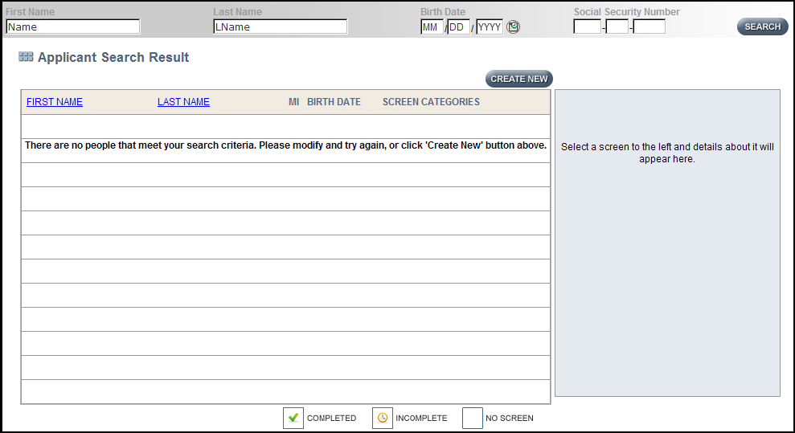Fig. 1: Search results for an applicant by the name of “Name LName” where there are no people who meet this search criteria that you have rights to see (that you “own”). Select the “CREATE NEW” button.

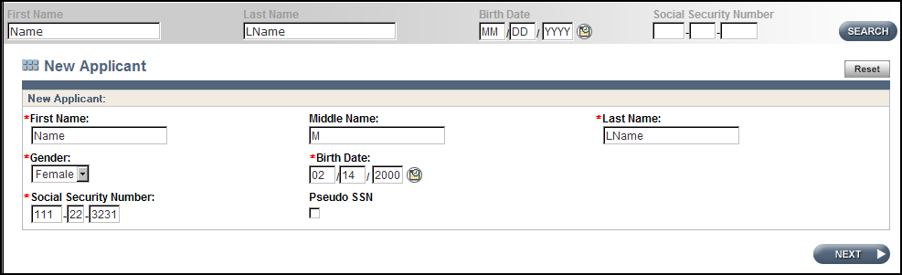The “New Applicant” page will appear. Enter the child’s name, gender, date of birth (DOB), and SSN (Fig. 2).

Fig. 2: Page to enter identifying information for a child who is a new applicant.

Select “Next” after completing the fields in the “New Applicant” page. The page titled “MCI Clearance Results” may appear if a potential match is found in the database (Fig. 3):

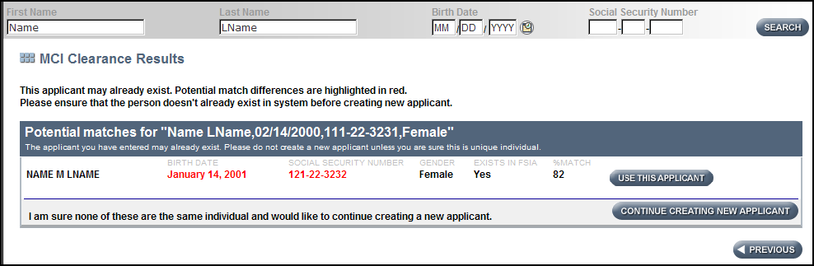Fig. 3: MCI Clearance Results for applicant by the name of “Name M LName.”

On the MCI Clearance page, potential matches for the child are displayed. Consider each potential applicant in this list.

In this example, there was one potential match with the name “Name M LName,” a slightly different date of birth (1/14/01 rather than 2/14/00), an SSN off by a few digits, the same gender, and “Yes” in the “Exists in FSIA” column. This represents an 82% match.

Notice the “Exists in FSIA” column. FSIA stands for Functional Screen Information Access. If there is a Yes in this column for a child, it means there is a functional screen for them that is currently “owned” by another agency.

It is critical to select “Use this Applicant” when the child is identified by name, date of birth (DOB), or SSN, even when “Exists in FSIA” indicates “No.” It does not need to be a perfect match; anything over 80% is good given the system’s limitations. If some of the information is inaccurate, it can be updated when entering the actual screen data. This is often the case for children who have had their last name changed.

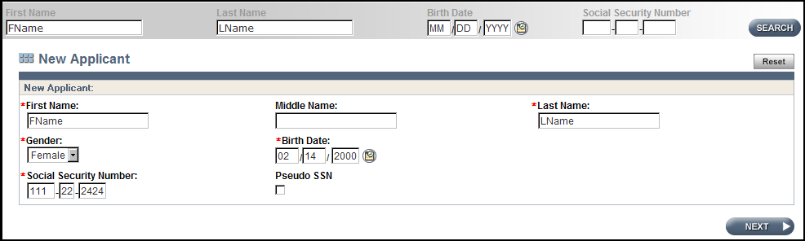Another example (Fig. 4):

Fig. 4: Identifying information for an applicant by the name of “FName LName” where there are no people who meet this search criteria that you have rights to see (that you “own”).

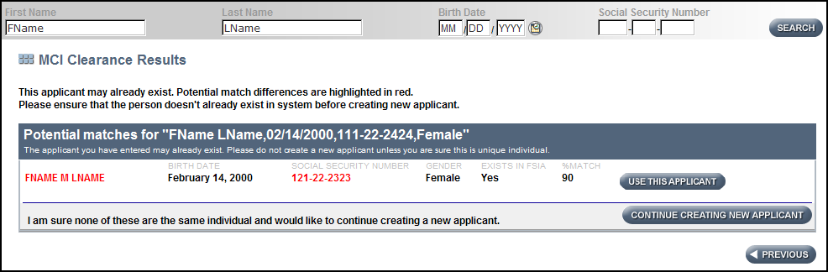The MCI Clearance page for this example (Fig. 5):

Fig. 5: MCI Clearance Results for applicant by the name of “FName LName.”

In this example, there was one potential match with the name “FName LName,” who has the middle initial of M, the same date of birth, an SSN off by a few digits, the same gender, and “Yes” in the “Exists in FSIA” column. This represents a 90% match.

Once “Use this Applicant” is selected, the child’s name will appear on your list of “My Recent Screens.” Once the “CLTS” box is selected to the right of the child’s date of birth (under “Screen Categories”), it displays that a different agency “owns” the screen and needs to be transferred accordingly. Once the screen is transferred, it will display when performing the search.

If no other agency “owns” this screen, then enter the child’s information into the CLTS FS system for the first time.

## 2.3 Screen Types

The screener will select one option whenever they complete a CLTS FS. There are two screen types from which to choose: *Initial* and *Rescreen*.

### Initial Screen

The first CLTS FS completed for a child interested in accessing programs that use the screen for functional eligibility.

An *Initial* screen is selected in the following four circumstances:

* The first time a screen is created for a new applicant. No previous screen exists for the child.
* A child has been on a waiting list for a particular program longer than 12 months and is now coming off the waiting list for program enrollment.
* A child was found NFE for services or had their services discontinued for over a year and is reapplying for the same/other children’s program(s).
* A child continues to be eligible for one program used by the screen (e.g., CCS) but has never been determined eligible for a different program for which the screen determines eligibility (e.g., CLTS Waiver).

### Rescreen

A *Rescreen* or recertification screen is required every 12 months for as long as a child is enrolled in a long-term support program.

If a screen has been completed within the previous 12 months that shows functional eligibility for a needed program, that screen should be used no matter which program/screener completed the screen. If a child has not been found eligible for a program within the past 12 months a new initial screen can be completed.

### Edit

A screener should use *Edit* to add or change information in a screen that they are currently working on or to make necessary updates to an unconfirmed NFE screen.

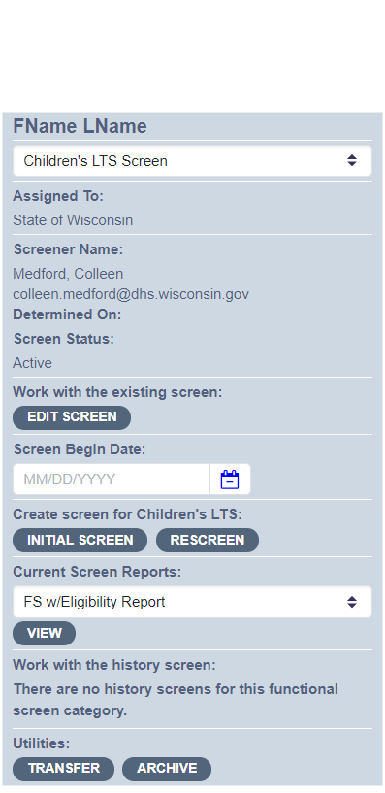

Fig. 6: Panel on “Recent Screens” Page on CLTS FS noting buttons to mark for Edit of screen; selection of initial or rescreen.

## 2.4 Screen Dates

### Referral Date

A **referral** is the act of making an initial inquiry or contact (which can include actions as informal as a phone call or email) to the CWA wherein the contact indicates that a child has a disability or exceptional need.

* Queries in which the caller inquires about supports, asks for help, or whose situation suggests the child could reasonably be expected to benefit from services should be considered referrals.
* The parent, legal guardian, or other person acting in the interest of the child does not have to mention specific supports, services, or interest in a specific program for the contact to be considered a referral.

The **referral date** is the date the initial inquiry or contact was made by a parent, legal guardian, or another person indicating they have a child with a disability or exceptional need which the family is seeking assistance from the agency in meeting.

The referral date is used as the start date for program timelines.

Note: A child has one referral date. When the initiating agency receives a referral, that initial referral date will be the date used when they are notified of an eligible child.

### Screen Begin Date

The Screen Begin Date is the date that the CLTS FS is begun. This date also establishes the age of the child at the time of screening.

The Referral Date and Screen Begin Date are used to assess state and local processes to assure timely responses to families’ requests for program enrollment and screening. The difference between the Referral Date and the Screen Begin Date is tracked as part of quality improvements. A Referral Date is only required on Initial Screens.

## 2.5 Screen Information

### Screener’s Name

The screener’s name must be selected from the drop-down box available on the screen. By selecting the screener’s name, the email on file will display automatically. Changes in email addresses/screener names must be sent to the [SOS Help Desk](mailto:dhssoshelp@wisconsin.gov).

### Referral Source

Select from the drop-down box to indicate who recommended that the family contact the screening agency. Use “parent” as the referral source only if *no other person* prompted them to contact the screener **or** if another parent provided the referral to this family. A referral source is only required on *Initial* screens.

**For which of the following programs is this Functional Screen being completed? (Check all that apply at this time.)**

* Community Recovery Services
* Children’s Community Options Program
* Children's Long-Term Support Waiver
* Katie Beckett Medicaid
* Comprehensive Community Service

In order to accurately track screen quality by program, this question indicates for which program(s) the screen is being completed. This field is for data collection purposes only and does not affect the results of the screen. The CLTS FS calculates eligibility for all programs; therefore, all screeners are screening for all programs.

## 2.6 Child’s Information

### Address

Enter the child’s “permanent residence.” For transient persons, enter the address they resided at the most in the last six months.

If there is a street address and a PO Box, enter the street address and apartment information on line 1, the PO Box on line 2, and use the PO Box zip code.

### County/Tribe of Residence and County/Tribe of Responsibility

For the purposes of the screen, residency is physical presence or the intent to reside. Select the appropriate county or tribe from the drop-down box. County of responsibility is usually the same as that of residence, so the CLTS FS program will automatically enter the county of responsibility. In some instances, people may live in one county, but another county or tribe is responsible for services, costs, or protective services and the default entry should be changed.

## 2.7 Living Situation

### Current Residence of the Child:

Select the appropriate response from the drop-down box. If the screener selects “other,” type an explanation in the box. Most of the drop-down options are self-explanatory.

If a family is homeless and the child is under 18 years old, please select “with parents” for their living situation. If they are over 18 years old and homeless, then select “no permanent residence.”

If a child is living in a kinship care arrangement, select “with other unpaid family members.”

### Number of residents (# of certified beds)

If a child lives in a multiple-bed complex, indicate the number of beds for the license. This applies to the following living situations: foster care or other paid caregiver’s home; treatment foster home; children’s group foster home; adult family home; and community-based residential facility. This information is necessary because certain out of home living situations are not allowable under BCS programs.

If a child is in an out-of-home placement, answer the question “**Is the child expected to return home within 6 months of screening date?”** appropriately. If a child’s recertification comes due while their enrollment is suspended and an agency receives an error message from the Eligibility and Enrollment Streamlining System (EES), the agency must contact the [SOS Help Desk](mailto:dhssoshelp@wisconsin.gov) for assistance.

## 2.8 Legal Concerns

**Are the child’s parents aware of the legal concerns (e.g., guardianship, power of attorney, and representative payee) once the child turns 18 years old?**

This is a required field once the child is 16 years of age. It is not necessary to know the family’s specific choice when the child reaches 18 years of age, since the intent of the question is whether or not they are considering the issues involved as their child becomes an adult.

### Supportive Decision Making

A supported decision-making agreement includes a list of decisions the individual wants assistance in making and identifies a supporter(s) they want to help them. A copy of the Supported Decision-Making Agreement ([F-02377](https://www.dhs.wisconsin.gov/library/f-02377.htm)) should be made available to the screener. It should be complete, signed by both the person and the supporter, as well as two witnesses and a notary. It lets the screener know that the person has given the supporter consent to hear, receive, and discuss information with them, and/or it is OK to release records to the supporter (provided applicable releases are signed). **Note: Wisconsin law limits access to personal information. Only information that is relevant to the decision with which a supporter has been asked to assist with is accessible to the supporter, and a supporter is allowed to access records that require a release only if the person has signed a release allowing the supporter to see the information.**

The possible roles of the supporter are limited to:

1. Accessing, collecting, or obtaining information relevant to a decision area the person has chosen.
2. Helping the person understand that information.
3. Helping the person understand their options, responsibilities, and consequences of that person’s life decisions without making those decisions on behalf of that person.
4. Assisting with communicating the person’s decision to others. Supported decision-making agreements do **not** give supporters any new rights.

**The supporter has no authority to make the person’s decisions (the person makes all their own decisions).** Supporters cannot sign legal documents for the person or bind a person to a legal agreement. Supporters only have the authority/role granted by the person under the terms of the supported decision-making agreement. Supported decision-making agreements do **not** restrict a person’s rights to make any decisions.

The person can include a specific date when the agreement ends. Either the person or the supporter can revoke a supported decision-making agreement at any time. Supported decision-making agreements are automatically revoked if the supporter has a substantiated allegation of neglect or abuse of the person, the supporter has been found criminally liable for abuse or neglect, or there is a restraining order against the supporter.

More information for screeners and families can be found [here](https://wi-bpdd.org/wp-content/uploads/2019/12/SDMToolkit.pdf).

**Is the child, who is 18 years of age or older, their own guardian (i.e., they do not have a legal guardian)?**

This is a required field once the child is 18 years of age. If the young adult does not require guardianship of person, they are considered a competent adult.

## 2.9 Ethnicity and Race Information

Ethnicity and racial data supports programs in monitoring equity in access and enrollment. To be respectful of how people self-identify, ask them how they define their ethnic background. The definitions below are to help assign potential answers to categories on the screen.

### Ethnicity

If needed, use the following definition to identify the appropriate option:

**Hispanic/Latino**: A person of Mexican, Puerto Rican, Cuban, Central American, South American, or other Spanish origin, regardless of racial identity.

### Race

Please check all boxes that apply. The choices here match federal insurance reporting requirements. If needed, use the following definitions to identify the appropriate option:

* **American Indian or Alaska Native**: Refers to people having origins in any of the original people of North and South America (including Central America), and who maintain tribal affiliation or community attachment. It includes people who indicate their race or races as Rosebud Sioux, Chippewa, or Navajo.
* **Asian**: Refers to people having origins in any of the original peoples of the Far East, Southeast Asia, or the Indian subcontinent. It includes people who indicate their race or races as “Asian Indian,” “Chinese,” “Filipino,” “Korean,” “Japanese,” “Vietnamese,” or “Other Asian,” or as Burmese, Hmong, Pakistani, or Thai.
* **Black or African American**: Refers to people having origins in any of the Black racial groups of Africa. It includes people who indicate their race as “Black,” African American, Afro-American, Nigerian, or Haitian.
* **Native Hawaiian or Other Pacific Islander**: Refers to people having origins in any of the original peoples of Guam, Samoa, or other Pacific Islands. It includes people who indicate their race or races as “Native Hawaiian,” “Guamanian or Chamorro,” “Samoan,” or “Other Pacific Islander,” or as Tahitian, Mariana Islander, or Chuukese.
* **White**: Refers to people having origins in any of the original peoples of Europe, the Middle East, or North Africa. It includes people who indicate their race as “White” or as Irish, German, Italian, Lebanese, Near Easterner, Arab, or Polish.

## 2.10 Interpreter Language Required

Families have the option to use an interpreter and/or receive forms in a language other than English. Offer access of an interpreter to the family; if they would like one, select their preferred language on the screen. If “Other,” please type the language needed in the space provided. If no interpreter or alternative forms are needed, leave this section blank. This information is on the screen to show the extent of such needs and help long-term care programs better serve people whose primary language is not English.

Interviews must be conducted in each family’s primary method of communication, which may include providing communication aids such as taped or Braille materials; sign language interpreters; and/or language interpreters for families who have limited English proficiency. Communication and translation services are provided at no cost to the family.

## 2.11 Contact Information

### Contact Information

For children under age 18, enter at least one “Contact” who has legal rights to the child’s records. There must also be at least one contact for applicants over age 18 if they are not their own legal guardians.

Parents must be entered separately as different contacts. DHS will send correspondence to the first contact listed if that contact has legal rights to the child’s records.

In cases of joint custody, both parents’ contact information must be included even if one parent does not reside with the child. If the second parent does not have joint custody, this information is optional.

For convenience, the child’s address and home telephone number will auto-fill if the screener selects “parent” as the type of contact. The screener can delete or write over this information if it is not correct. If a contact person’s name is unisex or their preferred pronouns are unclear, the screener can note that in the Notes section for future reference.

The home telephone number is a required field. If the person has no telephone, enter all “zeros” (000) 000-0000. Email address is an optional field; standard email formatting is required when entering an email address.

If a contact person does not have a known address, put the person’s name and any additional information the screener has in the note section on this page.

### Has legal rights to child’s record

For each contact listed, check this box if the contact has legal rights to the child’s records. This will typically be the child’s biological or adoptive parent(s) or guardian(s).

### Delete/Add New

For any contact listed on a previous screen that is no longer appropriate, the screener can select the Delete button and that entire contact will disappear. To add additional contacts, use the Add New button located towards the bottom of the page.

# Module 3: Diagnoses

### Overview of Diagnoses

This section covers the criteria a diagnosis must meet in order to be accepted for the CLTS FS. All diagnoses checked on the screen must be current and made by an appropriate medical or mental health professional. This module also describes how to use the diagnostic cue sheet to categorize those not explicitly listed on the CLTS FS and how to differentiate presenting diagnoses from others if a child has multiple diagnoses.

## 3.1 Has the child been determined disabled by the Disability Determination Bureau (DDB) or the Social Security Administration (SSA)?

Check “Yes” if the child is in Katie Beckett or receiving Supplementary Security Income (SSI) or Social Security related to the child’s disability in any state. This can be checked “Yes” based on guardian report.

## 3.2 Transplant Information

If child had a transplant, indicate the date completed. If a transplant is pending, check the appropriate box. The transplant must be imminent in the next 12 months. This does not exclude children who are having autologous (out of self) transplants or have a previously designated donor. A specific plan or timeline for the transplant is another option to establish this criterion.

## 3.3 Whose Diagnosis is Accepted?

Screeners are not to interpret people’s complaints or symptoms. If guardians report a diagnosis the screener must find out *when* the diagnosis was made and *who* diagnosed the child. If a physician diagnosed the child, the screener can check the diagnosis box.

* School records and Birth to 3 records may be used for diagnoses if the records show that they were made by qualified professionals, such as a school psychologist (cognitive delay) or speech therapist (speech delay). Birth to 3 Program professionals are qualified to make a “Developmental Delay” diagnosis. The education category of “significant developmental delay” on an IEP can be used because it was made by qualified professionals on the school evaluation team.
* A suspicion of a diagnosis *does not* count for the purposes of the CLTS FS. For example, if school personnel have done an autism rating scale or the child qualifies for special education services within the autism category, the screener will not check the diagnosis of Autism Spectrum Disorder on the screen unless is it also confirmed by a medical professional.
* An Autism Spectrum Disorder must be a medical diagnosis.
* Only check the diagnoses reported to the screener or those listed with appropriate documentation. Do not interpret diagnoses from symptoms. Only check the diagnoses for which the screener has verbal report from parent (non-mental health diagnosis) or provider or written record. **If the screener receives no diagnosis information, their notes must document any attempts to obtain diagnosis information.**

## 3.4 Child’s Diagnoses Must Be Current

Screeners may accept any medical or professional diagnosis made within the past year. If the child was diagnosed over a year ago but it is still relevant to their needs and condition, the diagnosis may be entered on the screen. If a screener is performing a rescreen, they may rely on verificationof diagnoses from previous screen calculations unless the child has had a change in condition.

A **few** diagnoses on the screen are conditions that *may improve*. Cancer, a wound or burn, failure to thrive or even some mental health diagnoses are examples of conditions that may **not** **apply** to a child anymore. If a condition has improved such that they are not receiving any medications or treatment related to the diagnosis and no longer have any symptoms, then that diagnosis should not be checked on the diagnoses page. Instead, these should be included in the note section.

***Example A****:* Ricky is a 15-year-old boy with muscular dystrophy. When he was 6, he was successfully treated for leukemia. He has had no recurrence or symptoms related to leukemia since then. The screener would not check Cancer on the diagnosis table.

***Example B****:* Sophia is a 5-year-old girl who is doing well and is typical size, weight, and development for her age. As an infant, she was diagnosed with failure to thrive, but that was resolved by the time she was 3 years old. A screener would not check Failure to Thrive on the diagnosis table.

If a screener is not certain that a diagnosis is still current for the child, they will need to check with the family or qualified medical professionals.

## 3.5 Mental Health Diagnoses

Any diagnosis of a mental health condition, including autism spectrum disorders (such as autism, Asperger syndrome and pervasive developmental disorder), substance use, and all other mental health diagnoses require the screener to follow these guidelines.

* Verify that the mental health diagnosis(es) (**not** a suspected diagnosis) was made by a psychiatrist, psychologist, physician, mid-level medical provider (Nurse Practitioner or physician’s assistant), licensed clinical social worker or licensed professional counselor (including licensed marriage and family therapist) for whom diagnosing a mental health disorder is appropriate to their specialization and within the scope of their training and practice.
* The mental health diagnosis(es) was made through a process using standardized testing, norm-referenced tools or a thorough professional assessment of the child’s symptoms (typically in accordance with the Diagnostic and Statistical Manual of Mental Disorders (DSM) fifth edition, 5-TR).

This verification can be made through written medical record documentation or verbal exchange as long as all requirements are met. This can be accomplished by reviewing clinical assessments or mental health evaluations completed at the time of diagnosis that include a description of the symptomatology. Recent or current progress notes detailing the symptoms associated with the verified diagnosis and the treatment protocols used to address them may also be used. If guardians can recall approximately when and which qualified professional made the diagnosis this can also be accepted.

Screeners must include information in the note section to support verification of all mental health diagnoses. If a screener is performing a rescreen, they may rely on verification that was obtained and documented for previous screen calculations unless the child has had a change in condition.

## 3.6 Other Diagnostic Considerations

### Avoid Synonyms for Current Conditions

If a child has a condition captured by one of the diagnoses listed on the screen or on the diagnoses cue sheet, check that one diagnosis. Do not include synonymous diagnoses.

***Example A****:* If a child has “Down Syndrome”, the screener checks that box. The screener does not also have to check synonyms such as “cognitive disability,” “developmental disability,” and “genetic/chromosomal disorder.”

***Example B****:* If a child has a current diagnosis of cognitive disability with a previous diagnosis of developmental delays from over a year ago, check only cognitive disability on the screen.

If the screener is not certain that one diagnosis is inherent in another diagnosis, then check both as long as they are both current.

### Multiple Conditions/Diagnoses/Diagnosis Sub-type

A child may have more than one condition, such as cerebral palsy and cancer. In those instances, both Cerebral Palsy and Cancer should be checked. The CLTS FS should accurately capture each *current* diagnosis given to the child. CLTS FS quality assurance procedures will determine if the diagnoses listed for a child are compatible with the needs and supports the child receives.

***Example A****:* The screener screens a child with muscular dystrophy and also checks in the health-related services section that the child is getting IVs. A second diagnosis should be selected as presenting to support why the child is getting IVs.

Sometimes a child may have a primary diagnosis as well as a secondary diagnosis; again, check all *current* diagnoses. Even if the screener thinks the primary diagnosis captures all the functional limitations of that child, it is still important to list each diagnosis given to them.

***Example B****:* The screener meets a child who has been diagnosed with a cognitive disability and has asthma and allergies. The functional limitations they experience are directly related to the diagnosis of cognitive disability. Nevertheless, the screener would check all three diagnoses on the diagnoses page.

Some diagnoses on the Diagnosis page of the CLTS FS have specific sub-types of a diagnosis that can be marked. For those diagnoses (i.e., Cerebral Palsy), the screener should determine what type of that diagnoses the child has, if possible, and mark the sub-type.

### Pending Diagnoses

In some instances, physicians cannot officially make a diagnosis until the child gets older. In those cases, other functional screen questions can determine correct program functional eligibility for the child, and the absence of a diagnosis should not matter if there are other presenting diagnoses checked. Provisional diagnoses cannot be selected on the CLTS FS.

### Down Syndrome

There are two listings for Down syndrome on the diagnoses page: Down Syndrome–Mosaic or Translocation and Down Syndrome–Trisomy 21. Guardians generally know which kind of Down syndrome their child has. Trisomy 21 is the most common form (95%) of Down syndrome. In Trisomy 21, the child has an extra chromosome 21 in all their cells. Mosaic Down syndrome indicates that the child has an extra chromosome 21 in only some of their cells. Because not all cells contain the extra chromosome 21, the range of physical problems varies depending on the ratio of cells with 46 to those with 47 chromosomes. Down syndrome caused by a translocation of a part of chromosome 21 to another chromosome also varies in severity.

## 3.7 Diagnoses Cue Sheet

The diagnoses page on the CLTS FS is not all-inclusive. For brevity, it groups categories of related diagnoses and lists common diagnoses a screener will encounter. Common diagnoses for the functional screen are those specifically mentioned in state or federal eligibility requirements or others needed to establish a specific target group.

Screeners will sometimes encounter diagnoses that they do not see listed in the table; different diagnoses with similar meanings are clustered together. If the screener does not see a particular diagnosis listed and is uncertain which diagnoses are considered similar, the [Diagnoses Cue Sheet, P-00920](https://www.dhs.wisconsin.gov/publications/p00920.pdf), will help to guide their response. The cue sheet will indicate which box to check on the diagnoses page. If the diagnosis is not on the cue sheet, then the screener can check the “Mental Health–Other” or “Substance Use–Other” box and write it in. For non-mental health or substance use conditions, enter the diagnosis in the note section on that page. Screeners’ entries are reviewed periodically to update the cue sheet.

If you use the Diagnoses Cue Sheet to determine the proper box to check on the diagnoses page, write the specific diagnosis the child has in the note section at the bottom of that page.

## 3.8 Is this a PRESENTING Diagnosis?

For every diagnosis checked on the CLTS FS, the screener must indicate if it is a Presenting Diagnosis. While all diagnoses a child has are relevant to the CLTS FS, presenting diagnoses allow the screen to differentiate the primary causes for the child seeking long-term support services. In other words, the functional limitations captured by the CLTS FS are directly related to a child’s presenting diagnoses.

***Example A***: A child has needs related to their diagnosis of an autism spectrum disorder that can be addressed through long-term support services, specifically waiver services. The child also has a diagnosis of asthma. The Presenting Diagnosis for this child is autism spectrum disorder. The other diagnoses are still indicated on the diagnoses page but may not be Presenting Diagnoses.

***Example B***: A child is applying for long-term support services because they have home modifications needed for their physical limitations related to cerebral palsy. This child also needs support services due to a cognitive disability. In addition, the child has delayed puberty. The Presenting Diagnoses for this child are cerebral palsy and cognitive disability. The other diagnoses are still indicated on the diagnoses page, but are not Presenting Diagnoses.

***Example C***: A child has Down syndrome and is applying to a variety of long-term support services to help with needs related to their condition. They have also been diagnosed with an ulcer and a soft palate deformity. The Presenting Diagnosis for this child is Down syndrome. The other diagnoses are still indicated on the diagnoses page but are not Presenting Diagnoses.

***Example D***:A child has severe food allergies resulting in needing a g-tube and needs help with the associated medical costs. They are applying for long-term support services through Katie Beckett Medicaid due to these allergies. The child also has a diagnosis of ADHD. The Presenting Diagnosis for this child is allergy. The other diagnoses are still indicated on the diagnoses page but are not Presenting Diagnoses.

***Example E:*** A child has oppositional defiant disorder requiring mental health counseling and a cognitive delay requiring special education in school and additional community supports. Both diagnoses are most likely contributing to the family seeking supports, although they might be seeking them from programs in both developmental and mental health realms. In this scenario, both diagnoses should be marked as presenting.

## 3.9 Primary Care Physician Information

This is a required field that does not affect functional eligibility. It is used for state and local system changes to improve children’s access to primary health care.

# Module 4: Mental Health

### Mental Health Diagnoses Summary

The information listed in Module 4 is directly from the Mental Health Information page on the CLTS Functional Screen. This provides the screener an opportunity to confirm that they have selected the correct mental health conditions for the child. The rest of the questions on this page refer to symptoms or needs directly related to mental health diagnoses.

## 4.1 Does the Child Need More than Outpatient Counseling to Address their Mental Health or Substance Use Disorder Needs?

Wisconsin Administrative Chapter [DHS 36.14](https://docs.legis.wisconsin.gov/code/admin_code/dhs/030/36/v/14), indicates that criteria for determining the need for psychosocial rehabilitation services shall be available to individuals who are determined to require more than outpatient counseling.

The question cited above would be answered “No,” if the child’s substance use disorder and/or mental health needs are being met through outpatient counseling and/or medication related appointments with a provider which are addressing the medical necessity and need related to a mental health and/or substance use disorder.

The answer to the question cited above would be answered “Yes,” if the child has functional impairments that interfere with or limit one or more major life activities, therefore necessitating more support than outpatient counseling and/or medication related appointments can provide. Examples include coordination of services or any psychosocial rehabilitation service to address the medical necessity and needs related to a mental health and/or substance use disorder.

## 4.2 Duration of Mental Health Diagnosis

The questions on this CLTS FS page reflect duration requirements for a psychiatric LOC.

**If the child has a clinical Mental Health diagnosis, has the diagnosis or related symptoms persisted for at least six months?**

* Yes
* No
* Child does not have a Mental Health Diagnosis

**If the child has a clinical Mental Health diagnosis, is the diagnosis expected to last a year or longer?**

* Yes
* No

Many of the questions on this Children's Long-Term Support Functional Screen (CLTS FS) page reflect current duration requirements for a psychiatric level of care.

**Note:**Autism spectrum disorders, (attention-deficit/hyperactivity disorder (ADHD), and attention deficit disorder (ADD) are mental health diagnoses. While many people identify these diagnoses as developmental in nature, they are clinical mental health diagnoses and, therefore, require an answer to this question for appropriate functional eligibility determination.

Complete the Mental Health section for every child. If a child does not have a mental health diagnosis but is exhibiting symptoms or receiving mental health services, the screener can indicate that on this page. Every question on this page relates directly to mental health issues or concerns.

## 4.3 Mental Health Symptoms/Minimum Frequency

The questions on this CLTS FS page reflect the minimum frequency requirements for a psychiatric Level of Care. The screener should check the box if one of the following is true:

* The child had the symptoms as defined at least once in the past three months
* The child had the symptoms as defined at least twice in the past year.

**Does the child have any of the following symptoms? (Check all that apply and enter notes below)**

* Anorexia/bulimia–Life-threatening symptomology.
* Psychosis–Serious mental illness with delusions and/or hallucinations.
* Suicidality–Suicide attempt or significant suicidal ideation (both passive and active) within the past 12 months.
* Violence–Life-threatening acts.

For Anorexia/Bulimia–Life-threatening symptomology this could include at least one of the following:

* Malnutrition diagnosed by a medical provider.
* Frequent lab monitoring related to malnutrition.
* Body weight or development below 20th percentile and/or delayed development due to the eating disorder as determined by a medical provider.

For anorexia/bulimia and psychosis, there should be a corresponding diagnosis in the diagnosis table of the CLTS FS.

Psychosis occurs only with severe mental conditions resulting in the loss of contact with reality through delusions or hallucinations. A delusion is defined to be a pathological belief (the result of an illness or illness process) held despite evidence to the contrary. A hallucination, in the broadest sense of the word, is perception in the absence of a stimulus. Hallucinations can occur in any sensory modality—visual, auditory, olfactory and tactile.

Suicidality involves both passive and active measures. Passive involves a caregiver report that the child has spoken/written of harming self, **and** this is believed to be a serious threat. An active measure involves a plan to act upon self-harm. Both the active and passive suicidality look-back period is 12 months from the time of screen begin date.

Violence is defined as life-threatening acts that endanger another person’s life. This life-threatening act **must** result in one of the following:

* An injury seeking medical attention.
* Use of weapons against someone (e.g., gun, knife, chains, switchblade, hands, furniture etc.).
* Purposeful fire setting
* Significant acts/plans of harm/death (hitlists, bomb threats, gun, etc.). This does not include impulsive statements.

If the behavior does not meet this requirement, the screener may be able to check one of the behaviors listed under the category: Aggressive or Offensive Behaviors on the Behavior Page of the CLTS FS.

## 4.4 Mental Health Services

**Does the child currently require* services from any of the following? (Check all that apply)**

* **Clinical Case Management and Service Coordination across Systems**, this is specifically for services rendered through the mental health system.
* **Criminal Justice System**, including juvenile and adult justice systems and police involvement.
* **Mental Health Services (check all that apply):**
* Psychiatric Medication with a Psychiatrist or other medical health provider
* Counseling Sessions
* Inpatient Psychiatric Treatment
* Day Treatment—either partial or full day
* Behavioral Treatment for Children with Autism Spectrum Disorders under the supervision of a mental health professional
* In-Home Psychotherapy under the supervision of a mental health professional
  + If a child is participating in ongoing treatment, once they have completed the intensive program it is only listed as mental health services if a psychiatrist or psychologist oversees the specific intervention.
  + This excludes treatment for substance abuse only, which is captured below.
* **Substance Abuse Services**, including day treatment and outpatient services.
* **In-school Supports for Emotional and/or Behavioral Problems** 
  + “In-school supports” includes special education classes, one-on-one assistance, informal supports or a behavioral intervention plan (BIP) in an individualized educational plan (IEP). This is for emotional or behavioral problems; do not check it for children with only cognitive and/or physical disabilities.
  + This item is checked in the following situations:
    - Child has an IEP for emotional/behavioral disorders (EBD) programming. This is not applicable for supports only related to focusing, staying on task, or organization.
    - Child has an active BIP in an IEP.
    - Child is in a specialized school for behavior/mental health issues.
    - Informal supports that can include sensory breaks, added support during peer/social interactions, classroom accommodations to aid behavior or other related supports.

*Require means that the specific service has been recommended by a professional and it is essential to address the identified mental health need. The professional recommendation must have been made within the past year. If the parent or child has not accessed recommended services for over 12 months, then this recommendation is no longer valid.

## 4.5 Rare and Extreme Conditions

The three rare and extreme conditions identified in the following three questions (requiring redirection, having nightmares/night terrors, and inability to perform routine cares) occur for children over the age of 6 and usually don’t cause physical harm to the child or others. They are directly associated with mental health disorders and inhibit the child’s ability to function throughout their day, every day. They are usually not overt behaviors and are better described as a lack of behavior or action. There are limited interventions because the condition appears to be a direct result of their mental health status. Consideration needs to be given to these rare and extreme conditions as a measure of the severity of a child’s mental health condition.

**QUESTION A:**

Does this child exhibit disruptive behaviors in structured settings on a daily basis that 1) require redirection from an adult at a frequency of every three minutes or more often **and 2)** this behavior has been demonstrated consistently for the past six months? Disruptive behaviors may include: sliding around a room in a chair, screaming out inappropriate words or phrases, or sitting in the center of a room and refusing to move.

* + - * Yes
      * No

NOTE: This question will only be answered “Yes” in rare situations. It is imperative that the screener confirm that the frequency of this disruptive behavior occurs “every three minutes or more often” all day, every day.

**QUESTION B:**

Does this child experience nightmares or night terrors at least four times a week **and** this sleep interruption has been consistent for the past six months? These nightmares or night terrors must be characterized by repeated frightening episodes of intense anxiety that may be accompanied by screaming, crying, confusion, agitation, and/or disorientation.

* Yes
* No

NOTE: All children have nightmares or even the occasional night terror. This question is intended for the child who has these intense experiences at least four nights a week, for six months or more. If the condition does not meet this frequency, then check “no” and describe the situation in the note section.

**QUESTION C:**

Is this child unable to complete routine events (hygiene tasks, leaving the house, walking on certain pavements, or sharing community equipment with others) throughout the day, every day, consistently for the past 6 months due to an obsession? An obsession is a thought, a fear, an idea, an image, or words that a child cannot get out of his/her mind. It does not include self-stimulating or compulsive behaviors. The child experiencing the obsession must be aware of the obsession but not be able to control the influence of his/her own thought patterns.

* Yes
* No

NOTE: In general, this question will be most appropriately answered “Yes” if the child has a diagnosis of a severe obsessive compulsive or anxiety disorder. This does not apply to a child with sensory needs that cause them to engage in repetitive behaviors. Keep in mind that the question indicates that the child would be able to express their awareness and desire to stop this behavior but is unable to due to their mental health condition.

# Module 5: Behaviors

## 5.1 Overview of Behaviors

This section allows screeners to describe behavioral symptoms that fall into “High Risk, Self-Injurious, Aggressive or Offensive, and Lack of Behavioral Controls.” If a screener checks a behavior, they will be asked about its “Frequency” and the “Interventions” in place to prevent or control it. “Frequency” ranges from “Never” to “4 or more days each week” and represents the average occurrence of the behavior over the last six months. “Interventions” are divided into three categories: Timeouts/Supervision, Medical/Professional, and Emergency. Finally, each behavior that is checked will have a “Notes” section. The screener should use these sections to describe the behavior in detail. 5.1.a Definition of Behaviors

## 5.2 Definition of Behaviors

Please follow the definitions and contact designated State or DHS staff with questions.

**Determining needs of the Child, not the Child in Services:**In understanding behaviors in children for the purposes of the screen, you are considering the child without services, excluding medication. Parents, schools, providers and other caregivers may have plans (formal or informal) in place to address the child’s behaviors.

As an example, a child who acts out aggressively when overstimulated in the classroom may spend gym time in an alternate environment to prevent the physical aggression that would otherwise occur. In this situation, the trigger or stimulus is removed, and the child is not engaging in the aggressive behavior. However, the child has also not internalized the self-regulation skills needed to interact successfully in gym class, so the occurrence and frequency of this behavior, if this accommodation was not in place, should be considered.

Another example of this concept is a child who runs away frequently but is no longer engaging in this behavior because their caregivers have installed safety measures to prevent this behavior from occurring (locks on doors/windows). However, in understanding this child, it would be appropriate to ask their caregiver what would happen if these measures were removed. If the child would resume the behavior, this item would be checked. This would not be checked when a child has internalized the skills needed to prevent the behavior and does not need outside controls.

Take note of this concept when interviewing: A caregiver will often know what triggers will lead a child to a particular behavior and will instinctively take action to ensure the child is successful when that trigger occurs. Interview caregivers to understand the extra measures they instinctively take to care for children.

### High-Risk Behaviors

* **Running Away**—Impulsive flight without regard to safety.

This behavior **is** checked for children who:

* + Run off in a store.
  + Leave a building without notice.
  + Run away without regard for safety or where they are going (e.g., darting out in traffic, unaware of surroundings).
  + Run as an emotional response or due to a lack of awareness of rules or structure.

This behavior is **not** checked for children who:

* + Run away from their parent or caregiver but never go out of the caregiver’s eyesight.
  + Wander off without supervision and without telling someone where they are going but are aware of their surroundings and return to home or school independently.
* **Substance Use**—Use of illegal drugs, alcohol, or misuse of prescription medications. This does not include use of tobacco products.
* **Dangerous Sexual Contact**—A child who is a victim of a sexual act/assault (including, but not limited to, sexual abuse, human trafficking, intercourse, oral sex, genital contact, exposure). This includes virtual/visual sexual “contact” via the internet (e.g., face-to-face, text, video, or social media), having substantially older sexual partners or having sex with strangers. This does not include peer-to-peer, consensual sexual contact.
* **Use of Inhalants** —Inhalants are substances that can be inhaled (huffing) from an aerosol can; a cloth, or a cotton ball that is soaked with an inhalant; a plastic bag; a gas tank of a car; or a balloon. This will cause an immediate, mind-altering effect after inhaling.
  + Examples (not an exhaustive list): Correcting fluid (“White-out”), degreasers, paint remover, paint thinner, containers that contain nitrous (aerosol cans, balloons, etc.), spray paint, nail polish remover.

### Self-Injurious Behaviors

In evaluating self-injurious behaviors, think about how often the behaviors occur and to what extent. It does not matter why a behavior occurs or under what circumstances (self-stimulation, regulation, frustration, etc.) but to the degree of injury/potential injury of that behavior.

* **Head-banging**—Repeatedly banging one’s head which can lead to injury. Banging one’s head without regard for the surface that they are hitting.
* **Cutting or Burning or Strangulating Oneself**—Repetitive cutting of the skin with a sharp object, burning of one’s skin including friction burns, or strangulation resulting in unconsciousness or near unconsciousness. This includes any abuse of current fad or social media challenges that pose a threat to the child’s safety and health (e.g., ice cube challenge or choke out challenge). If these behaviors are occurring with suicidal intent, they need to be captured as suicidality under Mental Health.

Injury that leaves a mark that disappears in a few hours would not meet these criteria. However, injury that requires time for the skin to heal does meet the criteria for self-injurious behavior.

* **Biting Oneself Severely**—Biting is a severe form of self-mutilation that can lead to damage of the body. A child who engages in this behavior will rupture the skin, which may bleed and scar. A child who bites their nails or cuticles because of a nervous habit would not be considered self-injurious. An injury that leaves a mark that disappears in a few hours would not meet these criteria. However, injury that breaks the skin and requires time for the skin to heal does meet the criteria for self-injurious behavior.
* **Tearing At or Out Body Parts**—Severe self-mutilation from rubbing the eyes, tearing their nose and ears, and any number of other severe injuries. A child who picks at a scab or scratches until a body part bleeds would not be considered self-injurious unless the injury requires intensive treatment.
* **Inserting Harmful Objects into Body Orifices**—Harmful objects include anything that can puncture the skin, such as scissors, knives, pens, and pencils. It also includes items that can cause physical harm or illness such as coins, batteries, and inedible objects.

### Aggressive or Offensive Behavior Toward Others

* **Hitting, Biting, or Kicking**—The aggressive behavior involves multiple victims on an ongoing basis (meaning the behavior does not just occur once or twice). Aggression is beyond an age-appropriate level when **two** of the following are present:
  + Child cannot regulate their body to cease the behavior.
  + Child approaches the incident with the intent to cause harm to others.
  + Others cannot stop the aggression with typical caregiving strategies.
  + The situation requires one or more of the following interventions:
    - An intervention plan (formal or informal) which includes adult intervention to cease the behavior, or avoidance of the stimuli triggering the behavior.
    - Use of physical protective measures, including the removal of other children from the vicinity or the removal of the child from others.
    - Physical intervention.
    - Police or police liaison intervention.
  + Child’s repeated acts of aggression have created an atmosphere of fear.
  + Victim sustains injuries severe enough to require medical attention.
* **Masturbating in Public**—Masturbation is not abnormal or excessive unless it occurs to the point of injury or is done in public places after age five or six, when most children learn discretion and masturbate only in private.
* **Inappropriate elimination: Urine, feces, or other bodily fluids (including spit or menstruation)**—This includes intentional urinating or defecating in inappropriate places, such as public parks and living spaces, containers, etc. Smearing feces involves spreading of feces on the floor, walls or furniture. This does not include accidental elimination.
* **Serious Threats of Violence**—Threats about hurting or killing someone or a group of people. This doesn’t include suicidal threats, as that is covered on the “Mental Health” page. This involves overt, serious, hostile behaviors or threats directed at one or more people. The threats must be perceived as true threats of violence.
* **Sexually Inappropriate Behavior Toward Children or Adults**—This behavior includes when the child’s sexual play or behaviors are not welcomed by others. This can include inappropriate sexual comments or gestures, or sexual molestation and abuse of other children or adults. Examples are aggressive attempts to undress, sexually touch or grab, or attempt intercourse.
* **Abuse or Torture of Animals**—Abusing animals to find power, joy, or fulfillment through the torture of victims they know cannot defend themselves. Most children, with guidance from parents and teachers, develop empathy for the pain animals can suffer.

### Lack of Behavioral Controls

* **Destruction of Property/Vandalism**—Destroying or vandalizing the property of self or others by means other than fire-setting (arson is covered in “Rare/Extreme” questions). Destruction of property can occur if a child is unable to regulate their emotional response to what is happening in their environment. If the behavior is significant (occurs repeatedly, produces damage), this behavior must be considered. Some examples include destroying objects in a child’s home or community.

It includes behavior such as breaking windows, slashing tires, spray painting a wall with graffiti, and destroying a computer system with a virus.

* **Stealing, Burglary, or Kleptomania within the Community** 
  + *Stealing* means taking the property of another without right or permission. For the purposes of the CLTS FS, it does not include taking property from the child’s own home, apart from money, credit cards, or valuables that are taken for the purposes of making money.
  + *Burglary* is the unlawful entry into a building or other structure with the intent to commit any theft or felony inside.
  + *Kleptomania* is a condition in which a person is compelled to steal things, generally things of little or no value, such as pens, decorative pins, or wall decorations. They are often unaware of performing the theft until sometime later.
* **Other (list)**—Extreme, atypical behavior that affects the child’s ability to be in a variety of settings because it causes serious problems for others around them. This option is reserved for a behavior that meets **both** of the following characteristics:
  + Cannot be captured in any of the other behavior options. The screener should assure the behavior does not fit under any other category, as behaviors listed under this category are not included in the eligibility calculation.
  + Causes extreme distress or disruption to others.

The screener should explain these behaviors in detail within the notes section.

## 5.3 Frequency of Behavior

When answering this question, consider the behavior each month over the past six months. Frequency is measured in days rather than episodes. The frequency is captured as it would occur *without* current interventions in place.

* **Never**
* **Less than once a month**
* **1-3 days each month**
* **1-3 days each week**
* **4 or more days each week**

If the behavior was present within the past six months but no longer occurs and there are no current interventions in place, indicate frequency as “Never.”

**\***When answering questions regarding the frequency of behaviors on the functional screen, the screener must remember to consider the impact of current interventions on the child’s behaviors. If the professionals involved agree that the child’s behaviors would resurface if they discontinued current interventions (except for medications), **the screener must record the frequency of the child’s behaviors prior to receiving the interventions.** See section 5.8 of instructions for further guidance.

***Example A****:* The screener meets a child who was engaging in self-injurious behaviors as recently as six months ago but was put on a behavioral action plan and has not engaged in that behavior since. The screener would select a frequency of “Never” for this behavior because the behavior occurred outside the 6-month window.

If the behavior is new, indicate the current frequency of the behavior.

***Example B****:* The screener meets a child who ran away from home for the first time two weeks ago, but the behavior will likely occur again. The screener would check “Less than once a month” for this behavior.

***Example C****:* The screener meets a child who started cutting their arm three weeks ago. The child is now engaging in this behavior at least two or three days a week. The screener would check “1-3 days each week.”

If the behavior fluctuates on a predictable basis, indicate the predictable frequency of the behavior.

***Example D****:* The screener meets a child who always has difficulty with aggression towards others on a cycle of one to two weeks every month. During these weeks, the child will be severely aggressive on a daily basis. The behavior then stops but always returns the next month. The screener would check “4 or more days each week.”

If the behavior fluctuates and is not predictable, consider it more “episodic” and select the average frequency of the behavior over the past six months.

***Example E****:* The screener meets a child who will bang their head severely but there is no pattern to this behavior. In the past six months the child engaged in this behavior two days the first month, not at all the second or third month, eight days the fourth month, not at all the fifth month and twice in the last week. The screener would select the average frequency of the behavior over the past six months, or “1-3 days each month.”

## 5.4 Current Intervention Category

If only one type of intervention has been used in the last six months to counteract a behavior, select the category that best matches that intervention (e.g., if a child that becomes aggressive is always calmed by a time-out, the screener should select “Timeout/Supervision”).

If multiple interventions have been used that represent different intervention categories, **select the most extreme intervention that has been used in the past six months and may be used in the future** (e.g., if a child that normally calms with timeouts was aggressive to the point police were called to intervene, the screener must select “Emergency”). Remember to consider the child vs. the child with interventions in place when choosing an “Intervention Category” and frequency.

### Timeout/Supervision

* **Regular timeouts**
* **Restricted community access**
* **Constant supervision (“in-line of sight”)**
* **Regular time-outs:** Child requires frequent breaks from activities to regain a state of calm behavior; this includes in-school suspension. This can include grounding or removing privileges as punishment for a behavior.
* **Restricted community access:** Restricting the child’s access to the community to prevent harm to themselves or others.
* **Constant supervision (“in-line of sight”):** Child needs constant supervision by one or more adults throughout the day. The adult(s) do not need to be within arm’s distance but must be in the same room for the safety of the child and others.

### Medical/Professional Intervention

* **Professional medical treatment**
* **Regular professional therapeutic treatment/intervention (school professionals, CCS, Mental Health Wraparound)**
* **Regular use of protective gear**
* **Environmental limitations**
* **Constant supervision (“within arm’s reach”)**
* **Interventions taught/recommended to parents/caretakers and used**
* **Evidence based Interventions parents/caretakers have sought out and used** 
  + Does not include having a medication prescribed to address behavioral issues.
* **Professional medical treatment:** Child’s behavior results in injury to themselves or others that required medical attention from a health professional. Do not check this box for injuries that were mended using first aid (Band-Aids for cuts, ice for bruises).
* **Regular professional therapeutic treatment:** Child’s behavior addressed through consistent behavioral or psychotherapeutic intervention as part of a plan developed with professional oversight. Such professionals could be a psychiatrist, licensed psychologist, clinical social worker, marriage and family therapist, or a school psychologist/therapist. This does not include monitoring or administration of a medication regimen.
* **Regular use of protective gear:** Child must wear protective gear to avoid injury tothemselves or others.
* **Environmental Limitations:** Child’s behavior is such that they need to have certain safety measures in place, such as an exterior door locks, fencing, a GPS device attached to the child, or alarms in place to ensure their safety or the safety of others.
* **Constant supervision (“within arm’s reach”):** Child’s behavior requires that adult(s) be able to intervene quickly to ensure physical safety of everyone present.

### Emergency

* **Urgent or emergency medical treatment**
* **Police involvement/Youth Justice involvement/Child Welfare**
* **Intervention resulting in a temporary placement out of the home for intensive monitoring/treatment within the last six months**
* **Urgent or emergency medical treatment:** Child’s behavior resulted in the need for emergency medical intervention, either for the child or others. Violent acts that result in inpatient care for the victim are covered in the “Mental Health” section.
* **Police/Youth Justice/Child Welfare involvement:** Child’s behavior that has been caused by their diagnosis has resulted in the police/criminal justice or child welfare system to investigate. It does not matter if charges were filed. This is also captured as a Mental Health Service under Criminal Justice System.

## 5.5 Duration of Behavior

### Expected to last 6 months or longer?

If the behavior is chronic, check “yes” for this question. If the screener is uncertain, check “yes” to give the child the benefit of the doubt but be certain to review the behavior at time of a rescreen. **If a behavior is marked “no” as in not expected to last for longer than six months, additional notes indicating specific reasoning are needed.**

## 5.6 Describe Behavior in Detail

Once a behavior has been selected, it must be described in detail in the notes section. Some questions to consider are:

* Is there a precursor to this behavior?
* Where has or does the behavior usually happen?
* When has or does the behavior usually happen?
* What does the behavior typically look like?
* How severe is the behavior?
* What do others do when the behavior occurs?
* If the behavior occurs in multiple environments, in which environments is it most frequently occurring?
* What sources of information were utilized?

These behavior-specific notes will not be saved with the history screens but will serve to guarantee that the behavior was selected appropriately on the functional screen. Any time one of the three dropdowns associated with a previously selected behavior is changed (frequency, intervention, or duration), the Note section will need to be completed. This is a required textbox on the screen.

## 5.7 Unable to Describe Child

There may be behaviors children demonstrate that are not reflected in the questions asked on the CLTS FS. As with ADL/IADL questions, the CLTS FS captures items that will affect functional eligibility, which is why behaviors need to be more extreme. If the screener wishes to document behaviors not reflected in the specific CLTS FS questions, those behaviors can be described in the Notes section. The Notes section should not be seen as a field to input information in place of selecting a behavior.

## 5.8 Evaluating the Child not the Child in Services

Children’s behavior will frequently improve with the addition of needed interventions. It is important to evaluate a child’s baseline of behaviors without the services and supports. This evaluation provides a more accurate picture of the child; therefore, screeners should evaluate frequency of behaviors as if the services/supports were removed. If the behavior would increase without the services/supports in place, that frequency must be listed on the CLTS FS.

In addition, the screener must select that the behavior is expected to last six months or longer. *Do not* try to predict what the behavior would be in the future; rely on the information available prior to treatment.

In this context, physical/therapeutic interventions do not include medications. If a child is on a medication and no longer exhibiting a specific behavior or the frequency of a behavior has changed as a result of medication, only check what is true within the past six months for the child.

This option does not apply in situations where the child has been removed from their family home due to issues or behaviors that are specific to their family of origin and not repeated in other homes. This is an example of a circumstance that requires the support of the foster care system rather than children’s long-term support programs.

# Module 6: Activities of Daily Living (ADLs) and Instrumental Activities of Daily Living (IADLs)

## 6.1 Overview of ADLs/IADLs

The computer application of the CLTS FS will calculate the child’s age and present only the ADL (Bathing, Dressing, Grooming, Eating, Toileting, and Mobility/Transfers,) and IADL (Learning, Communication, Social Competency/Self Direction, and Capacity for Independent Living) answer choices appropriate for the child’s age. Starting at 33 months, if the child is within three months of the next age cohort, the application will offer these choices as well.

These answer choices were developed by the screen workgroup using well-established child development guidelines. Modifications were made in order to meet our screen development goals:

* Accuracy (match current functional eligibility rules and clinical judgment)
* Brevity (unnecessary information was left out)
* Objectivity/inter-rater reliability (reduce subjectivity as much as possible)
* Inclusiveness (able to describe various needs of children)

## 6.2 ADL/IADL Requires Substantial Impairment **AND** Frequent Assistance

A substantial functional impairment is a restriction on the child’s ability to engage in age-appropriate everyday activities or perform daily functions. The ADL/IADL questions on the screen are designed to capture substantial impairments based on the child’s age. The child must need hands-on adult assistance to complete these functions across settings including home, school, and community. The help that is provided is not offered to be more convenient but as a necessity to complete the task on a daily basis.

**Frequency** is a critical aspect of the substantial impairment requirement. ADL/IADL questions are to be checked only if the child needs help from an adult in order to complete the ADL on a regular basis as defined by the functional screen questions. If the child has been able to complete the specific task(s) on a rare or infrequent occasion, which means the child is considered unable to complete the task on a regular basis, the box is checked. If the child needs assistance most of the time, then the box is checked.

One way a screener can obtain clearer information is to ask the parent, "In the past several months, would you say he’s needed help most of the time?" In general, consider ADL/IADL function over a 12-month timeframe, unless the child has new needs or has developed new skills.

It is not expected that the screener test the child or measure their needs or abilities during a home visit. A child’s needs cannot be determined from a single episode but must reflect the child's typical or average functional need over the past 12 months across environments. This is particularly important when reviewing documentation about a child's abilities. A report that indicates a child completed a specific task may not represent the typical needs of that child. Be certain to verify any statement or assessment of frequency with various care providers who know the child well. The screener should consider if the child would be able to perform the ADL/IADL outside of their home environment (school, community, other).

***Example A****:* Juan has cancer and gets very sick during chemotherapy and needs help with his ADLs then; at other times, he is independent with them. Juan gets chemotherapy one week each month. The screener does **not** indicate that Juan needs help with his ADLs, because he needs help only some of the time—one week out of four.

***Example B****:* Tia was potty trained two months ago and is doing well with it. The screener does **not** check the box for needs help with toileting (although she did four out of the past six months), because Tia has developed this skill and now rarely needs any help.

## 6.3 "Needs” versus “Safety”/Fluctuating Needs

“Needs” and “safety” should not be over-interpreted or overused to express screeners’ subjective opinions. The CLTS FS is intended to be an objective screen of a child’s need for assistance. Thus, the screener should ask, “Would another screener of another discipline rank the child the same way?”

If a child can complete a task independently but it takes them a long time, the screener needs to consider whether or not the child "needs any help to complete the task." Just because a child is physically capable of completing a task independently does not mean the child does not need assistance. Sometimes it takes a child so long that the parent must do the task so the child gets to school on time. This is not just for convenience and amounts to most of the time (five days out of seven); it would be counted as help needed on the functional screen. This only applies to situations where the family members are providing physical assistance to get the task completed.

It is not uncommon for a child or parent to underrate the need for assistance. Screeners should use the following process when determining a child’s level of help needed:

* Ask more questions and rely on professional expertise in interview and observation. Ask the family or child for additional details or perhaps a demonstration of a skill. Consider the whole picture, to see if the “pieces” make sense.
* Seek additional information from other people, such as other family members, teachers, therapists, physicians, and others who interact with the child in a variety of settings.
* Ask, “Given all this information, what would other screeners choose for an answer?”

To review an example of how to use this process, see Section 1.9 of the instructions.

The screener will quite often encounter different versions of the child’s abilities from different parties. This is discussed in the first part of the instructions. There are also instructions for how to deal with fluctuating needs and the fact that a child may function differently at home than at school. Review those earlier sections as needed under 1.9 Screening Considerations.

## 6.4 Step-by-Step Cueing Versus Reminders and Encouragement

Some ADL questions will ask whether the child requires “Step-by-Step Cueing.” This means a need for another person to be present while the child completes the task to verbally cue the child for steps during the task. Cueing can also be less specific. If a parent or caregiver is asking the child, “Now what do you do?” or “What comes next?” this can also be considered cueing.

Cueing does not apply to children who need to be told repeatedly to brush their teeth or take a shower because they don’t want to. It does not apply to children who have to be sent back into shower again because they missed a spot or didn’t rinse enough. It means step-by-step instruction or prompting.

## 6.5 Communication and Learning Assessments

All assessments listed for Communication and Learning are either criterion or standardized norm-referenced tests that specifically measure expressive communication, receptive communication, or cognition.Criterion-referenced tests compare a person's knowledge or skills against a predetermined standard, learning goal, performance level, or other criterion; norm-referenced assessment is designed such that a child’s performance is compared to a larger group. Usually the larger group or “norm sample” is a national sample representing a wide and diverse cross-section of children. The result is a bell curve based on that normative sample. The normative sample also determines for which age group these assessments and results can be used.

### Valid Results

The results of any assessment **must** be considered **Valid**. The only scores that should be considered when answering this question are assessment results in which the evaluator is confident in the accuracy of the test results. There are many circumstances in which the test results are not accurate and therefore not useable:

* If the child was considered “un-testable,” do not assume that they would meet a 30% delay or two standard deviations below the mean.
* If the child being tested was of a different age than the range that is measured by a particular tool, do not consider those results to be an accurate reflection of the child’s abilities.
* If the test was not administered in full or within the allotted time limit, do not consider those results to be an accurate reflection of the child’s abilities.

Make special note of the number of months and years associated with each question (it varies based on the age of the child).

In order to document a valid assessment on the CLTS FS, the following information must be available:

* Assessment date (MM/YYYY)
* Name of the assessment tool
* Valid results of the assessment
  + Within normal limits
  + A percent delay (greater than, less than, or equal to the required delay for purposes of functional eligibility)
  + A standard deviation below the norm (greater than, less than, or equal to the required delay for purposes of functional eligibility)

Knowing the child’s percentile is not the same as their percent delay and is not relevant for the purpose of the CLTS FS.

### Interpreting Test Results–Standard Deviations

Interpreting test results is often difficult. Most tests are based on a normative score of 100 with a standard deviation of 15. That means normal results are within 15 points of 100; or between 85 and 115. To get this average, one standard deviation is subtracted from the norm and one standard deviation is added to the norm (100-15 = 85 and 100+15 = 115). Borderline scores fall between 70 and 85, which is one to two standard deviations below the norm. If one standard deviation is 15 points, then two standard deviations is 30 points. Assuming that 100 is the norm, two standard deviations below the norm would be a score of 70 or below. Many test results do not report a final score that fits into the category of standard deviations. One option is to contact the professional who administered the test. In the case of communication assessments, any speech pathologist may be able to help accurately interpret the results. In the case of cognitive assessments, any psychologist may be able to help accurately interpret the results.

Some norm-referenced tests results indicate scores in the single digits, like 1 or 3. Without knowing the norm score and the standard deviation score, these are very challenging to interpret. Again, consulting with the administrator of the assessment or another qualified professional may be the best method to interpret this data.

### Interpreting Test Results–Percent Delay

The most important meaning to be aware of when talking about percentages is to understand the clear distinction between percent delay and the term “percentile.” Percentile is often listed in the results of a norm-referenced assessment. It represents where the child’s score ranks against all scores from other children who have taken that same assessment. By definition, a percentile rank is the proportion of scores in a distribution that a specific score is greater than or equal to. For instance, if a student received a score of 95% on a math test (by getting 95 out of 100 questions correct) and this score was greater than or equal to the scores of 88% of the students taking the test, then the percentile rank would be 88. The student would be in the 88th percentile. Clearly, percentile does not address what percentage of a delay the student has in math. In this example, the student would have a 5% delay with a percentile of 88.

In general, assessments of children with communication or learning delays result in percentile scores that are often much lower, like the first or second percentile. Although this sounds like a substantial delay, it does not directly translate to how delayed their skills are.

A percent delay measures how far behind the child’s results are to other children their age. This is evident in age-equivalency (AE) scores. If a 12-year-old child took a norm-reference test and had a valid result with an age-equivalency score of 6;6 (years; months), they would be more than 30% delayed. In fact, they are demonstrating nearly a 50% delay. This is the most common use of percent of delay: looking at the age of the child at the time of testing and the age equivalence they scored on communication and cognitive assessments. This calculation of percent delay can only occur when you know the age at the time of testing and the valid age-equivalency score the child had.

There are 12 months in a year. This has to be incorporated in order to turn a child’s age or age-equivalency score into an integer. Remember that AE scores are written in years and months (years; months). If a child’s age is 4 years, 6 months, or a child’s age-equivalency score is 4;6, that is the same as 4.5years (as an integer). Take the number of months and divide by 12 months in a year. One can also decide to perform the equations in total months rather than with integers (e.g., if a child’s age is 4 years, 6 months, that’s 54 months). Take the number of years, multiply by 12, and add the additional number of months.

*Examples:*

* If a child’s age is 5 years, 7 months or AE is 5;7:
  + 5.6 years (7¸12=.58=0.6, 5+0.6=5.6)
  + 67 months (5x12+7=67)
* If a child’s age is 2 years, 11 months or AE is 2;11:
  + 2.9 years (11¸12=0.9, 2+0.9=2.9)
  + 35 months (2x12+11=35)

To determine percent delay:

* Take the valid AE score and divide it by the child’s age at the time of testing. This tells you the percent they scored on the assessment.
* Subtract the percent they scored from 1.0 or 100%.

***Example A***: A child who was 8 years old at the time of testing scores a valid AE score of 6. Start by taking 6 divided by 8 and your result is .75 or 75% (6 ¸ 8 = .75), which is the percent the child scored. Subtract .75 from 1.0 or 75% from 100% and you will see their percent delay is .25 or 25% (1.0-.75=.25 or 100-75=25%).

***Example B***: A child who was 9-and-a-half years old at the time of testing scores a valid AE score of 6;2.

In Years: Take 6.16 (their AE score in years) divided by 9.5 (their age at testing in years) with a result of .648, rounded to the nearest hundredths is .65 or 65%. That means they scored 65%. Second, and the most important step, subtract the results from 1.0, so in this case, 1.0-.65 = .35 or 35% delay.

In Months: Take 74 (their AE score in months) divided by 114 (their age at testing in months) with a result of .649, rounded to the nearest hundredths is .65 or 65%. That means they scored 65%. Second, and the most important step, subtract the results from 1.0, so in this case, 1.0-.65 = .35 or 35% delay.

***Example C***: A child’s age at the time of testing is 13 years and 4 months. They scored an AE score of 8;9.

In Years: Starting with 8.75, the AE score in years, divided by the age at the time of testing, in this case 13.33 years; 8.75 ¸ 13.33 = .656. This rounds up to .66. Now subtract that from 1.0 (1.0-.66) to get .34 or 34% delay.

In Months: Starting with 105, the AE score in months, divided by the age at the time of testing, in this case 160 months; 105 ¸ 160 = .656. This rounds up to .66. Now subtract that from 1.0 (1.0-.66) and you get .34 or 34% delay.

On the functional screen, screeners are required to indicate the results of the valid assessment. There are three options available:

* Within normal limits
* Percent delay
* Standard deviation below the norm

For children under a year of age:

* Normal limits score is considered between 75 and 125.
* Percent delay must be greater than or equal to 25% to be considered a substantial functional impairment.
* Standard deviation below the norm must be greater than or equal to 1.5 standard deviations below the norm to be considered a substantial functional impairment.

For children a year old or older:

* Normal limits score is considered between 70 and 130.
* Percent delay must be greater than or equal to 30% to be considered a substantial functional impairment.
* Standard deviation below the norm must be greater than or equal to 2 standard deviations below the norm to be considered a substantial functional impairment.

### Full-Scale Intelligence Quotient (IQ)

The full-scale IQ scores are used as a way to address the overuse and under-use of the diagnosis of intellectual disability. There are limitations of IQ testing. The federal definition of intellectual disability is a full-scale IQ below 70. Federal guidelines do acknowledge an IQ score error range of five points. DHS has chosen to use 75 as a “cut-off” point instead of 70 in recognition of that error range.

If the clinician conducting the IQ test expressed concern about the validity of the results due to the child’s ability to participate in the testing process, consider these results with caution and mark this in the notes section. The screener will want to consider the results from the most recent IQ test a child has taken. It does not matter how old the IQ test is as long as it is the most current one on record for that child. The screener is required to select the accurate drop-down option based on the child’s valid Full-Scale IQ Score on the CLTS FS.

### Assessment Results within Normal Limits

If the test results or IQ score do not represent a substantial functional impairment in communication or learning, the screener must look to the questions related to the child’s age cohort to see if there are individual options that apply. With some diagnoses, a child can have an IQ or test within normal limits but can have difficulty applying those skills in daily life. Select any applicable skill the child has not mastered even if they have an assessment within normal limits.

### Other Assessments

If a child has valid testing that is not provided in the dropdown menu, screeners have the option to select “other” and manually enter the name of testing. Testing should only be entered if valid, is criterion or norm referenced, and was conducted by an individual with experience and training in conducting that test.

## 6.6 Age-Specific ADL/IADL Answer Choices

The following tables provide information and guidance about the ADL/IADL questions on the CLTS FS. The table is organized by ADL category (Bathing, Dressing, Grooming, Eating, Toileting, and Mobility/Transfers,) and IADL (Learning, Communication, Social Competency/Self Direction, and Capacity for Independent Living). The columns to the left side of the table indicate the age at which the specific answer choice appears on the CLTS FS. If the column is white, the question applies to that age group; if the column is grey, the question does not apply to that age group. The main skills are listed in **Bold**. Following the specific skill is an explanation or relevant examples.

**Note:** For ADLs/IADLs after the age of 33 months, if the child is within three months of the next age cohort, the items in both their current age cohort and the next will appear as selections that can be marked.

In the following tables, the symbol þ is used to indicate that if the information listed here is true for the child, the screener would check that box on the CLTS FS.

The symbol **** is used to indicate that if the information listed here is true for the child, the screener would **not** check that box on the CLTS FS.

This is not an inclusive or exclusive list of information. The children for whom a CLTS FS is completed are complicated individuals, and every situation has not been represented on the screen or in these instructions. The information provided is meant to offer guidance to the screener. For most of the questions, the answers should be relatively clear once the screener has met the child and reviewed the available documentation.

|  |
| --- |
| 6.7 Bathing The ability to shower, bathe, or take sponge baths for the purpose of maintaining adequate hygiene. For children ages 9 and older, this also includes the ability to get in and out of the tub, turn faucets on and off, regulate water temperature, wash, and dry fully. |

| **0-6 mos** | **6-12 mos** | **12-18 mos** | **18-24 mos** | **24-36 mos** | **36 mos-4 yrs** | **4-6 yrs** | **6-9 yrs** | **9-12 yrs** | **12-14 yrs** | **14-18 yrs** | **18 yrs +** | **☑ Indicates that the item on the functional screen should be checked.**  ** Indicates that the item on the functional screen should NOT be checked.** |
| --- | --- | --- | --- | --- | --- | --- | --- | --- | --- | --- | --- | --- |
|  |  |  |  |  |  |  |  |  |  |  |  | **Not applicable for the purposes of this screen.** This option does not appear on the functional screen because young children are expected to require assistance in this category. |
|  |  |  |  |  |  |  |  |  |  |  |  | **Needs adaptive equipment.**  *Adaptive equipment can include “low-tech” equipment the parents use, such as a baby seat to bathe a baby who cannot sit on her own. Such low-tech or generic equipment count* ***only if*** *it is used to compensate for a child’s* ***physical impairment.*** *Note the term is “needs” equipment, regardless of whether the child currently has the equipment.*  ☑ Uses shower chair, tub bench, mechanical lift, grab bars, railings or any other informal/formal devices/home modifications (chairs, counters), timers, or sensors if they are used to compensate for the child’s physical impairment/safety needs.  ☑ The parents or caregivers prefer another method and have not obtained adaptive equipment.  ☑ The child is a year or older and unable to maintain a sitting position unsupported.  ☑ Accommodations have been made to these processes which without them, the child would need added help (i.e., auto faucet, assistive devices). |
|  |  |  |  |  |  |  |  |  |  |  |  | **Becomes agitated requiring alternative bathing methods.**  ☑ Becomes unsafe in bathing and needs to be constrained or sponge bathed.  ☑ Sensory needs require alternative bathing methods or tools to complete bathing (e.g. child cannot tolerate water on face or must have sponge bath due to avoidance of running water, has a rigid routine that must be followed to avoid problem behavior).   Takes a shower rather than a bath. |
|  |  |  |  |  |  |  |  |  |  |  |  | **Is combative during bathing (e.g., flails, takes two caregivers to accomplish task).**  ☑ Extreme avoidance behavior of the task that results in bathing being unsafe for child or caregiver.  ☑ Caregiver is in tub or shower with child because of child’s unsafe behavior.  ☑ Sensory needs require alternative bathing methods or tools to complete bathing (e.g. cannot tolerate water on face or must have sponge bath due to avoidance of running water, has a rigid routine that must be followed to avoid problem behavior). |
|  |  |  |  |  |  |  |  |  |  |  |  | **Needs physical assistance.**  It is expected that children under 5 years old require some physical assistance, which is why this option is not available to those children.  ☑ Requires someone to bathe them (hands on) whether in a bath or shower.  ☑ This also includes children ages 9 and older who need an adult to set the water temperature for them or need help washing hair. |
|  |  |  |  |  |  |  |  |  |  |  |  | **Needs to be lifted in and out of bathtub or shower.**  **** Able to get in and out, but parent chooses to lift them.  **** Needs hands-on assistance, verbal cues, or supervision but can get in and out without others lifting them. |
|  |  |  |  |  |  |  |  |  |  |  |  | **Needs help getting in and out of bathtub or shower.**  ☑ Needs hands-on assistance, someone to do the task completely, verbal cues, or close supervision throughout the task. |
|  |  |  |  |  |  |  |  |  |  |  |  | **Needs step-by-step cueing to complete the task.**  ☑ Needs someone with them throughout the bath or shower telling them each step of the process.  **** Needs reminder to bathe (e.g., “Don’t forget to take a bath tonight”).  **** Needs reminders before the bath takes place (e.g., “Remember to wash under your arms”).  **** Needs an occasional cue, but not step-by-step instructions.  **** Needs prompts throughout the bathing process to stay on task (e.g., “Have you washed your body yet?”). |
|  |  |  |  |  |  |  |  |  |  |  |  | **Lacks an understanding of risk and must be supervised for safety.**  ☑ Stands or jumps in the tub resulting in a fall risk.  ☑ Ingests non-edible items such as lotion or soap.  ☑ Child is unaware of water level and/or of water being too hot or too cold. |
|  |  |  |  |  |  |  |  |  |  |  |  | **Exhibits extreme behavior(s) to the point that the child does not regularly perform bathing tasks at an age-appropriate level, which affects the child’s physical or social emotional well-being**.  *This question is intended for children with behaviors that result in extreme mood swings including anger, or apathy and affect the child’s ability to accomplish tasks that they have the intelligence and developmental ability to complete.* |

|  |
| --- |
| 6.8 Grooming Brushing teeth, washing hands and face, hair care. For older age cohorts, consider more advanced grooming skills such as shaving, application of deodorant, and nail clipping. |

**BATHING**

| 0-6 mos | 6-12 mos | 12-18 mos | 18-24 mos | 24-36 mos | 36 mos-4 yrs | 4-6 yrs | 6-9 yrs | 9-12 yrs | 12-14 yrs | 14-18 yrs | 18 yrs + | ☑ **Indicates that the item on the functional screen should be checked.**  ** Indicates that the item on the functional screen should NOT be checked.** |
| --- | --- | --- | --- | --- | --- | --- | --- | --- | --- | --- | --- | --- |
|  |  |  |  |  |  |  |  |  |  |  |  | **Not applicable for the purposes of this screen.** This option does not appear on the functional screen because young children are expected to require assistance in this category. |
|  |  |  |  |  |  |  |  |  |  |  |  | **Is combative during grooming tasks (e.g., flails, clamps mouth shut, takes two caregivers to accomplish task).**  ☑ Exhibits avoidance behavior of the task that is extreme and requires atypical intervention.  ☑ Needs one caregiver to hold them while another completes the task.  ☑ Sensory concerns (toothbrush bristles or taste of toothpaste) result in avoidance of the behavior.   Runs around the house to avoid grooming tasks but eventually complies.   Doesn’t like grooming tasks and fusses a bit but not more than some peers. |
|  |  |  |  |  |  |  |  |  |  |  |  | **Unable to wash hands.**  ☑ Has picture cards or other visual cues and requires assistance from others to use the cues to complete the process.  ☑ Unable to turn on the faucet or apply soap or rinse hands under the water.   Unable to select an appropriate water temperature.   Independently uses picture cards or other visual cues to complete the process. |
|  |  |  |  |  |  |  |  |  |  |  |  | **Unable to wash hands or face.**  ☑ Unable to turn on the faucet, apply soap, and rinse hands under the water.  ☑ Unable to wash face using a washcloth.   Unable to select an appropriate water temperature. |
|  |  |  |  |  |  |  |  |  |  |  |  | **Needs physical help with grooming tasks.**  ☑ Needs parent or caregiver to help in the teeth brushing process.  ☑ Needs parent or caregiver to assist in washing hands.  ☑ Needs parent or caregiver to assist with washing face (including but not limited to, turning on faucet, pumping soap, etc.).  ☑ Accommodations have been made to these processes which without them, the child would need added help (i.e., auto faucet or assistive devices). |
|  |  |  |  |  |  |  |  |  |  |  |  | **Needs step-by-step cueing during grooming tasks.**  *This question represents a need for another person to be present to verbally or visually cue the child while the child completes the task.*   Needs reminders to groom self. |
|  |  |  |  |  |  |  |  |  |  |  |  | **Exhibits extreme behavior(s) to the point that the child does not regularly participate in grooming tasks at an age-appropriate level, which affects the child’s physical or social emotional well-being.**  *This question is intended for children with behaviors that result in extreme mood swing including anger, rage, or apathy and affect the child’s ability to accomplish tasks that they have the intelligence and developmental ability to complete.* |

|  |
| --- |
| 6.9 Dressing The ability to dress as necessary. This does not include the fine motor coordination for buttons and zippers. |

| **0-6 mos** | **6-12 mos** | **12-18 mos** | **18-24 mos** | **24-36 mos** | **36 mos-4 yrs** | **4-6 yrs** | **6-9 yrs** | **9-12 yrs** | **12-14 yrs** | **14-18 yrs** | **18 yrs +** | **☑ Indicates that the item on the functional screen should be checked.**  ** Indicates that the item on the functional screen should NOT be checked.** |
| --- | --- | --- | --- | --- | --- | --- | --- | --- | --- | --- | --- | --- |
|  |  |  |  |  |  |  |  |  |  |  |  | **Has physical characteristics or medical needs that make dressing very difficult, such as tubes, casting, contractures, extreme hypotonia, or extreme hypertonia.**  ☑ This can include difficulty with baby’s diaper changes.  ☑ This can include having ostomies, severe pain, helmets, AFOs, orthopedic braces, or serial casting. |
|  |  |  |  |  |  |  |  |  |  |  |  | **Does not assist with dressing by helping to place arms in sleeves or legs into pants.**  ☑ Unable to assist with arms or legs (or both).  **** Can assist in their own dressing tasks. |
|  |  |  |  |  |  |  |  |  |  |  |  | **Unable to pull off hats, socks, and mittens.**  ☑ Unable to take off any of these items independently.  ☑ Needs someone to get the item partially off (then the child is considered unable to pull off item).  **** Can only take off any one of the mentioned items (e.g., can pull off socks but not hats or mittens). |
|  |  |  |  |  |  |  |  |  |  |  |  | **Unable to undress self independently.**  ☑ Unable to take off any one item that is worn on a regular basis or requires a device or other physical assistance to take off item.  **** Unable to undo buttons but can pull buttoned shirts off over their head.  **** Unable to undo fasteners on the backs of clothing. |
|  |  |  |  |  |  |  |  |  |  |  |  | **Needs physical assistance with getting clothing on/off.**  At this age it is expected that typically developing children can dress themselves and children ages 9 and older are independent in dressing including fasteners.  ☑ A parent or caregiver needs to hold pants while a child steps into them or help pull a shirt over the child’s head.  ☑ Puts clothing on by self but clothing is inside out, or backwards or shoes are on the wrong feet.  ☑ Children ages 9 and older who need an adult to assist with buttons, zippers, and snaps.  ☑ Independent in dressing but takes added time, supervision or adaptions to complete the process (sock assist tool, grabbers, etc.).  ☑ Sensory concerns result in resistance to dressing or undressing and significantly impact family routines.  **** For children under 9, can dress independently but needs help with fine tuning (e.g., tucking shirt in, zipping pants, buttoning shirt). |

|  |
| --- |
| 6.10 Eating The ability to eat and drink by finger feeding or using routine or adaptive utensils. The ability to swallow sufficiently to obtain adequate intake. Does not include cooking food or preparing it for consumption (cutting food into bite size pieces or pureeing if needed). |

| **0-6 mos** | **6-12 mos** | **12-18 mos** | **18-24 mos** | **24-36 mos** | **36 mos-4 yrs** | **4-6 yrs** | **6-9 yrs** | **9-12 yrs** | **12-14 yrs** | **14-18 yrs** | **18 yrs +** | **☑ Indicates that the item on the functional screen should be checked.**  ** Indicates that the item on the functional screen should NOT be checked.** |
| --- | --- | --- | --- | --- | --- | --- | --- | --- | --- | --- | --- | --- |
|  |  |  |  |  |  |  |  |  |  |  |  | **Receives tube feedings or TPN.** |
|  |  |  |  |  |  |  |  |  |  |  |  | **Needs help with tube feedings or TPN.**   A teen independently self-administers tube feedings. In this case, the screener would check “Receives tube feedings or TPN,” but not “receives help with” them. |
|  |  |  |  |  |  |  |  |  |  |  |  | **Child is at risk of not obtaining adequate nutrition without intervention.**  ☑Requires significant modifications, efforts, or accommodations (e.g. must have protein shakes, specialized meals, constant monitoring of environmental conditions so that child will eat)  ☑ Food preparation time for special diets or failure to thrive (Ketogenic, High Calorie).  ☑ Children who are severely restricting their food choices to only one or two items. |
|  |  |  |  |  |  |  |  |  |  |  |  | **Requires more than one hour per feeding.**  ☑ Takes a great deal of time to feed orally (nurse or bottle fed).   Is tube fed. |
|  |  |  |  |  |  |  |  |  |  |  |  | **Needs to be fed.**  ☑ Cannot feed self (orally) to obtain adequate nutrition.   Able to feed self but makes a mess or doesn’t use utensils, so the parent prefers to feed child.   Able to feed self, but parent prefers to feed the child. |
|  |  |  |  |  |  |  |  |  |  |  |  | **Needs one-on-one monitoring to prevent choking, aspiration, or other serious complications.**  ☑ Needs to be monitored for life-threatening choking incidents.  ☑ Food access must be controlled to ensure safety due to diagnosis or disorder.  ☑ Has a condition that requires constant monitoring of amount and/or type of food.  ☑ Will overstuff mouth with food, often resulting in gagging or vomiting.  ☑ Has current eating disorder requiring one-on-one monitoring at meals.  ☑ Avoids certain foods, gags, or spits out foods due to oral sensitivities.   Parents or caregivers thicken liquids for the child who can be left to drink without one-on-one monitoring.   Has food cut into bite-size pieces but does not require monitoring during the meal.   Is monitored because of concerns the child will choke, but the child has no history of choking while eating. |

|  |
| --- |
| 6.11 Toileting The ability to use a toilet or urinal, transferring on/off a toilet, changing menstrual pads, and pulling pants down or up. |

| **0-6 mos** | **6-12 mos** | **12-18 mos** | **18-24 mos** | **24-36 mos** | **36 mos-4 yrs** | **4-6 yrs** | **6-9 yrs** | **9-12 yrs** | **12-14 yrs** | **14-18 yrs** | **18 yrs +** | ☑**Indicates that the item on the functional screen should be checked.**  **Indicates that the item on the functional screen should NOT be checked.** |
| --- | --- | --- | --- | --- | --- | --- | --- | --- | --- | --- | --- | --- |
|  |  |  |  |  |  |  |  |  |  |  |  | **Applicable questions for the purposes of this screen have been covered on the Health Related Services Section.** |
|  |  |  |  |  |  |  |  |  |  |  |  | **Has no awareness of being wet or soiled.**  ☑ Does not know or care that their diaper or underpants are wet or soiled. |
|  |  |  |  |  |  |  |  |  |  |  |  | **Does not use toilet/potty chair when placed there by a caregiver.**  ☑ Will sit on toilet or potty chair but does not use it to void. |
|  |  |  |  |  |  |  |  |  |  |  |  | **Incontinent during the day (of bowel and/or bladder).**  ☑ Is incontinent most days throughout the week.  þ Has accidents because they did not get to bathroom on time.  þ Is wet between self-cathing intervals.  ****Uses pull-ups to have bowel movements but has control of their bowel.  ****Behavioral problems involving voiding or defecating.  ****Uses a catheter with some leakage. |
|  |  |  |  |  |  |  |  |  |  |  |  | **Needs physical help (other than wiping).**  ☑ Child consistently needs hands-on assistance to use toilet.  **** Child is not able to wipe self after a bowel movement but is otherwise independent in toileting.  **** Needs assistance getting on or off toilet.  **** Uses adaptive equipment with toileting (e.g., hand bars). |
|  |  |  |  |  |  |  |  |  |  |  |  | **Needs physical help, step-by-step cues, or a toileting schedule.**  A “**toileting schedule**" is when other people must take the child to the toilet at regular times, day or night, to reduce incontinence. This does not include a child who needs verbal reminders to use the bathroom at regular times.  ☑ Parent or caregiver performs catheterization or assists the child with cathing.  þ Needs help wiping following a bowel movement.  þ Needs help with feminine hygiene tasks such as changing menstruation pads, tampons, period underwear or cups.  **** Can self-cath at regularly scheduled intervals. |
|  |  |  |  |  |  |  |  |  |  |  |  | **Incontinent of bowel during the night.** |
|  |  |  |  |  |  |  |  |  |  |  |  | **Incontinent (of bowel and/or bladder).**  When one does not have physical control of bowel or bladder. When considering whether child is incontinent most of the time, incontinence should be counted by days, not the number of times the child voids each day.  ☑ Is incontinent most days throughout the week.  þ Has accidents because they did not get to bathroom on time.  þ Is wet between self-cathing intervals.  ****Behavioral problems involving voiding or defecating (captured under the behavior section).  ****Uses a catheter with some leakage. |

|  |
| --- |
| 6.12 Mobility The ability to move between locations in the individual's living environment. For children, this includes home and school. Mobility includes walking, crawling, or wheeling oneself around at home or at school. For functional eligibility purposes, mobility does not include transporting oneself between buildings or moving long distances outdoors. |

| **0-6 mos** | **6-12 mos** | **12-18 mos** | **18-24 mos** | **24-36 mos** | **36 mos-4 yrs** | **4-6 yrs** | **6-9 yrs** | **9-12 yrs** | **12-14 yrs** | **14-18 yrs** | **18 yrs +** | **☑ Indicates that the item on the functional screen should be checked.**  ** Indicates that the item on the functional screen should NOT be checked.** |
| --- | --- | --- | --- | --- | --- | --- | --- | --- | --- | --- | --- | --- |
|  |  |  |  |  |  |  |  |  |  |  |  | **Not applicable for purposes of this screen.** This option does not appear on the functional screen because young children are expected to require assistance in this category. |
|  |  |  |  |  |  |  |  |  |  |  |  | **Unable to maintain a sitting position when placed.**  ☑ Pillows or props are used, and the child still cannot support their own trunk.  **** Pillows or props are used, and the child is able to maintain a sitting position. |
|  |  |  |  |  |  |  |  |  |  |  |  | **Unable to move self by rolling, crawling, or creeping.**  ☑ Cannot move self.  **** Can do one but not the others. |
|  |  |  |  |  |  |  |  |  |  |  |  | **Unable to pull to stand.** |
|  |  |  |  |  |  |  |  |  |  |  |  | **Unable to sit alone.**  ☑ Unable to transition in and out of a seated position independently.  ☑ Needs pillows or props to support the child in a seated position. |
|  |  |  |  |  |  |  |  |  |  |  |  | **Unable to creep or crawl**.  ☑ Able to creep but not crawl.  ☑ Able to crawl but not creep. |
|  |  |  |  |  |  |  |  |  |  |  |  | **Requires a stander or someone to support the child’s weight in a standing position.**  ☑ Cannot stand even if they have something to hold onto.  ☑ Does not have the strength in their legs to support their own weight.  **** Can support their own weight (e.g., cruising on furniture or using a walker). |
|  |  |  |  |  |  |  |  |  |  |  |  | **Unable to ambulate independently.**  ☑ Uses a wheelchair or walker or specialized equipment (AFO’s, crutches, prosthesis, canes, etc.) to compensate for a physical impairment in mobility.  ☑ Uses generic equipment (e.g., a stroller), **only** ifit is used to compensate for the child’s physical mobility impairment.  ☑ Requires another person to help hold the child up while they walk.  ☑ Unable to ambulate due to extreme pain or skin breakdown.  ☑ Over age 6, unable to walk long distances due to fatigue from the significant effort involved in ambulating*.*  ☑ Needs continuous physical guidance while walking to avoid hazards due to vision. |
|  |  |  |  |  |  |  |  |  |  |  |  | **Unable to take steps holding on to furniture**.  ☑ Can pull to stand with the aid of furniture but then cannot take a step.  **** Can take a small number of steps.  **** Cannot pull to stand. Instead, the screener would check “Requires a stander or someone to support the child’s weight in a standing position." |

|  |
| --- |
| 6.13 Transfers The physical ability to move between surfaces: from bed or chair to wheelchair, walker, or standing position. This excludes transfers into bathtub or shower or on and off the toilet, because those are captured in bathing and toileting ADLs. This does not include transfers in and out of a car or other vehicle. |

| **0-6 mos** | **6-12 mos** | **12-18 mos** | **18-24 mos** | **24-36 mos** | **36 mos-4 yrs** | **4-6 yrs** | **6-9 yrs** | **9-12 yrs** | **12-14 yrs** | **14-18 yrs** | **18 yrs +** | **☑ Indicates that the item on the functional screen should be checked.**  ** Indicates that the item on the functional screen should NOT be checked.** |
| --- | --- | --- | --- | --- | --- | --- | --- | --- | --- | --- | --- | --- |
|  |  |  |  |  |  |  |  |  |  |  |  | **Not applicable for purposes of this screen.** This option does not appear on the functional screen, because young children are expected to require assistance in this category. |
|  |  |  |  |  |  |  |  |  |  |  |  | **Needs to be transferred.** |
|  |  |  |  |  |  |  |  |  |  |  |  | **Needs physical help with transfers.**  ☑ Child or others use formal/informal methods to transfer child (boards, slings, belts, sheets, etc.). |
|  |  |  |  |  |  |  |  |  |  |  |  | **Uses a mechanical lift.**  ☑ Uses a mechanical lift with or without assistance. |

## 6.14 Communication

### Hearing Impairments

Many of the questions in this category are related to auditory/verbal communication. If a child has a known hearing impairment, some interpretation will be required to answer the questions correctly. Consider the child’s primary method of communication when answering these questions. If they communicate primarily through sign language due to a hearing impairment, then complete the questions with that understanding (e.g., for a child who is deaf, to complete “Does not use more than 10 meaningful words or word approximations,” the screener would inquire if they can sign 10 words). The same holds true for a child who uses a communication device as their primary mode of communication. That would not be the case for a child with Down syndrome who has a speech delay and is enhancing their communication with sign language. For that child, their primary method of communication is still verbal.

Some questions cannot be modified for a child with a severe hearing impairment. In these cases, check the question appropriately given this disability (e.g., it is expected that a child with a significant hearing impairment would have this item checked: “Does not startle, jump or blink to sudden, loud, unexpected noises”). Another example is, “Does not imitate environmental sounds through any means.” If a child cannot demonstrate the communication skill with consideration of their primary mode of communication, then the item is checked on the screen.

### Assessment of 30% delay or two standard deviations (Refer to section 6.5)

The latest editions of tests should always be used when available (see supporting document). Select the correct tool from the drop-down menu on the CLTS FS. Indicate the date (MM/YYYY) that the assessment was completed.

|  |
| --- |
| **6.14 Communication** |

| **0-6 mos** | **6-12 mos** | **12-18 mos** | **18-24 mos** | **24-36 mos** | **3-4 yrs** | **4-6 yrs** | **6-9 yrs** | **9-12 yrs** | **12-14 yrs** | **14-17 yrs** | **18 yrs +** | **☑ Indicates that the item on the functional screen should be checked.**  ** Indicates that the item on the functional screen should NOT be checked.**  **An R following an item stands for a receptive skill; An E following an item stands for an expressive skill.** |
| --- | --- | --- | --- | --- | --- | --- | --- | --- | --- | --- | --- | --- |
|  |  |  |  |  |  |  |  |  |  |  |  | **A norm/criterion referenced assessment in receptive language within the last *three months*. (A substantial functional impairment is defined by results that indicate a delay of 25% or greater or 1.5 standard deviations (SD) below the mean.) (R)**  *See note above regarding specific assessment tools that are accepted for this question. See “6.7 Communication and Learning Assessments” for further instruction.* |
|  |  |  |  |  |  |  |  |  |  |  |  | **A norm/criterion referenced assessment in expressive language within the last three *months*. (A substantial functional impairment is defined by results that indicate a delay of 25% or greater or 1.5 standard deviations (SD) below the mean.) (E)**  *See note above regarding specific assessment tools that are accepted for this question. See “6.7 Communication and Learning Assessments” for further instruction.* |
|  |  |  |  |  |  |  |  |  |  |  |  | **A norm/criterion referenced assessment in receptive language within the last *six months*. (A substantial functional impairment is defined by results that indicate a delay of 30% or greater or 2 standard deviations (SD) below the mean.) (R)**  *See note above regarding specific assessment tools that are accepted for this question. See “6.7 Communication and Learning Assessments” for further instruction.* |
|  |  |  |  |  |  |  |  |  |  |  |  | **A norm/criterion referenced assessment in expressive language within the last *six months*. (A substantial functional impairment is defined by results that indicate a delay of 30% or greater or 2 standard deviations (SD) below the mean.) (E)**  *See note above regarding specific assessment tools that are accepted for this question. See “6.7 Communication and Learning Assessments” for further instruction.* |
|  |  |  |  |  |  |  |  |  |  |  |  | **A norm/criterion referenced assessment in receptive language within the last *year*. (A substantial functional impairment is defined by results that indicate a delay of 30% or greater or 2 standard deviations (SD) below the mean.) (R)**  *See note above regarding specific assessment tools that are accepted for this question. See “6.7 Communication and Learning Assessments” for further instruction.* |
|  |  |  |  |  |  |  |  |  |  |  |  | **A norm/criterion referenced assessment in expressive language within the last *year*. (A substantial functional impairment is defined by results that indicate a delay of 30% or greater or 2 standard deviations (SD) below the mean.) (E)**  *See note above regarding specific assessment tools that are accepted for this question. See “6.7 Communication and Learning Assessments” for further instruction.* |
|  |  |  |  |  |  |  |  |  |  |  |  | **A norm/criterion referenced assessment in receptive language within the last *three* *years*. (A substantial functional impairment is defined by results that indicate a delay of 30% or greater or 2 standard deviations (SD) below the mean.) (R)**  *See note above regarding specific assessment tools that are accepted for this question. See “6.7 Communication and Learning Assessments” for further instruction.* |
|  |  |  |  |  |  |  |  |  |  |  |  | **A norm/criterion referenced assessment in expressive language within the last *three years*. (A substantial functional impairment is defined by results that indicate a delay of 30% or greater or 2 standard deviations (SD) below the mean.) (E)**  *See note above regarding specific assessment tools that are accepted for this question. See “6.7 Communication and Learning Assessments” for further instruction.* |
|  |  |  |  |  |  |  |  |  |  |  |  | **Does not startle, jump, or blink to sudden, loud, unexpected sounds. (R)**  ☑ Does not react in any way to sudden sounds, such as fire engines, slamming a door, a dog barking, or a garbage truck.  ☑ Does not respond (quiets or smiles) when spoken to. |
|  |  |  |  |  |  |  |  |  |  |  |  | **Does not make any vocal sounds (includes crying). (E)**  ☑ Does not cry differently for different needs. (check for a child with a tracheostomy).  ☑ Does not vocalize to get other’s attention. |
|  |  |  |  |  |  |  |  |  |  |  |  | **Does not react to changes in tone of voice. (R)**  ☑ Does not turn head in the direction of the speaker when there is an obvious change in tone of voice.  ☑ Does not interpret visual change from a happy face to a mad face (especially for children who are hearing impaired).  ☑ Does not engage in any level of eye contact when spoken to. |
|  |  |  |  |  |  |  |  |  |  |  |  | **Does not express themselves through vocal, visual, or gesture exchange. (E)**  ☑ Does not convey needs to parent or caregiver. |
|  |  |  |  |  |  |  |  |  |  |  |  | **Does not jabber or babble as if they are trying to say something. (E)**  ☑ Does not make noises as if they are talking.  ☑ Does not use simple words or sounds meaningfully (mama, papa, baba).  **** Uses variations in intonation, sentence patterns (breaks in babble), or multiple consonants sounds. |
|  |  |  |  |  |  |  |  |  |  |  |  | **Does not respond to simple requests (e.g., no, stop, come here, give me, look). (R)**  ☑ Does not seem to notice that someone has said (signed) something to them.  ☑ Does not look to familiar people when named.  **** Understands the request but does not comply. |
|  |  |  |  |  |  |  |  |  |  |  |  | **Does not point to or look at any familiar objects or people when asked. (R)**  *Examples: nuk, bottle, cup, dog, cat, blanky, mama, dada, ball, car.*  ☑ Does not respond to requests to look at the puppy(or other items in the child’s day-to-day environment).  ☑ Does not identify three body parts. |
|  |  |  |  |  |  |  |  |  |  |  |  | **Does not imitate environmental sounds through any means. (E)**  *Examples: animal sounds, up-up-up when walking up the stairs, honk-honk, beep-beep, brrr = car engine.*  ☑ Does not copy others when they make silly, familiar sounds.  ☑ Does not imitate names of objects. |
|  |  |  |  |  |  |  |  |  |  |  |  | **Does not use more than 10 meaningful words or word approximations.** **(E)**  ☑ Only says words when repeating what others say. Does not use spontaneous speech.  ☑ Does not use true words in jargon-like utterances.  ☑ Prefers the use of gestures over words. |
|  |  |  |  |  |  |  |  |  |  |  |  | **Does not join familiar words into phrases (e.g., “me drink,” “red truck”, “baby cry”, “no juice”).** **(E)**  ☑ Does not use early pronouns (me, mine).  ☑ Uses primarily single words to communicate, although parents or caregivers have heard a few two-word phrases emerging.  ☑ Only combines words that are commonly taught together, almost as one word, such as bye-bye, thank you, all done, or all gone. |
|  |  |  |  |  |  |  |  |  |  |  |  | **Does not point to or look at three familiar objects or people when asked. (R)**  ☑Does not identify objects in pictures.  *Examples: nuk, bottle, cup, dog, cat, blanky, mama, dada, ball, car.* |
|  |  |  |  |  |  |  |  |  |  |  |  | **Does not follow two-step instructions that are related and are not routine. (R)**  ☑ Does not understand concepts such as all/one/none.  ☑ Does not respond to simple “wh” questions. (Where is...?; What is…?)  ☑ Does not follow any instructions. |
|  |  |  |  |  |  |  |  |  |  |  |  | **Does not use at least 50 words.** **(E)**  ☑ Does not state first and last name.  ☑ Does not converse in short sentences.  ☑ Uses 50 or more words but words are repetitive or echolalic in nature. |
|  |  |  |  |  |  |  |  |  |  |  |  | **Does not use “mine” to indicate possession. (E)** |
|  |  |  |  |  |  |  |  |  |  |  |  | **Does not understand any preposition (e.g., in, on, under) in instructions. (R)**  ☑ Cannot follow any one of the following: 1) put the block *under* the chair, 2) put the toy car *on* the TV, or 3) put the toy *in* your shoe. |
|  |  |  |  |  |  |  |  |  |  |  |  | **Does not combine three or more words into a meaningful sentence. (E)**  ☑ Does not use sentences that give detail (e.g., I like to read books).  ☑ Does not tell stories and stay on topic.  **** Can only be understood by familiar people. |
|  |  |  |  |  |  |  |  |  |  |  |  | **Does not seem to understand most of what is said to them at home or in school. (R)**  ☑ Does not answer simple questions about a short story. |
|  |  |  |  |  |  |  |  |  |  |  |  | **Does not ask for objects by naming them. (E)**  May be through verbal language, communication device, sign language, and so on. |
|  |  |  |  |  |  |  |  |  |  |  |  | **Does not combine six or more words into meaningful sentences. (E)**  Able to communicate thoughts and needs in a functional manner; excludes repetitive language, echolalia or rote lines from programs). |
|  |  |  |  |  |  |  |  |  |  |  |  | **Is not understood by familiar people that have contact with the child. (E)** |
|  |  |  |  |  |  |  |  |  |  |  |  | **Does not follow three-step instructions that are related *and* are not routine. (R)**  *Examples*:  *Take your dishes to the sink, rinse them and place them in dishwasher*  *For children who are non-ambulatory:*  *Tell me your name, your address and birthdate.*  *For children who are non-verbal:*  *Point to your eyes, your nose and your mouth.*  *Do not check if child understands the request but refuses to comply. It doesn’t matter in what order they complete the tasks. Do check if the only instructions a child can follow are part of their daily routine.*  ☑ Can follow three *unrelated* instructions, such as, “Turn off the TV, put your books away, and make yourself a snack,” but they are *not* able to follow a series of three *related* instructions, such as, “Collect the garbage from upstairs, tie the bags tight, and put them on the curb.” |
|  |  |  |  |  |  |  |  |  |  |  |  | **Does not follow two single-step instructions given at the same time that are unrelated and not routine. (R)**  *Examples:*  *Go get your library book and put your clothes in the hamper.*  *OR*  *Point to your nose and tell me the day of the week.*  *Do not check if child understands the request but refuses to comply. It doesn’t matter what order they complete the tasks in.*  ☑ Does not comprehend multi paragraph material.  ☑ Does not answer “Wh” questions to multi paragraph material. |
|  |  |  |  |  |  |  |  |  |  |  |  | **Does not use language to share information (E)**  *Examples include giving directions, describing feelings, providing details.*  ☑ Atypical speech pattern that impairs a child’s ability to communicate such as the non-contextual use of jargon, idiosyncratic language, or echolalia.  ☑ Does not use complete multi word sentences.  ☑ Does not use grammatically correct sentences including past tense.  ☑ Can only talk about topics that are important to them and will refuse or are not able to engage in reciprocal conversation with a communication partner.  ☑ Cannot articulate internal/physical feelings (e.g., bad, happy, excited, hurt, upset, etc...). |
|  |  |  |  |  |  |  |  |  |  |  |  | **Is not understood by strangers.** (E)  *Children should be 95% intelligible to unfamiliar listeners.* |

## 6.15 Learning

### Compromising Impairments

Under the category of Learning, the CLTS FS is capturing cognitive development. The questions have been stated in broad terms to try to account for different developmental issues affecting children. If a child has limitations that mask their cognitive development, try to determine the actual cognitive ability. If a child has a significant vision impairment, has a significant hearing impairment, or has a complex physical disability that compromises the child’s ability to demonstrate their intelligence, consider the question in light of that impairment (e.g., “Does not seek objects that were hidden,” is a question asked for a 12-to-18-month-old child. If a child is blind, this skill may not be possible to measure). If a child has a physical disability that limits their movement, we may still be able to tell that the child understands object permanence by seeing if they continue to look in the direction of a toy that was hidden or start looking away as if the toy disappeared. When the child’s compromising impairments result in not being able to adequately measure their cognitive impairment, make note of the situation in the notes section on that page and contact state clinical staff for further assistance.

### Assessment of 30% delay or two standard deviations

A criterion-based or norm-referenced cognitive test is one method of verifying a cognitive delay. Due to testing time and cost, this might not be an option. In that case, using the questions under each age cohort can also be used to determine where a child is at with learning. The latest editions of the test should always be used when available. Select the correct tool from the drop-down menu on the CLTS FS. Indicate the date (MM/YYYY) that the assessment was completed.

|  |
| --- |
| 6.15 Learning |

| **0-6 mos** | **6-12 mos** | **12-18 mos** | **18-24 mos** | **24-36 mos** | **36 mos-4 yrs** | **4-6 yrs** | **6-9 yrs** | **9-12 yrs** | **12-14 yrs** | **14-18 yrs** | **18 yrs +** | **☑ Indicates that the item on the functional screen should be checked.**  ** Indicates that the item on the functional screen should NOT be checked.** |
| --- | --- | --- | --- | --- | --- | --- | --- | --- | --- | --- | --- | --- |
|  |  |  |  |  |  |  |  |  |  |  |  | **A norm/criterion referenced assessment in cognition within the last three *months*. (A substantial functional impairment is defined by results that indicate a delay of 25% or greater or 1.5 standard deviations below the mean.)**  *See note above regarding specific assessment tools that are accepted for this question. See “6.7 Communication and Learning Assessments” for further instruction.* |
|  |  |  |  |  |  |  |  |  |  |  |  | **A norm/criterion referenced assessment in cognition within the last six *months*. (A substantial functional impairment is defined by results that indicate a delay of 30% or greater or 2 standard deviations (SD) below the mean.)**  *See note above regarding specific assessment tools that are accepted for this question. See “6.7 Communication and Learning Assessments” for further instruction.* |
|  |  |  |  |  |  |  |  |  |  |  |  | **A norm/criterion referenced assessment in cognition within the last *year*. (A substantial functional impairment is defined by results that indicate a delay of 30% or greater or 2 standard deviations (SD) below the mean.)**  *See note above regarding specific assessment tools that are accepted for this question. See “6.7 Communication and Learning Assessments” for further instruction.* |
|  |  |  |  |  |  |  |  |  |  |  |  | **A norm/criterion referenced assessment in cognition within the last *three years*. (A substantial functional impairment is defined by results that indicate a delay of 30% or greater or 2 standard deviations below the mean.)**  *See note above regarding specific assessment tools that are accepted for this question. See “6.7 Communication and Learning Assessments” for further instruction.* |
|  |  |  |  |  |  |  |  |  |  |  |  | **Has a valid full scale IQ. (A substantial functional impairment is defined by a full scale IQ score of 75 or less.)**  *Consider most recent valid Full-Scale IQ score if child has had more than one test done. It doesn’t matter how old the test is, as IQ tests are often not repeated throughout childhood. See “6.7 Communication and Learning Assessments” for further instruction.* |
|  |  |  |  |  |  |  |  |  |  |  |  | **Is not soothed when needs are met.**  ☑ No matter what is offered (food, diaper change, hugs, and snuggles) the child is not soothed.  ☑ Cries throughout the day and night without any predictable pattern.  ****Is a “colicky” or “fussy” baby but can be soothed with some effort to meet needs.  ****Is fussy for a fairly predictable period of almost every day. |
|  |  |  |  |  |  |  |  |  |  |  |  | **Does not show an interest in people or objects.**  ☑Does not turn head or move eyes to visually explore surroundings.  ☑Does not look at objects for at least 3 seconds.  ☑Does not explore objects in a variety of ways (visually, orally etc.). |
|  |  |  |  |  |  |  |  |  |  |  |  | **Does not seek objects that were hidden.**  *This is a common milestone of typical development called* ***object permanence****. Intended to determine if a child understands that an object still exists even if it disappears from sight.*  ☑ Once an object disappears from sight, the child does not show any indication that they understand that the object itself still exists.  ****Follows an object with an eye gaze as it is put it under a blanket and then continues to look at the blanket. This is important to consider for children with physical limitations. |
|  |  |  |  |  |  |  |  |  |  |  |  | **Cannot intentionally bang, shake, or drop toys.**  ☑ Grasps toys but does not “play” with toys.  ☑ Drops toys by accident but not with intention.  **** Engages in these activities ***only*** as self-stimulation. |
|  |  |  |  |  |  |  |  |  |  |  |  | **Cannot imitate gestures or activities (e.g., wave bye-bye, clap hands, make faces).**  ☑ Does not imitate these activities following a demonstration.  **** Engages in these activities ***only*** as self-stimulation. |
|  |  |  |  |  |  |  |  |  |  |  |  | **Does not know any body parts on self or others.**  ☑ Does not respond or consistently responds incorrectly to “Where’s your nose?” or other similar questions.  ****When asked about a body part, the child shows you on a doll, in pictures, on themselves, or on you.  ****Only knows one body part. |
|  |  |  |  |  |  |  |  |  |  |  |  | **Does not place objects in containers during play.**  ☑Places objects in containers seemingly by accident while playing.  ☑Only bangs objects together for repetition/self-stimulation.  ****Will not place objects in containers based on the direction of others but will do it on their own at other times.  ****Does not have the physical ability to place objects in a container due to physical limitations. |
|  |  |  |  |  |  |  |  |  |  |  |  | **Does not connect a familiar action with an expected outcome (e.g., starting the water means a bath or shower).**  ☑ Does not know that they are about to go outside when someone brings them a coat.  ☑Cannot sequence related actions in play involving multiple steps (e.g., pretend making food, serve it, then clean up dishes). |
|  |  |  |  |  |  |  |  |  |  |  |  | **Does not know at least three body parts.**  ☑ Knows the “Head, Shoulder, Knees and Toes” song but cannot identify body parts at any other time.  ****Only knows three parts of the face. |
|  |  |  |  |  |  |  |  |  |  |  |  | **Cannot match any basic shapes.**  *Examples: putting a round lid on a pot, putting a square lid on Tupperware.*  ☑ Given a wooden puzzle with three pieces, a square, circle, and a triangle, the child cannot place any piece correctly.  ****Child with quadriplegia can match shapes by sight.  ****Given a wooden puzzle with three pieces, a square, circle, and a triangle, the child can place one piece correctly consistently. |
|  |  |  |  |  |  |  |  |  |  |  |  | **Cannot identify objects in pictures by naming or pointing.**  ☑Does not interact while reading a book with an adult.  ☑Does not point to picture when asked “where is the…?” |
|  |  |  |  |  |  |  |  |  |  |  |  | **Cannot match three shapes or three colors.**  This question is intended to capture children’s understanding of sorting and putting like objects together.  *Examples for shapes: sorting blocks, using a shape sorter, matching animal crackers, sorting pictures or stickers of shapes.*  *Examples for colors: sorting socks, mittens, M&Ms, crayons, vitamins.* |
|  |  |  |  |  |  |  |  |  |  |  |  | **Cannot rote count to 10 without mistakes.**  Rote counting is counting numbers sequentially from memory.  ☑ Counts to 10 but usually misses a couple of numbers along the way.  ****Counts to 10 consistently but doesn’t know the value of the numbers. |
|  |  |  |  |  |  |  |  |  |  |  |  | **Cannot maintain an attention span of at least three minutes for an enjoyable activity (not including self-stimulating behavior).**  *Enjoyable Activity can include; playing a game with a friend, engaging in a project such as Lego building or a craft, watching a movie or show, etc****.***  **** Child’s enjoyable activity includes hyper-focused or obsessive behaviors. |
|  |  |  |  |  |  |  |  |  |  |  |  | **Cannot accurately identify at least seven colors.**  *Examples of questions: “Show me blue,” or “Which picture is yellow?”* |
|  |  |  |  |  |  |  |  |  |  |  |  | **Cannot accurately identify at least five shapes.**  *Examples of questions: “Show me square,” “Where is the circle?” or “Point to the triangle.”* |
|  |  |  |  |  |  |  |  |  |  |  |  | **Cannot count three objects.**  This question is intended to capture children who do not understand that numbers have meaning. *Example: “Give me three blocks.”*  ☑ Can only repeat counting when done by another person or TV show.  ☑ Can count to three or even higher but does not know that numbers represent a certain quantity of things. |
|  |  |  |  |  |  |  |  |  |  |  |  | **Cannot group objects by category.**  *Examples: dogs and cats are animals, cars and trucks are vehicles, bananas and apples are fruit.*  ☑ Unable to match items based on function or physical characteristics. |
|  |  |  |  |  |  |  |  |  |  |  |  | **Does not know common opposites (e.g., tall-short, more-less, hard-soft).**  *Other examples include in-out, rough-smooth, hot-cold, tall-short.* |
|  |  |  |  |  |  |  |  |  |  |  |  | **Does not understand sequencing of events.**  *Examples: hear a story and put pictures in order (1. running water, 2. washing, 3. drying), (1. mixing cake, 2. baking cake, 3. eating cake), (1. planting a seed, 2. watering, 3. growing plant).*  ☑ Can recite the alphabet or other memorized rote sequences but cannot sequence pictures from a story.  ☑ Does not understand sequence of reading a book from left to right, top to bottom.  ☑ Is not able to predict what happens next in a story. |
|  |  |  |  |  |  |  |  |  |  |  |  | **Cannot name 10 colors.**  *Colors include red, green, blue, yellow, orange, purple, violet, brown, white, black, grey, pink, silver, gold, turquoise, navy, teal, fuchsia, maroon.*  ****Correctly answers “what color is this?” for 10 different examples. |
|  |  |  |  |  |  |  |  |  |  |  |  | **Does not recognize their first and last name.**  ☑ Does not recognize first/last name verbally or in writing.  ****Responds properly when asked, “Will Pat Smith please stand up?” or “Will Pat Jones please raise your hand?”  ****Knows their own first and last name but cannot say them. |
|  |  |  |  |  |  |  |  |  |  |  |  | **Is two or more grade levels behind in two academic subjects.**  ☑ Parent report only, no documentation. |
|  |  |  |  |  |  |  |  |  |  |  |  | **Cannot tell time on a digital clock or watch.**  *Can be either on a digital or analog clock or watch.*  ☑ Recites digits but does not understand the concept of time.  ****Able to read time but cannot relate time to their daily schedule. |
|  |  |  |  |  |  |  |  |  |  |  |  | **Cannot identify coins by name.**  *By name means penny, nickel, dime, quarter.*  ☑ Able to identify some but not all.  ****Able to identify names of coins but not their value. |
|  |  |  |  |  |  |  |  |  |  |  |  | **Cannot tell a story with a beginning, middle, and end.** |
|  |  |  |  |  |  |  |  |  |  |  |  | **Cannot provide primary address**  *Includes house number, street, and city.*  ****Does not have address memorized but can provide it in written form.  **** Is not able to use resources (e.g., phone contacts, contact card) to obtain address/phone number. |
|  |  |  |  |  |  |  |  |  |  |  |  | **Cannot make change for a dollar**.  *This question is trying to determine if a child understands that there is a relationship between coins and dollars. It is not intended to measure advanced math skills of actually determining change from a purchase in a store. It is intended to see if a child knows that certain coins in combination equal a dollar.*  ☑ Doesn’t understand that four quarters equals one dollar.  ☑ Has no concept that money has value.  ☑ Able to identify some coin names but not all.  ****Cannot figure out how much change they should receive from a dollar for a purchase that cost $.53.  ****Knows that 10 dimes equal one dollar.  ****Able to identify names of coins but not their value. |
|  |  |  |  |  |  |  |  |  |  |  |  | **Requires supervision due to inability to problem solve routine issues.**  *Example: if child missed their ride (bus, parent forgot to pick up after school), would the child know what to do?*  ☑ Cannot be left at home for long periods of time, because the child will not know what to do if someone comes to the door or calls on the phone.  ☑ Is not able to identify appropriate procedures when presented with an emergency (real or simulated).  ****The reason the child needs supervision is due to impulsivity or potential to participate in mischievous acts. |
|  |  |  |  |  |  |  |  |  |  |  |  | **Does not use time to follow a schedule.**  ☑ Cannot understand the passage of time.  ☑ Does not relate time to activities throughout the day.  ☑ Can recite the time, but time has no meaning to them.  **** Does not make good use of their time or procrastinates. |
|  |  |  |  |  |  |  |  |  |  |  |  | **Is three or more grade levels behind in two academic subjects.**  ☑ Parent report only, no documentation. |

## 6.16 Social Competency/Self-Direction

Social competency consists of self-awareness (aware of how one’s actions affect others), social awareness (understanding of and appropriate reaction to others), self-management (ability to regulate oneself emotionally with others/environment), relationship management (being able to initiate and reciprocate in relationships), and responsible decision making (having the skills to make good choices). Social competency captures a child’s self-direction (the ability to make and apply personal and social judgments and decisions).

Unlike many ADL/IADLs, social competency is a skill that continues to develop throughout childhood for all children. As children age, the skills required for social competency become much more sophisticated and subtle. As a result, the questions contained in the CLTS FS that aim to measure delays in social competency require that the screener consider the child’s development to that of their same-age peers. It would be uncommon for a child with significant behavior or functional limitations to be at the same social competency level as that of peers of the same age.

If a child is unable to develop the social or self-direction skill due to a physical, communication, or learning impairment, then they will demonstrate delays in social competency. A screener should mark all social competency items that apply to the child.

|  |
| --- |
| 6.16 Social Competency/Self-Direction The ability to form relationships, interest in, and skills needed to maintain positive relationships with adults and children, ability to understand the perspective and feelings of others, and skills needed to get along well in a group setting (e.g., conflict resolution skills). |

| **0-6 mos** | **6-12 mos** | **12-18 mos** | **18-24 mos** | **24-36 mos** | **36 mos-4 yrs** | **4-6 yrs** | **6-9 yrs** | **9-12 yrs** | **12-14 yrs** | **14-18 yrs** | **18 yrs +** | **☑ Indicates that the item on the functional screen should be checked.**  ** Indicates that the item on the functional screen should NOT be checked.** |
| --- | --- | --- | --- | --- | --- | --- | --- | --- | --- | --- | --- | --- |
|  |  |  |  |  |  |  |  |  |  |  |  | **Does not offer a social smile to immediate family.** *A social smile occurs in response to a noise, something within baby's sight, or another person’s smile.*  ☑ Does not smile  ☑ Does not react to another’s social smile.  **** Smiles in response to a noise, something in their sight, or another person’s smile. |
|  |  |  |  |  |  |  |  |  |  |  |  | **Does not calm down within a half an hour when soothed by a parent.** *Unable to respond to comforting actions from familiar adults.*  ☑ Continues to cry after all efforts to meet the baby’s needs have been exhausted.  **** Cries frequently but calms after comforting (fed a bottle, changed a diaper, snuggled).  **** Colicky/fussy babies |
|  |  |  |  |  |  |  |  |  |  |  |  | **Does not enjoy being picked up and held by family members.** *Stiffens and arches back when picked up.*  ☑ Reacts adversely to being touched by family members.  **** Occasionally will resist being picked up or held by family members.  **** Doesn’t like one particular family member touching them. |
|  |  |  |  |  |  |  |  |  |  |  |  | **Does not demonstrate separation anxiety.** *Does not become upset or cry when primary caregivers or parents leave.*  ☑ Is not concerned when their parents leave them in a ***new*** environment.  **** No longer cries or becomes upset when parents leave because they have become accustomed to the setting (e.g., day care).  **** Cries or becomes upset when parents leave because they are emotionally attached to them. |
|  |  |  |  |  |  |  |  |  |  |  |  | **Does not show an interest in what others around them are doing.** *Ignores other people in immediate environment.*  ☑ Does not interact or initiate interaction with others.  ☑ Does not react to an adult trying to engage with them (e.g., being silly, playing with a toy near them, and offering to play a game).  **** Is involved in an activity that holds their complete attention (such as TV) and does not notice when others enter the room.  **** When given the opportunity to watch a toy or watch a person, generally child would rather watch other people. |
|  |  |  |  |  |  |  |  |  |  |  |  | **Does not want to play near or be with immediate family members.** *Prefers to be alone rather than near those they trust.*  ☑ Avoids others or shows a preference to be alone.  ☑Does not bring toys to share with caregiver. |
|  |  |  |  |  |  |  |  |  |  |  |  | **Does not play simple interactive games (e.g., So Big, Peek-a-Boo, Pat-a-Cake).** *Does not respond to other’s attempts to engage in playful exchange*.  ☑ Regardless of encouragement from trusted adults, or other children, will not play interactive games.  **** Plays some interactive games but doesn’t like other ones. |
|  |  |  |  |  |  |  |  |  |  |  |  | **Does not enjoy interacting with immediate family members.** *Does not like family time, looking at books, listening to songs, or rough-and-tumble play.*  ☑ Resists activities with family members and would rather be alone.  ☑Does not repeat activities that elicit laughter/positive responses from family.  **** Is apprehensive about interacting with other children or familiar adults outside of their immediate family. |
|  |  |  |  |  |  |  |  |  |  |  |  | **Does not like to be around other children.** *Prefers to spend time alone even when other children are around.*  ☑ Typically, when in the presence of other children, chooses to play away from them.  **** Enjoys the opportunity to sit near or play in the vicinity of other children, although may not interact with the other children or parallel play.  **** Doesn’t have opportunity to be around other children due to complex or fragile health condition. |
|  |  |  |  |  |  |  |  |  |  |  |  | **Does not make sure their parents are nearby when exploring new places.** *Approaches new environments without fear or caution.*  ☑ Investigates all new surroundings boldly without making sure parents are around.  **** Checks in, at least visually, with a parent as they begin a journey into new places.  **** Doesn’t continuously seek a parent during their exploration. |
|  |  |  |  |  |  |  |  |  |  |  |  | **Does not enjoy interacting with nonfamily members.** *Would prefer to avoid trusted adults or children outside of immediate family.*  ☑ Refuses to interact with familiar people outside of immediate family. This may include neighbors, sitters, and extended family members like grandparents, cousins, or others they do not live with.  **** Doesn’t interact with strangers.  **** Willing to test the waters by interacting with people not in their immediate family. |
|  |  |  |  |  |  |  |  |  |  |  |  | **Does not show an interest in a variety of toys.** *Does not enjoy playing with a number of toys designed for their developmental level.*  ☑ Shows interest in items like fans, lights, and doors in absence of playing with toys designed for their developmental level.  **** Has a favorite toy that they prefer to play with but shows some interest in other toys as well. |
|  |  |  |  |  |  |  |  |  |  |  |  | **Does not parallel play with other children.** *Is not comfortable playing with similar toys next to other children.*  ☑ Watches other children play from a distance but does not try to engage in similar activities near other children.  **** Engages in cooperative play (e.g., building a block tower) with other children. This demonstrates a more advanced social skill.  **** Doesn’t have opportunity to be around other children due to complex or fragile health condition. |
|  |  |  |  |  |  |  |  |  |  |  |  | **Does not assume different roles in play.** *Does not engage in make believe or pretend play (e.g., pretends to play a mom, dad, cat, or dog).*  ☑ Is not able to pretend to be someone or something other than themselves.  **** Will pretend but doesn’t want others to watch. Child can often be overheard playing make-believe by themselves in their room.  **** Is able to play make-believe games but doesn’t like to. Would prefer to play something else. |
|  |  |  |  |  |  |  |  |  |  |  |  | **Does not play in group games with adult supervision.** *Will not play games led by trusted adults, such as hokey pokey, circle games, or Simon says.*  ☑ Refuses to engage in group games even with adults directing the play.  ☑ Does not play interactively with other children.  **** Demonstrates initial hesitation and watches for a while before joining in. |
|  |  |  |  |  |  |  |  |  |  |  |  | **Does not take turns in play.** *Does not share toys or wait for their turn in a group game.*  ☑ Is unable to play games like duck-duck-goose, because only one person is “it” and others have to wait their turn.  **** Will not share their own toys but will share toys typically shared in group settings (e.g., shovels in the sandbox, swings on the playground). |
|  |  |  |  |  |  |  |  |  |  |  |  | **Does not insist on trying to do things independently.** *Willingly allows others to help in all activities throughout the day.*  ☑ Does not have the “me do” or “I can do it myself” attitude to activities that they have the physical ability to accomplish.  ☑ Does one activity on their own but is unwilling to try to complete other activities independently.  **** Has the attitude and willingness to do many activities of daily living throughout the day but doesn’t like putting away their toys or other activities that may be more like a chore.  **** Wants to do things by themselves but gets frustrated to the verge of tantrums when problems arise: paint that drips, paper airplane that will not fold right. |
|  |  |  |  |  |  |  |  |  |  |  |  | **Does not have an awareness of another child’s need for help or feelings.** *Does not recognize when another child is happy, sad, or hurt.*  ☑ Is oblivious to the feelings of others.  ☑ Is not aware when another person needs help. |
|  |  |  |  |  |  |  |  |  |  |  |  | **Does not identify one special friend.** *Will play with anyone but does not have a best friend.*  ☑ Plays with anyone who will play with them but does not seek out a particular friend with whom they are more compatible.  ☑ Does not have any friends. |
|  |  |  |  |  |  |  |  |  |  |  |  | **Does not participate in groups at play.** *Prefers to play by self rather than be part of a group.*  ☑ When welcomed to join a group activity (e.g. game of tag, make-believe games, building with blocks) chooses to play alone instead.  **** Is not invited to join a group at play.  **** Doesn’t have opportunity to be around groups due to complex or fragile health condition. |
|  |  |  |  |  |  |  |  |  |  |  |  | **Does not seek information or assistance from parents or teachers.** *Does not ask for help (verbally or nonverbally) or seek information from a trusted adult.*  ☑ Does not ask teachers when they have a question or need help.  **** Is shy and needs encouragement to talk to adults other than parents or teachers but can ask teacher questions in school. |
|  |  |  |  |  |  |  |  |  |  |  |  | **Does not make transitions from one activity to another without significant difficulty.**  *Unable to make transitions without having their discomfort affect others in the group.*  ☑ Cannot end an activity when it is time to move onto something else without disruption.  ☑Cannot adapt to change without great distress.  ☑ Is provided extra time in their school day to make transitions when other children can be in a separate space so this child does not disrupt the process for others (e.g., leaves classroom five minutes early to go to another class or lunch so they are alone in the hallways because they would otherwise make it difficult for the other children to get to their next class on time).  **** Doesn’t like making a transition but does with encouragement. |
|  |  |  |  |  |  |  |  |  |  |  |  | **Does not question rules or punishments viewed as unfair.**  *Unable to express their sense of unfairness or simply doesn’t care when things are unfair. Conversely, child frequently feels they are being treated unfairly to an extent that it effects participation in activities.*  ☑ Has no understanding of rules.  ☑ Cannot tell someone that they believe they were treated unfairly.  ☑ Cannot challenge decisions pertaining to discipline, household rules, or societal rules, such as homework must be done before watching TV, a set bedtime, that certain kids are disciplined more at school than others, or that girls may be treated differently than boys.  ☑Child gets upset when they don’t win a game or get to go first and think that this is always unfair.  ☑ The child’s belief that everything is unfair results in an inability to participate in age-appropriate activities due to constant disagreement and opposition.  **** Can tell their parent that their teacher has unfair rules but is not able to tell their teacher that they think the rules are unfair. Important skill is to be able to assert that they were wronged, not confront the person who made the rule.  **** Even though their perception of wrongdoing may be incorrect, they are able to express their sense of unfairness. |
|  |  |  |  |  |  |  |  |  |  |  |  | **Presenting behaviors interfere with ability to form/maintain relationships.**  ☑ Cannot express own opposing view in disagreements with friends without losing control and either having a temper tantrum reaction that is inappropriate for their age or running away from the confrontation.  ☑ Cannot engage in disagreements with their peers due to significant limitations in cognition or communication.  **** Loses temper on occasion when disagreeing with other children or parents.  **** Can express conflicting opinions while managing own emotions in disagreements with peers. |
|  |  |  |  |  |  |  |  |  |  |  |  | **Does not have the ability to compromise in relationships.**  ☑Does not demonstrate interpersonal give-and-take necessary to keep a friend.  ☑ Has only superficial friendships with classmates but has not tested the waters of reciprocity with one particular friend.  **** Has friends that they have known for a long time. |
|  |  |  |  |  |  |  |  |  |  |  |  | **Does not express an interest in spending time with similar aged peers.** *Isolates himself/herself from peers.*  ☑ Does not want to participate in activities with other children.  ☑ Only participates in activities because their parents make them and would rather be left alone.  **** Has an interest in participating in activities like after-school programs, scouts, 4-H, sports, music groups, or clubs. |
|  |  |  |  |  |  |  |  |  |  |  |  | **Does not show concern for the feelings of friends.** *Does not notice another person’s feelings and offer care or comfort*.  Note: It is not enough to recognize the feelings of another person. This item requires that a child also know how to demonstrate the ability to offer care or comfort to another person.  ☑ Does not recognize that a peer’s feelings have been hurt.  ☑ Can identify that someone else’s feelings have been hurt but doesn’t know what to do to provide comfort.  **** Demonstrates concern for others when their feelings are hurt, but the effort they make doesn’t result in the other person feeling happy again. |
|  |  |  |  |  |  |  |  |  |  |  |  | **Is not self-confident in social situations.** *Is not comfortable enough to express their own opinion in everyday peer interactions.*  ☑ Unable to express own view in conversations with friends.  ☑ Does not have the cognitive or communication skills necessary to engage in this type of conversation.  ☑Difficulty coping with social fears, anxieties, or frustrations.  **** Is able to assert own opinions in their own social circle but not in large or unfamiliar groups. |
|  |  |  |  |  |  |  |  |  |  |  |  | **Does not assert social autonomy from parents.**  *Does not make decisions about interests, activities, or ideas independent from parents such as social outings, daily schedule, or taking medication.*  ☑ Unable to make decisions affecting own daily life.  ☑ Completely dependent on parents to make all decisions for them.  **** Able to make and follow through with own decisions, live by own set of rules about right and wrong, and be less emotionally dependent on their parents.  **** Consults with parents to help make decisions but ultimately makes final decision for themselves. |
|  |  |  |  |  |  |  |  |  |  |  |  | **Repeatedly does not avoid situations that are likely to result in trouble.**  *Gets involved in situations that have caused trouble in the past or does not avoid peer pressure in going along with a bad idea.*  ☑ Has received correction or redirection to avoid dangerous or risky situations but continues to participate again and again.  ☑ Demonstrates excessive familiarity with strangers.  ☑ Unable to resist going along with a peer group even though they know the activity is dangerous or risky and should be avoided.  **** Able to avoid peer pressure by giving a reason why it is a bad idea to go along, making an excuse as to why they can’t participate, simply saying no, suggesting an alternative activity, or just leaving the situation all together. |
|  |  |  |  |  |  |  |  |  |  |  |  | **Does not show respect for other people.** *Does not get along with a variety of people, use prosocial manners, and show gratitude towards others.*  ☑ Unable to interact positively with others.  **** Able to demonstrate basic acts of kindness towards others. This includes but is not limited to saying, “Please,” and “Thank you.”  **** Able to interact positively with people who have different values and opinions than their own. |
|  |  |  |  |  |  |  |  |  |  |  |  | **Does not demonstrate the capacity for intimacy with another.** *Has not established close relationships that are open, honest, caring, and trusting.*  ☑ Unable to establish friendships that involve being open, honest, caring, and trusting.  **** Has close friendships but does not have a romantic relationship with anyone. |
|  |  |  |  |  |  |  |  |  |  |  |  | **Does not avoid situations that may get them into trouble.** *Makes unhealthy and unsafe decisions concerning drinking alcohol, using drugs, safe driving, safer sex, use of the internet, and other comparable situations.*  ☑ Repeatedly makes poor choices in situations that may cause harm to self or others.  **** Has a legal guardian due to a severe cognitive impairment.  **** Has experimented with unsafe situations but does not persist in them.  **** Has made some mistakes along the way but in general makes healthy and safe decisions. |

|  |
| --- |
| 6.17 Capacity for Independent Living The ability to utilize age-appropriate skills required to live independently without specialized supports from others**.** |

|  |  |  |  |  |  |  |  |  |  |  |  |  |
| --- | --- | --- | --- | --- | --- | --- | --- | --- | --- | --- | --- | --- |
| **0-6 mos** | **6-12 mos** | **12-18 mos** | **18-24 mos** | **24-36 mos** | **36 mos-4 yrs** | **4-6 yrs** | **6-9 yrs** | **9-12 yrs** | **12-14 yrs** | **14-18 yrs** | **18 yrs +** | **☑ Indicates that the item on the functional screen should be checked.**  ** Indicates that the item on the functional screen should NOT be checked.** |
|  |  |  |  |  |  |  |  |  |  |  |  | **Needs help making simple meals for self.**  ☑Unable to make simple meal such as a sandwich. |
|  |  |  |  |  |  |  |  |  |  |  |  | **Needs help with managing money.**  ☑Cannot make small purchases independently. |

## 

## 6.18 Duration of Needs

**\*Is at least one of the functional impairments checked expected to last for at least one year from the date of screening?**

For functional eligibility for long-term support programs, the child’s need for help (their functional impairments) must be long term. For every ADL/IADL item checked, screeners are asked to indicate whether the functional impairment(s) are expected to last for at least one year from date of screening. Healthcare providers regularly make such predictions. If some of the functional impairments are not expected to last but one or more is, then check “Yes” for this question. If the screener is not clear about the duration, the screener can seek additional information. When the expected duration is not clear, the screener should check “Yes.”

Please take your time answering these questions. It is imperative that screeners accurately record the duration of any specific functional limitation. On the ADL and IADL page, consider the specific check marks in each category (Bathing, Dressing, and so on) and check that the limitation is expected to last if **any** of the items checked are expected to last a year from the date of screening.

***Example A***: Brandon is a 5-year-old child. Under Toileting, the screener has checked both Incontinent during the day and needs physical help, step-by-step cues, or a toileting schedule; consider if either one is going to last for a year. If Brandon is not likely to be incontinent for another full year but will continue to need physical help in the bathroom, the screener would select “Yes” to the duration question because there is at least one impairment under toileting that is expected to last a year.

If a child is nearing a change in age cohort (0-6 months, 6-12 months, 12-18 months, 18-24 months, 24-36 months, 3-4 years, 4-6 years, 6-9 years, 9-14 years, 14-18 years, 18+years) and it is likely that the child will master the task you have checked but will not be able to complete the tasks listed for the next age cohort within the year, then answer “Yes” to the duration question.

The screener should check “No” if the child has cancer, an illness, or surgery that resulted in higher needs than normal. This is especially true if the child had typical functional skills before this acute episode.

***Example B****:* Carlos is a 2-month-old with congenital heart defects. He is expected to have surgery next month and is expected to recover and regain full functioning within three months. Carlos is not eligible for long-term support programs.

# Module 7: School and Work

## 7.1 School

### Does the child’s physical health, physical health risk or stamina level cause them to miss over 50% of school and classes or require home education?

Unlike most questions on the CLTS FS, this focuses on **physical health conditions** for children with physical disabilities who might be able to do their ADLs/IADLs but are unable to participate in school due to their condition.

This includes children who go to school but miss more than half of their classes due to therapies, treatments, or rest periods needed due to their condition. This does not include children who are present at school but have difficulties participating because of medication side effects, such as fatigue.

Home schooling may be a choice unrelated to the child’s condition. Screeners will need to ask if the child is home schooled due to their physical health.If the screener questions the reason for home schooling, follow up with a qualified medical professional or a public school.

If the child is not currently in school because of a school holiday but the child would miss over 50% if school were in session, the screener would check “Yes.”

If the child has not missed school but a new diagnosis or increase in health needs will most likely cause them to miss over 50%, the screener would check “Yes.”

### Do the child’s emotional or behavioral needs result in failing grades, repeated truancy, expulsion, suspension, and/or the inability to conform to school or work schedule more than 50% of the time?

This question refers to the child’s needs within the past six months. Check “Yes” if the child is in and can function well in a special school for children with emotional disorders but cannot function in a public school setting. Check “Yes” if the parent/guardian needed to home school the child due to issues with emotional or behavioral problems. If parent/guardian indicated that the child only does better being homeschooled, further questions should be asked. Check “Yes” if the child misses, is sent home from school more than 50% of the time due to behaviors. Check “Yes” if the child’s school day is reduced by 50% or more due to behaviors.

### Is the child currently home-schooled?

If the child is home-schooled for any reason, select “Yes” for this question. This does not include homebound instruction offered by the school district or any virtual education programs, such as Wisconsin Virtual Academy.

### Is the child currently attending high school?

For the purposes of the screen, ninth through 12th grade are considered high school.

If the child is between grades (e.g., it is June and the child has finished eighth grade and will enter high school in the fall), the screener will enter the anticipated grade. If the child is home-schooled, consider the grade they would be in public school based on their age.

### What year is the child expected to leave school?

For most children this will be the anticipated graduation date. However, some children will graduate but not leave high school. In this situation, the screener will use the anticipated date they will actually leave school, which will often be at age 21.

### Transition-related supports provided to the child

This question does not affect functional eligibility. It is included in the CLTS FS to help promote continuity of care in the transition from the child to the adult services system for children ages 14-18. The screener will check services identified for the child by their support team.

CWAs must plan for the child's transition to adult waiver services by the time the child is 17 years and 6 months old. Document this within the individual’s record. Reasonable steps must be taken to assure continuity of services as the youth reaches adult status. Limited exceptions to this exist, including when a court has ordered placement for an 18-year-old child residing in a foster home.

## 7.2 Employment

Conversations regarding employment for the child should occur throughout a child’s youth. Employment discussions in this section must occur once a child reaches the age of 14 years.

### Current employment status

* **Not employed** means the person does not have a job and is not working.
* **Employed part time** means the person works less than 30 hours a week.
* **Employed full time** means the person works 30 hours a week or more.

### Employment Interest

**Interested in a job** means employment in the community is a goal for the child and family. Use this question as an opportunity to provide information to children and families about how they can prepare for future employment. Key areas to help children and families explore as part of the preparation and planning process include:

* Seek an inclusive school experience, starting in preschool.
* Work with their school to develop an academic and career plan (ACP) that reflects children’s goals for their future and includes a plan for achieving those goals. All children develop ACPs starting in sixth grade.
* For children who have an individualized education program (IEP), encourage their school to include key elements of the academic and career plan in their IEPs.
* Use the plan families develop when the child is 14, that outlines meaningful goals for the postsecondary transition plan.
* Apply for services through the Division of Vocational Rehabilitation (DVR).
* Support children and families by providing planning resources and attending IEP meetings.

Additional information on how SSCs can help children and families prepare for employment in the community is available through DHS’s [Think Possible! Training](https://www.dhs.wisconsin.gov/clts/waiver/transition/youcanwork.htm).

### If employed, where? (check all that apply)

* **Attends prevocational day/work activity program** is selected if the person/child currently attends a program designed to teach them concepts needed to perform a job effectively.
* **Attends a sheltered workshop** is selected if the person is working in a segregated facility that exclusively or primarily employs persons with disabilities.
* **Has paid job in the community** is selected if the person is working for pay in the community. Babysitting, mowing lawns, working at stores or restaurants, etc. are examples of jobs in the community.
* **Works at home** is selected if the person is doing work for pay while at their home. Receiving an allowance for doing tasks around the house does not count. An example would be a microenterprise, like making jewelry.

### Need for assistance to work

Completing this section for every child age 16 years and older helps determine what services are needed to meet the child and family’s employment goals. This question must be answered regardless if a youth is currently employed or not.

* **Independent (with assistive devices if uses them)** means the person could be independent on a job but may need assistive devices or technology to help them (e.g., a person may need a tablet to remember their work tasks or an alarm to return from breaks on time).
* **Needs help weekly or less (e.g., if problems arise)** means the person would most likely need minimal help if they were employed (e.g., a person’s schedule of activities changes bi-weekly, and they need support when the schedule changes each time).
* **Needs help every day but does not need the continuous presence of another person** means the person would need help at work, but not one-to-one support (e.g., a person needs help setting up their task and their task changes several times a day). This person may need someone to help set up the task but can do the task independently until the next task needs to be set up.
* **Needs the continuous presence of another person** means the person would need one-to-one support on an ongoing basis to be employed (e.g., the person has a court order that they may not be left alone).

# Module 8: Health-Related Services

## 8.1 Overview of the Health-Related Services (HRS) Table

The Health-Related Services (HRS) Section covers medical conditions, skilled nursing care and treatment needs. “Skilled nursing” describes the task being done, **not who is doing it**. Often parents and other family members or school professionals are trained to do highly skilled nursing tasks.

Things to consider when completing the HRS section:

* There are several standards in which a child can meet nursing home or hospital level of care (LOC); therefore, it is important to be thorough and mark all needs that apply.
* The screen was developed to recognize differences in severity, frequency and age of child
* For example: wound care for a baby (considered a “non-reporter”) requires much more oversight than wound care in a healthy teenager who can report problems and get help if needed
* Medications (except for those administered intravenously) are absent from the HRS section.

The HRS Section is designed to capture the child’s medical needs and the extent of their functional limitations. It is important to be thorough and accurate when completing the functional screen. Remember that responses to all questions on the functional screen are assessed in total when calculating functional eligibility.

## 8.2 Medical or Skilled Nursing Needs

| **Medical or Skilled Nursing Needs (Check all that Apply)** | **☑** Indicates that the item on the functional screen **should** be checked.  **** Indicates that the item on the functional screen **should NOT** be checked. |
| --- | --- |
| **Rehabilitation program for brain injury or coma – minimum 15 hours/week** | ☑ Child has comprehensive home rehabilitation program to address physical, social, and psychological needs to follow recent discharge from a rehabilitation hospital.   Child has finished inpatient brain injury rehabilitation and is receiving therapies at home or school.   Child had a brain injury years ago and receives ongoing therapies at home and school. |
| **Unable to turn self in bed or reposition self in wheelchair** | ☑ Child has quadriplegia and cannot turn self over in bed. (Would expect child to need help with ADLs as well.)  ☑ Child needs someone to reposition them in a wheelchair and in bed to prevent skin breakdown.   Child can reposition self somewhat in a wheelchair and can turn self in bed. |
| **Recurrent Cancer** | ☑ “Recurrent cancer” is written in child’s records.  ☑ Parent can clearly state cancer is “recurrent,” or that cancer was treated, the child was in remission, and now it has come back.  ☑ Child was in remission but now another cancer has been diagnosed, regardless of how much time has passed.  ☑ Child completed treatment for a cancer, but the same or another cancer has come back or developed.  ☑ Child has had radiation therapy, but the cancer has spread to other parts of the body (“metastasized”).  ☑ A new kind of cancer has developed, regardless of how much time has passed since the last cancer was treated.   Child is still in first phase of treatment for primary/initial cancer diagnosis.   Screener is not sure whether cancer is “recurrent” or child is still receiving treatment for initial/primary cancer diagnosis. |
| **High Risk Cancer** | **High Risk Cancer (mark if any one of the below apply):**  ☑ Child has been diagnosed with metastatic cancer (cancer that has spread from its origin to different parts of the body).  ☑ There are multiple modalities of treatment currently being utilized (surgery, chemotherapy and/or radiation)  ☑ Treatment is expected to last for 6 months or more.  ☑ Health Care documents include statements of Stage IV, high risk, or metastatic cancer.   Parent says child’s prognosis is poor, but has not heard of “Stage Four,” high-risk, or metastatic cancer, and the screener does not see it in records. |
| **Tracheostomy** | ☑ Child has a current tracheostomy (“breathing hole” through front of throat).   Child had a tracheostomy in the past that is now almost healed/closed. |
| **Ventilator (positive pressure)** | ☑ Child continually uses an invasive or mechanical volume ventilator, through their tracheostomy tube as the child is unable to breathe on their own.  ☑ Child uses a mechanical volume ventilator only while sleeping.   Child uses “C-PAP” or “BI-PAP” (See respiratory treatment below)  *If ventilator is checked as a Medical Need, the criteria for Tracheostomy also needs to be met.* |
| **PT, OT, OR SLP by therapist (does not include behavioral problems)** | ☑ Child receives PT (physical therapy), OT (occupational therapy), or SLP (speech language pathology) from a licensed therapist or an appropriately supervised therapy aide.  ☑ Child receives PT, OT, or SLP during the school year but not over the summer, because it is not provided by the school at that time.  ☑ PT, OT, or SLP has been recommended but child has not received it yet.   In-home autism spectrum disorder program.   Behavioral therapies.   PT, OT, or SLP has been recommended by a physician but no evaluation of required frequency has been established.   Exercises done by someone other than a therapist or therapy aide.   Child sees a therapist less than once a month.  **“Less than 5 sessions/week” OR “5 or more sessions/week”**  A session must be at least 15 minutes long to be counted.  Add all three therapy disciplines to count the number of sessions per week.  A joint therapy session (e.g., PT and OT together at same time) can be counted as two sessions.  Group therapy sessions can be counted as long as led by a qualified professional.  Therapy can be provided at any location: home, school, or clinic. |
| **PT, OT, SLP therapy follow through: Exercises, sensory stim, stander, serial splinting/casting, braces, orthotics** | **This item refers to a variety of therapy treatments, all of which should be established by a physician or licensed therapist. Follow the definitions provided below.**  **“Exercises”**  ☑ Records indicate the exercises are “PT, OT, SLP therapy follow through.”  ☑ Exercises are part of an individualized treatment plan developed from a licensed therapist’s full assessment and therapist(s) have taught caregivers what to do.  ☑ Parents continue to do therapy exercises with their child, as instructed by therapists, although they and child no longer require therapy oversight at this time.  **“Sensory stimulation”**  ☑ A therapist has taught the family or school staff to do sensory stim for a child with tactile sensitivity.  **“Stander”** (A special positioning device to place a child in an upright position for weight bearing)  ☑ Child is put into a stander   Child has a stander but doesn’t use it anymore.  **“Serial splinting or serial casting”**  ☑ Child’s caregivers are doing “serial splinting.” This includes a caregiver applying specially adjusted splints or bi-valved casts to progressively stretch the child’s muscles, prevent contractures and facilitate treatment.  Child has worn the same splints (e.g., AFOs, KAFOs) for months to prevent contractures. This is not “serial splinting”.   Child is in a total body cast.  **“Braces, orthotics”**  ☑ Child is unable to place the brace or orthotics on independently, and parents or caregivers must apply braces or orthotics and monitor for skin and nerve involvement. |
| **Wound, site care or special skin care** | **“Wound care”**  :☑ Child has an active need for care and parents have been trained on a specific wound care regimen that requires routine medical provider or nurse assessment, or specialized dressings.   Parents are applying “Band-Aids.”  **“Site or Special skin care”** *(Site care must be required on a daily basis)*  ☑ Child requires more than routine site care of an ostomy, catheter, or central venous line (IV).  ☑ Child’s site is infected and requires daily dressing changes.  ☑ Child has a rare and severe skin disease that creates open skin, requiring medicine and wrapping.   Child receives lotions or ointments applied to intact skin. |

## 8.3 Definitions for Particular Health-Related Services

This table lists conditions and needs with frequency of help needed. See “8.4 Frequency of Help/Services Needed” for instructions on how to fill in the frequency rows on the HRS table.

| **Medical or Skilled Nursing Need** | ☑ Indicates that the item on the functional screen **should** be checked.   Indicates that the item on the functional screen **should NOT** be checked. |
| --- | --- |
| **BOWEL or OSTOMY - Related SKILLED Tasks (digital stim, changing wafer, irrigation)**  **Does not include site care.** | ☑ Parents report that child receives one or more of the treatments listed.  ☑ Parents perform “skilled” tasks, including changing the wafer (which adheres to the skin and needs to be cut to proper size to avoid skin breakdown around the ostomy) and/or irrigations.   Child receives suppositories, laxatives, or other medications.   Child is on a “toileting schedule” but has none of tasks listed in the row.  Someone empties the ostomy bag a few times a day. (This is not a skilled task.)   Child has urinary ostomy from the bladder. (See Urinary Catheter row.)  *Site care and dressings for ostomy is captured in the wound care row, not here.* |
| **DIALYSIS (hemodialysis or peritoneal, in home or at clinic)** | Dialysis is usually every other day, or three days a week. That should be the frequency checked for this row; do not check higher frequencies for general monitoring of blood pressure, fluid and diet, and so on.  ☑ Child goes to a dialysis clinic every other day or receives treatment in home under same frequency. (Check “4-7 days/week” frequency.)  ☑ Home health nurse or parents administer “peritoneal dialysis” every night. (Check “2 or more times/day” frequency for hooking up and disconnecting the dialysis system.)   *Site care and dressings to the dialysis shunt (an IV-like line for access to blood vessels) is captured in the wound care row, not here.* |
| **IVs - peripheral or central lines - fluids, medications, transfusions. Infusion pumps related to diabetic care**  **Does not include site care.** | Peripheral or central IV Lines:  ☑ Child goes to outpatient hospital or clinic to receive IV treatments.  ☑ Parent flushes child’s central line once a day.  ☑ Child has a port that is accessed twice a week for chemotherapy.  *Definition: “flush.” If an IV does not have fluids dripping in, it needs a “flush”- a tiny injection of blood thinner (“heparin”) or saline to keep it from clotting closed.*  *Site care and dressings for IVs and ports is captured in the wound care row, not here.*  Insulin Pump: Must be a continuous infusion. Mark the frequency of skilled help needed with insulin pump.  ☑ Child is not independent with programming the pump or changing the insulin bag.  Does not include periodic insulin injections or periodic insulin bolus.   Does not include monitoring glucose levels with a glucometer or counting carbohydrates eaten  *Site care and changing the needle or dressing for insulin pump is captured in the wound care row, not here.* |
| **OXYGEN and/or deep SUCTIONING – With Oxygen to include only SKILLED tasks such as titrating oxygen, checking blood saturation levels, etc.**  **Includes use of pulse oximeter and apnea monitor** | ☑ “Deep” suctioning (down the back of the throat or through a trach into the windpipe) is being done.  ☑ Child wears oxygen while napping and overnight. Parent needs to apply it. The child’s vital signs are assessed when applying and discontinuing oxygen supply. (Check “2 or more times/day” box.)  ☑ Child is on oxygen and needs continual monitoring of it. (Check 2 or more times a day.”)   “Oral” or pharyngeal suctioning (just in the mouth) is being done.   Bulb suctioning in infant’s nostrils. |
| **RESPIRATORY TREATMENTS: Chest PT, C-PAP, Bi-PAP, IPPB treatments (does NOT include inhalers or nebulizers)** | **Use this row to record frequency for respiratory treatments such as “C-PAP” or “Bi-PAP” and chest physiotherapy and postural drainage.**  ☑ Child receives chest PT and respiratory therapy from a respiratory therapist.  *Definition: “Chest PT” is chest physiotherapy to help move mucous up out of the lungs. It includes someone clapping on the child’s back, or vests or machines that shake or tap on the torso.*  ☑ Parents and school aides do chest PT and postural drainage twice every day.  ☑ Child uses C-PAP or Bi-PAP during sleep times.  *Definition of C-PAP and Bi-PAP: Non-invasive airway support using a facemask, Unlike the ventilator, this machine does not breathe for the child; it creates extra pressure when the child takes a breath to help open the child’s airway structures.*  ☑ Child receives IPPB treatments one to four times a day depending on their breathing status. On average over the past few months, they receives IPPB treatments twice a day. (Check “2 or more times/day” box.)  *Definition: IPPB treatments involve pouring a precise amount of liquid medicine into an aerosolizing machine.*   An adult administers hand-held inhalers or aerosols. |
| **TPN (total parenteral nutrition)**  **Does not include site care.** | *Definition: This is when the child gets all their nutrition through an IV (intravenous) line. This is not a feeding into the stomach, i.e., g-tube.*  TPN is always run via an IV pump for precise infusion rate control. It requires close monitoring, so the screener would check the “2 or more times a day” column.  ☑ The child is not meeting their nutritional requirements via their intestinal system (oral or through a feeding tube), so they receive TPN intravenously to meet their nutritional needs. Check “2 or more times a day.”  Note: Children may take some nutrition through their intestinal system while receiving TPN (e.g. to keep interest in foods or stimulate the intestines) but it is not enough to support all of their nutritional needs.   Child has continual IVs, which parent calls “sugar water,” but the IV bags contain clear fluid, parent has never heard of “TPN,” and child eats food. *This is IV fluid with just a little sugar, not complete nutrition; it is not TPN.*  *Site care and dressings for IVs and ports is captured in the wound care row, not here.* |
| **TUBE FEEDINGS Does not include site care** | *Definitions*  *NG (nasogastric): A feeding tube down the nose (or mouth) and esophagus to the stomach. NG tubes are temporary, due to risk of aspiration into lungs, discomfort in nose and throat, and skin breakdown of the nostrils.*  *G-tube (gastrostomy): A feeding tube goes through the abdomen into the stomach.*  *J-tube (jejunostomy): A feeding tube goes through the abdomen into the intestine just below the stomach.*  *G and J tubes require a special button apparatus to hold the-tube in place. Common buttons are “Mic-key button” and “AMT Mini-one button”.*  The screener does not need to separate out every single task if several are done at the same time. Instead, indicate the general number of times a day that the tube feeding is **changed, started, and stopped.** Do not include flushing the tubing after medication administration.  ☑ Young child is on a continuous tube feeding. The skilled tasks (checking for proper placement, starting a new bag of feeding, running the pump, and so on) are most often done many times a day. Check the “2 or more times a day” column.  ☑ Child is starting to eat, but receives an eight-hour tube feeding two or three times a week. To properly account for starting/stopping feeds, check “4 to 7 times/week” column.  ☑ Child can eat by mouth but receives needed hydration through a G-tube. Check frequency of tube feedings for liquids.  ☑ Child can eat, and the G-tube is being used only for medications. The only **skilled** task is changing the G-tube every 30 days and as needed. Check “1-3 times/month” column.   Flushing the tubing after medication administration is not counted as a skilled task. |
| **URINARY CATHETER-RELATED *SKILLED* TASKS (straight caths, irrigations, instilling meds).** | *Definition: “Straight catheterizations” or “Intermittent urinary catheterizations” are an “in & out” cathing, done usually every four to eight hours.*  ☑ Child has a vesicostomy (small opening from the bladder out of the lower abdomen), and the parent needs to dilate it. Check the frequency for which it is dilated.  ☑ Child has a suprapubic catheter (through a stoma on the skin into the bladder). Parents “irrigate” (flush) the catheter twice a day. Check “2 or more times/day column.”  ☑ Child has a continuous indwelling catheter. Someone else empties the bag three times a day. The only skilled task is to change the catheter every 30-60 days as ordered by physician, and as needed. Check “1 to 3 times/month.”  ☑ Child has a urinary catheter overnight only. Putting it in and taking it out count as two separate tasks. Check “2 or more times/day.”  ☑ 10-year-old boy with Spina Bifida self-catheterizes six times a day, using “clean” technique (not sterile). Though independent with cathing, his parents still need to assess daily for signs of a urinary tract infection Therefore four to seven times a week frequency is most accurate.  ☑ When a child can self-catheterize, but needs one-to-one direction, this would be considered “skilled nursing help.” Therefore, check the “2 or more times a day” box.   Child has vesicostomy and it is draining without dilation.   Routine “cath care” usually just soap and water as normal part of bathing. |

## 8.4 Frequency of Help/Services Needed

* For each condition or need a child has, the screener must indicate either that the child is *independent* with the task, **or** that they need skilled nursing *help from others*.
* If the child does need skilled nursing help from others, screeners must indicate the **frequency** at which that help is needed.

Precision is important, and screeners may need to consult with health care providers or other experts familiar with the child and their needs.

### Child is INDEPENDENT in Managing a Health-Related Service

☑ A child is independent in turning the oxygen on and off, taking it on and off, checking their oxygen saturation level (**if** required), and changing water bottles and tubing (**if** required).

☑ School nurse oversees the child’s self-catheterizing due to school policy, but the child is completely **independent** with the task and with monitoring for problems.

If the child is not independent in managing a condition, place one check mark in the column showing the most accurate frequency of “Skilled Nursing Help from Others.”

### Skilled Nursing Help from Others

“Skilled nursing” describes the task being done, **not who is doing it**. Parents and other family members or school professionals are often trained to do highly skilled nursing tasks. Skilled nursing help includes step-by-step cueing. The screen does not capture “unskilled” tasks not listed on the functional screen.

#### Frequencies of Skilled Nursing Help

The column headings are:

* 1 to 3 times/month
* 1 to 3 times/week
* 4 to 7 times/week
* 2 or more times a day

#### Indicate Frequency of Skilled TASKS, Not Duration of Condition

For health related services that are continuous (such as an indwelling urinary catheter), check the frequency of tasks related to the service.

*Example:* Oxygen is often worn continually; screeners should find the frequency at which the child needs help from others with particular tasks related to the oxygen.

##### Multiple Frequencies of One Health-Related Service

There are often multiple skills with different frequencies for a single health-related service. As a rule of thumb, check the skill with the highest frequency (e.g., there will often be several skilled tasks for one IV, each at a different frequency. Check the one of highest frequency).

**Example:** Sara has an indwelling urinary (“Foley”) catheter. The catheter is changed (by a nurse) every 30 days. Daily “cath care” is soap and water as a normal part of bathing and is not considered a “health-related service” on the screen. No irrigations are needed. Sara also has a tracheostomy. Tasks related to this include having a nurse change the trach tube once every month, and a parent or caretaker clean the trach site (“trach care”) twice a day. The screener places **two** check marks: 1) Urinary catheter-related skilled tasks at “1 to 3 times/month” and 2) Tracheostomy Care at “1-2 times/day.”

#### Averaging Frequencies

The screener will encounter frequencies of health related services that do not fit the columns in this section. Options are limited for brevity. Here are some guidelines for rounding off or taking averages for differing frequencies:

* If the frequency of treatments varies **over weeks or months**, select the answer that seems closest to the **average** frequency of help needed.
* If the frequency of treatments varies **day to day**, select the answer that most accurately describes their needs on the **higher** frequency days.
* If something is done less than once every month, the screener will not check it in the HRS section. If a task is done “every month or two,” ask how many times over the past six or 12 months. If that averages to almost once a month, check the “1 to 3 times/month” column.

#### Expected Frequencies

If the child is expecting to encounter health-related services in the near future, it may be difficult to determine the average frequency of help or services needed. With some conditions, an educated estimate can be made. If a child is expected to get a central line very soon, it might be hard to predict the frequency of skilled tasks. However, since most central lines need to be flushed once a day, that is a safe box to check.

## 8.5 Expected to last, at this frequency, and child is not expected to become independent at this task for at least six months or more

A child must need **long-term** support, not just short-term. Sometimes the duration of a child’s health-related needs may be challenging for screeners to discover. Health care professionals routinely make predictions about health conditions and treatments and their expected duration. Ask the parents if the clinicians have explained this to them or look to see if it is documented somewhere. If there is no health care professional prediction, check “Yes” for expected to last.

### Check “Yes” if:

* The child currently has a **tracheostomy, central line, TPN,** or is on a **ventilator**, which is **expected to be removed** in less than six months. The screener is to give the benefit of the doubt in case it takes longer than expected to wean the child from these life-sustaining treatments.
* Child is waiting for an organ transplant.
* Child is receiving PT, OT, and ST through the school system, and the IEP indicates the therapy will continue next year.
* There is uncertainty regarding how long support is needed.
* A child needs assistance but is expected to need less assistance, but not be independent, within the next six months.

### Check “No” if:

* Child is likely to be independent with the task within the next six months.
* Child is expected to have surgery soon and to fully recover within several weeks after that.
* Child has a temporary ostomy that is expected to be repaired within three months.

# Module 9: Screen Time and Notes

## 9.1 Screen Completion Date

The screener enters the Screen Completion Date on the day they finish entering all the required information into the CLTS FS and are prepared to calculate eligibility. The Screen Completion Date is on the last page of the CLTS FS.

### Screen “Determined On” Date

This is system-generated and will report the date eligibility was calculated by the system.

## 9.2 Time to Complete Screen

### Face-to-Face Contact with Child and Parent(s) or Guardian

This is the time a screener spends in face-to-face contact with the child and/or their primary caregiver(s).

### Collateral Contacts

This is time the screener spent in face-to-face meetings or on the phone with collateral contacts (extended family members, teachers, therapists, health care providers). Do not include time from the home visit (e.g., if the child’s teacher is present at the home visit, this is recorded as face-to-face contact even though a teacher is considered a collateral contact).

### Paper Work

This is the time the screener spent doing paperwork and research to complete the CLTS FS. Phone contact with the parent or primary caregiver should be included in this category. This does not include intake preparation.

### Travel Time

This is the time the screener spent traveling to and from appointments associated with the gathering of information necessary to complete the CLTS FS.

* Write all times as hours and minutes rounded to the nearest 15 minutes.
* The CLTS FS application will sum them up for the total time.

## 9.3 Final Notes

The **primary** purpose of the notes is to strengthen and corroborate items checked or not checked on the CLTS FS. If notes are added to existing notes later, *the most current notes should always be at the top of the list*. Notes are to be entered in the following format:

Date (**MM/DD/YY**): Comments… Screener initials

In this format, a screener’s comments are written between the date of the note and their initials, reducing the opportunity for other screeners to inadvertently add comments to someone else’s notes. Screeners are responsible for the notes they create.

# Module 10: Functional Eligibility Results

Once a screen has been completed with information outlined in the previous modules, it can be calculated to determine functional eligibility. Screeners are advised not to calculate the screen before all functional information has been entered.

Screeners **should not** attempt to change their answer choices to get the results they anticipated. If the screener finds that they unintentionally checked something on the screen, they can use the Edit button to make changes to their answer choices and recalculate eligibility. If the Calculate Eligibility button is selected multiple times on a single child, the screener may be temporarily blocked from calculating eligibility again.

## 10.1 Information Available on the Eligibility Results Page

Once the screener has selected Calculate Eligibility, a new screen will appear with important identifying information at the top of the page:

* Screen Begin Date
* Screener Name
* Screen Entered By
* Eligibility calculated by Agency

The page will then display the following chart:

|  |  |  |
| --- | --- | --- |
| **Eligibility Program** | **Eligibility Results** | **Pending Results** |
| **Comprehensive Community Service** |  |  |
| **Community Recovery Services** |  |  |
| **Children’s Community Options Program** |  |  |
| **CLTS Waiver Program** |  |  |
| **Katie Beckett Medicaid** |  |  |

The results indicate that the child meets (or does not meet) functional eligibility for certain programs. It does not mean that they meet program eligibility for each of the programs the child was found functionally eligible. Some programs have additional criteria, including financial eligibility. The CLTS FS only determines functional eligibility.

For **Comprehensive Community Service**, the following **Functional Eligibility Results** are possible:

* Functionally determined to need services
* Not functionally determined to need services

For the **Children’s** **Community Options Program,** the following **Functional Eligibility Results** are possible:

* Functionally eligible
* Not functionally eligible
* Not eligible due to living situation
* For an individual of this age, refer to the adult functional screen

For the **Children's Long-Term Support (CLTS) Waiver Program**, the following **Functional** **Eligibility Results** are possible:

* Mental Health Target Group (Psych Hospital LOC)
* Physical Disability Target Group (Nursing Home LOC)
* Physical Disability Target Group (Hospital LOC)
* DD Target Group (ICF-IID/DD1 LOC)
* DD Target Group (ICF-IID/DD2 LOC)
* Not eligible due to living situation
* This screen should not be used for an individual of this age
* Not functionally eligible

**Note**: The CLTS Waiver Functional Eligibility Results will list all the target groups for which the child meets functional eligibility requirements. The decision of which target group to select for a child is the responsibility of the agency or county using the CLTS Waiver.

For the **Katie Beckett Medicaid Program**, the following **Functional Eligibility Results** are possible:

* Psychiatric Hospital Level of Care
* Hospital Level of Care
* Nursing Home Level of Care
* ICF-IID/DD1 Level of Care
* ICF-IID/DD2 Level of Care
* Functionally eligible but is in an ineligible living situation
* Not eligible due to age
* Not functionally eligible

**Pending Results** may include:

* Requires a disability determination
* Living Situation
* N/A
* None

If a CLTS FS indicates there are Pending Results for functional eligibility, only when those issues are resolved can one determine that a child meets the functional eligibility requirement for that particular program.

The CLTS FS Functional Screen Information Access (FSIA) pending timeframe is 31 days. This allows screeners additional time for reviewing a child’s not functionally eligible (NFE) results, consulting with their agency’s CLTS FS lead, and email [CLTS FS mailbox](mailto:DHSCLTSFS@dhs.wisconsin.gov) to resolve any issues. Screeners should continue to check the box to send results to iChange immediately when the calculated result remains eligible. If the screen is NFE, the results should not be sent to iChange.

An exception to Pending Results:

If a child has a pending result that reads, “Requires a disability determination,” for Katie Beckett but the child is applying for the CLTS Waiver Program, the application can proceed.

At the bottom of the page is the reminder that “**This does not include FINANCIAL eligibility.”** This is important because financial eligibility is significant to certain programs.

## 10.2 Confirming the Functional Eligibility Results

Screeners, as knowledgeable professionals in the field who have met the child and reviewed valuable information about them, are responsible for confirming that the results of the CLTS FS agree with their professional judgment. If the outcome is not what the screener expected, the screener needs to complete a thorough review of the screen. If the results are the same following this initial review, they should conduct an internal review with someone else from the same agency. If the results are still in question, the screener should email the [CLTS FS mailbox](mailto:DHSCLTSFS@dhs.wisconsin.gov) for assistance.

If the child is found not functionally eligible (NFE), the screener should **always** request an internal review by their agency. Each agency is responsible for quality assurance at a local level. When specific questions arise and eligibility results cannot be verified, consult with state staff by emailing the [CLTS FS mailbox](mailto:DHSCLTSFS@dhs.wisconsin.gov).

Online enrollment automatically verifies that waiver participants meet functional eligibility requirements. A screener must determine, initially and annually, that each waiver participant is functionally eligible, as calculated by the CLTS FS. When enrolling a child from the Children’s Long-Term Support Wait List, the screen determining functional eligibility must have been calculated by a certified screener within the last 12 months.

Screeners will only transfer CLTS FS results to iChange (i.e., check the box on the Functional Screen Information Access (FSIA) system’s eligibility results page) when a child is found functionally eligible. If a child is found Not Functionally Eligible (NFE), screeners should email the [CLTS FS mailbox](mailto:DHSCLTSFS@dhs.wisconsin.gov) for assistance.

### With All NFE Results

CLTS Functional Screen results can pend up to 31 calendar days before affecting enrollment, allowing time to review screens and address any issues.

Additionally:

* Screens are subject to DHS NFE protocol. Screeners may be contacted by a Program Eligibility Specialist from DHS with questions or further instructions.
* Screeners must work with DHS and follow the state’s guidance to resolve any functional screen issues or errors.
* After 31 days, an NFE result for an enrolled participant will automatically be transferred to the [EES](https://www.dhs.wisconsin.gov/clts/ees.htm) online enrollment system and the CWA must enter an end date into [EES](https://www.dhs.wisconsin.gov/clts/ees.htm).
* If a child is found eligible, screeners check the box to send the results to EES immediately.

## 10.3 Sharing Functional Eligibility Results with Others

If the screener sees from the results that the child has met the functional eligibility for another program, the screener should discuss these programs with the family, answer any questions they may have about the other programs, and make a referral to these programs if the family would like. Remember, the CLTS FS does not determine program eligibility, so being found functionally eligible for a program does not guarantee program eligibility.

## 10.4 Functional Eligibility Results Affecting Eligibility for Other Programs

The CLTS FS determines functional eligibility for multiple programs. Therefore, it may find children not functionally eligible for multiple programs. When the functional eligibility results indicate that a child is no longer functionally eligible for a program they are currently receiving services from, it is the screener’s responsibility to inform that program of the results within two business days of a confirmed NFE. If a screener is completing a CLTS FS for CCOP and the results indicate that the child is no longer eligible for Katie Beckett Medicaid, CCOP has a responsibility to inform Katie Beckett Medicaid of this change immediately. Similarly, if a screen is being completed for CCS recertification and the screen no longer reflects functional eligibility for a waiver program, the CCS screener must inform the affected program and work collaboratively to confirm accurate results.

It does not matter which program completed the CLTS FS as the functional eligibility results are binding for all programs in which a child is enrolled.

The following outlines the procedure to follow when a screen shows a change to Not Functionally Eligible from previously Eligible:

**Step 1:** If the screen results change the child’s functional eligibility for Katie Beckett Medicaid from Functionally Eligible to Not Functionally Eligible:

1. Email the [Katie Beckett Central Office](mailto:DHS%20Katie%20Beckett%20%3cDHSKatieBeckett@dhs.wisconsin.gov%3e).
   1. In the “Subject” heading write: **Change in FS Results**.
   2. In the “Message” of the email indicate the **first and last name of the child**, spelled correctly, and **describe the change** in their functional eligibility results.
   3. Be sure your email includes your full name, title, agency and phone number.
2. Administrative staff at KBMA Central Office will forward your email to the assigned Katie Beckett staff. Staff will contact you to discuss the screen results.

**Step 2:** If the screen results change the child’s eligibility for any other program (not including Katie Beckett) to Not Functionally Eligible, then you must contact all programs for whom your screen changed eligibility results and work with the other programs to either confirm or update the screen.

The screen lead you contact must reply to you with the needed information within 10 business days. If the previous screener does not reply to your original request within 10 business days, continue with your customary process for finalizing and communicating to the family the eligibility results for your program. Continue to reach out to the other programs.

**Step 3:** If the child is currently active on **both** Katie Beckett Medicaid and the CLTS Waiver, the screener for the CLTS Waiver takes the lead in the discussion regarding the change in the CLTS FS results. Katie Beckett Medicaid staff are not involved at this point because they have had no recent contact with the child for review of eligibility. Refer to *Termination of CLTS Waiver Participation* policy for further information as needed.

**Step 4:** You and the previous certified screener(s) will have a dialogue about the child’s needs and functional eligibility upon the exchange. Remember that there are many reasons why eligibility results may have changed, including a change in the child’s condition, their age, or that different information was obtained from a variety of sources. You will discuss the need for any further information with the other screener(s) and agree on a method to collect this. If appropriate, you will make edits to the screen using the new or expanded information gathered during this process and recalculate eligibility.

**Step 5:** If you and the previous screener **agree** that the results of the most current finalized screen are accurate and reflect your experience with the child and family, then each screener will proceed with the actions appropriate to the program with which they work.

If the result of this process is that you and the previous screener are unable to reach an agreement about the screen results, you must refer this situation to the CLTS FS team for a final decision. Email the [CLTS FS team](mailto:dhscltsfs@dhs.wisconsin.gov).

## 10.5 CLTS Functional Screen with Eligibility Report

At the conclusion of the functional eligibility determination, the family must be provided with a copy of the Functional Screen with Eligibility Report and be notified of all the programs for which the child in their care is either functionally or not functionally eligible.

When the family is interested in pursuing enrollment in other programs for which the child in their care is eligible, the sending entity/program must assure connection to the other program and include the individual in the process. This should include communication involving the family and both providers. Receiving program shall provide verification of family contact to the sending program.

Receiving program must accept the functional screen as fulfilling their program requirements for functional eligibility and will comply with additional program requirements to complete eligibility and enrollment. Please note functional screens are valid for 12 months and do not need recalculation prior to that time unless a child has not been found functionally eligible for a program of interest.

# Module 11: Resources for Certified Screeners

## 11.1 CLTS Functional Screen Online Course

Before screeners can complete a CLTS FS with a family, they must take the online CLTS FS course via the DHS Learning Center. To register for the online course, follow these steps for registration and course completion.

1. Go to the [DHS Functional Screener Learning Center](https://wss.ccdet.uwosh.edu/stc/dhsfunctscreen).
2. Select the **Registration** link.
3. Click on the **Registration Account Form** link.
   1. Fill in your information including your agency code, given to you by your screen lead. Indicate the course(s) you wish to take. Submit the completed form to UW-Oshkosh as indicated on the form.
   2. Registration account requests are processed within 48 hours. UW-Oshkosh Partner Training Team (PTT) registration staff will notify you by email of your login ID. Your login ID becomes your unique personal identification for future functional screen courses hosted on the Learning Center. Retain it for future use.

### Accessing the course:

After you receive your login ID, go to the [DHS Functional Screener Learning Center](https://wss.ccdet.uwosh.edu/stc/dhsfunctscreen).

1. Click on the **My Curriculum** link on the left navigation bar.
2. Select the **Children’s Long-Term Support Functional Screen Certification Course**.
3. Click on the first Module Code **FUNCT_100**.
4. Click on the **Module Components** tab to begin the course.

Following completion of the online course, screeners will be prompted to print/save a certificate of completion. If there are issues with accessing the certificate, screeners should contact the [LC Registration Staff](mailto:regstaff@uwosh.edu)

## 11.2 Obtaining, Deleting, or Changing Access for Certified Screeners

### Obtaining Access to the CLTS Functional Screen

To gain access to the CLTS Functional Screen as a certified screener, follow these steps. Screeners should use their work email and contact information in all instances.

1. Go to the [State of Wisconsin’s Human Service System Gateway page](https://fsia.wisconsin.gov/).
2. If you do not already have a WAMS ID, you will need to select the “WAMS” link and create one.
3. Select the “FSIA Request Access” link.
4. Complete the Functional Screen Web Access Request On-Line Form.
5. Under #12 Profiles, select profiles needed regarding the Children’s Screen. If you have questions regarding which profile is needed, email the [DHS SOS HelpDesk](mailto:dhssoshelp@wisconsin.gov)
6. Once completed, click the **Submit** button to send in the Functional Screen Web Access Request Form.

### Changing Access Information

Whenever a change needs to be made to a screener’s access to the functional screen, the Functional Screen Web Access Request On-Line Form is also used. This would include termination of access or change to a profile.

Click on the link to “FSIA–Request Access” and update the necessary information on the form and then follow the instructions on that page.

### Maintaining Access with a Change in Name of an Employee

When a screener changes their name for any reason, they will need to email the [DHS SOS HelpDesk](mailto:dhssoshelp@wisconsin.gov)

### Restricting Access to the CLTS Functional Screen

When a screener leaves your agency and no longer needs to access the CLTS FS, the screen lead or supervisor is responsible for directing the [DHS SOS HelpDesk](mailto:dhssoshelp@wisconsin.gov) to delete the screener profile for that person. This is to ensure the integrity and confidentiality of the personal data kept on the CLTS FS website. If a screener will be doing screens in a different county or agency, they should have their profile reactivated by the new employer.

## 11.3 CLTS FS Listserv

Once certified, it is an expectation that all certified screeners are up-to-date with all current CLTS FS instructions, policies, and resources and review existing resources frequently. DHS will provide all notifications about these changes via the CLTS FS listserv. Therefore, screeners are strongly encouraged to sign up for the [CLTS FS Listserv](https://public.govdelivery.com/accounts/WIDHS/subscriber/new?topic_id=WIDHS_54).

**To join or unsubscribe to the Listserv:** Go to the [Functional Screen listserv website](https://public.govdelivery.com/accounts/WIDHS/subscriber/new?topic_id=WIDHS_54). Once signed up, you can click on “subscriber preferences” and manage your lists. You will receive a confirmation email once your request is approved. It is recommended that you store this message on your computer or print a hard copy for future reference. You must have an individual email address to participate in the listserv. Listserv owners may verify that new subscribers have a need to know the information shared by the listserv. After your request is received, an email will be sent to the listserv that you are a new subscriber.

## 11.4 DHS Website for the Functional Screen

Certified screeners can find important information concerning the CLTS FS on [this website](http://dhs.wisconsin.gov/ltcare/FunctionalScreen/#childrens), including the following:

* Current clinical instructions
* Tip and System Change updates
* Diagnoses Cue Sheet
* Paper form of the CLTS FS
* Instructions for generating age-specific questions for ADLs and IADLs
* Links to available trainings

## 11.5 CLTS FS Team

Email the [CLTS FS email box](mailto:dhscltsfs@dhs.wisconsin.gov) regarding specific clinical questions on the CLTS FS, when the final functional eligibility result is not what the screener expected, or any time a screener has a question about the options available on the CLTS FS. When using Personally Identifiable Information (PII) or Protected Health Information (PHI) such as member name, SSN, birthdate, or MCI number that information should never be sent in an email unless that email is encrypted.

## 11.6 DHS SOS Help Desk

Phone: 608-266-9198

Screeners can receive technical assistance on the CLTS FS by contacting the SOS Help Desk. The DHS [SOS HelpDesk email](mailto:DHSSOSHelp@dhs.wisconsin.gov)  should be used for:

* Technical issues related to the CLTS FS.
* Changes in screeners’ email or contact information.
* Errors with identifying information that the screener is unable to change.
* MCI number, level of care, and parental payment liability fee issues in the ForwardHealth CLTS Waiver Enrollment Wizard. This includes the error messages “Member not found or no level of care in FSIA” and “The Member does not have a [sic] LOC for the requested enrollment period.”

This **does not include** the error message, “The member is not Medicaid eligible for enrollment at this time.” For this message and questions that directly relate to ForwardHealth, contact the ForwardHealth Portal Help Desk. They are the **primary point of contact** for all ForwardHealth Portal and CLTS Waiver Enrollment Wizard technical support issues not specifically listed above. They are best reached by phone at 1-866-908-1363.

## 11.7 Process for Transferring a Functional Screen

The CLTS FS improves access to long-term supports for families by reducing multiple applications and eligibility reviews. In addition to simplifying the process for families, it saves time and resources at the state and county level. Central to this process is accepting another certified screener’s results for a child. Since each certified screener has specific security and access rights, a transfer process is needed to provide access to a different agency with differing security access.

The functional screen is a protected health record under HIPAA (the federal Health Insurance Portability and Accountability Act). Transferring screens between agencies must be done in compliance with federal confidentiality and security rules and requirements. Sharing of confidential information *without* signed consent between county agencies and state staff is outlined in [Wis. Stat. §§ 51.30(4)(b)](https://docs.legis.wisconsin.gov/document/statutes/51.30(4)(b)), [[Wis. Admin. Code § 92.04(5)](https://www.law.cornell.edu/regulations/wisconsin/Wis-Admin-Code-Department-of-Health-Services-SS-DHS-92.04#:~:text=%285%29PROGRESS%20DETERMINATION%20AND%20ADEQUACY%20OF%20TREATMENT.%20%28a%29Treatment%20records,s.%2051.30%284%29%20%28b%29%205%2C%20Stats.%2C%20and%20this%20subsection.),](https://www.law.cornell.edu/regulations/wisconsin/Wis-Admin-Code-Department-of-Health-Services-SS-DHS-92.04#:~:text=%285%29PROGRESS%20DETERMINATION%20AND%20ADEQUACY%20OF%20TREATMENT.%20%28a%29Treatment%20records,s.%2051.30%284%29%20%28b%29%205%2C%20Stats.%2C%20and%20this%20subsection.) and federal Medicaid laws on confidentiality.

### When requesting a screen be transferred

* Contact the transferring agency and request that they transfer the screen to your agency. Provide the transferring agency with the exact name of the child, the child’s date of birth, and the exact name of your agency as it appears in the CLTS FS application. This is especially important if there is more than one agency in your county.
* All requests for transfers from Katie Beckett Medicaid can be emailed to the [Katie Beckett Central Office](mailto:DHS%20Katie%20Beckett%20%3cDHSKatieBeckett@dhs.wisconsin.gov%3e). In the “Subject’” heading state: **CLTS FS Transfer**.

### When transferring a screen

* Transfer the screen to the requesting agency. Be sure to confirm that you have selected:
  + The correct individual applicant.
  + The correct screen type (such as the adult screen, children’s screen, mental health screen).
  + The correct receiving agency from the drop-down list.
* Notify the requesting agency that you have transferred the screen.
* Review the receiving agency’s screen privileges. In the following example, the screen agency has access to the Children’s LTS (screen) so if all information has been verified, the screen can be transferred. Screens should not be transferred to an agency that does not have the Children’s LTS privilege.
* Review the Confirm Applicant Transfer page to make sure that the Receiving Agency Screen Privileges and the Screen(s) Transferred fields match.
* Proceed to transfer the screen.

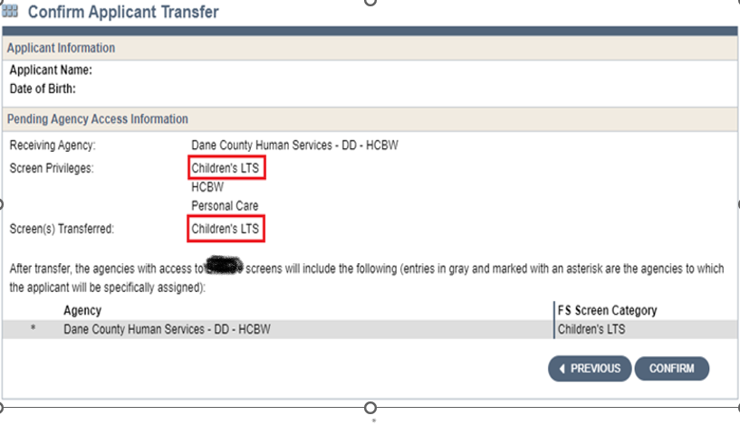

Once a screen is transferred, it cannot be revoked. If a screener transfers a screen to the wrong agency, only the agency that received the screen can transfer it back to your agency. It is not acceptable to ask the agency that incorrectly received the transferred screen to forward or transfer the screen to the correct agency.

If you need help transferring a screen, contact the SOS Help Desk at:

[SOS Help Desk](mailto:dhssoshelp@wisconsin.gov)

608-266-9198

[dhssoshelp@wisconsin.gov](mailto:dhssoshelp@wisconsin.gov)

### What the person receiving the functional screen will do

The person receiving the screen must check that the correct child’s screen was transferred. Within a timely manner, the screener should review any past screens and if there is an eligible screen within the last 12 months, it must be used until a new screen is due. There is no need to update with the current county/screener’s name until the 12-month mark.

*Initial* screen**:** Complete an *Initial* screen if the child is applying for a different program in the new county or if the screen was previously NFE for that program.

## 11.8 Incomplete Screens

Incomplete Screens create multiple problems on the CLTS FS. By definition, an incomplete screen is a screen where functional eligibility has not been calculated. This happens when a screener has used Edit to update information on an existing screen and has not recalculated eligibility. It may seem that the updated information was not pertinent to functional eligibility but the screen still requires recalculation. Anytime a screener enters information in the CLTS FS, they must save that information and check that “Eligibility” in the left-hand navigation column continues to have a green check mark next to it. If there is no green check mark, functional eligibility must be calculated again.

There are two other ways to know if a screen is complete. The first is to look on the “My Recent Screens” page. If there is a clock image next to “CLTS” in the same row as the child’s name, that screen is incomplete. The other is to run the **Screen Summary at Agency Level** report to generate a list of all incomplete screens by a screener’s name.

## 11.9 Note Sections on the CLTS FS

Note sections are available on every page of the CLTS FS. This space is provided for the screener to enhance or support the items they have checked (or did not check) on each page. **The purpose or expectation is that notes will be made to strengthen and corroborate items checked on the screen.**

**The following specific notes are expected on certain pages:**

**DIAGNOSIS**: Note any specific diagnosis the child has that is on the Diagnoses Cue Sheet, followed by the specific names of the child’s diagnosis.

**Examples:**

* 09/07/21: Developmental Disability and Seizure Disorder have been checked per the Diagnoses Cue Sheet for a diagnosis of Cornelia De Lange Syndrome. PB
* 09/07/21: Metabolic Disorder has been checked per the Diagnoses Cue Sheet for a diagnosis of Sanfilippo Syndrome. PB

**MENTAL HEALTH**: Note all details regarding any check marks for specific symptoms (violence, suicidality, psychosis, and anorexia/bulimia). Note all specifics regarding any selection of rare and extreme conditions.

**Examples:**

* 09/07/21: Violence has been checked because the child took a knife to school last week and threatened to use it. The police were involved. CM
* 09/07/21: Psychosis was checked as this child has many behaviors that resemble psychotic behaviors, including reporting that they are hearing voices. CM
* 09/07/21: Although this child continues to have a diagnosis of anorexia, the symptoms are well managed and, therefore, Anorexia/Bulimia was not checked on this page. CM
* 09/07/21: Child attempted suicide two months ago. They were released from the hospital. The discharge summary verifies this information. CM

**BEHAVIOR**: Note a detailed description of any check marks for specific behaviors, especially those that occur at a frequency of “1-3 times/week” or “more than 4 times/week” and any time “Other” is checked.

**Examples:**

* 09/07/21: Child is going through a difficult transition and has run away every weekend, often requiring police to help find them. They report they were going to a friend’s house but were found miles away from home, often walking along the side of a highway. Their parents and the police reports support this. MS
* 09/07/21: Child engages in head banging behavior on a daily basis. They wear a helmet to protect their head at home and at school. They will strike their head on walls and floors. This accommodation is in their IEP and they were wearing their helmet at the home visit. MS

### Five Attributes of CLTS Functional Screen Quality Notes

Notes contain the evidence to support what is selected (or not selected) on the CLTS FS. There is a reason certified screeners select certain items on the CLTS FS. Notes should provide the details that led to those decisions.

#### Purpose of Quality Notes:

If a screen is reviewed after a period of time, anyone (the screener, the child’s guardians, an administrative law judge, the CLTS FS Team, or an agency supervisor) should be able to stand behind the functional screen results with the evidence contained in the note sections. It must be clear that functional eligibility was determined based on all evidence available at the time.

#### Five Attributes of Quality Notes:

1. **Proper Format**

Dates and initials appear with notes, in desired format:

* 1. Newest notes at the top of the note section; and
  2. Date (MM/DD/YY) - Notes - Initials.

Notes appear on every page of the CLTS FS. Proper formatting ensures anyone reviewing the screen knows where to look for the most relevant information and locking (bookends) in a screener's notes so no one else accidentally adds to notes another screener has written.

2. **Professional Appearance**

Notes must reflect a professional, court-ready document. The CLTS FS represents the screener's best work. Acronyms and abbreviations should not be used. Additionally, notes with correct grammar and spelling will be easier for a subsequent screener or someone reviewing the screen to understand.

3. **Previous Notes are Accurate**

Every note on a functional screen must support the child’s current functional abilities. Notes are always saved with screens in the “History” of the CLTS FS. If previous notes remain entirely accurate and pertinent to the current screen, screeners should indicate that in a newly dated entry.

4. **Incorporate Multiple Sources**

Notes indicate that findings were corroborated from multiple sources and identify the specific sources. Sources must represent the child’s functional abilities in multiple locations throughout their day. Multiple sources are important throughout the screen but are essential on all selected categories on the Mental Health, Behavior, and IADL pages. Sources include the following:

* Child: observations during the home visit
* Parent: information shared during the home visit and in written form (such as on the application)
* Others: verbal reports from others in the child’s life
* Reports: written documentation of the child’s functional abilities

5. **Contain Detailed Evidence**

Notes provide details of the child’s functional ability that led to what was (not) selected on the CLTS FS. Notes answer the question, “How would someone know the information selected on the CLTS FS is correct?” Notes:

* Include objective descriptions of skills demonstrated at the home visit.
* Provide evidence gathered from reports.
* Provide facts, including the what, who, why, where, and when.

When another person (another screener, a hearing officer, or a parent) looks at a screen you have completed, it should be clear from reading the notes why certain items were (not) checked on the screen. There does not need to be a note every time a check mark is made. The critical notes address items on the screen that might be questioned by someone else reviewing the screen. This is especially important at the state-level review when confirming NFE screens.

**Examples of items that do *not* require notes**:

* A child with cerebral palsy who has items checked on the ADL page.
* A child with Down syndrome who has items checked on the IADL page.
* A child with bipolar who has services checked on the Mental Health page.
* A child with spinal muscular atrophy who has items checked on the HRS page.

**Examples of items requiring notes**:

* A child with Down syndrome who has Running Away checked on the Behavior page.
* A child with depression who has Respiratory Treatments checked on the HRS page.
* Any child who has Violence checked on the Mental Health page.
* Any child who has Torture or Abuse of Animals “4 or more days each week” checked on the Behavior page.

## 11.10 Reports Available on the CLTS FS

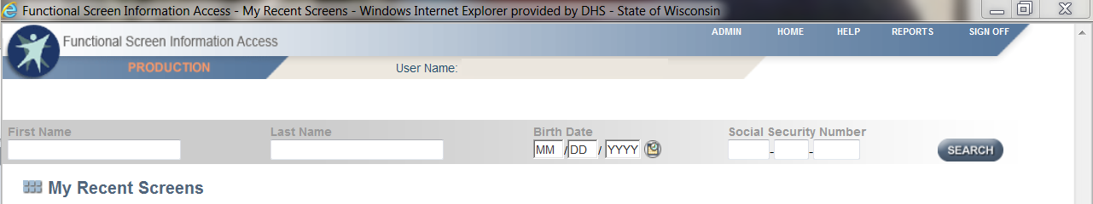The reports available on the CLTS FS were designed for use by screeners and agencies. To access the reports from any page within the functional screen, select REPORTS from the upper right corner of the page:

Select Children’s Long Term Supports Reports:

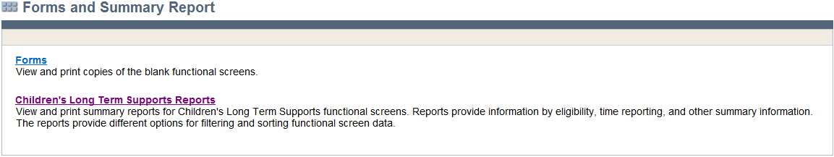

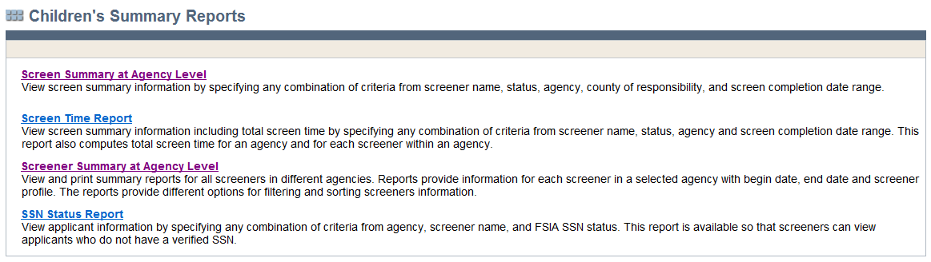There are currently four reports available:

1. **Screen Summary at Agency Level**

This report helps agencies monitor screens that are incomplete and the types of screens being completed, among other factors.

View Screen Summary information by specifying any combination of criteria:

* County
* Agency
* Screener
* Status (incomplete or complete)
* Screen Archive Status (active or archived)

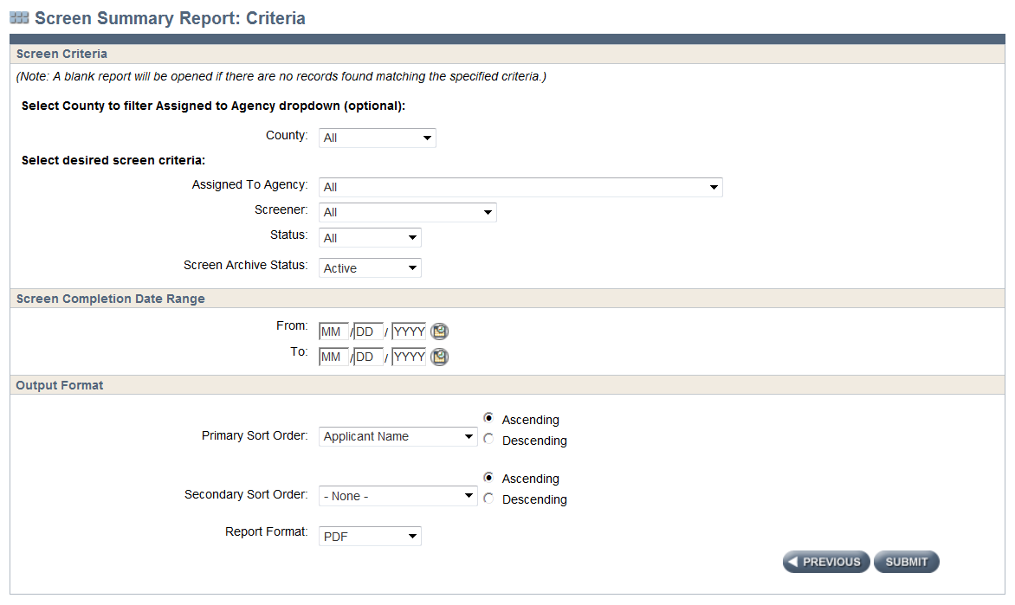Information can be collected within a specific date range. The report generated can be sorted as specified and created as a PDF document or Excel spreadsheet.

Once all criteria are selected, click Submit.

The report will list:

* Child's Name
* Child’s Date of Birth
* Child’s SSN
* Screener’s Name
* Screen Completed Date
* County of Residence
* County of Responsibility
* Screen Type (Initial or ReScreen)
* Status (Complete or Incomplete)

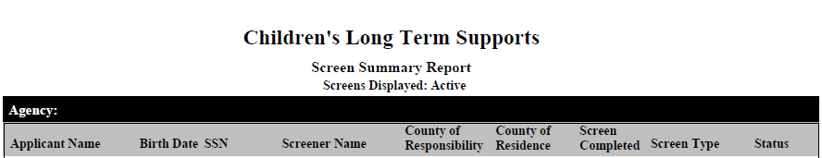

1. Screen Time Report

This report helps agencies monitor the amount of time it takes for screeners to complete a functional screen.

View Screen Time information by specifying any combination of criteria:

* County
* Screener
* Agency
* Screen Archive Status (active or archived)

Information can be collected within a specific date range. The report generated can be sorted as specified and created as a PDF document or Excel spreadsheet.

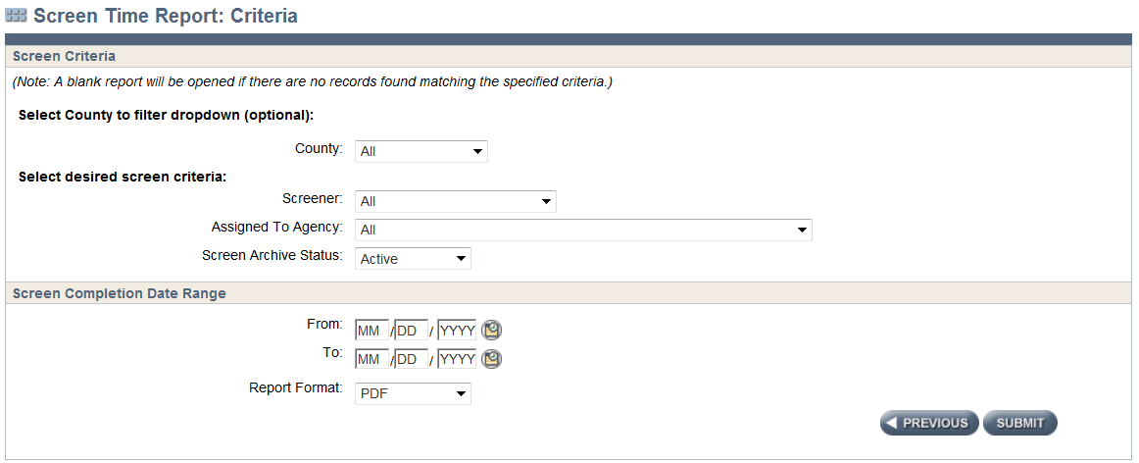

Once all criteria are selected, click Submit.

This report will generate a list that includes all of the following information:

* Screener’s Name
* Child’s Name
* Child’s Date of Birth
* Child’s SSN
* Screen Complete Date
* Screen Type (Initial or Annual)
* Screen Time
* Referral Date
* Screen Begin Date
* Days from Referral Date to Screen Begin Date
* Days from Screen Begin Date to Screen Completion

This report also computes total screen time for an agency and for each screener within an agency.

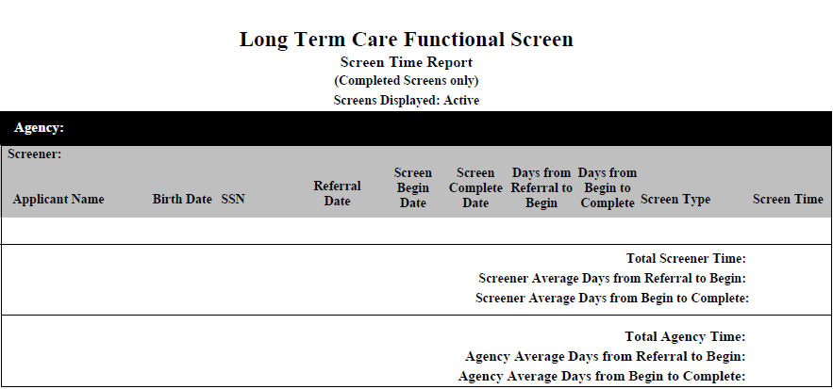

1. Screener Summary at Agency Level  
   This report helps agencies monitor the status of their screeners. This is especially important when an employee leaves or assumes a different role in the functional screen process.

View Screener Summary information by specifying any combination of criteria:

* County
* Agency
* Screener Status (Active or Inactive)
* Screener Profile (Child Screener, Child Screener - View Only)

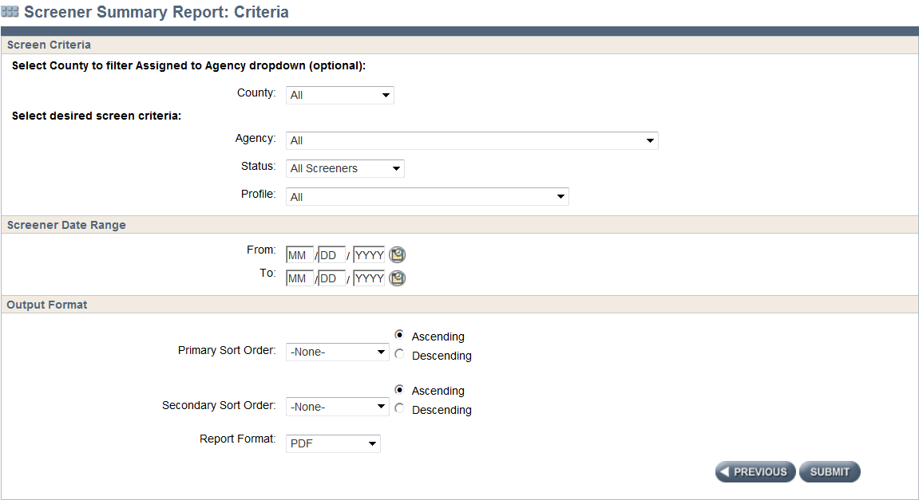Information can be collected within a specific date range. The report generated can be sorted as specified and created as a PDF document or Excel spreadsheet.

Once all criteria are selected, click Submit.

This report will generate a list that includes all of the following information:

* Screener’s Name
* Certification Begin Date
* Certification End Date
* Screener Profile (Child Screener, Child Screens - View Only)
* 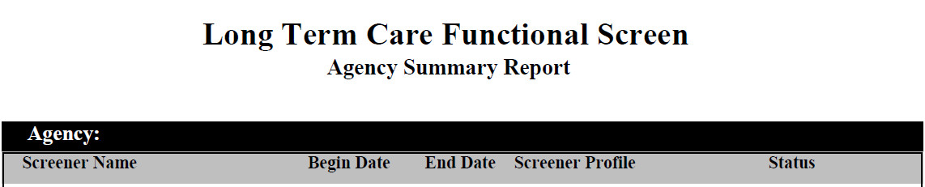Status (Active, Inactive)

1. SSN Status Report  
   This report is available so that screeners can view applicants who do not have a verified SSN.

View SSN Status information by specifying any combination of criteria:

* County
* Screener
* Agency
* SSN Status

Information can be collected within a specific date range. The report generated can be sorted as specified and created as a PDF document or Excel spreadsheet.

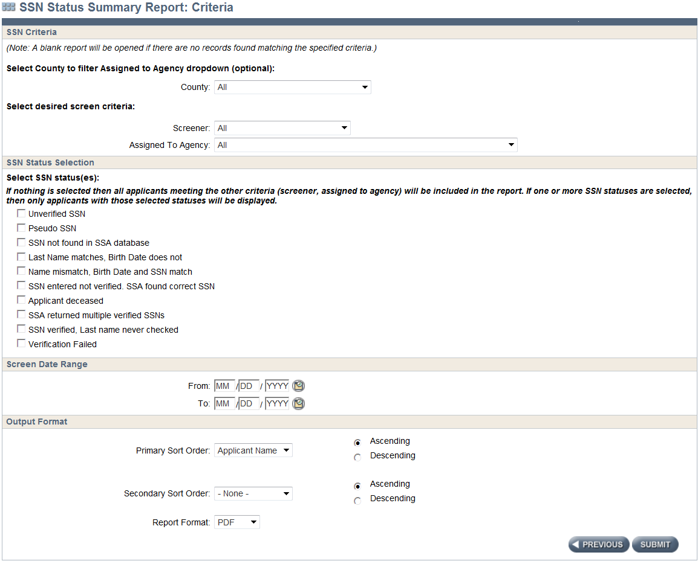

Once all criteria are selected, click Submit.

This report will generate a list that includes all of the following information:

* Child’s Name
* Child’s Date of Birth
* Child’s Gender
* Screener’s Name
* Child’s SSN
* SSN Status

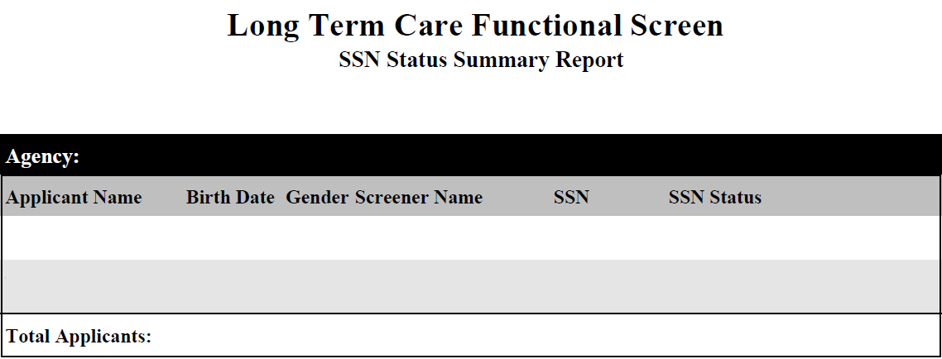

## 11.11 Not Functionally Eligible LOC Results

Once functional eligibility is calculated, an icon appears in the upper-right corner of the Eligibility Results page for every child (see image below). Clicking on the “Print NFE Results” icon will open a new PDF document that will outline Not Functionally Eligible (NFE) Results. Note that this option does not work on previous eligibility calculations or history screens. Previously calculated screens will display the Child’s Results as “null.”

Image of the Eligibility Results page with the Print NFE Results icon

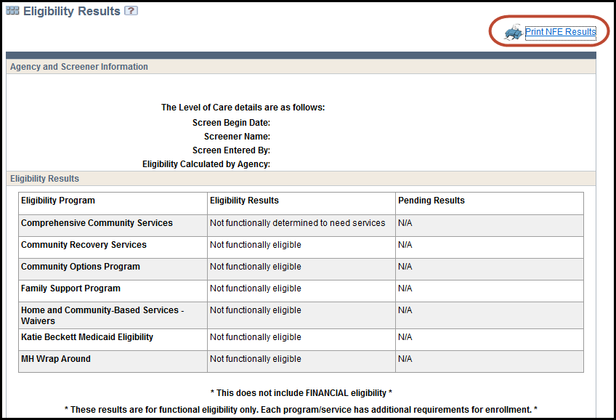

In addition, a “Print NFE Results” button is located to the right panel on the “My Recent Screens” page of the CLTS FS.

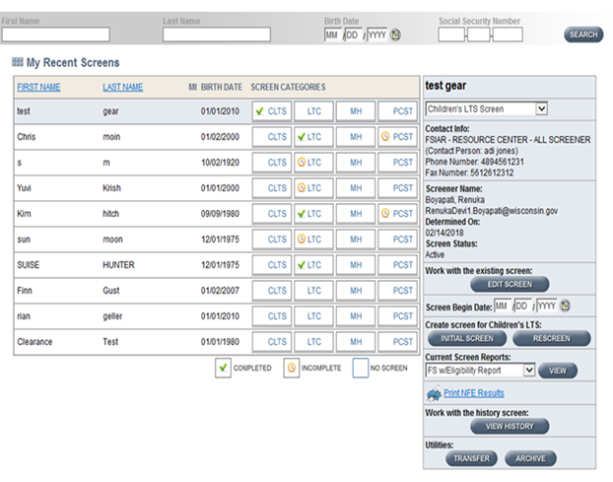

The NFE Results document will outline the criteria for each of the four institutional levels of care. Following the criteria, the specific Child’s Results will be outlined. This lists the first criterion for each level of care that was not met.

### Possible NFE Results for the ICF-IID (DD) LOC:

* This child does not have a diagnosis of a cognitive disability or a similar diagnosis as required to meet Criterion 1 of the ICF-IID Level of Care.
* This child does not demonstrate substantial functional limitations as required to meet Criterion 2 of the ICF-IID Level of Care.

### Possible NFE Results for the Psychiatric Hospital (Mental Health) LOC:

* This child does not have a diagnosis of a mental health condition as required to meet Criterion 1 of the Psychiatric Hospital Level of Care Requirements.
* This child’s mental health diagnosis has not existed for the required duration of time as required to meet Criterion 2 of the Psychiatric Hospital Level of Care Requirements.
* This child’s mental health diagnosis is not expected to persist for the required duration of time as required to meet Criterion 2 of the Psychiatric Hospital Level of Care Requirements.
* This child is not currently receiving or in need of involvement with the mental health service system as required to meet Criterion 3 of the Psychiatric Hospital Level of Care Requirements.
* This child does not exhibit severe symptomology or dangerous behaviors at the intensity or frequency of required interventions to meet Criterion 4; Standards I-VI of the Psychiatric Hospital Level of Care Requirements.
* This child does exhibit the rare or extreme circumstances or substantial social competency impairment required to meet Criterion 4; Standard VII of the Psychiatric Hospital Level of Care Requirements.

### Possible NFE Results for the Nursing Home (Physical Disability) LOC:

* This child does not have a diagnosis of a medical or physical disability as required to meet Criterion 1 of the Nursing Home Level of Care Requirements.
* This child does not require the skilled nursing interventions or does not have substantial functional limitations required to meet Criterion 2 of the Nursing Home Level of Care Requirements.

### Possible NFE Results for the Hospital (HOS) LOC:

This child does not meet the need for frequent and complex medical care that requires the use of equipment to prevent a life-threatening situation for the required duration.

With the information provided in the NFE Results document, screeners can gather information from the CLTS FS, the institutional levels of care, and all additional documentation they have about the child to formulate a clear and concise explanation of why a child did not meet any one or all four levels of care. This PDF document can be shared with families.