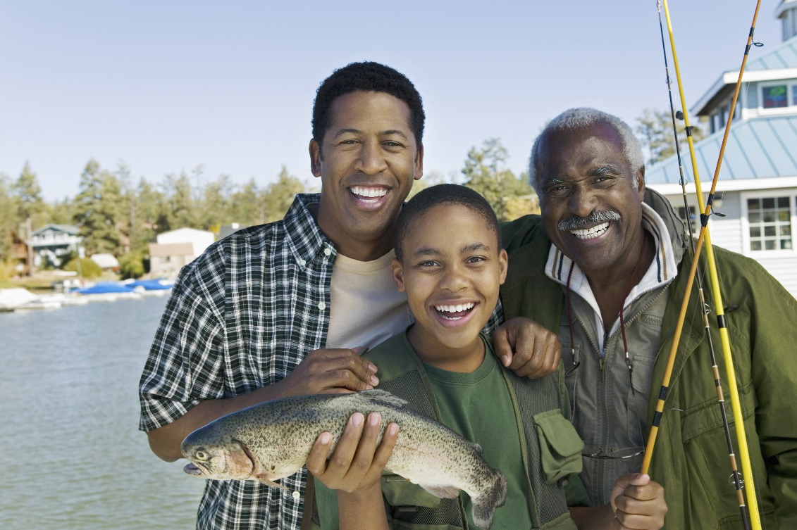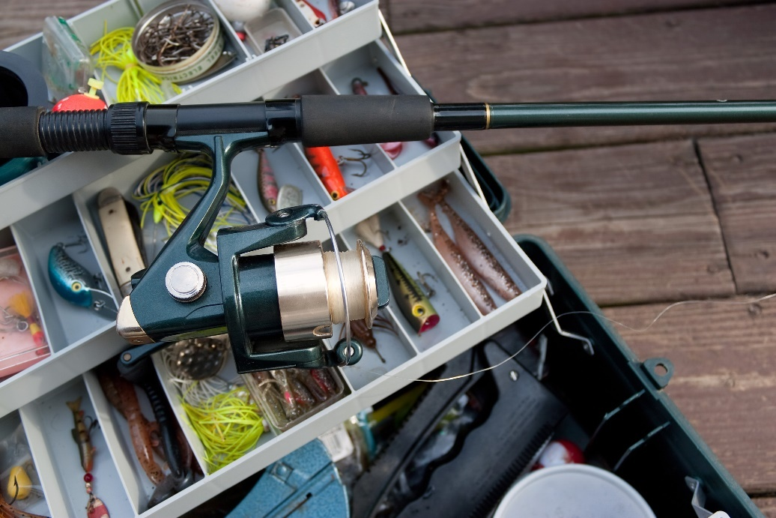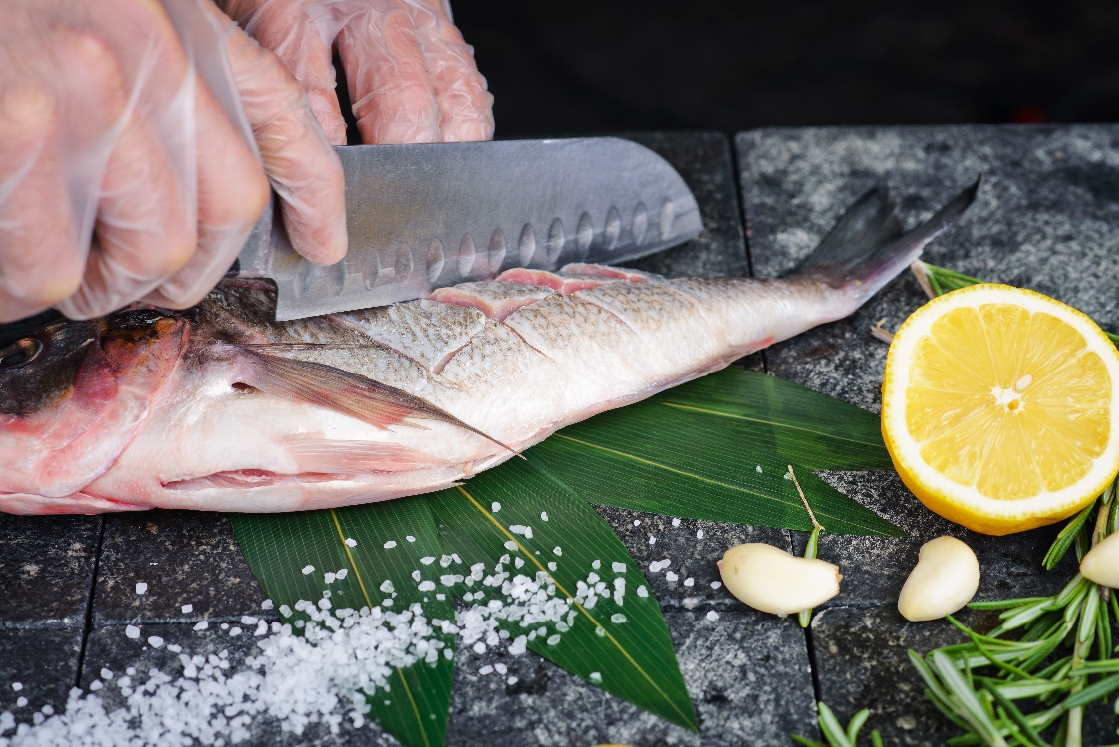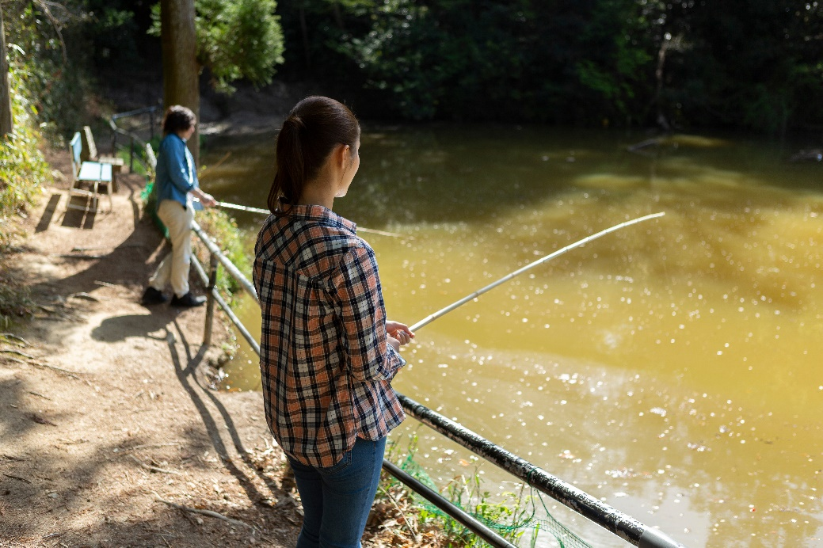

**EAT FISH, SAFELY:**

A Toolkit for Communicating Public Health Recommendations



**Bureau of Environmental and Occupational Health**

<https://www.dhs.wisconsin.gov/water/fish/index.htm>

August 2024

Table of Contents

Introduction 2

Website Text 5

Newsletter Text 6

Social Media Posts 7

Videos 11

Frequently Asked Questions 14

Additional Resources 16

Print and Digital Handouts 18

Acknowledgements 20

# Introduction

Eating fish you catch in Wisconsin is a good source of protein, vitamins, and healthy fats. Although fish have many health benefits, there are some risks when eating fish from Wisconsin waterbodies. Most fish have small amounts of contaminants, or unsafe chemicals, in them that can harm your body when eaten in large amounts.

These contaminants are mostly [mercury](https://www.dhs.wisconsin.gov/chemical/mercury.htm), [PCBs](https://www.dhs.wisconsin.gov/chemical/pcb.htm) (polychlorinated biphenyls), and [PFAS](https://www.dhs.wisconsin.gov/chemical/pfas.htm) (perfluoroalkyl and polyfluoroalkyl substances). Fish take them in from their environment and food.

Over time, these contaminants can cause health problems, like cancer or damage to your lungs, kidneys, liver, and brain. This is especially concerning for children, infants, and unborn babies whose brains are still growing. That’s why people who could become pregnant, are pregnant or are nursing, and children under 15 should avoid eating too many fish with these contaminants, since it can lead to learning problems later in life.

The amount of these contaminants varies across waterbodies throughout the state. Eating fish is healthy, but there are things to keep in mind when enjoying your fish.

The Wisconsin Department of Health Services (DHS) and Wisconsin Department of Natural Resources (DNR) work together to provide resources to local and Tribal health departments, and to educate people who eat their catch on how much and what kind of fish are safe to eat.

# Purpose

This toolkit is for local and Tribal public health departments to educate their communities on how to safely eat fish caught in Wisconsin. It includes website text, social media posts, videos, and other resources to share with your community.

**This information is not intended to discourage people from eating fish, but to help them select fish that are low in contaminants.**

# Disclaimer

The information found in this toolkit was published in **August 2024**. This information may change as new research becomes available.

The DNR provides the state with the latest fish advisory information. Visit the [Wisconsin DNR Fish Consumption](https://dnr.wisconsin.gov/topic/Fishing/consumption) page for the most current information.

# How this affects your community

The Wisconsin Department of Health Services’ Fish Program manages [projects focused on fish advisory awareness, exposure to harmful chemicals, and fish-eating habits](https://www.dhs.wisconsin.gov/water/fish/projects.htm) in Wisconsin.

Through these studies, we found that:

* Urban anglers had higher concentrations of PFAS, PCBs, and mercury in their bodies than other U.S. adults.
* Minorities and women tend to be less aware of fish advisories than other groups.

Additionally, in our 2020 study of Asian women of child-bearing age in the Milwaukee area, we found the following information:

Over 78%reported **eating the head or skin of fish** at least some of the time.

Only 25% were **aware of any Wisconsin sportfish advisories**. And only 19% of respondents were aware of local advisories.

71% reported that their fish consumption **remained the same or increased during pregnancy**.

# What this means for your community

While these studies took place in specific Wisconsin areas with diverse populations, it is important that the entire state follows safe fish consumption advice as recommended by the Wisconsin Department of Natural Resources (DNR). This is because there are contaminants in all Wisconsin waterbodies, and advisories may change.

**Bottom-line**

* Many people may not know what the fish consumption advisories are for waterbodies in their area and may be eating more than the recommended amount of fish.

🡪 **Help raise advisory awareness by educating your community about what the advisories are for your local waterbodies and showing people where to find that information.**

* People who could become pregnant, are pregnant or nursing, as well as those feeding children under the age of 15 may not be aware of advisories that suggest restricting their fish consumption, and may be eating more than they should, or eating fish species that are not recommended for consumption.

🡪 **Conduct appropriate education and outreach to these groups using the information provided in this toolkit.**

* Many people are eating the head or the skin of the fish. They may not know that this is where most of the PCBs accumulate.

🡪 **Encourage people to eat the fillet for this reason, as it is generally the safest part of the fish to eat.**

* Asian communities may be less aware of advisories and the contaminants in fish due to effects of systemic racism and inaccessible language and messaging, putting them at higher risk of health problems from mercury, PCBs, and PFAS.

🡪 **Use plain language and translated materials when sharing information with these communities and acknowledge cultural traditions.**

You can find the information you need to communicate these messages to your community in this toolkit. Please keep in mind that these messages were generalized to be relevant to all areas of Wisconsin. If you feel that a message needs more information, please edit as you see fit. You know your community best. For example, you may want to look up specific advice for a common fishing spot, or large lake in your county on the [DNR’s Online Query Tool](https://dnr.wisconsin.gov/topic/Fishing/consumption) (found half way down on this link’s page).

# When to talk about fish consumption

**Summer:** We primarily suggest communicating this information beginning in **May and throughout the summer**. The Wisconsin general inland fishing season opener is the first Saturday of May. According to our studies, people eat fish most frequently in the summer months.

**Winter:** Wisconsin has a significant number of people who ice fish in the winter months. We suggest repeating this information during this time.

All communications and outreach materials for your use can be found on the Wisconsin Department of Health Services [Eat Fish, Safely: Resources page](https://www.dhs.wisconsin.gov/water/fish/resources.htm).

# Website text

This information applies as a general message for the entire State of Wisconsin and can be used on a website page to highlight the importance of safe fish consumption. For fish consumption advice for a specific area, please refer to the DNR Choose Wisely Guide found on the [Eating Your Catch – Making Healthy Choices](https://dnr.wisconsin.gov/topic/Fishing/consumption) page.

Fish are a good source of protein, vitamins, and healthy fats. Although fish have many health benefits, there are some risks when eating fish from Wisconsin waterbodies. Most fish have small amounts of contaminants, or unsafe chemicals, in them that can harm your body when eaten in large amounts. These contaminants are mostly [mercury](https://www.dhs.wisconsin.gov/chemical/mercury.htm), [PCBs](https://www.dhs.wisconsin.gov/chemical/pcb.htm) (polychlorinated biphenyls), and [PFAS](https://www.dhs.wisconsin.gov/chemical/pfas.htm) (perfluoroalkyl and polyfluoroalkyl substances). Fish take them in from their environment and food.

Over time, these contaminants can cause health problems, like cancer or damage to your lungs, kidneys, liver, and brain. This is especially concerning for children, infants, and unborn babies whose brains are still growing. That’s why people who could become pregnant, are pregnant or nursing, and children under 15 should avoid eating too many fish with these contaminants since it can lead to problems with growth and development.

You can still enjoy eating your catch, safely, when you follow these tips:

* Know the fish advisories for the waterbody you plan to fish.
* Eat types of fish known to have fewer contaminants.
* Follow local and state advice on how much and how often you should eat fish.
* Before cooking your fish, cut off the skin, head, and fat and remove the guts, since this is where most PCBs are found. In general, the fillet is the safest part of the fish to eat. You cannot remove mercury or PFAS from fish.

**Note**: Celebrating culture is an important part of health. If a traditional dish includes these parts, try to save this meal for special occasions to reduce contaminant intake over time.

Find this advice, and more in the Wisconsin Department of Natural Resources’ **Choose Wisely Guide** or **online query tool,** both found on the DNR’s [Eating Your Catch – Making Healthy Choices](https://dnr.wisconsin.gov/topic/Fishing/consumption) page.

More resources about how to eat fish safely can be found on the [Wisconsin Department of Health Services](https://www.dhs.wisconsin.gov/water/fish/recommendations.htm) website.

# Newsletter text

This text can be used in newsletters, or other similar formats to create awareness around safe fish consumption and where to find resources.

**Short**

Eating your catch this fishing season? Before you do, make sure you find out which fish are safe to eat in your fishing spot. Visit the [Wisconsin Department of Natural Resources](https://dnr.wisconsin.gov/topic/Fishing/consumption) website. More resources can be found on the [Wisconsin Department of Health Services](https://www.dhs.wisconsin.gov/water/fish/recommendations.htm) website.

**Long**

Eating your catch this fishing season? Fish have many health benefits, but most have some contaminants in them that can cause health problems when eaten in large amounts.

Take these steps so you can eat Wisconsin fish safely:

* Know the fish advisories for the waterbody you plan to fish.
* Eat types of fish known to have fewer contaminants.
* Follow local and state advice on how much and how often you should eat fish.
* Before cooking your fish, cut off the skin, head, and fat and remove the guts, since this is where most PCBs are found. In general, the fillet is the safest part of the fish to eat. You cannot remove mercury or PFAS from fish.

**Note**: Celebrating culture is an important part of health. If a traditional dish includes these parts, try to save this meal for special occasions to reduce contaminant intake over time.

Find this advice, and more, in the Wisconsin Department of Natural Resources’ **Choose Wisely Guide** or **online query tool,** both found on the [Eating Your Catch – Making Healthy Choices](https://dnr.wisconsin.gov/topic/Fishing/consumption) page.

More resources can be found on the [Wisconsin Department of Health Services](https://www.dhs.wisconsin.gov/water/fish/recommendations.htm) website.

# Social media posts

These social media posts can be used for your local government, health department, or organization’s social media profiles to inform people of how to eat fish safely.

The Wisconsin fishing season is generally the first Saturday of May through March the following year. We suggest posting these throughout the summer, during peak fishing season.

Remember to tag us in your posts!

* Facebook: @DHSWI
* X (Twitter): @DHSWI
* Instagram: @dhs.wi

Download graphics to accompany your social media posts from the Wisconsin Department of Health Services [Eat Fish, Safely: Resources page](https://www.dhs.wisconsin.gov/water/fish/resources.htm).

**General advice for sensitive populations**

*(People who could become pregnant, are pregnant or nursing, and children under 15)*

Are you pregnant, nursing, or have kids under 15? If so, eating fish can provide key nutrients that support development. But before you do, check with the latest safe-eating guidelines from @WisconsinDNR to pick the healthiest fish. Learn more: <https://dnr.wisconsin.gov/topic/Fishing/consumption>.

If you could become pregnant, are pregnant or nursing, or are feeding children under 15, make sure to check the safe-eating guidelines for Wisconsin fish before eating your catch. Many types of fish are both nutritious and lower in contaminants. Learn how to safely eat fish from @DHSWI: dhs.wi.gov/fish.

Need help figuring out what Wisconsin fish to feed your child? Check out the @WisconsinDNR Choose Wisely Guide for advice on the amount and types of fish to eat! <https://dnr.wisconsin.gov/topic/Fishing/consumption>

Eating fish is part of a healthy diet! Make sure your family is eating the correct amount and type of Wisconsin fish. Learn more from @DHSWI: dhs.wi.gov/fish.

Looking forward to eating your catch this fishing season? Us too! Just remember that those who could become pregnant, are pregnant, nursing, or under 15 should follow stricter advice than others when eating Wisconsin fish. Learn more from @DHSWI: dhs.wi.gov/fish.

Safe-eating advice for Great Lakes fish is a little stricter than Wisconsin’s inland waters. Before you eat your catch from the Great Lakes, check with the @WisconsinDNR Choose Wisely Guide on the latest advice for the amount and types of fish to eat. Find it here: <https://dnr.wisconsin.gov/topic/Fishing/consumption>.

**General advice for Wisconsin’s inland lakes and rivers (not Great Lakes)**

As Wisconsinites, we love eating fish! They are a good source of protein, vitamins, and healthy fats. You can get the health benefits from eating fish while reducing unwanted contaminants by eating the right amount and following guidance from @DHSWI and@WisconsinDNR.

Most adults can eat one to two servings per week of fish that are lower in contaminants. Children under 15, and people who could become pregnant, are pregnant, or nursing should not eat more than one serving per week.

Learn more about the waterbody you fish in from the DNR Choose Wisely Guide: <https://dnr.wisconsin.gov/topic/Fishing/consumption>

We hope you’re enjoying some good fishing this summer! Get the health benefits from fish, while reducing contaminants by knowing your fish’s species and source! Learn more from @DHSWI: dhs.wi.gov/fish

Eating your catch is part of a healthy, balanced diet. But before you do, find advice for eating fish from Wisconsin waters with the @WisconsinDNR online query tool: <https://apps.dnr.wi.gov/fishconsumptionadvisoryquery/>.

*\*Note: Refer to the* *Videos section* *of this toolkit for the “How to safely eat fish caught in Wisconsin” video and accompanying social media posts.*

**Contaminants**

Three contaminants, or unsafe chemicals, are responsible for most fish advisories in Wisconsin: PCBs, mercury, and PFAS. While most Wisconsin fish have small amounts of these contaminants in them, you can still safely eat Wisconsin fish by following advice from @WisconsinDNR on the amount and type of fish to eat, found here: <https://dnr.wisconsin.gov/topic/Fishing/consumption>.

You cannot tell if a fish has contaminants, or unsafe chemicals, in it by looking at it or tasting it. That’s why it’s important to check with the @WisconsinDNR Choose Wisely Guide before eating your catch from Wisconsin waters! Find the guide here: <https://dnr.wisconsin.gov/topic/Fishing/consumption>.

*Note: Refer to the* *Videos section* *of this toolkit for the “What to know about contaminants in Wisconsin fish” video and accompanying social media posts.*

**Advisories**

Are you eating your catch this fishing season? Consumption advice from @WisconsinDNR and @DHSWI may have changed since you last looked them up. Get the latest information at: <https://dnr.wisconsin.gov/topic/Fishing/consumption>.

**Cooking**

Eating fish you caught? You can remove most of the contaminants, PCBs, in fish by cutting off the skin, head, and fat and removing the guts before cooking. In general, the fillet is the safest part of the fish to eat. You cannot remove mercury or PFAS from fish. Learn more about eating fish safely from @DHSWI: dhs.wi.gov/fish.

When cooking fish, it is best to bake or grill it in a way that allows the juices to drip away. This is because there may be a lot of contaminants in those juices. After the fish has cooked, throw the juices away and do not reuse them. Learn more about eating fish safely from @DHSWI: dhs.wi.gov/fish.

When eating fish, reduce your health risk from PCBs by choosing fish from waterbodies known to have fewer contaminants and remove the organs. In general, the fillet is the safest part of the fish to eat. You cannot remove mercury or PFAS from fish. Learn more from @DHSWI: dhs.wi.gov/fish.

Eating your catch? Before you do, remove the parts of the fish that have most of the contaminants, PCBs, in them: the skin, head, organs, and juices that drip out when cooking.

However, celebrating culture is an important part of health. If a traditional dish includes these parts, try to save this meal for special occasions to reduce contaminant intake over time. In general, the fillet is the safest part of the fish to eat.

Learn more about how to eat fish safely from @DHSWI: dhs.wi.gov/fish.

*Note: Refer to the* *Videos section* *of this toolkit for the “How to safely prepare and cook fish” video and accompanying social media posts.*

**Commercial fishing advice**

Before you buy fish at the store, check the @FDA advice about eating fish. Find out which fish are the best choices to eat, and which ones to avoid: <https://www.fda.gov/food/consumers/advice-about-eating-fish>.

***Notes***

*Refer to the* *Videos section* *of this toolkit for the “How to safely choose fish from the store” video and accompanying social media posts.*

*For more social media posts on commercial fish, check out the* [*FDA/EPA social media toolkit*](https://www.fda.gov/food/consumers/social-media-toolkit-fdaepa-advice-about-eating-fish)*.*

# Videos

There are four educational videos that explain 1) contaminants in fish, 2) advisories for Wisconsin fish, 3) advisories for commercial fish, and 4) how to safely prepare and cook fish. Each video is available in English, Spanish, Chinese, Hmong, Karen, Burmese, and Rohingya. All the videos include subtitles, except for Rohingya, which does not have a written language. You can find the videos on the Wisconsin Department of Health Services [Eat Fish, Safely: Resources page](https://www.dhs.wisconsin.gov/water/fish/resources.htm), or linked to YouTube, in the following list:

* [English](https://youtube.com/playlist?list=PLrVDlKoVyjBRh1lkJ0msiDXJErKsTj3re&si=SVlBhCjF2waYgEl0)
* [Spanish](https://youtube.com/playlist?list=PLrVDlKoVyjBRV_6qUv6Q9J2YwxbeIb-rI&si=LcGCXMg1r_-GU_Kx)
* [Hmong](https://youtube.com/playlist?list=PLrVDlKoVyjBTNyZdd1aU6dYvufvySg6iB&si=lk_22eYlCPtVR6eV)
* [Chinese](https://youtube.com/playlist?list=PLrVDlKoVyjBRG8wBjVwdlhKIN2aYijPMY&si=3XFwYcIBs-zHDzFy)
* [Burmese](https://youtube.com/playlist?list=PLrVDlKoVyjBSEnd5t-Nl0YizCy3raabmo&si=p2hqKdNOBI-_25d8)
* [Karen](https://youtube.com/playlist?list=PLrVDlKoVyjBQPRKPiV3cShM05ey2EhFzj&si=haDfBuDg4NVeTm-Z)
* [Rohingya](https://youtube.com/playlist?list=PLrVDlKoVyjBTejtUghSdgAAlJtoc8rD8e&si=cyS5cxPveChnvpQF)

**Video promotion**

These videos can be shared on your websites, social media, newsletters, in-person events, or other applicable media outlets.

Suggested text as an introduction to this video series on your website:

“Watch these videos from the Wisconsin Department of Health Services to learn how to eat fish, safely! Each video is available in English, Spanish, Chinese, Hmong, Karen, Burmese, and Rohingya.”

1. **“What to know about contaminants in Wisconsin fish”**
   * Suggested caption for website:

This video from the Wisconsin Department of Health Services will teach you how you can protect yourself and the people you care about from contaminants when eating fish from lakes, rivers, streams, or other Wisconsin waterbodies.

* + Suggested posts for social media:
    - While most Wisconsin fish have a small amount of contaminants in them, there are still ways to eat fish safely and enjoy Wisconsin fish! Learn more from @DHSWI <https://youtu.be/9Xz2cRYLDLQ?si=jkkw6H9T5MlwjB97>

*[Or insert video language relevant to your community.]*

* + - Before you eat your catch this season, make sure you know what’s in the water. Learn how to eat fish safely from @DHSWI <https://youtu.be/9Xz2cRYLDLQ?si=jkkw6H9T5MlwjB97>

*[Or insert video language relevant to your community.]*

1. **“How to safely eat fish caught in Wisconsin”**
   * Suggested caption for website:

This video from the Wisconsin Department of Health Services will teach you how you can protect yourself and the people you care about when eating fish caught from lakes, rivers, streams, or other waterbodies located in Wisconsin.

* + Suggested posts for social media:

Most waterbodies in Wisconsin have some contaminants in them. However, you can still eat fish safely by following the advice in this video: <https://youtu.be/LT2QZz0CgAs?si=goepNMofUWAbl3sm> *[Or insert video language relevant to your community.]*

* + - Did you know that people who could become pregnant, are pregnant or nursing, and children under 15 should never eat musky? Find out why and learn more from @DHSWI in this video <https://youtu.be/LT2QZz0CgAs?si=goepNMofUWAbl3sm> *[Or insert video language relevant to your community.]*

1. **“How to safely choose fish from the store”**
   * Suggested caption for website:

This video from the Wisconsin Department of Health Services will teach you how to choose the healthiest fish to purchase at the store.

* + Suggested posts for social media:

Before you buy fish at the store, check advisories from the government, choose healthy types of fish, and make sure you’re eating the recommended number of servings. Learn more in this video <https://youtu.be/9GwtaFoBELU?si=aXTe3urI9OGTNljU> *[Or insert video language relevant to your community.]*

* + - If you could become pregnant, are pregnant or nursing, or are feeding kids under 15 years old, check out advice from the @FDA (<https://www.fda.gov/food/consumers/advice-about-eating-fish>) before eating fish you buy at the store. Watch this video to learn more <https://youtu.be/9GwtaFoBELU?si=aXTe3urI9OGTNljU> *[Or insert video language relevant to your community.]*

1. **“How to safely prepare and cook fish”**
   * Suggested caption for website:

This video from the Wisconsin Department of Health Services will show you how you can safely prepare and cook fish.

* + Suggested posts for social media:
    - When we prepare and cook fish safely, we can remove the contaminants in the fish by nearly half! Watch this video to learn how <https://youtu.be/9FBdnYBpuyg?si=PKFbb1rX_aihrHFt> *[Or insert video language relevant to your community.]*
    - Are you cooking your catch this fishing season? Follow the advice in this video to remove PCBs and other chemicals that may have built up in the fish <https://youtu.be/9FBdnYBpuyg?si=PKFbb1rX_aihrHFt> *[Or insert video language relevant to your community.]*

# Frequently asked questions

These FAQs may be posted to a website or used as a reference for specific inquiries.

Find more [FAQs on Wisconsin fish from the DNR.](https://dnr.wisconsin.gov/topic/Fishing/consumption/questions.html)

*Why is there different advice for people who may become pregnant, are pregnant or nursing, and children under 15?*

People who may become pregnant, are pregnant or nursing, and children under 15 should follow stricter advice because these contaminants (mercury, PCBs, and PFAS) can be especially harmful to children and babies, even before they are born. They can harm the brain and nervous system of babies and children. This can affect their behavior and learning ability as they grow.

***What if I’m not pregnant or planning to become pregnant?***

Mercury, PCBs, and PFAS can build up in a person’s body before they become pregnant, so it is recommended that people who may become pregnant choose fish known to have fewer contaminants in case they do become pregnant.

People who are not of childbearing age and cannot become pregnant should still follow safe fish-eating guidelines because mercury, PCBs, and PFAS pose health risks to all adults, such as loss of coordination, increased risk of cancer, and harm to the immune system.

*Is it safe to touch a fish that has contaminants in it?*

Yes. You do not need to wear gloves or worry about getting the contaminants on you. They will not be absorbed by your skin from the fish. Catch and release is almost always safe, regardless of where you’re fishing. However, sometimes your local health department may issue a temporary warning against touching the water—including the fish that live in the water—because of problems like sewage overflow or harmful algal blooms. As a best practice, it is always advised to wash your hands with soap and water after fishing.

*Why should I follow this advice?*

If you eat a lot of fish, you might also be eating contaminants, like mercury, PCBs, or PFAS. These contaminants can stay in your body for a long time. Advice from the DNR and DHS is designed to protect everybody who eats fish on a regular basis. Using resources like the **DNR online query tool** and **Choose Wisely Guide** (both found on the [Eating Your Catch – Making Healthy Choices](https://dnr.wisconsin.gov/topic/Fishing/consumption) page) will keep you from getting too many contaminants in your body at once.

Scientists set eating limits so that you are protected from possible health problems from the contaminants no matter how long they stay in your body. The contaminants in fish also won’t make you sick right away. It is difficult to know who might get sick from contaminants in fish and who will not. Make the safe choice now, so you won’t have to worry about it later.

*What if a fish I want to eat is not listed in the statewide general guidance?*

If a fish is not listed, it means there was not enough data to determine the contaminant levels or that it was not a fish commonly found in this area. When data are not available, people who could become pregnant, are pregnant or nursing, and kids under 15 years old should limit eating these fish to one meal per month. Everyone else should limit eating unlisted fish to one meal per week.

*How serious is contaminant exposure from fish?*

Contaminants such as mercury, PCBs, and PFAS can build up in your body over time. Health problems associated with eating contaminated fish range from hard-to-detect neurological changes to birth defects and possibly cancer. A developing fetus and young children are most at risk.

*Can I eat fish from water with harmful algal blooms in it?*

There is not enough research on this topic to support a definitive health risk from eating fish caught in a waterbody with harmful algal blooms (HABs). Therefore, you should avoid catching and eating fish from water with HABs present. If you are unsure if a bloom is present, and plan on eating fish from that waterbody, make sure to thoroughly rinse the fish and remove the organs before you eat it. Algal toxins mostly build up in the guts of the fish and are found in lower amounts in the fillet. In general, the fillet is the safest part of the fish to eat.

*What if I eat fish from a waterbody between states? Where can I find those recommendations?*

The DNR’s [Choose Wisely Guide](https://widnr.widen.net/s/s6mkcq6tmr/pub_fh_824_choosewisely) includes safe-eating recommendations for waterbodies that border other states, and the Great Lakes.

[For more information, refer to “Bordering States” in the Additional Resources section on the following page.]

*Why does the advice change sometimes?*

The DNR tests for contaminants in fish from several locations each year and use those new results, along with past testing, to update the advice for those newly tested waters. It is important for anglers who frequently eat fish to check each year for new advisory updates.

# Additional resources

**Wisconsin fish advisories**

*This DHS website provides recommendations and resources on how to choose the best fish to eat. It also highlights recent projects at DHS on fish advisory awareness, exposure to harmful chemicals, and fish-eating habits in Wisconsin.*

[Wisconsin DHS: Eat Fish, Safely](https://www.dhs.wisconsin.gov/water/fish/index.htm)

*This Wisconsin Department of Natural Resources (DNR) website provides information on contaminants that can be found in fish along with frequently asked questions. It also has tools to help you when you are fishing, including: 1) an up-to-date guide on the Choose Wisely publication that has Wisconsin’s current fish advisories, including interstate waterways, 2) general state-wide safe-eating guidelines, and 3) an online query tool to find advice for the waterbody that you’ll be fishing.*

* [Wisconsin DNR - Eating Your Catch—Making Healthy Choices](https://dnr.wisconsin.gov/topic/Fishing/consumption)
  + [Local advisory online query tool](https://apps.dnr.wi.gov/fishconsumptionadvisoryquery/)
  + [FAQs](https://dnr.wisconsin.gov/topic/Fishing/questions)

**Bordering states**

*These websites provide safe-eating guidelines for states that share waterbodies with Wisconsin.*

* [Illinois Department of Public Health—Fish Advisories](https://dph.illinois.gov/topics-services/environmental-health-protection/toxicology/fish-advisories.html)
* [Michigan Health and Human Services—Find Your Area, Safe Fish Guidelines](https://www.michigan.gov/mdhhs/safety-injury-prev/environmental-health/topics/eatsafefish/find-your-area)
* [Minnesota Department of Health—Fish Consumption Guidance](https://www.health.state.mn.us/communities/environment/fish/index.html)

**Commercial fish advisories**

*These EPA and FDA websites provide advice on eating commercial fish. A chart is included to help you choose which fish to eat and how often to eat them.*

* [Environmental Protection Agency](https://www.epa.gov/choose-fish-and-shellfish-wisely) (EPA)
* Food and Drug Administration (FDA)

**Wisconsin fishing license and regulations**

*These DNR websites provide information related to fishing in Wisconsin, including fishing regulations, getting a license, and recognizing Wisconsin fish species.*

* [Wisconsin DNR Fishing Information](https://dnr.wisconsin.gov/topic/Fishing)
* [Wisconsin DNR Hook and Line Fishing Regulations](https://dnr.wisconsin.gov/topic/Fishing/regulations/hookline.html)

**Communicating risk**

*These websites from ATSDR, AAAS, CDC and EPA provide information on how to effectively communicate health risks to the public.*

* [Agency for Toxic Substances & Disease Registry (ATSDR)—A Primer on Health Risk Communication](http://www.atsdr.cdc.gov/risk/riskprimer/index.html)
* [American Association for the Advancement of Science (AAAS)—Communication Toolkit](https://www.aaas.org/resources/communication-toolkit)
* [Centers for Disease Control and Prevention (CDC)—Gateway to Health Communication](https://www.cdc.gov/healthcommunication/index.html)
* [Environmental Protection Agency (EPA)—Learn about Risk Communication](https://www.epa.gov/risk-communication/learn-about-risk-communication)

# Print and digital handouts

These educational materials may be printed and handed out or linked from a website. There are some suggested uses provided, but local and Tribal health departments and local organizations are encouraged to use them in ways that best fit their community and people they serve.

Find these resources on the Wisconsin Department of Health Services [Eat Fish, Safely: Resources page](https://www.dhs.wisconsin.gov/water/fish/resources.htm).

**Your Guide to Eating Fish Safely** (electronic two-pager)

Use: Link to it on a website, include it in newsletters, or hand it out at events, etc.

Available in [English](https://www.dhs.wisconsin.gov/publications/p03622.pdf), [Spanish](https://www.dhs.wisconsin.gov/publications/p03622s.pdf), [Hmong](https://www.dhs.wisconsin.gov/publications/p03622h.pdf), [Chinese](https://www.dhs.wisconsin.gov/publications/p03622cm.pdf), [Burmese](https://www.dhs.wisconsin.gov/publications/p03622bu.pdf), and [Karen](https://www.dhs.wisconsin.gov/publications/p03622ka.pdf).

**Your Guide to Eating Fish Safely** (brochure)

Use: Provide it in the lobby, put it in the WIC packet; include it in newborn letters; include it in brochure holders on boat landings; take it to bait shops; include it with tick kits; or hand it out at Rural Safety Days, county fairs, farmers markets, events, etc.

Available in [English](https://www.dhs.wisconsin.gov/publications/p03622a.pdf), [Spanish](https://www.dhs.wisconsin.gov/publications/p03622as.pdf), [Hmong](https://www.dhs.wisconsin.gov/publications/p03622ah.pdf), [Chinese](https://www.dhs.wisconsin.gov/publications/p03622acm.pdf), [Burmese](https://www.dhs.wisconsin.gov/publications/p03622abu.pdf), and [Karen](https://www.dhs.wisconsin.gov/publications/p03622aka.pdf).

**Advice for Eating Wisconsin Fish** (half page)

Use: Affix to bulletin boards at boat landings; provide it in the lobby; put it in the WIC packet; include it in newborn letters; include it in brochure holders on boat landings; take it to bait shops; or hand it out at Rural Safety Days, county fairs, farmers markets, events, etc.

Available in [English](https://www.dhs.wisconsin.gov/publications/p03622c.pdf), [Spanish](https://www.dhs.wisconsin.gov/publications/p03622cs.pdf), [Hmong](https://www.dhs.wisconsin.gov/publications/p03622ch.pdf), [Chinese](https://www.dhs.wisconsin.gov/publications/p03622ccm.pdf), [Burmese](https://www.dhs.wisconsin.gov/publications/p03622cbu.pdf), and [Karen](https://www.dhs.wisconsin.gov/publications/p03622cka.pdf).

**FDA Advice for Eating Commercial Fish** (half page)

Use: Affix to bulletin boards at boat landings; provide in the lobby; put it in the WIC packet; include it in newborn letters; include it in brochure holders on boat landings; take it to bait shops; or hand it out at Rural Safety Days, county fairs, farmers markets, events, etc.

Available in [English](https://www.fda.gov/media/102331/download?attachment), [Spanish](https://www.fda.gov/media/141562/download?attachment), [Hmong](https://www.fda.gov/media/141558/download?attachment), [Chinese](https://www.fda.gov/media/141556/download?attachment), [Burmese](https://www.dhs.wisconsin.gov/non-dhs/dph/burmese-epa-fda-advice-about-eating-fish.pdf) and [Karen](https://www.dhs.wisconsin.gov/non-dhs/dph/karen-epa-fda-advice-about-eating-fish.pdf).

**10 Tips to Cook Fish Safely** (bookmark)

Use: Provide in the lobby, partner with the local library to distribute, put it in WIC packets, include it in newborn letters, include it in the Little Free Library (if the health department or municipality sponsors one), etc.

Available in [English](https://www.dhs.wisconsin.gov/publications/p03622b.pdf), [Spanish](https://www.dhs.wisconsin.gov/publications/p03622bs.pdf), [Hmong](https://www.dhs.wisconsin.gov/publications/p03622bh.pdf), [Chinese](https://www.dhs.wisconsin.gov/publications/p03622bcm.pdf), [Burmese](https://www.dhs.wisconsin.gov/publications/p03622bbu.pdf), and [Karen](https://www.dhs.wisconsin.gov/publications/p03622bka.pdf).

**Harmful Algal Blooms and Fish Consumption** (electronic two-pager)

Use: Link to it on a website, include it in newsletters, hand it out at events, etc.

Available in [English](https://www.dhs.wisconsin.gov/publications/p03625.pdf), [Spanish](https://www.dhs.wisconsin.gov/publications/p03625s.pdf), [Hmong](https://www.dhs.wisconsin.gov/publications/p03625h.pdf), [Chinese](https://www.dhs.wisconsin.gov/publications/p03625cm.pdf), [Burmese](https://www.dhs.wisconsin.gov/publications/p03625bu.pdf), and [Karen](https://www.dhs.wisconsin.gov/publications/p03625ka.pdf).

**Fish recipes**

Use: Link to it on a website, include in newsletters, hand out at events, etc.

* [Catfish Soup](https://www.dhs.wisconsin.gov/water/fish/traditional-hmong-fish-recipe.pdf)—a traditional Hmong recipe
* [Ceviche de Pescado (Fish Ceviche)](https://www.dhs.wisconsin.gov/water/fish/traditional-mexican-fish-recipe.pdf)—a traditional Mexican recipe
* [Fish and Tomato](https://www.dhs.wisconsin.gov/water/fish/traditional-burmese-fish-recipe.pdf)—a traditional Burmese recipe
* [Green Chili Fish Curry](https://www.dhs.wisconsin.gov/water/fish/traditional-rohingya-fish-recipe.pdf)—a traditional Rohingya recipe
* [Shui Zhu Yu, 水煮鱼 Sichuan Boiled Fish](https://www.dhs.wisconsin.gov/water/fish/traditional-chinese-fish-recipe.pdf)—a traditional Chinese recipe
* [Sinigang Na Hipon (Shrimp/Fish in Sour Soup)](https://www.dhs.wisconsin.gov/water/fish/traditional-filipino-fish-recipe.pdf)—a traditional Filipino recipe
* [(Kayin) Mohinga](https://www.dhs.wisconsin.gov/water/fish/traditional-karen-fish-recipe.pdf)—a traditional Karen recipe

# Acknowledgements

This toolkit was made possible through funding from the Environmental Protection Agency, and the dedicated staff at the Wisconsin Department of Health Services who contributed their time and knowledge to its development.

Special thanks to the Wisconsin Department of Natural Resources for their partnership, expertise, and content review.

We would like to extend a sincere thanks to Alan Talaga with the University of Wisconsin Population Health Institute for making our videos possible with his video management.

We would also like to recognize those who contributed their talents to our videos: Steve Kovo with Runner Studio for his animation work, Ryan Rosmann at Hi-Five Studio for sound engineering, John Lyons and the Wisconsin Sea Grant for providing fish imagery, and our seven voice actors who graciously provided their time and voice to all four videos: Aza Amir Hamzah, Cingsuan Neam, Abby Phillips, Estela Vazquez-Ornelas, Tha Bley Wah, Judy Yan, and Gao Sue Yang.